Computational Modeling Project
As a final computational activity, you and your group (of no more than three people) will choose a topic to model. The suggested problems below will ask you to write a VPython program that simulates a physical system and to use the program to determine the answer to a scientific question.

You will then present your results to the class in a conference-style session planned for November 21.
In your presentation, you will need to introduce the problem, outline the structure of your program, demonstrate it (it will produce an animation that will be interesting to watch), and explain the conclusions that you can draw from experimenting with the program and observing the output. You will need to prepare visual slides to accompany your presentation.

Each suggested problem below my only be addressed by one group per section. They will be awarded on a first-come-first-served basis. I suggest sending me your top few choices.

Suggested Computational Problems

1 – Start by writing a simulation of the Moon's orbit around the Earth, using realistic masses, distances, and speeds. After that, you can add a third object: a spacecraft like the ones used in the Apollo missions, which had a mass of about 5000 kg after burning off most of the fuel. Please start the spacecraft near Earth, and on the opposite side of the Earth from the Moon. Find a set of initial parameters that places it into an orbit around both the Earth and the Moon. Keep track of all of the interesting orbital trajectories that you see, and if you can, find a set of initial conditions that results in a figure-8 around the Earth and the Moon.

2 – Start by writing a simulation of the Earth's orbit around the Sun, using realistic masses, distances, and speeds. You should first document that this works. After that, you can ask the question “what if gravity worked differently?” by modifying the force law so that, rather than being proportional to 1/r2, the force is proportional to a different power of r. You can try 1/r and 1/r3 and see what kinds of orbits (or not-quite-orbits) you can make happen. You will need to modify the gravitational constant G; for a 1/r3 force, you could try multiplying it by the distance to the Sun, giving G = 10 N m3/kg2. For the
1/r force, you would need to divide by this distance, giving G = 4.4 × 1022 N m/kg2.
3 – You can investigate how fast the Ranger 7 spacecraft was moving when it crashed into the Moon. It had a mass of 173 kg after burning off its fuel. You can start it at that point, 50 km above the Earth's surface. You can experimentally determine the minimum speed needed to reach the Moon from Earth; please do this to three significant digits. (Check that you are using a small enough time step that your result does not change when you make it even smaller.) If the initial speed is 10% higher than this minimum speed, how long does it take to get to the Moon? What is the spacecraft's speed when it crashes into the Moon's surface? You can do all of this at first under the assumption that the Earth and the Moon are fixed in place, so that only the spacecraft is moving. How do your results change when you allow the Earth and the Moon to move as well?

4 – (This problem should only be chosen if your whole group feels super-duper ambitious. It will require familiarizing yourself with the basics of special relativity, which will not be covered much in class until the very end of the course.) The nearest stars to the Earth, other than our Sun, are located about 4.3 light years away. Suppose you have a spaceship with a mass of 5000 kg with engines that can apply a constant force of 50000 N. Set up this ship to take a trip to these stars, accelerating forwards until halfway there and then accelerating backwards to come to a stop at our neighbor stars. First do this with the usual non-relativistic assumption that γ = 1; how does your maximum speed compare to the speed of light, and how many Earth-years does it take to reach your destination? You will probably find that this is not possible, so please repeat the calculation with a relativistically correct approach. You will also want to compare the shapes of graphs of speed vs. time for your two calculations.

5 – Build a model of a system with two masses that are connected to three springs, as illustrated in the figure below (reproduced from figure 4.65 in Matter and Interactions). You could let each mass be 1 kg and each spring have a stiffness of 20 N/m and a relaxed length of 0.5 m. You should be able to find different initial conditions that give two “normal modes” of oscillations of the two masses: in one case, they will move in the same direction as each other, and in the other their motions will be mirror images. How do the periods of these oscillations compare to what you would expect for a simple one-dimensional harmonic oscillator?
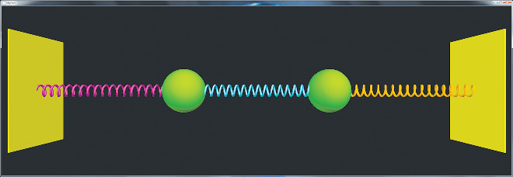
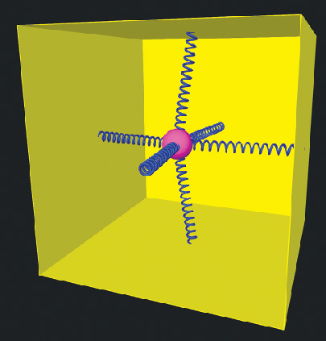
6 – Build a model of a system consisting of a mass connected to six springs, each of which has one end fixed to the center of a side of a cube, as in the figure below (reproduced from figure 4.66 in Matter and Interactions). You could let each mass be 1 kg and each spring have a stiffness of 50 N/m and a relaxed length of 0.5 m. What kinds of motions can you get the mass to make? How does the period of motion compare to a simple one-dimensional harmonic oscillator?

7 – A block moves on a flat table, connected by a spring to a post at the center of the table, as shown in the figure below (reproduced from Figure 4.67 in Matter and Interactions). Vary the mass of the block and the stiffness and relaxed length of the spring and see what kinds of motion you can make the block trace out. Start without friction, and then observe what happens when you add a friction force, starting with a small coefficient of kinetic friction and then making it larger.

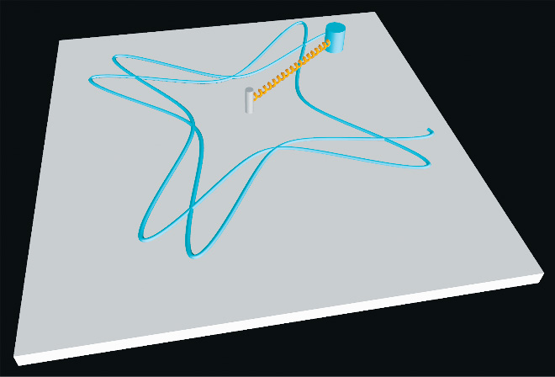

8 – First, write programs that model a standard one-dimensional harmonic oscillator in both its horizontal and vertical orientations; the primary difference is that a gravitational force is relevant in the vertical case. Check that you find that the position is sinusoidal as a function of time, and that the oscillation period matches your expectation. Next, consider a nonlinear “spring” that exerts a force that is proportional to s3 rather than just s. You could, for example, let its stiffness k = 5000 N/m3. Modify your programs to model a one-dimensional oscillator with this “spring.” Does the position still seem to vary sinusoidally? How does the oscillation period depend on the amplitude?

