Class09

Elizabeth Trujillo

2/5/2020

##K-means clustering

Let’s try the kmeans() function in R to cluster some made-up example data

#tmp ##c puts things into a vector ##first call to R gives me 30 points with a mean of -3 (30 points clustered around -3) ##second call to R gives me 30 points with a mean of 3 (30 points clustered around 3)

##cbind binds data?? and will put x as first column, and y as a second column ##rev means list the numbers in reverse

tmp <- c(rnorm(30,-3), rnorm(30,3))  
  
x <- cbind(x=tmp, y=rev(tmp))  
  
plot(x)

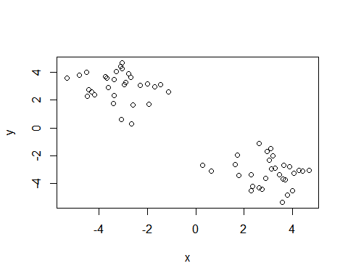

#KM is KMEANSs(x, CENTERS=2, NSTART=20)

km <- kmeans (x, centers =2, nstart=20)

print(km)

## K-means clustering with 2 clusters of sizes 30, 30  
##   
## Cluster means:  
## x y  
## 1 2.990119 -3.197845  
## 2 -3.197845 2.990119  
##   
## Clustering vector:  
## [1] 2 2 2 2 2 2 2 2 2 2 2 2 2 2 2 2 2 2 2 2 2 2 2 2 2 2 2 2 2 2 1 1 1 1 1 1 1 1  
## [39] 1 1 1 1 1 1 1 1 1 1 1 1 1 1 1 1 1 1 1 1 1 1  
##   
## Within cluster sum of squares by cluster:  
## [1] 61.6416 61.6416  
## (between_SS / total_SS = 90.3 %)  
##   
## Available components:  
##   
## [1] "cluster" "centers" "totss" "withinss" "tot.withinss"  
## [6] "betweenss" "size" "iter" "ifault"

##clustering vectors - the different clusters (cluster 1 and cluster 2)

##What is the output object ‘km’ ? ##Atributes function to find this information use ‘attributes()’

attributes(km)

## $names  
## [1] "cluster" "centers" "totss" "withinss" "tot.withinss"  
## [6] "betweenss" "size" "iter" "ifault"   
##   
## $class  
## [1] "kmeans"

##size gives you the number of points for vector 1 and 2

km$size

## [1] 30 30

#cluster is a vector of integers indicating the cluster to which each point is allocated

km$cluster

## [1] 2 2 2 2 2 2 2 2 2 2 2 2 2 2 2 2 2 2 2 2 2 2 2 2 2 2 2 2 2 2 1 1 1 1 1 1 1 1  
## [39] 1 1 1 1 1 1 1 1 1 1 1 1 1 1 1 1 1 1 1 1 1 1

##let’s check how many 2s and 1s are in this vector with the cluster function

table(km$cluster)

##   
## 1 2   
## 30 30

##plot x colored by the kmenas cluster assignment and add cluster centers as blue points

plot(x, col=km$cluster)

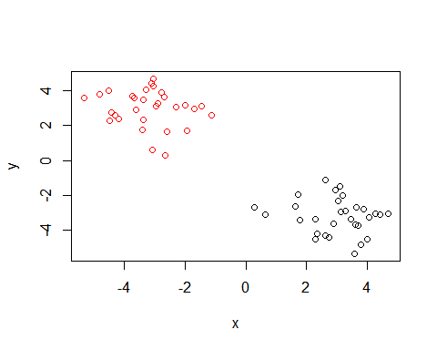

c(rep("red", 30), rep("blue", 30))

## [1] "red" "red" "red" "red" "red" "red" "red" "red" "red" "red"   
## [11] "red" "red" "red" "red" "red" "red" "red" "red" "red" "red"   
## [21] "red" "red" "red" "red" "red" "red" "red" "red" "red" "red"   
## [31] "blue" "blue" "blue" "blue" "blue" "blue" "blue" "blue" "blue" "blue"  
## [41] "blue" "blue" "blue" "blue" "blue" "blue" "blue" "blue" "blue" "blue"  
## [51] "blue" "blue" "blue" "blue" "blue" "blue" "blue" "blue" "blue" "blue"

plot(x, col=km$cluster+1)

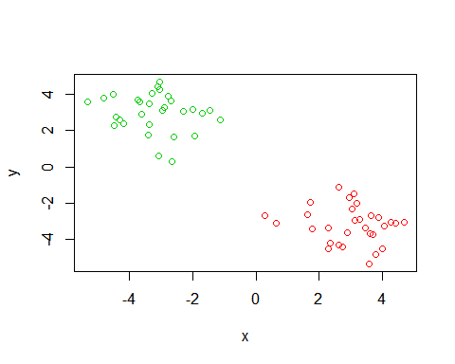

plot(x, col=km$cluster+2)

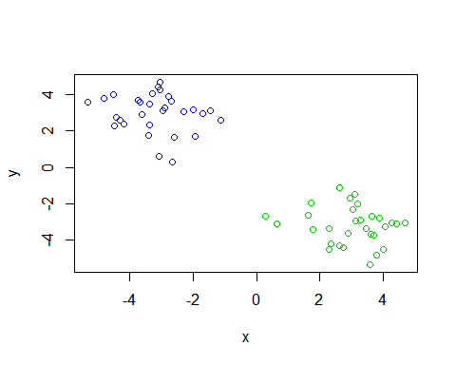

plot(x, col=km$cluster)  
points(km$centers, col="blue")

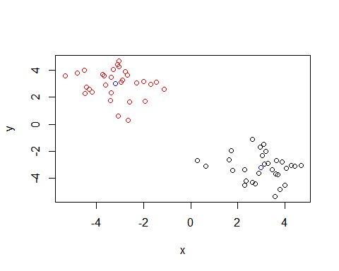 ##pch is for characters so you can get a big blue square

plot(x, col=km$cluster)  
points(km$centers, col="blue", pch=15)

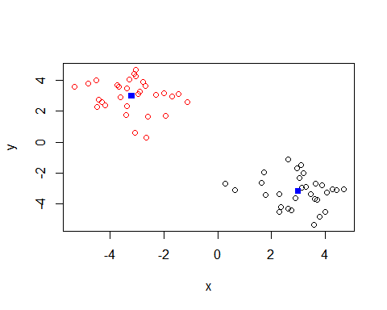

#can change shape of pch if you assign it a different number

plot(x, col=km$cluster)  
points(km$centers, col="blue", pch=17)

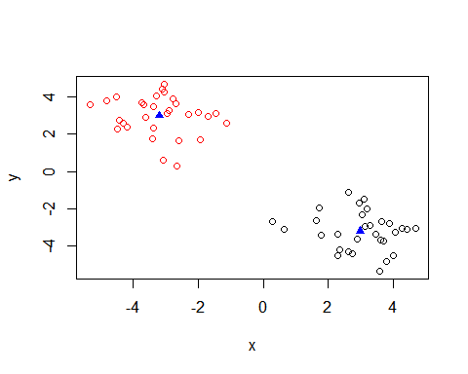

#dist to calculate the distance ##HCLUST(DIST(X)) calcualting distance matrix

#the hclust() function is the main hierarchcal clustering method in R and it **must** be passed a **distance matrix** as input not your raw data!

#you can call seqeunce identities here, or structures

hc <- hclust(dist(x))

hc

##   
## Call:  
## hclust(d = dist(x))  
##   
## Cluster method : complete   
## Distance : euclidean   
## Number of objects: 60

plot(hc)

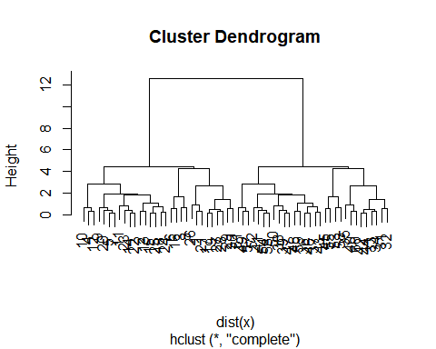

##1st vector contains points 1-30, 2nd vector contains points 31 - 60

#cut below red line and get two branches

plot(hc)  
abline(h=6, col="red")

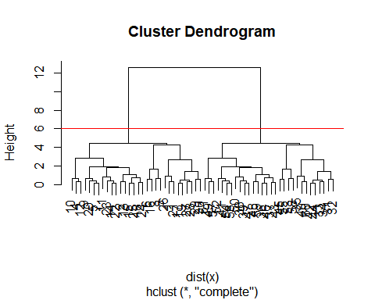

#tell it a height of where to cut (cut by height **h**) #lty to get a dashed line

plot(hc)  
abline(h=6, col="red", lty=2)

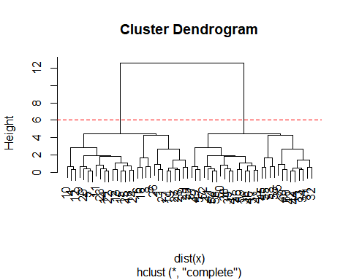

cutree(hc, h=6)

## [1] 1 1 1 1 1 1 1 1 1 1 1 1 1 1 1 1 1 1 1 1 1 1 1 1 1 1 1 1 1 1 2 2 2 2 2 2 2 2  
## [39] 2 2 2 2 2 2 2 2 2 2 2 2 2 2 2 2 2 2 2 2 2 2

##Now cut them into kgroups #the higher the k gropu number, the higher the number of groups you get

plot(hc)  
abline(h=6, col="red", lty=2)  
abline(h=6, col="blue", lty=2)

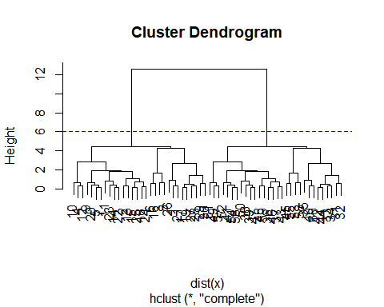

cutree(hc, k=3.5) # Cut into k grps

## [1] 1 1 1 1 1 1 1 1 1 1 1 1 1 1 1 1 1 1 1 1 1 1 1 1 1 1 1 1 1 1 2 2 2 2 2 3 3 3  
## [39] 3 2 3 2 3 2 2 3 3 3 3 3 3 3 2 3 2 3 3 2 3 2

##use a table to see how many points in each group

table(cutree(hc, h=3.5))

##   
## 1 2 3 4 5 6   
## 9 17 4 9 17 4

##ask for k instead; you can also ask cutree() for the k number of gorups that you want

cutree(hc, k=5)

## [1] 1 2 1 2 2 1 2 1 2 2 2 2 2 2 2 1 1 2 1 2 1 2 2 2 2 1 1 1 1 1 3 3 3 3 3 4 4 4  
## [39] 4 3 4 3 4 3 5 4 4 4 4 4 4 4 5 4 5 4 4 5 4 3

cutree(hc, k=3.5)

## [1] 1 1 1 1 1 1 1 1 1 1 1 1 1 1 1 1 1 1 1 1 1 1 1 1 1 1 1 1 1 1 2 2 2 2 2 3 3 3  
## [39] 3 2 3 2 3 2 2 3 3 3 3 3 3 3 2 3 2 3 3 2 3 2

##Using different hierarchical clustering methods

hc.complete <- hclust(d, method=“complete”) hc.average <- hclust(d, method=“average”) hc.single <- hclust(d, method=“single”)

# Step 1. Generate some example data for clustering

x <- rbind(  
matrix(rnorm(100, mean=0, sd=0.3), ncol = 2), # c1  
matrix(rnorm(100, mean=1, sd=0.3), ncol = 2), # c2  
matrix(c(rnorm(50, mean=1, sd=0.3), # c3  
rnorm(50, mean=0, sd=0.3)), ncol = 2))  
colnames(x) <- c("x", "y")

# Step 2. Plot the data without clustering

plot(x)

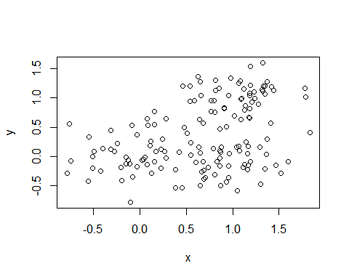

# Step 3. Generate colors for known clusters

# (just so we can compare to hclust results)

col <- as.factor( rep(c("c1","c2","c3"), each=50) )  
plot(x, col=col)

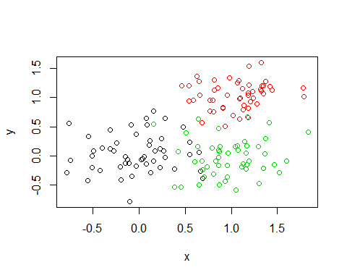

#Q. Use the dist(), hclust(), plot() and cutree() functions to return 2 and 3 clusters

#membership factor (grps3)

#Q. How does this compare to your known ‘col’ groups?

hc <- hclust(dist(x))  
plot(hc)

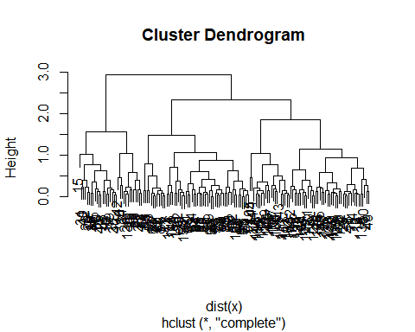

grps3 <- cutree(hc, k=3)  
grps3

## [1] 1 2 1 1 1 3 2 2 2 2 1 1 1 1 2 2 2 2 2 2 1 2 1 2 1 2 2 1 2 2 2 2 2 1 2 2 2  
## [38] 2 2 2 2 2 2 1 2 1 2 1 2 1 3 3 3 3 3 3 3 3 3 3 3 3 3 3 3 3 3 3 3 3 3 3 3 3  
## [75] 3 3 3 3 3 3 3 3 3 3 3 3 3 3 3 3 3 3 3 3 3 3 3 3 3 3 1 1 1 1 1 1 1 1 1 1 1  
## [112] 1 3 1 1 3 1 1 1 1 1 1 1 1 1 1 1 1 1 1 1 1 1 1 1 2 1 1 1 1 3 1 1 1 1 1 1 1  
## [149] 1 3

table(grps3)

## grps3  
## 1 2 3   
## 62 33 55

#color it by the membership (grps3) factor

plot(x, col=grps3)

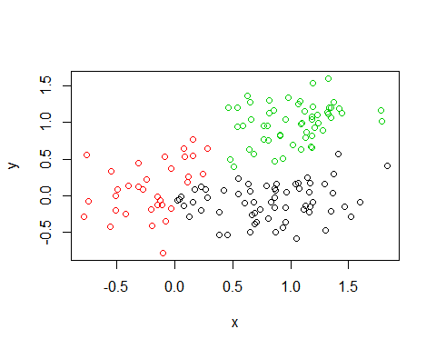

table(grps3)

## grps3  
## 1 2 3   
## 62 33 55

##set up a cross table

##this will show you the points that were false-positives (the smallest number in the table per c1, c2, or c3)

table(grps3, col)

## col  
## grps3 c1 c2 c3  
## 1 17 0 45  
## 2 32 0 1  
## 3 1 50 4

#**this should have given me a tale c1, c2, c3 rows and 1, 2, 3 columns**

#Principal Component Analysis (PCA) the absolute basics #when you have a tone of cell lines #*PCA converst correlation or lack there of a represenation that you can actually look at* PCA shows us that those that cluster together are similar

#*the x-axis (PC1) are more important*

#the main function in bas R for PCA is called prcomp(). Here we will use PCA to examine the funny food that folks eat in the UK and N. Ireland

x <- read.csv("UK_foods.csv")

## Preview the first 6 rows

rownames(x) <- x[,1]  
x <- x[,-1]  
head(x)

## England Wales Scotland N.Ireland  
## Cheese 105 103 103 66  
## Carcass_meat 245 227 242 267  
## Other_meat 685 803 750 586  
## Fish 147 160 122 93  
## Fats_and_oils 193 235 184 209  
## Sugars 156 175 147 139

spotting major differences in trends

barplot(as.matrix(x), beside=T, col=rainbow(nrow(x)))

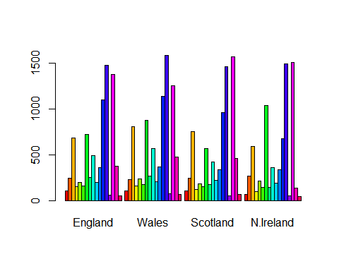

pairs(x, col=rainbow(10), pch=16)

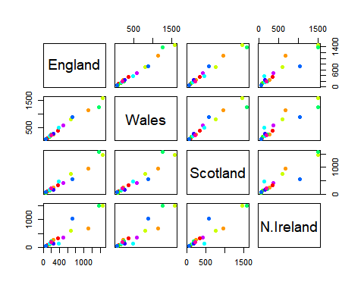

# Use the prcomp() PCA function

##t means transpose (from math)

pca <- prcomp(t(x))

#gives the standard deviation #looking at portion of variance. look at most amount of variance

summary(pca)

## Importance of components:  
## PC1 PC2 PC3 PC4  
## Standard deviation 324.1502 212.7478 73.87622 4.189e-14  
## Proportion of Variance 0.6744 0.2905 0.03503 0.000e+00  
## Cumulative Proportion 0.6744 0.9650 1.00000 1.000e+00

##second and third row from above are in percentages

#look at the arributes

# Plot PC1 vs PC2

plot(pca$x[,], pca$x[,], xlab="PC1", ylab="PC2", xlim=c(-270,500))  
text(pca$x[,1], pca$x[,2], colnames(x)) #this adds text for x and y coordinates and the country names

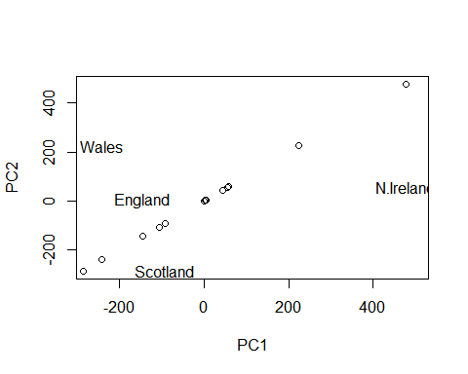

#Customize your plot so that the colors of the country names match the colors in our UK and Ireland map and table at start of this document

plot(pca$x[,], pca$x[,], xlab="PC1", ylab="PC2", xlim=c(-270,500))  
text(pca$x[,1], pca$x[,2], colnames(x), col=c("black", "red", "blue", "dark green"))

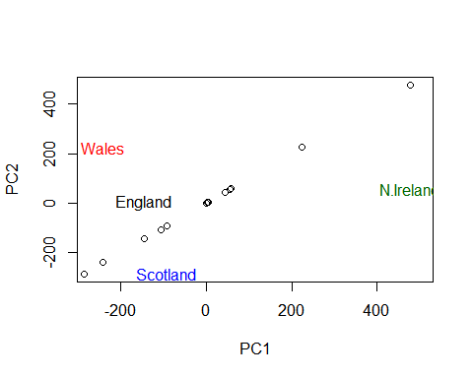

#adding colors: black for england b/c first on the table, wales in red, scotland in blue, and ireland in dark green

#gives me a barplot

plot(pca)

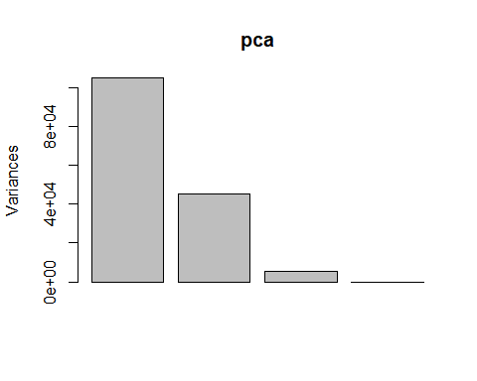

## Lets focus on PC1 as it accounts for > 90% of variance

par(mar=c(10, 3, 0.35, 0))  
barplot( pca$rotation[,1], las=2 )

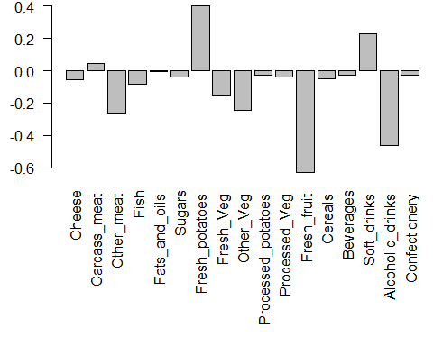

par(mar=c(10, 3, 0.35, 0))  
barplot( pca$rotation[,2], las=2 )

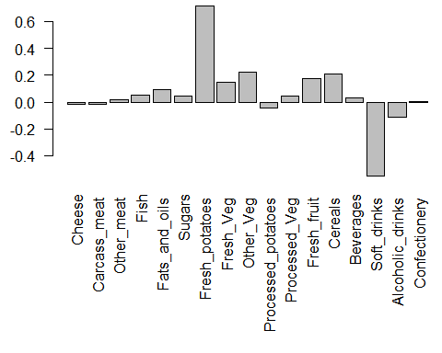

par(mar=c(10, 3, 0.35, 0))  
barplot( pca$rotation[,3], las=2 )

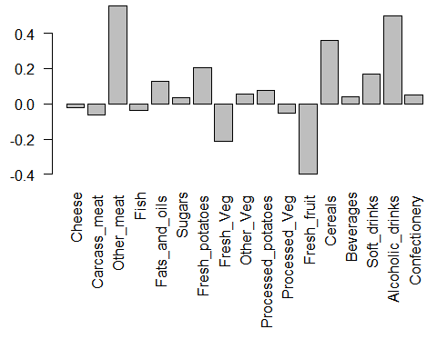

par(mar=c(10, 3, 0.35, 0))  
barplot( pca$rotation[,1], las=1 )

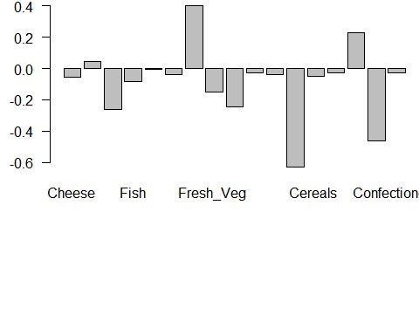 #las gives you just one word and changes the y-axis

par(mar=c(10, 3, 0.35, 0))  
barplot( pca$rotation[,1], las=3 )

