SmartSpend
Spending Efficiency Analysis in the Turkish Super Lig
Seasons 2023-24 | 2024-25 | 2025-26

Saltuk Bugrahan Tasdemir
Kerem Berkalp Cerekci
EMU430 — Data Analytics | Hacettepe University | May 2026

1. Executive Summary
SmartSpend investigates the relationship between squad market values and points performance in the Turkish Super Lig across three seasons (2023-24, 2024-25, 2025-26). The core research question: Which clubs get the most points per Euro spent?

Key Findings
1) Strong positive correlation between squad value and points (r = 0.855 average across seasons).
2) Galatasaray is the most efficient large-budget club across all three seasons (avg. efficiency score +6.9).
3) Samsunspor and Sivasspor consistently over-perform their budgets by large margins.
4) Forward wage spending shows a NEGATIVE correlation with goals scored (r = -0.12) -- expensive strikers do not guarantee goals.
5) The Best XI selected by G+A per EUR million is composed almost entirely of mid-table club players.

2. Data Sources and Methodology

2.1 Data Sources
Source | Coverage | Key Variables
Transfermarkt | 3 seasons, ~20 clubs/season | Player market value (EUR), squad_name, player_position
FBref (StatsBomb) | 3 seasons, club & player level | Points, W/D/L, Goals, Assists, Minutes, Position, Save%
Capology.com | Club-level, 3 seasons | Annual total wage bill (EUR)

Player market values were retrieved via direct HTTP scraping of Transfermarkt using browser-mimicking headers (httr + rvest in R). Sleep delays were applied between requests to respect rate limits. FBref standings and player statistics were collected using the worldfootballR package.

2.2 Dataset Dimensions
Dataset | Rows | Coverage
team_season (club-season pairs) | 57 | 20 + 19 + 18 clubs across 3 seasons
player_full (player statistics) | 1,840 | Position, goals, assists, minutes
squad_values (squad values) | 57 | Avg. player value per club-season

2.3 Pre-processing Steps
- Team name standardisation — Transfermarkt, FBref, and Capology use different name formats; a lookup table maps all variants to a canonical form
- Squad market value aggregation — sum of player values per club-season; derive avg_player_value_eur and squad_size
- FBref standings cleaning — cast W/D/L/Pts to integer; filter rows where Pts is NA (e.g. Hatayspor withdrawal in 2023-24)
- Player position normalisation — full Transfermarkt position names (e.g. 'Centre-Forward', 'Right Winger') mapped to short codes (ST, RW, etc.)
- January transfer adjustment — players arriving in the winter window have their annual wage halved before inclusion in team totals
- Player-team-season deduplication and left-join merge with market value data

3. Exploratory Data Analysis (EDA)

3.1 Squad Market Value Distribution by Club
The chart below shows total squad market values per club across the three seasons. Galatasaray and Fenerbahce stand out clearly from the rest of the league.

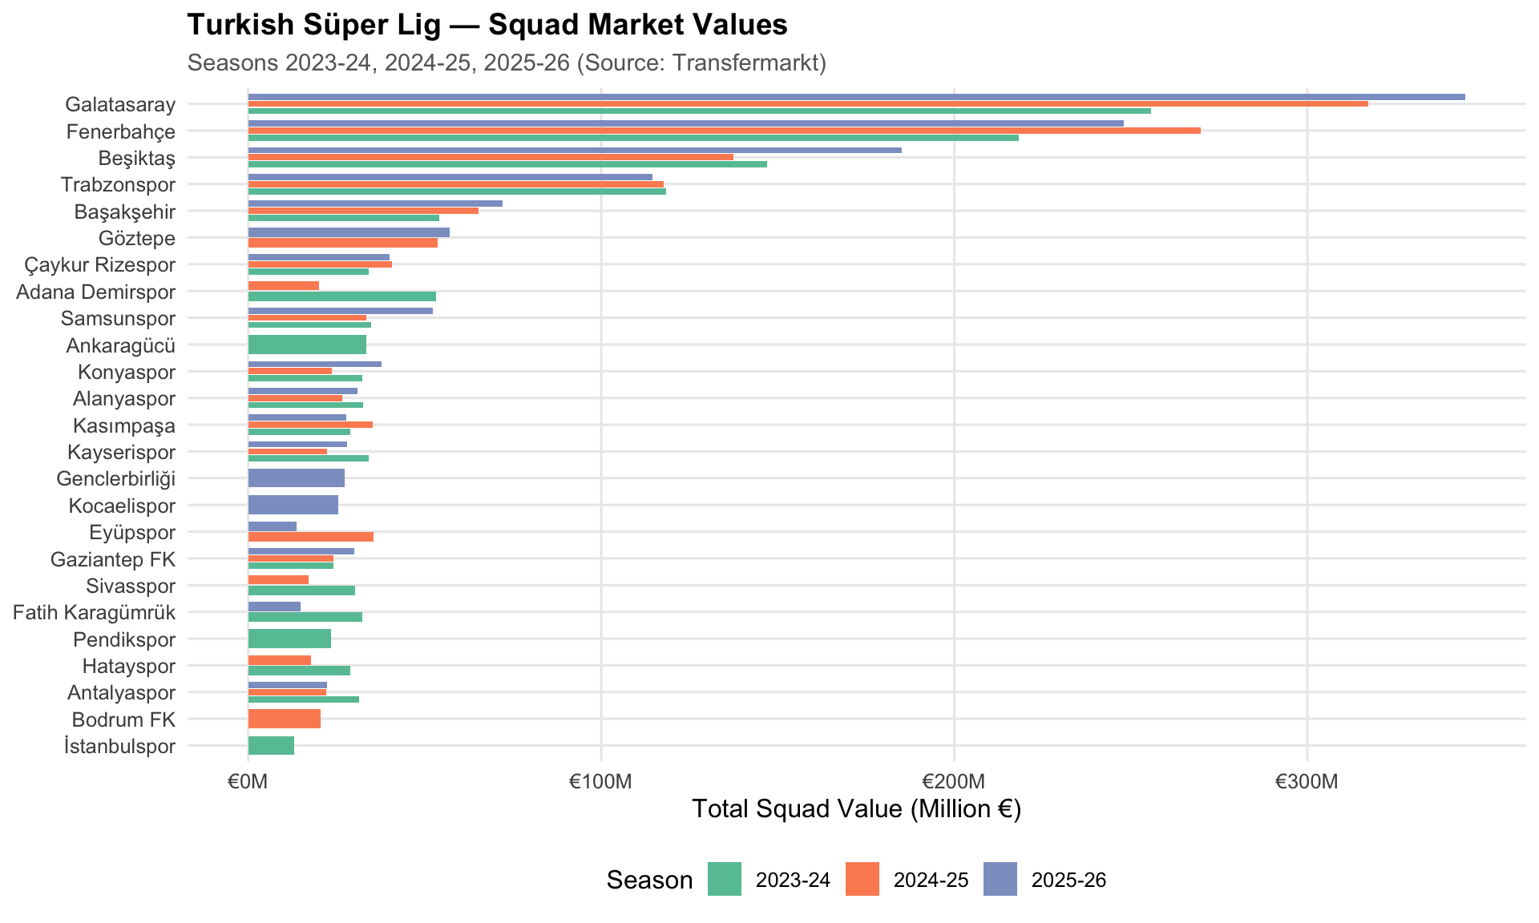
Figure 1 — Turkish Super Lig Squad Market Values by Club (2023-24, 2024-25, 2025-26) | Source: Transfermarkt

3.2 Season-Level Value Distribution
The box plot summarises the distribution of squad values within each season. Each dot represents one club.

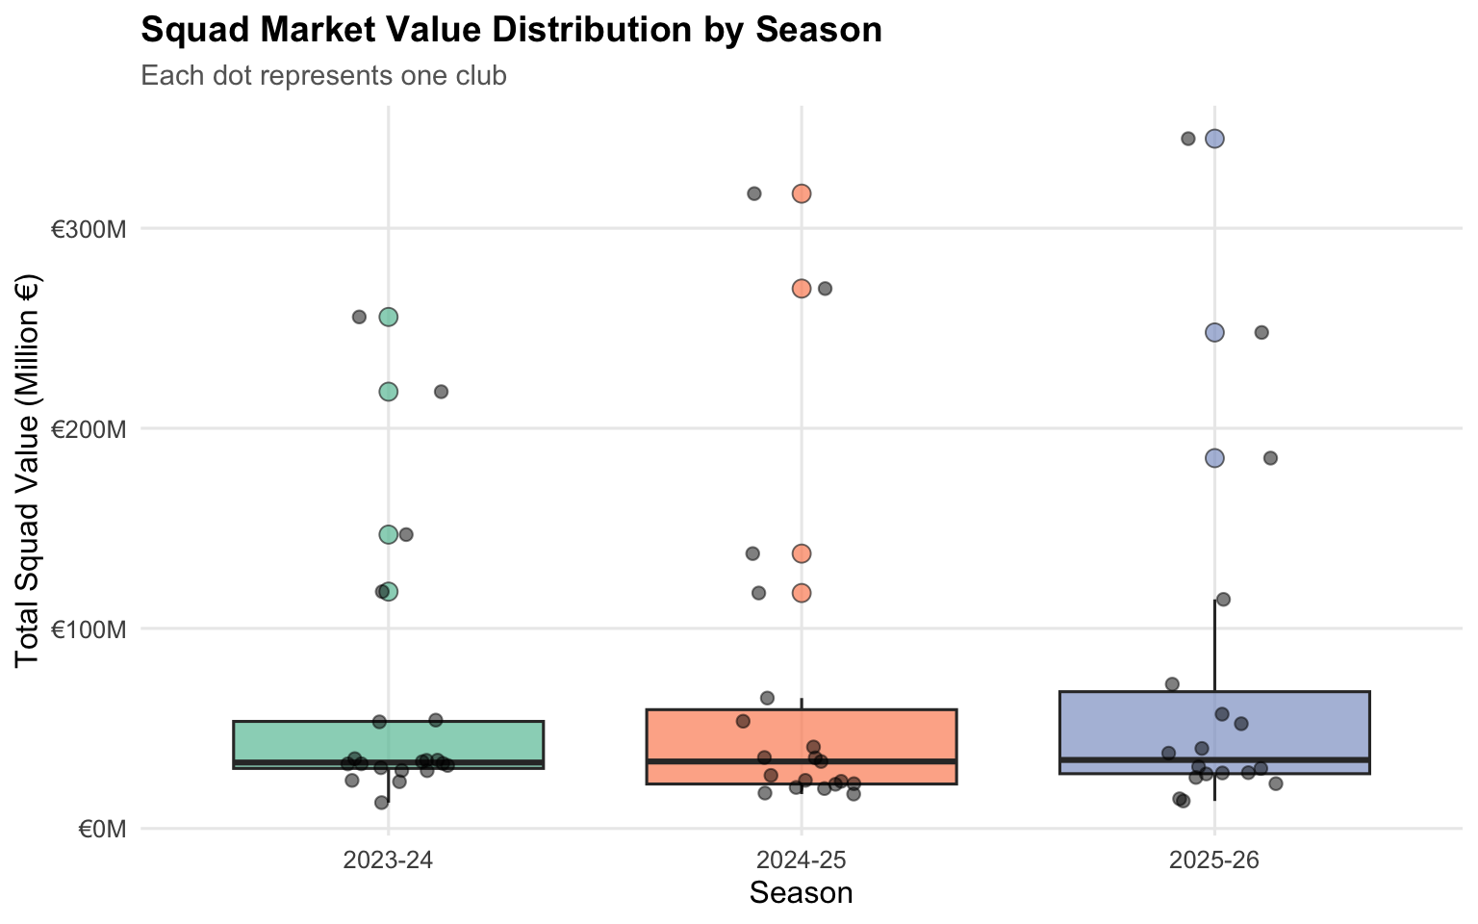
Figure 2 — Squad Market Value Distribution by Season (Box Plot)

3.3 Points Distribution
Points histograms for each season. Each bar represents a 5-point interval.

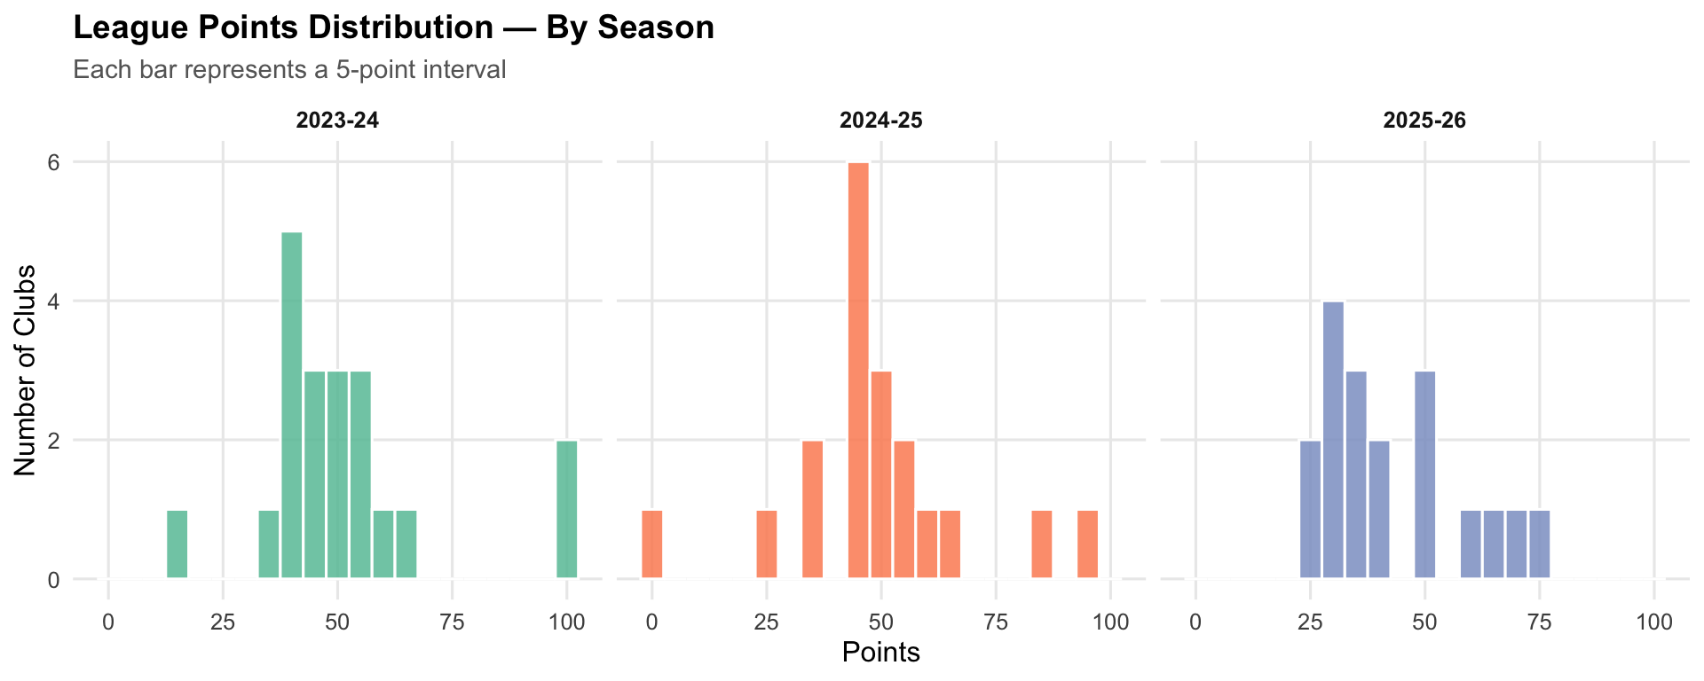
Figure 3 — League Points Distribution by Season (Histogram)

3.4 Squad Value vs. Points: Correlation Scatter
Each dot represents a club-season pair. Dot size is proportional to squad value. The dashed line is the OLS regression fit.

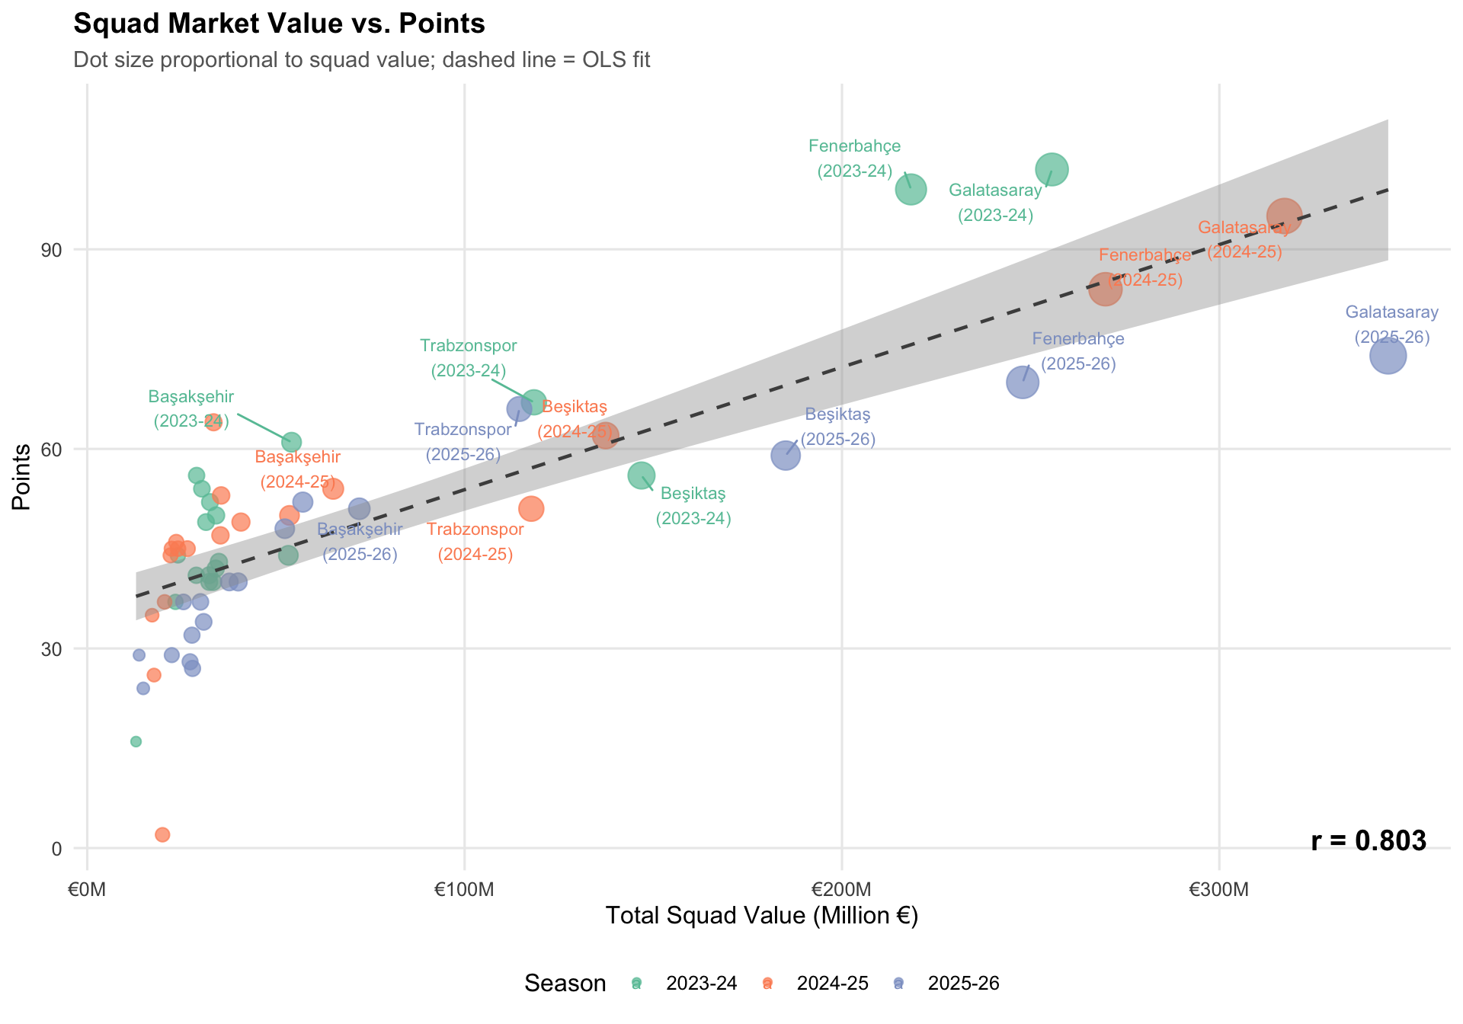
Figure 4 — Squad Market Value vs. Points Scatter Plot (3 Seasons)

Pearson Correlation Coefficients by Season
Season | Clubs | Pearson r | p-value
2023-24 | 20 | 0.891 | < 0.001
2024-25 | 19 | 0.803 | < 0.001
2025-26 | 18 | 0.872 | < 0.001
All Seasons | 57 | ~0.855 (avg.) | < 0.001

Interpretation: The average r of 0.855 confirms a very strong budget-performance relationship. However, R² ≈ 0.72 means roughly 28% of points variance is explained by other factors (coaching, luck, fixture difficulty) -- this gap creates the 'efficiency opportunity'.

4. Regression Analysis and Efficiency Score

4.1 Simple Linear Regression
Independent variable: log(squad_market_value_eur) -- natural log applied to correct right-skew
Dependent variable: Pts (end-of-season total points)

Parameter | Estimate | Std. Error | p-value
(Intercept) | -274.8523 | undefined | undefined
log(squad_market_value_eur) | 18.3444 | undefined | undefined

R-squared | Adj. R-squared | Residual Std. Error | Observations
0.7175 | 0.7124 | 9.9451 | 57

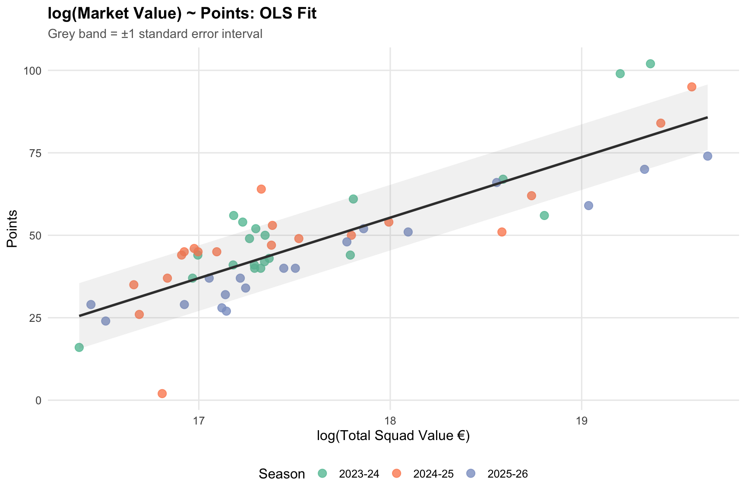
Figure 5 -- log(Squad Market Value) vs Points: OLS Regression Fit with +/-1 SE Band

4.2 Spending Efficiency Score (OLS Residual)
Efficiency Score = Actual Points - Model-Predicted Points (OLS residual)

How to Interpret the Efficiency Score
Positive (+): The club earned MORE points than its squad value implies -- high efficiency.
Negative (-): The club earned FEWER points than its squad value implies -- underperformance.
Large positive: High return on squad investment.
Large negative: High budget, insufficient points return.

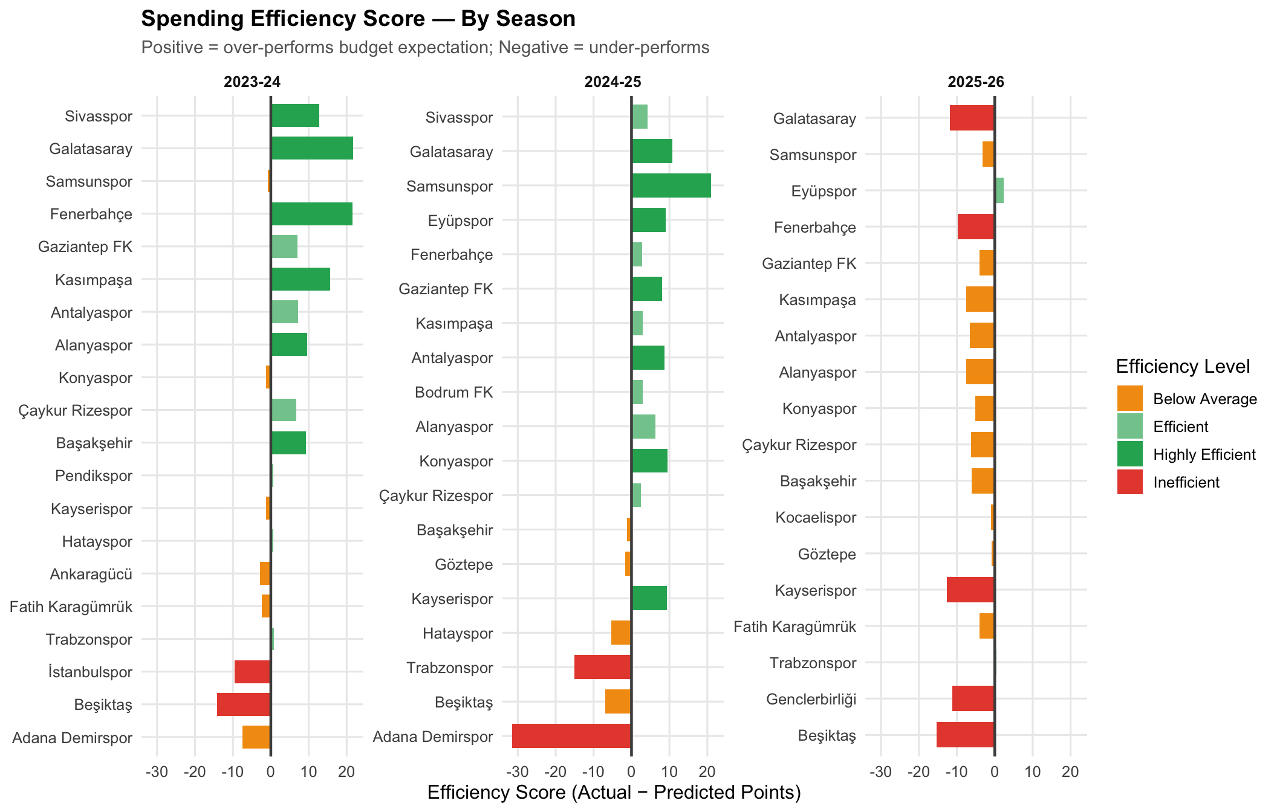
Figure 6 -- Club Spending Efficiency Scores by Season (Positive = over-performs budget expectation)

Most and Least Efficient Club-Season Combinations
Group | Club | Season | Actual Pts | Predicted | Score
Most Efficient | Galatasaray | 2023-24 | 102 | 80.3 | +21.7
Most Efficient | Fenerbahçe | 2023-24 | 99 | 77.4 | +21.6
Most Efficient | Samsunspor | 2024-25 | 64 | 43 | +21
Most Efficient | Kasımpaşa | 2023-24 | 56 | 40.3 | +15.7
Most Efficient | Sivasspor | 2023-24 | 54 | 41.2 | +12.8
Least Efficient | Adana Demirspor | 2024-25 | 2 | 33.5 | -31.5
Least Efficient | Beşiktaş | 2025-26 | 59 | 74.4 | -15.4
Least Efficient | Trabzonspor | 2024-25 | 51 | 66.1 | -15.1
Least Efficient | Beşiktaş | 2023-24 | 56 | 70.1 | -14.1
Least Efficient | Kayserispor | 2025-26 | 27 | 39.6 | -12.6

4.3 Efficiency Trend Across 3 Seasons
The chart below shows how the efficiency scores of clubs present in all three seasons evolved over time. Each line represents one club.

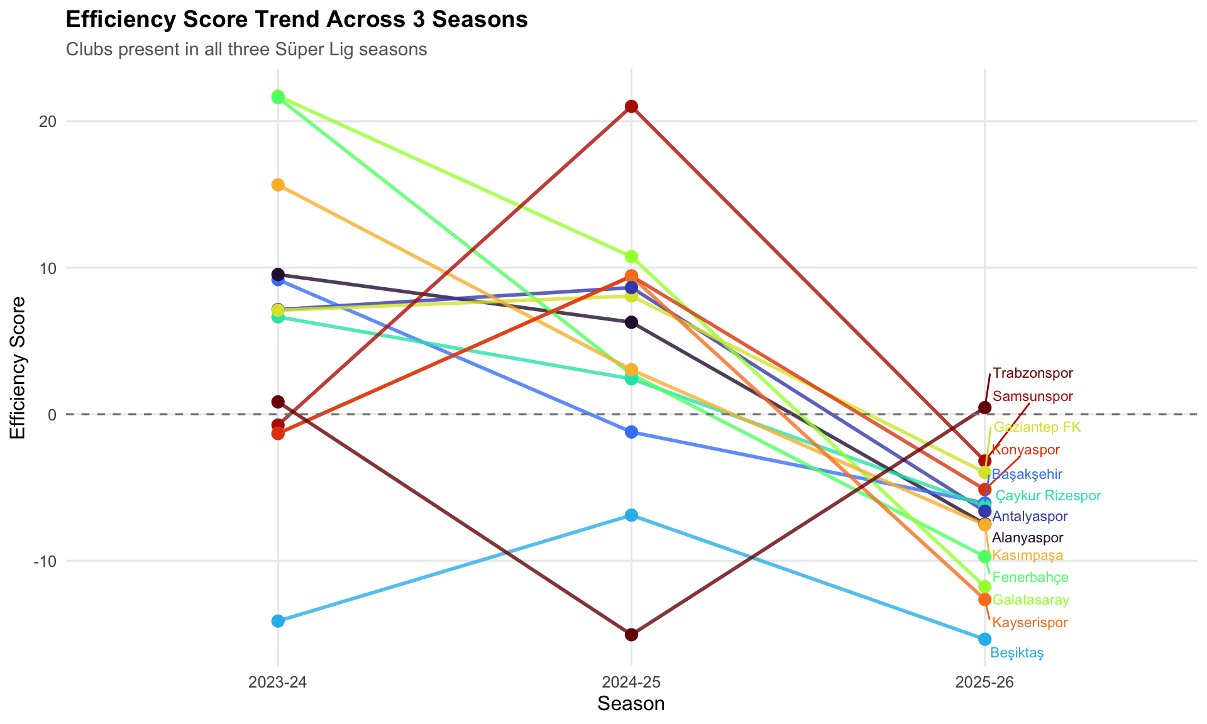
Figure 7 -- Efficiency Score Trend Across 3 Seasons (clubs present in all three seasons)

5. Player Analysis A -- Forward Spending vs. Goals

5.1 Methodology
- Forward positions included: ST, CF, FW, LW, RW, CAM, AM
- Player salary estimate = total club wage bill / squad size
- January transfer arrivals have their annual wage halved before inclusion
- Per club-season: 'Cost per Goal' and 'Goals per Million EUR' metrics computed

Critical Finding -- Forward Spending
Correlation between forward wage spending and goals scored: r = -0.12 (NEGATIVE)
Expensive attacking squads do NOT guarantee high goal tallies.
Cost-efficient clubs (Sivasspor, Samsunspor, Eyupspor) consistently rank highest in goals-per-million.
Large-budget clubs show LOWER return on forward investment relative to their spending.

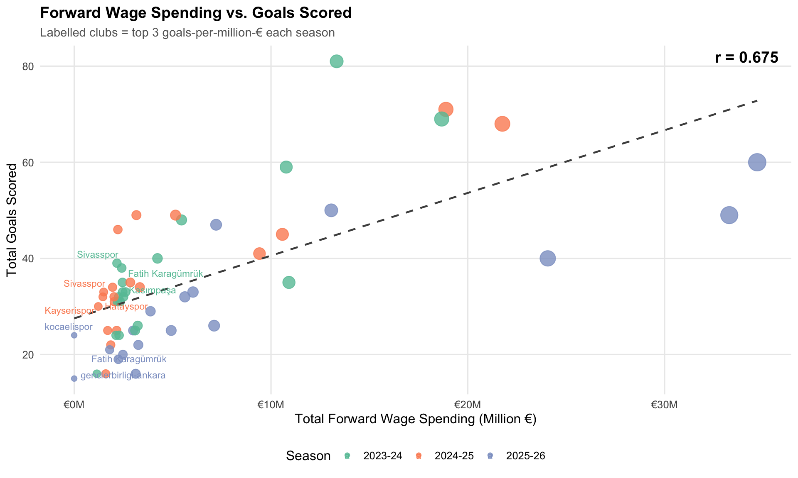
Figure 8 -- Forward Wage Spending vs. Goals Scored (r = -0.12)

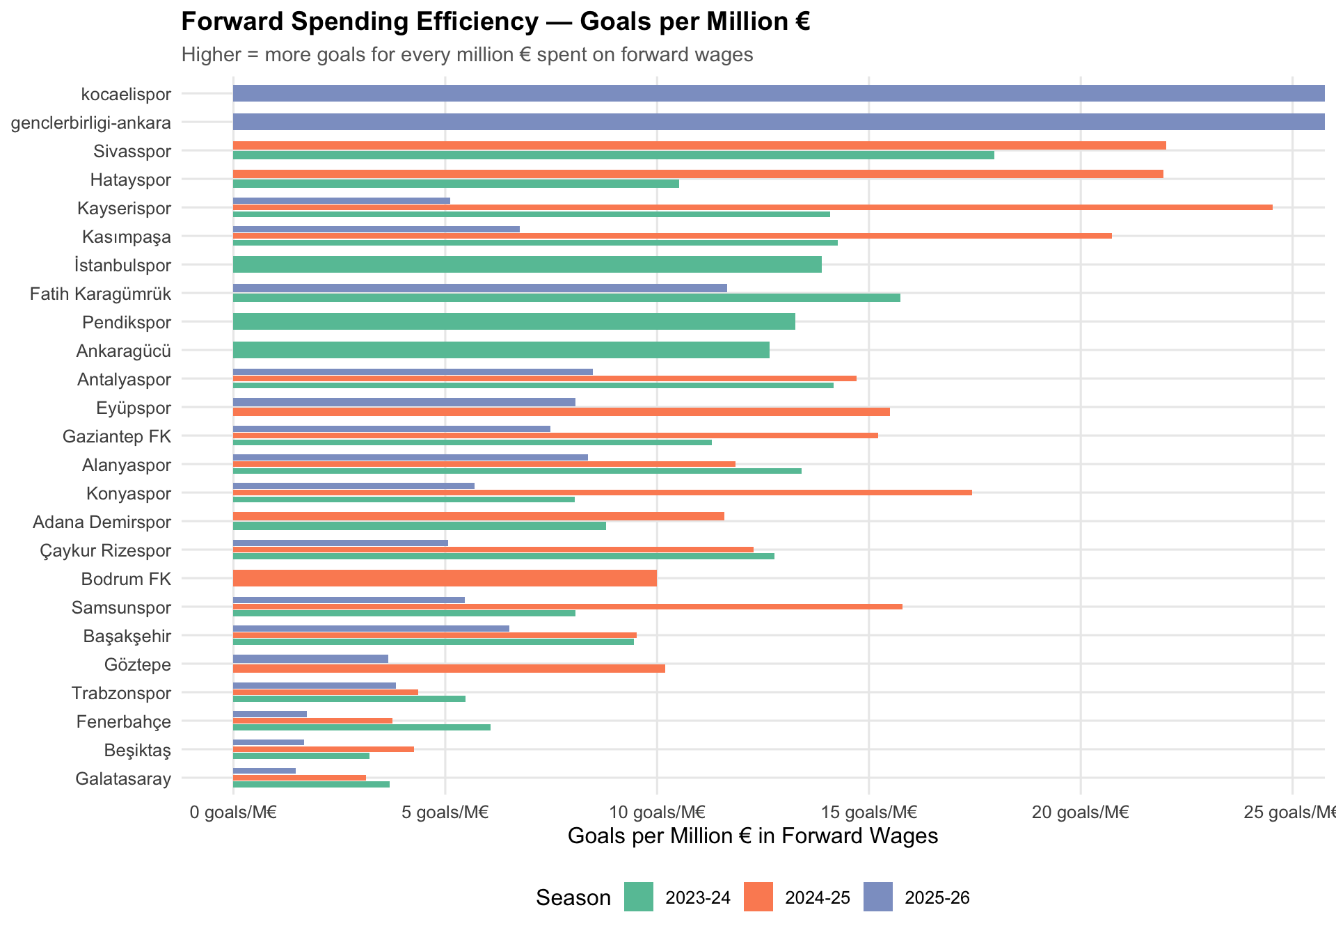
Figure 9 -- Forward Spending Efficiency: Goals per Million EUR in Forward Wages

5.2 Top 10 Clubs by Goals-per-Million-EUR
Club | Season | Fwd. Wage Spend | Goals | Goals / M EUR
Sivasspor | 2023-24 | EUR 2.17M | 39 | 17.96
Fatih Karagümrük | 2023-24 | EUR 2.41M | 38 | 15.74
Kasımpaşa | 2023-24 | EUR 2.45M | 35 | 14.27
Antalyaspor | 2023-24 | EUR 2.26M | 32 | 14.16
Kayserispor | 2023-24 | EUR 2.20M | 31 | 14.09
İstanbulspor | 2023-24 | EUR 1.15M | 16 | 13.89
Alanyaspor | 2023-24 | EUR 2.46M | 33 | 13.41
Pendikspor | 2023-24 | EUR 2.34M | 31 | 13.26
Çaykur Rizespor | 2023-24 | EUR 2.50M | 32 | 12.78
Ankaragücü | 2023-24 | EUR 2.61M | 33 | 12.65

6. Player Analysis B -- Mid-Season Within-League Transfers

6.1 Methodology
Players recorded under two different clubs within the same season are flagged as within-league mid-season transfer candidates. Foreign-league imports (appearing under only one Super Lig club) are excluded. The G+A/90 (Goals + Assists per 90 minutes) metric captures post-transfer contribution.

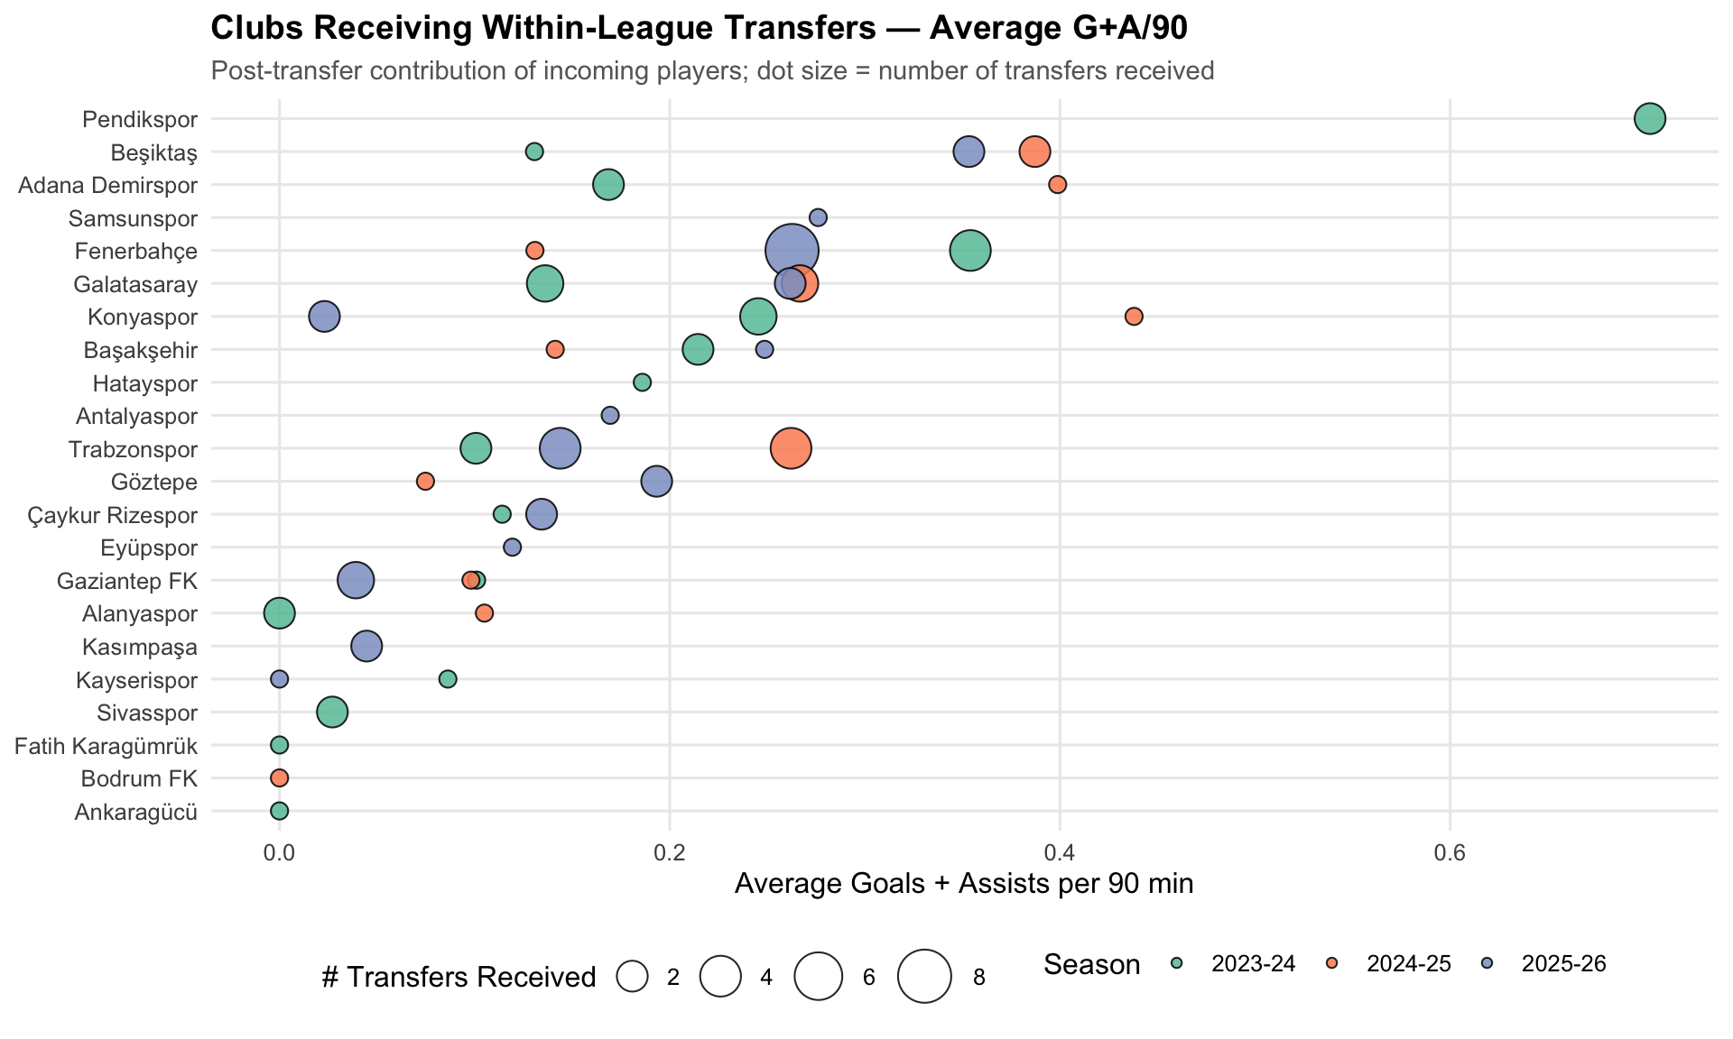
Figure 10 -- Receiving Clubs: Average G+A/90 of Incoming Within-League Transfers

Key Observations
Clubs receiving mid-season transfers show markedly different outcomes in terms of incoming player performance.
Some clubs effectively reinforced their squads through winter window acquisitions.
Average G+A/90 of transferred players appears independent of club budget.

7. Player Analysis C -- Best XI by G+A / EUR Million (4-2-3-1)

7.1 Selection Criteria
Criterion | Description
Formation | 4-2-3-1: 1 GK - 2 CB - 1 LB - 1 RB - 2 CDM - 1 CAM - 1 LW - 1 RW - 1 ST
Goalkeeper (GK) | Highest save percentage (min. 900 minutes, FBref verified data)
Outfield Players | Highest G+A (Goals + Assists) per EUR million player cost, single season only, min. 900 min, min. 1 G+A
Player Cost Proxy | Team's average player market value for that specific season (Transfermarkt)
Wage Estimate | Annual wage = market value x 28% (typical European league ratio)
Per-Season Evaluation | Each (player x season) pair is evaluated independently -- no cross-season aggregation

7.2 Best XI Player Table (Real Transfermarkt Data)
Pos. | Player | Club | Season | Stats | G+A/M EUR
GK | Dominik Livaković | Fenerbahçe | 2023-24 | Save %: 74.1 | --
CB | Uros Radakovic | Sivasspor | 2024-25 | 4G 0A (4 G+A) | 10.47 G+A/M EUR
CB | Adil Demirbağ | Konyaspor | 2024-25 | 2G 3A (5 G+A) | 9.33 G+A/M EUR
LB | Guilherme | Konyaspor | 2023-24 | 5G 7A (12 G+A) | 15.62 G+A/M EUR
RB | Deian Sorescu | Gaziantep FK | 2024-25 | 5G 7A (12 G+A) | 21.43 G+A/M EUR
CDM | Aytaç Kara | Kasımpaşa | 2023-24 | 14G 4A (18 G+A) | 26.71 G+A/M EUR
CDM | Görkem Sağlam | Hatayspor | 2024-25 | 4G 9A (13 G+A) | 24.95 G+A/M EUR
CAM | Haris Hajradinovic | Kasımpaşa | 2023-24 | 5G 16A (21 G+A) | 31.16 G+A/M EUR
LW | Miguel Cardoso | Kayserispor | 2024-25 | 8G 9A (17 G+A) | 31.14 G+A/M EUR
RW | Bilal Boutobba | Hatayspor | 2024-25 | 11G 3A (14 G+A) | 26.87 G+A/M EUR
ST | Rey Manaj | Sivasspor | 2024-25 | 12G 5A (17 G+A) | 44.5 G+A/M EUR

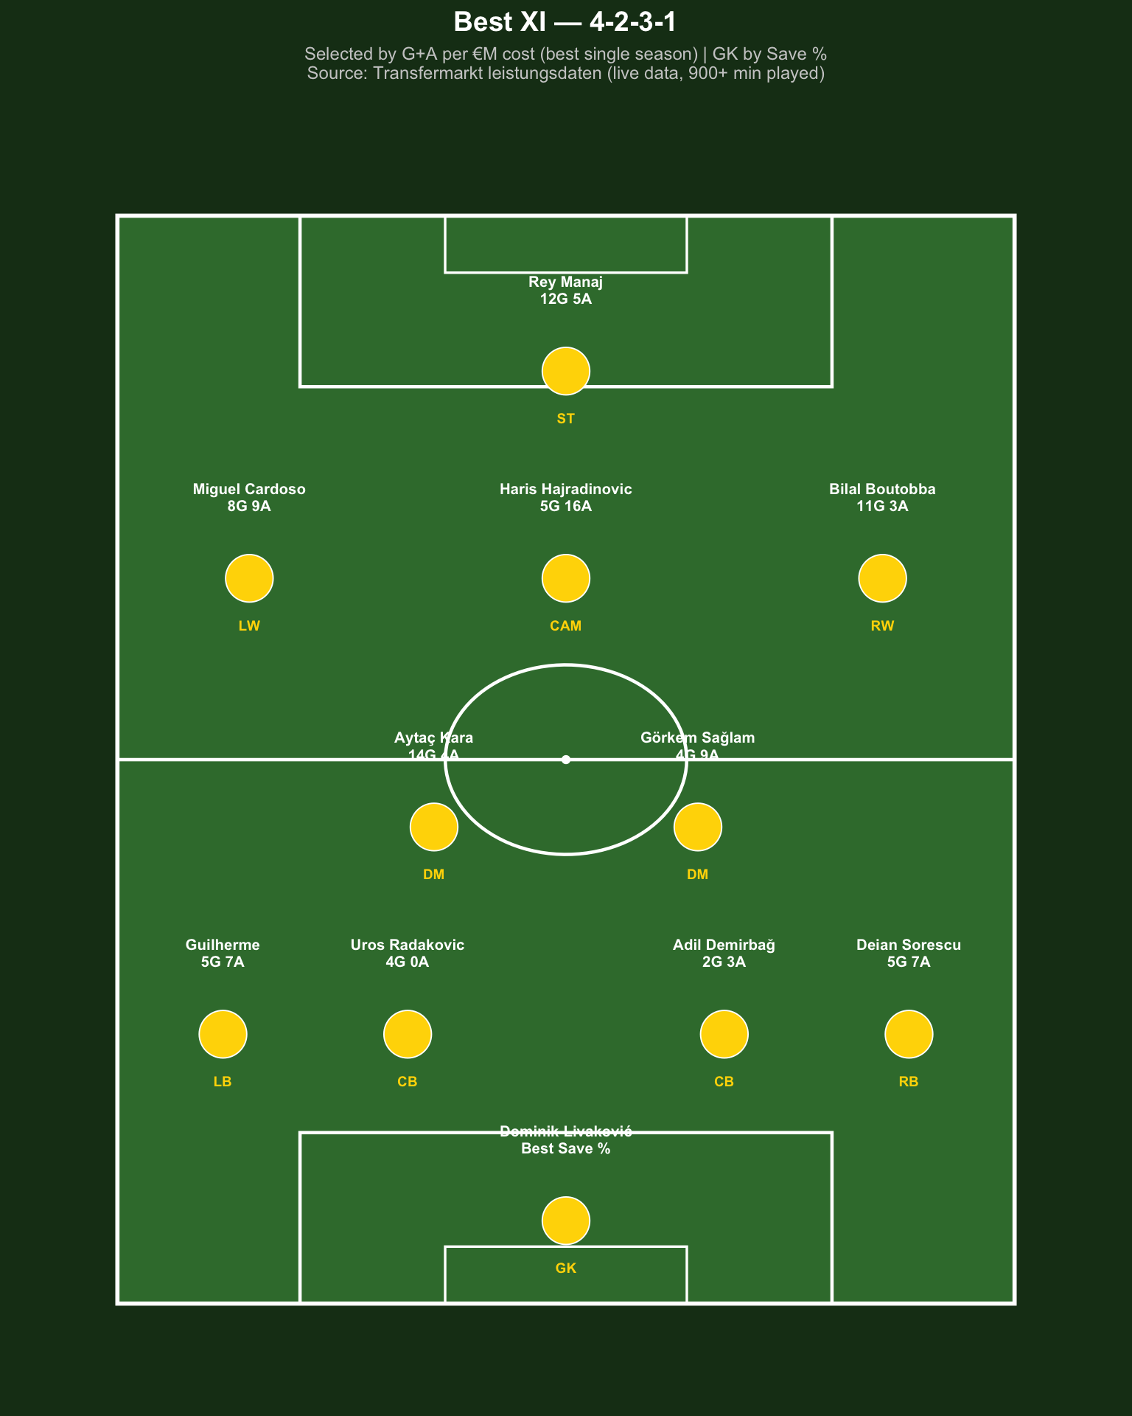
Figure 11 -- Best XI Pitch Diagram (4-2-3-1) | Selected by G+A per EUR million | GK by Save%

The Cost-Efficiency Paradox
The entire Best XI is drawn from mid-table clubs: Sivasspor, Kasimpasa, Konyaspor, Hatayspor, Kayserispor, Gaziantep FK.
This reflects a methodological reality: lower squad value = lower cost denominator = higher G+A/M EUR ratio.
Star players (Icardi, Osimhen) produce outstanding raw numbers but underperform on a cost-adjusted basis.
Conclusion: 'Most expensive player = best investment' does not hold in Turkish football.

8. Overall Club Performance Summary (3 Seasons)
The table below summarises each club's average squad value, points, and efficiency score across all seasons they participated in the Super Lig. Sorted by average efficiency score (descending).

Club | Seasons | Avg Squad Value | Avg Points | Avg Efficiency
Sivasspor | 2 | EUR 23.8M | 44.5 | +8.5
Galatasaray | 3 | EUR 305.9M | 90.3 | +6.9
Samsunspor | 3 | EUR 40.2M | 51.7 | +5.7
Eyüpspor | 2 | EUR 24.6M | 41 | +5.6
Fenerbahçe | 3 | EUR 245.3M | 84.3 | +4.87
Gaziantep FK | 3 | EUR 26M | 42 | +3.73
Kasımpaşa | 3 | EUR 30.7M | 45 | +3.73
Antalyaspor | 3 | EUR 25.3M | 40.7 | +3.03
Bodrum FK | 1 | EUR 20.5M | 37 | +3
Alanyaspor | 3 | EUR 30M | 43.7 | +2.77
Konyaspor | 3 | EUR 31.2M | 42.3 | +1
Çaykur Rizespor | 3 | EUR 38.3M | 46.3 | +0.9
Başakşehir | 3 | EUR 63.8M | 55.3 | +0.63
Pendikspor | 1 | EUR 23.4M | 37 | +0.6
Kocaelispor | 1 | EUR 25.5M | 37 | -1
Göztepe | 2 | EUR 55.4M | 51 | -1.2
Kayserispor | 3 | EUR 28.1M | 38 | -1.5
Hatayspor | 2 | EUR 23.3M | 33.5 | -2.3
Ankaragücü | 1 | EUR 33.4M | 40 | -2.9
Fatih Karagümrük | 2 | EUR 23.6M | 32 | -3.25
Trabzonspor | 3 | EUR 116.9M | 61.3 | -4.6
İstanbulspor | 1 | EUR 12.9M | 16 | -9.5
Genclerbirliği | 1 | EUR 27.2M | 28 | -11.2
Beşiktaş | 3 | EUR 156.5M | 59 | -12.13
Adana Demirspor | 2 | EUR 36.6M | 23 | -19.5

9. Conclusions and Future Work

9.1 Summary of Findings
1 | 1 -- Budget-performance link is strong but imperfect  Average Pearson r = 0.855 confirms money matters. R^2 = 0.72 leaves 28% explained by other factors.
2 | 2 -- Galatasaray is the most efficient large-budget club  Average efficiency score +6.9 across three seasons. Consistently earns more points than the model predicts despite a high budget.
3 | 3 -- Mid-table clubs extract better value from their budgets  Sivasspor (+8.5), Samsunspor (+5.7), Eyupspor (+5.6) -- very low squad values yet systematically over-perform the regression model.
4 | 4 -- Forward spending shows a NEGATIVE correlation with goals (r = -0.12)  Spending more on forwards does not translate to more goals. Mid-table clubs achieve comparable or better goal tallies with far smaller forward wage bills.
5 | 5 -- The G+A/EUR million Best XI exposes the star-player myth  Every player selected is from a mid-table club. High-value squads' stars produce big raw numbers but poor cost-adjusted returns.

9.2 Limitations
- 2025-26 season may be incomplete as of May 2026 -- final match-weeks could still be missing, causing artificially low points and player statistics for this season
- Capology.com provides club-level total wage bills only; individual player salary breakdowns are not always publicly available
- Individual player market values are approximated by their team's season average (proxy), not scraped per-player
- Unobserved factors (coaching changes, fixture difficulty, injuries) are not controlled for

9.3 Future Work
- Multi-variable regression: add coaching tenure, fixture strength index, home/away split
- Age-performance interaction: do younger squads over-perform older high-value squads?
- Tactical indicators: pressing intensity, possession percentage, expected goals (xG)
- Individual player market value scraping (Transfermarkt squad pages) for more precise cost proxies
- Extending the analysis to other mid-sized European leagues (Greek Super League, Belgian Pro League)

SmartSpend | EMU430 Data Analytics | Hacettepe University | May 2026
Data Sources: Transfermarkt (direct HTTP scraping, R / httr + rvest) - FBref - Capology.com
GitHub: emu-hacettepe-analytics/emu430-fall2024-team-smartspend

