Analysis: Team Firefighters
Zeynep Zünbüldere & Ömer Can Kaynarca
2026-05-12
#About this site This section presents a comprehensive Exploratory Data Analysis (EDA) of Türkiye’s forest dynamics and wildfire patterns over the last two decades. The primary objective of this site is to transform raw environmental data into actionable insights by examining the correlation between forest density, regional climate risks, and human-induced fire triggers.
The data utilized in this study is sourced from the official records of the General Directorate of Forestry (OGM), covering a detailed timeline from 2004 to 2024. Throughout this page, we employ advanced data wrangling techniques and spatial visualizations to uncover historical trends, identify high-risk “hotspots” in the Mediterranean and Aegean belts, and analyze the socio-economic causes behind these ecological disturbances. By bridging the gap between statistical data and environmental narrative, we aim to provide a clear roadmap for future conservation and prevention strategies.

This is the part in the previous data.qmd file
library(readxl)
library(tidyverse)
library(janitor)
orman_dagilimi <- read_excel("~/Desktop/adsız klasör/orman_dagilimi.xlsx",
col_names = FALSE)
head(orman_dagilimi)
orman_dagilimi <- orman_dagilimi %>%
slice(-(1:5))
final_data <- orman_dagilimi %>%
select(
sehir = 2,
toplam_alan_ha = 3,
toplam_orman_ha = 6
)
final_data <- final_data %>%
mutate(
toplam_alan_ha = as.numeric(toplam_alan_ha),
toplam_orman_ha = as.numeric(toplam_orman_ha)
) %>%
mutate(orman_orani = (toplam_orman_ha / toplam_alan_ha)*100)
knitr::kable(final_data)
# A tibble: 6 × 14
...1 ...2 ...3 ...4 ...5 ...6 ...7 ...8 ...9 ...10 ...11 ...12 ...13
<chr> <chr> <chr> <chr> <chr> <chr> <chr> <chr> <chr> <chr> <lgl> <chr> <chr>
1 1.6 O… <NA> <NA> <NA> <NA> <NA> <NA> <NA> <NA> <NA> NA <NA> <NA>
2 Distr… <NA> <NA> <NA> <NA> <NA> <NA> <NA> <NA> <NA> NA <NA> <NA>
3 <NA> <NA> İl G… Orma… <NA> <NA> Orma… Serv… <NA> <NA> NA Artı… <NA>
4 <NA> <NA> <NA> Norm… Boşl… Topl… <NA> Norm… Boşl… Topl… NA Norm… Boşl…
5 İBBS(… <NA> Hekt… ha ha ha % m³ m³ m³ NA m³ m³
6 TR Türk… 7800… 1381… 9549… 2336… 29.9… 1735… 6297… 1798… NA 4900… 1951…
# ℹ 1 more variable: ...14 <chr>
sehir | toplam_alan_ha | toplam_orman_ha | orman_orani
Türkiye -Turkey | 78004644 | 23363084 | 29.9508886
İstanbul | 541609 | 240688 | 44.4394388
Tekirdağ | 628510 | 101174 | 16.0974368
Edirne | 617386 | 103014 | 16.6855096
Kırklareli | 641501 | 254124 | 39.6139679
Balıkesir | 1460268 | 632405 | 43.3074614
Çanakkale | 1000510 | 480253 | 48.0008196
İzmir | 1182170 | 478547 | 40.4803878
Aydın | 822661 | 326941 | 39.7418864
Denizli | 1217993 | 588672 | 48.3313122
Muğla | 1227859 | 830358 | 67.6264946
Manisa | 1332567 | 539337 | 40.4735372
Afyonkarahisar | 1406710 | 271334 | 19.2885527
Kütahya | 1165137 | 654518 | 56.1751966
Uşak | 553937 | 223496 | 40.3468264
Bursa | 1079544 | 483542 | 44.7913193
Eskişehir | 1419998 | 410057 | 28.8772942
Bilecik | 419565 | 240252 | 57.2621644
Kocaeli | 337426 | 143227 | 42.4469365
Sakarya | 488650 | 208226 | 42.6125038
Düzce | 241092 | 133203 | 55.2498631
Bolu | 819169 | 539963 | 65.9159465
Yalova | 79192 | 47570 | 60.0691989
Ankara | 2577976 | 473229 | 18.3566100
Konya | 3957121 | 643068 | 16.2509056
Karaman | 999953 | 212488 | 21.2497987
Antalya | 2061764 | 1180241 | 57.2442336
Isparta | 873283 | 404922 | 46.3677868
Burdur | 698630 | 335719 | 48.0539055
Adana | 1417417 | 593660 | 41.8832284
Mersin | 1563068 | 835534 | 53.4547441
Hatay | 546954 | 208067 | 38.0410418
Kahramanmaraş | 1433300 | 521413 | 36.3784972
Osmaniye | 331318 | 156228 | 47.1534900
Kırıkkale | 447147 | 70286 | 15.7187681
Aksaray | 780843 | 23469 | 3.0055978
Niğde | 717237 | 60026 | 8.3690607
Nevşehir | 517365 | 14938 | 2.8873233
Kırşehir | 669005 | 43668 | 6.5273055
Kayseri | 1742082 | 166864 | 9.5784240
Sivas | 2819148 | 503469 | 17.8589063
Yozgat | 1370370 | 275956 | 20.1373352
Zonguldak | 346160 | 201521 | 58.2161428
Karabük | 389553 | 287761 | 73.8695376
Bartın | 228576 | 133531 | 58.4186441
Kastamonu | 1320561 | 876314 | 66.3592216
Çankırı | 769942 | 204541 | 26.5657673
Sinop | 572565 | 367096 | 64.1142927
Samsun | 975104 | 389500 | 39.9444572
Tokat | 999067 | 478379 | 47.8825744
Çorum | 1253797 | 474887 | 37.8759081
Amasya | 560474 | 220681 | 39.3739942
Trabzon | 521299 | 182543 | 35.0169480
Ordu | 587114 | 202896 | 34.5581948
Giresun | 711632 | 258153 | 36.2761933
Rize | 383729 | 174297 | 45.4218993
Artvin | 710973 | 417016 | 58.6542668
Gümüşhane | 591592 | 239577 | 40.4969979
Erzurum | 2470413 | 289341 | 11.7122522
Erzincan | 1179862 | 259181 | 21.9670606
Bayburt | 363809 | 29793 | 8.1891872
Ağrı | 1087975 | 5320 | 0.4889818
Kars | 808808 | 55108 | 6.8134835
Iğdır | 534005 | 2974 | 0.5569236
Ardahan | 547671 | 43289 | 7.9041980
Malatya | 1263081 | 218748 | 17.3186043
Elazığ | 913111 | 187013 | 20.4808616
Bingöl | 805637 | 266338 | 33.0593059
Tunceli | 775188 | 271305 | 34.9986068
Van | 1898097 | 45141 | 2.3782241
Muş | 884686 | 78426 | 8.8648402
Bitlis | 1018997 | 180237 | 17.6876870
Hakkari | 753662 | 179847 | 23.8630845
Gaziantep | 688660 | 112617 | 16.3530625
Adıyaman | 731084 | 159234 | 21.7805341
Kilis | 131457 | 27032 | 20.5633781
Şanlıurfa | 1919798 | 14850 | 0.7735189
Diyarbakır | 1516918 | 325359 | 21.4486874
Mardin | 874277 | 204804 | 23.4255276
Batman | 425240 | 114919 | 27.0245038
Şırnak | 672427 | 297105 | 44.1839783
Siirt | 610208 | 232264 | 38.0630867
NA | NA | NA | NA
NA | NA | NA | NA

CREATING THE FOREST SPREAD MAP
#AI helped finding and creating the map because i didn’t know how to do it
library(sf)
Linking to GEOS 3.13.0, GDAL 3.8.5, PROJ 9.5.1; sf_use_s2() is TRUE
library(rnaturalearth)
library(rnaturalearthdata)
Attaching package: 'rnaturalearthdata'
The following object is masked from 'package:rnaturalearth':
countries110
library(tidyverse)

city names in the map package
turkiye_map <- ne_states(country = "Turkey", returnclass = "sf")
harita_isimleri <- turkiye_map$name
print("--- HARİTA PAKETİNDEKİ İSİMLER ---")
[1] "--- HARİTA PAKETİNDEKİ İSİMLER ---"
print(harita_isimleri)
[1] "Ardahan" "Artvin" "Sirnak" "Hakkari"
[5] "Iğdir" "Agri" "Van" "Kirklareli"
[9] "Edirne" "Kars" "Mardin" "Sanliurfa"
[13] "Kilis" "Gaziantep" "Hatay" "Istanbul"
[17] "Tekirdag" "Çanakkale" "Rize" "Trabzon"
[21] "Giresun" "Ordu" "Samsun" "Sinop"
[25] "Kastamonu" "Bartın" "Zinguldak" "Düzce"
[29] "Sakarya" "Kocaeli" "Yalova" "Bursa"
[33] "Balikesir" "Izmir" "Aydin" "Mugla"
[37] "Antalya" "Mersin" "Adana" "Bolu"
[41] "Ankara" "Bilecik" "Eskisehir" "Çankiri"
[45] "Karabük" "Tokat" "Sivas" "Çorum"
[49] "Amasya" "Kütahya" "Konya" "Karaman"
[53] "Nigde" "Kayseri" "Isparta" "Manisa"
[57] "Denizli" "Burdur" "Aksaray" "Nevsehir"
[61] "Yozgat" "Kirsehir" "Usak" "Erzincan"
[65] "Tunceli" "Afyonkarahisar" "Kinkkale" "K. Maras"
[69] "Mus" "Erzurum" "Malatya" "Elazig"
[73] "Bitlis" "Bingöl" "Osmaniye" "Adiyaman"
[77] "Diyarbakir" "Batman" "Siirt" "Bayburt"
[81] "Gümüshane"

city names in my excel because names were different and couldn’t match AI helped
excel_isimleri <- unique(final_data$sehir)
print("--- BENİM EXCEL'İMDEKİ İSİMLER ---")
[1] "--- BENİM EXCEL'İMDEKİ İSİMLER ---"
print(excel_isimleri)
[1] "Türkiye -Turkey" "İstanbul" "Tekirdağ" "Edirne"
[5] "Kırklareli" "Balıkesir" "Çanakkale" "İzmir"
[9] "Aydın" "Denizli" "Muğla" "Manisa"
[13] "Afyonkarahisar" "Kütahya" "Uşak" "Bursa"
[17] "Eskişehir" "Bilecik" "Kocaeli" "Sakarya"
[21] "Düzce" "Bolu" "Yalova" "Ankara"
[25] "Konya" "Karaman" "Antalya" "Isparta"
[29] "Burdur" "Adana" "Mersin" "Hatay"
[33] "Kahramanmaraş" "Osmaniye" "Kırıkkale" "Aksaray"
[37] "Niğde" "Nevşehir" "Kırşehir" "Kayseri"
[41] "Sivas" "Yozgat" "Zonguldak" "Karabük"
[45] "Bartın" "Kastamonu" "Çankırı" "Sinop"
[49] "Samsun" "Tokat" "Çorum" "Amasya"
[53] "Trabzon" "Ordu" "Giresun" "Rize"
[57] "Artvin" "Gümüşhane" "Erzurum" "Erzincan"
[61] "Bayburt" "Ağrı" "Kars" "Iğdır"
[65] "Ardahan" "Malatya" "Elazığ" "Bingöl"
[69] "Tunceli" "Van" "Muş" "Bitlis"
[73] "Hakkari" "Gaziantep" "Adıyaman" "Kilis"
[77] "Şanlıurfa" "Diyarbakır" "Mardin" "Batman"
[81] "Şırnak" "Siirt" NA

map from the package
turkiye_map <- ne_states(country = "turkey", returnclass = "sf")

city name matching, left side: names in the package, right side: names in the excel, this part was so hard to do because ai wasn’t helpful and i had to do it manually
turkiye_map <- turkiye_map %>%
mutate(name_fixed = case_when(
name == "Zinguldak" ~ "Zonguldak",
name == "Kinkkale" ~ "Kırıkkale",
name == "K. Maras" ~ "Kahramanmaraş",
name == "Adayaman" ~ "Adıyaman",
name == "Afyonkarahisar" ~ "Afyonkarahisar",
name == "Diyarbakir" ~ "Diyarbakır",
name == "Nigde" ~ "Niğde",
name == "Elazig" ~ "Elazığ",
name == "Gumushane" ~ "Gümüşhane",
name == "Sanliurfa" ~ "Şanlıurfa",
name == "Sirnak" ~ "Şırnak",
name == "Cankiri" ~ "Çankırı",
name == "Tekirdag" ~ "Tekirdağ",
name == "Aydin" ~ "Aydın",
name == "Izmir" ~ "İzmir",
name == "Istanbul" ~ "İstanbul",
name == "Usak" ~ "Uşak",
name == "Iğdir" ~ "Iğdır",
name == "Adiyaman" ~ "Adıyaman",
name == "Gümüshane" ~ "Gümüşhane",
name == "Çankiri" ~ "Çankırı",
name == "Mugla" ~ "Muğla",
name == "Agri" ~ "Ağrı",
name == "Mus" ~ "Muş",
name == "Nevsehir" ~ "Nevşehir",
name == "Eskisehir" ~ "Eskişehir",
name == "Balikesir" ~ "Balıkesir",
name == "Kirklareli" ~ "Kırklareli",
name == "Kütahya" ~ "Kütahya",
name == "Kirsehir" ~ "Kırşehir",
name == "Karabük" ~ "Karabük",
name == "Bartın" ~ "Bartın",
name == "Çanakkale" ~ "Çanakkale",
TRUE ~ name # Diğerlerini olduğu gibi bırak
))

clear the gaps
map_data_final <- final_data %>%
filter(sehir != "Türkiye -Turkey") %>%
mutate(sehir_join = str_trim(sehir))

merging the data
final_map_table <- turkiye_map %>%
left_join(map_data_final, by = c("name_fixed" = "sehir_join"))

drawing the map by the colors red and green, because these colors can be more useful with the visualization of forests
ggplot(data = final_map_table) +
geom_sf(aes(fill = orman_orani)) +
scale_fill_gradient(
low = "red",
high = "green",
limits = c(0, 100),
na.value = "grey90"
) +
labs(
title = "Türkiye Orman Yoğunluğu Haritası",
fill = "Orman %",
caption = "Kaynak: OGM 2024"
) +
theme_minimal()
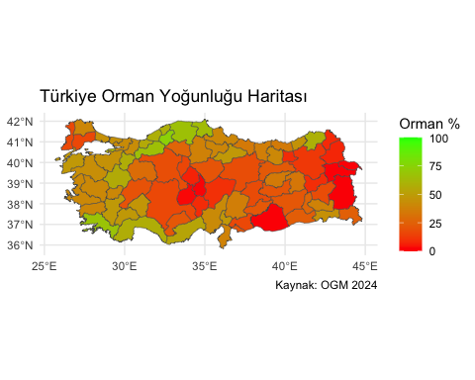

FORESTS FIRES NUMBERS AND AREA ANALYSIS BY CITIES

This is the part from the previos data.qmd file
library(sf)
library(tidyverse)
library(readxl)
library(scales)
harita_yolu <- "/Users/zzunb/Downloads/tr-cities.json"
adet_yolu <- "/Users/zzunb/Downloads/illere_gore_yangin_adet_2004-2024.xlsx"
alan_yolu <- "/Users/zzunb/Downloads/illere_gore_yanan_alan_2004-2024.xlsx"
tr_map <- read_sf(harita_yolu)
df_adet_ham <- read_excel(adet_yolu, skip = 3)
colnames(df_adet_ham)[1] <- "Bolge"
df_adet_ham <- df_adet_ham %>%
filter(!is.na(Bolge)) %>%
slice(1:(which(Bolge == "Zonguldak"))) %>%
mutate(across(-Bolge, ~ suppressWarnings(as.numeric(.))))
df_alan_ham <- read_excel(alan_yolu, skip = 3)
colnames(df_alan_ham)[1] <- "Bolge"
df_alan_ham <- df_alan_ham %>%
filter(!is.na(Bolge)) %>%
slice(1:(which(Bolge == "Zonguldak"))) %>%
mutate(across(-Bolge, ~ suppressWarnings(as.numeric(.))))
temizle_ve_topla <- function(df) {
df_sonuc <- df %>%
filter(!Bolge %in% c("Toplam-Total", "DKMPGM")) %>%
mutate(Bolge = recode(Bolge, "K.Maraş" = "Kahramanmaraş", "Afyon" = "Afyonkarahisar")) %>%
rowwise() %>%
mutate(Toplam_21_Yil = sum(c_across(where(is.numeric)), na.rm = TRUE)) %>%
ungroup()
return(df_sonuc)
}
df_adet <- temizle_ve_topla(df_adet_ham) %>% arrange(desc(Toplam_21_Yil))
df_alan <- temizle_ve_topla(df_alan_ham) %>% arrange(desc(Toplam_21_Yil))

1. time series analysis/line graphs
p1 <- df_adet_ham %>%
filter(Bolge == "Toplam-Total") %>%
pivot_longer(cols = -Bolge, names_to = "Yil", values_to = "Deger") %>%
mutate(Yil = as.numeric(Yil)) %>%
filter(!is.na(Yil)) %>%
ggplot(aes(x = Yil, y = Deger)) +
geom_line(color = "#E69F00", size = 1.2) +
geom_point(color = "black", size = 2) +
geom_smooth(method = "lm", color = "blue", linetype = "dashed", se = FALSE, size = 1) +
scale_x_continuous(breaks = seq(2004, 2024, by = 2)) +
theme_minimal() +
labs(title = "Yillara Gore Toplam Yangin Adeti (2004-2024)",
subtitle = "Mavi kesik cizgi genel artis/azalis egilimini gosterir.",
x = "Yil", y = "Yangin Adeti")
Warning: Using `size` aesthetic for lines was deprecated in ggplot2 3.4.0.
ℹ Please use `linewidth` instead.

2. merging map and data
p2 <- df_alan_ham %>%
filter(Bolge == "Toplam-Total") %>%
pivot_longer(cols = -Bolge, names_to = "Yil", values_to = "Deger") %>%
mutate(Yil = as.numeric(Yil)) %>%
filter(!is.na(Yil)) %>%
ggplot(aes(x = Yil, y = Deger)) +
geom_line(color = "#D55E00", size = 1.2) +
geom_point(color = "black", size = 2) +
annotate("text", x = 2016, y = 125000, label = "2021 Yili Dev Yanginlari:\n~139.503 Hektar", color = "red", fontface = "bold") +
annotate("curve", x = 2018, y = 125000, xend = 2020.8, yend = 139500,
arrow = arrow(length = unit(0.3, "cm")), curvature = -0.3, color = "red", size = 1) +
scale_x_continuous(breaks = seq(2004, 2024, by = 2)) +
scale_y_continuous(labels = label_number(big.mark = ".", decimal.mark = ",")) +
theme_minimal() +
labs(title = "Yillara Gore Toplam Yanan Alan (2004-2024)", x = "Yil", y = "Hektar Alan")
print(p1)
`geom_smooth()` using formula = 'y ~ x'
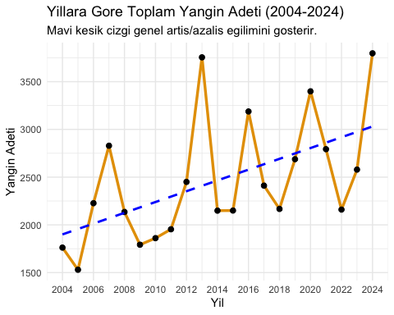
print(p2)
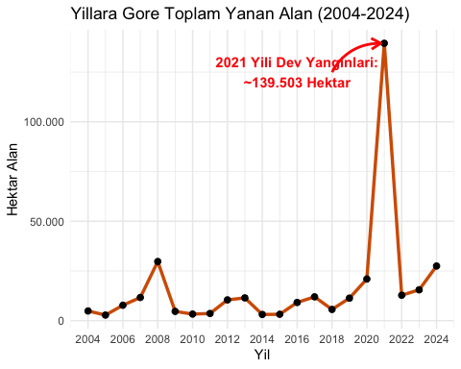

3.drawing the map-data visualization
harita_adet <- tr_map %>% left_join(df_adet, by = c("name" = "Bolge"))
g1 <- ggplot(data = harita_adet) +
geom_sf(aes(fill = Toplam_21_Yil), color = "black", size = 0.2) +
stat_sf_coordinates(aes(label = name), geom = "text", size = 2.2, color = "black", fontface = "bold", check_overlap = TRUE) +
scale_fill_gradientn(colors = c("#00BA38", "yellow", "#F8766D", "#B71C1C"), name = "Toplam Adet", na.value = "gray90") +
theme_void() +
theme(
plot.margin = margin(t = 20, r = 20, b = 20, l = 20, unit = "pt"),
plot.title = element_text(hjust = 0.5, face = "bold", size = 14, margin = margin(b = 15)),
plot.caption = element_text(hjust = 1, margin = margin(t = 10), lineheight = 1.2), # SatD1r aralD1D D1 eklendi
legend.margin = margin(l = 10, r = 10)
) +
labs(
title = "Illere Gore Toplam Yangin Sayisi (2004-2024)",
caption = "Veriler: OGM\nGri renkteki iller icin veri bulunmamaktadir."
)
harita_alan <- tr_map %>% left_join(df_alan, by = c("name" = "Bolge"))
g2 <- ggplot(data = harita_alan) +
geom_sf(aes(fill = Toplam_21_Yil), color = "black", size = 0.2) +
stat_sf_coordinates(aes(label = name), geom = "text", size = 2.2, color = "black", fontface = "bold", check_overlap = TRUE) +
scale_fill_gradientn(
colors = c("#00BA38", "yellow", "#F8766D", "#B71C1C"),
trans = "pseudo_log",
breaks = c(100, 1000, 10000, 100000),
labels = c("100", "1.000", "10.000", "100.000+"),
name = "Toplam Hektar\n(Log Skala)",
na.value = "gray90"
) +
theme_void() +
theme(
plot.margin = margin(t = 20, r = 20, b = 20, l = 20, unit = "pt"),
plot.title = element_text(hjust = 0.5, face = "bold", size = 14, margin = margin(b = 15)),
plot.caption = element_text(hjust = 1, margin = margin(t = 10), lineheight = 1.2), # SatD1r aralD1D D1 eklendi
legend.margin = margin(l = 10, r = 10)
) +
labs(
title = "Illere Gore Toplam Yanan Alan (Hektar) (2004-2024)",
caption = "Veriler: OGM\nGri renkteki iller icin veri bulunmamaktadir."
)
print(g1)
Warning in st_point_on_surface.sfc(sf::st_zm(x)): st_point_on_surface may not
give correct results for longitude/latitude data
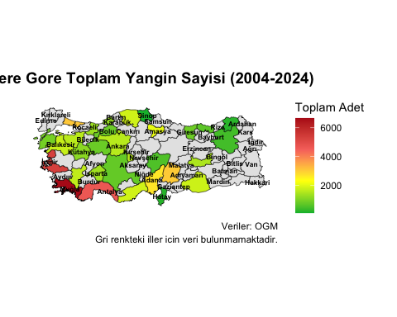
print(g2)
Warning in st_point_on_surface.sfc(sf::st_zm(x)): st_point_on_surface may not
give correct results for longitude/latitude data
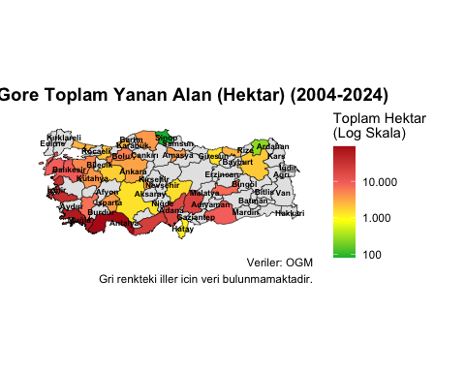

FOREST FIRES CAUSING MAIN REASONS

This is the part from the previos data.qmd file
library(sf)
library(tidyverse)
library(readxl)
harita_yolu <- "/Users/zzunb/Downloads/tr-cities.json"
excel_yolu <- "/Users/zzunb/Downloads/2022-2024_sebep_adet_toplam.xlsx"
tr_map <- read_sf(harita_yolu)
yangin_verisi <- read_excel(excel_yolu, skip = 5, n_max = 31, col_names = FALSE) %>%
select(
Bolge = 1,
Aniz = 2, Coplu = 3, Avcilik = 4, CobanAtesi = 5, Sigara = 6, Piknik = 7, Diger_Ihmal = 8,
Teror = 10, Kundaklama = 11, Acma = 12, Diger_Kasit = 13,
Enerji = 15, Trafik = 16, Diger_Kaza = 17,
Bilinmeyen = 19, Dogal = 20
) %>%
mutate(across(-Bolge, ~as.numeric(ifelse(. == "-", "0", .)))) %>%
filter(!Bolge %in% c("DKMPGM", "Toplam-Total"))
yangin_verisi <- yangin_verisi %>%
mutate(Bolge = recode(Bolge,
"K.MaraE " = "KahramanmaraE ",
"Afyon" = "Afyonkarahisar"))

1. determining the dominant reason of fires
baskin_analiz <- yangin_verisi %>%
pivot_longer(cols = -Bolge, names_to = "Alt_Sebep", values_to = "Miktar") %>%
group_by(Bolge) %>%
slice_max(order_by = Miktar, n = 1, with_ties = FALSE) %>%
ungroup() %>%
# 5. AdD1mdaki recode kD1smD1nD1 E ununla gC<ncelle:
mutate(Alt_Sebep = recode(Alt_Sebep,
"Bilinmeyen" = "Sebebi Bilinmeyen",
"Dogal" = "Dogal (Yildirim)",
"Diger_Ihmal" = "Ihmal(Diger)", # D0sim deD iE ti
"Aniz" = "Aniz(Ihmal)", # D0sim deD iE ti
"Diger_Kasit" = "Diger (Kasit)",
"Diger_Kaza" = "Diger (Kaza)",
"CobanAtesi" = "Coban Atesi"))

2. seting the colors of the categories
renk_paleti <- c(
# D0HMAL - Sadece SarD1 ve AC'D1k Turuncu (KD1rmD1zD1dan tamamen baD D1msD1z)
"Aniz" = "#FFFFE5", "Coplu" = "#FFF7BC", "Avcilik" = "#FEE391",
"Coban Atesi" = "#FEC44F", "Sigara" = "#FE9929", "Piknik" = "#EC7014", "Diger (Ihmal)" = "#CC4C02",
# KASIT - Koyu KD1rmD1zD1 ve Bordo TonlarD1
"Teror" = "#FCBBA1", "Kundaklama" = "#FB6A4A", "Acma" = "#CB181D", "Diger (Kasit)" = "#67000D",
# KAZA - Saf Mavi TonlarD1
"Enerji" = "#DEEBF7", "Trafik" = "#6BAED6", "Diger (Kaza)" = "#08306B",
# SEBEBD0 BD0LD0NMEYEN - Mor
"Sebebi Bilinmeyen" = "#9467BD",
# DOD AL - YeE il
"Dogal (Yildirim)" = "#2CA02C"
)

3. drawing the final map of the causes
harita_final <- tr_map %>%
left_join(baskin_analiz, by = c("name" = "Bolge"))
ggplot(data = harita_final) +
geom_sf(aes(fill = Alt_Sebep), color = "black", size = 0.2) +
# Il isimleri
stat_sf_coordinates(aes(label = name), geom = "text", size = 2.2, color = "black", fontface = "bold", check_overlap = TRUE) +
scale_fill_manual(
values = c(
# IHMAL GRUBU (Sari/Turuncu)
"Aniz(Ihmal)" = "#FFFFE5", "Coplu" = "#FFF7BC", "Avcilik" = "#FEE391",
"Coban Atesi" = "#FEC44F", "Sigara" = "#FE9929", "Piknik" = "#FB9A29",
"Ihmal(Diger)" = "#EC7014",
# KASIT GRUBU (Kirmizi)
"Teror" = "#FEE5D9", "Kundaklama" = "#FCAE91", "Acma" = "#FB6A4A", "Diger (Kasit)" = "#CB181D",
# KAZA GRUBU (Mavi)
"Enerji" = "#DEEBF7", "Trafik" = "#6BAED6", "Diger (Kaza)" = "#08306B",
# DIGERLERI
"Sebebi Bilinmeyen" = "#9467BD",
"Dogal (Yildirim)" = "#2CA02C"
),
na.value = "gray90",
name = "Baskin Sebep Detayi"
) +
theme_minimal() +
theme(
axis.text = element_blank(),
axis.ticks = element_blank(),
panel.grid = element_blank(),
legend.position = "right",
legend.title = element_text(face = "bold", size = 9),
legend.text = element_text(size = 8),
plot.title = element_text(hjust = 0.5, face = "bold", size = 14),
plot.subtitle = element_text(hjust = 0.5, size = 10, face = "italic"),
plot.caption = element_text(hjust = 0, size = 8, lineheight = 1.2)
) +
labs(
title = "Turkiye Orman Yanginlari Baskin Sebep Analizi (2022-2024)",
subtitle = "Sari/Turuncu: Ihmal | Kirmizi: Kasit | Mavi: Kaza | Mor: Bilinmeyen | Yesil: Dogal",
caption = paste0(
"Veriler Orman Genel Mudurlugune aittir.\n\n",
"Ihmal(Diger) Kategorisi: Coban/avci atesi, cocuklarin atesle oynamasi, copluk ve tarla temizligi,piknik,sigara gibi nedenleri kapsar.\n\n",
"Gri alanlar veri seti disinda kalan illeri temsil eder."
)
)
Warning in st_point_on_surface.sfc(sf::st_zm(x)): st_point_on_surface may not
give correct results for longitude/latitude data
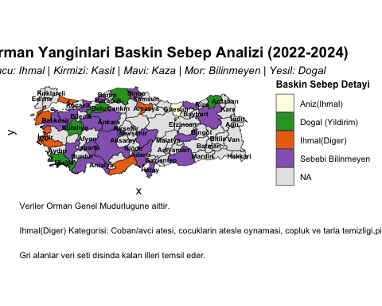
#Key Takeaways Data Foundation: In this study, we analyzed the 2004–2024 datasets from the General Directorate of Forestry (OGM) to examine forest density, fire frequency, burned areas, and the underlying causes of forest fires across Türkiye.
Fire Trends: Our time-series analysis reveals a steady upward trend in the number of fire incidents. However, the most significant finding is the catastrophic spike in 2021, where the burned area reached approximately 139,503 hectares—a historic outlier.
Regional Risk Profiles: We identified the Aegean and Mediterranean regions as high-risk zones for both fire frequency and severity. In contrast, Central Anatolia and the Black Sea regions are primarily characterized by smaller-scale fires often linked to negligence.
Dominant Causes: A striking portion of fires remains categorized as “Unknown.” Among identified causes, “Negligence”—including stubble burning, picnics, and discarded cigarettes—emerges as the primary driver of forest loss.
#1. Forest Distribution and Spatial Density We initiated our analysis by mapping the current state of forest cover across Türkiye. By calculating the ratio of forest area to the total land area for each province, we created a “Forest Density Map.” Our visualization utilizes a red-to-green gradient to highlight the stark contrast between the forest-rich regions of the Black Sea and Western Mediterranean and the arid landscapes of Central and Southeastern Anatolia. This spatial understanding is crucial as it defines the “fuel load” available for potential fire incidents.
#2. Temporal Evolution of Forest Fires (2004–2024) Over the last two decades, forest fires have evolved from seasonal environmental concerns into a persistent crisis fueled by climate change and human activity. Our time-series analysis shows that while the annual number of fires fluctuates, the general trend is rising. The year 2021 stands out as a devastating “tipping point.” During this period, the total burned area skyrocketed, exceeding the combined totals of several previous years. This suggests that while we are facing more fires, the fires themselves are becoming harder to contain and more destructive.
#3. Regional Risk and Impact Assessment To better understand the geography of these disasters, we mapped both fire frequency and total burned area. Our findings indicate that provinces like Antalya, Muğla, and İzmir are “hotspots” where fires occur most frequently. However, the impact is not uniform. By using a logarithmic scale for the burned area map, we were able to visualize that a single fire in the Southern coastal belt often results in far greater ecological damage than multiple fires in the North. This is largely due to the flammable nature of Mediterranean vegetation (maquis and pine) and the prevailing wind conditions.
#4. Root Cause Analysis: The Human Element One of the most critical aspects of our report is the analysis of fire triggers, categorized into Negligence, Intentional, Accident, Natural, and Unknown. We found that “Negligence”—specifically stubble burning (anız) and picnic-related activities—is a dominant force in many provinces. Perhaps more concerning is the high frequency of “Unknown” causes. This lack of data suggests a need for more sophisticated post-fire investigation techniques. In certain regions, energy transmission line failures (Accidents) also appear as significant contributors, indicating that infrastructure maintenance is as vital as public awareness.
#Recommendations for Fire Prevention Based on our data-driven findings, we propose the following strategies to mitigate future forest loss:
Public Awareness Campaigns: Since negligence (picnics, cigarettes, stubble burning) is a leading cause, targeted education programs should be implemented, especially during the high-risk summer months.
Infrastructure Modernization: Our analysis showed “Energy” as a recurring cause. Power lines passing through forest zones must be regularly inspected and modernized to prevent sparks during high winds.
Early Detection Systems: Investment in AI-powered thermal cameras and drone surveillance is essential for the Mediterranean belt to ensure that fires are caught within the first few minutes of ignition.
Strict Regulatory Enforcement: Increasing the legal consequences for stubble burning and unauthorized fire use in forest areas can serve as a deterrent.
Expansion of Post-Fire Investigation: To reduce the “Unknown” category in our data, specialized forensic teams should be established to determine exact fire triggers, allowing for better-targeted prevention policies.

