The February 6, 2023 Kahramanmaras Earthquake and Migration Dynamics
Damage, Displacement, and Recovery in 11 Earthquake-Affected Provinces

Şevval Miray Başar and Büşra Halil
Hacettepe University, Department of Industrial Engineering
EMU660 - Spring 2026
May 2026

Abstract
This study examines the demographic impacts of the earthquakes centered in Kahramanmaraş that occurred on February 6, 2023. The study utilized population and damage intensity data obtained from reliable sources such as TÜİK and AFAD. By examining various effects, including population structure and inter-provincial migration patterns, the study conducted damage intensity analysis, migration flow analysis, time series analysis, and recovery status analysis. Focusing on the period between 2018 and 2025, the study reveals a significant population loss and strong migration movements in provinces with high damage intensity. Furthermore, an examination of the recovery process indicates that recovery from earthquake damage takes longer in certain provinces with high damage intensity, and that the pace of recovery varies across all provinces.

1. Introduction

The earthquakes that struck on February 6, 2023, with magnitudes of 7.7 and 7.6 and centered in Kahramanmaraş, are considered one of the largest disasters in Turkey’s recent history. The earthquakes in the region caused widespread destruction across a large geographical area. It has not only caused physical destruction but has also led to significant changes in the region’s social, economic, and demographic structures. Following the disaster, people were forced to leave their homes, leading to a large-scale internal migration. This study examines 11 provinces affected by the earthquake. The study aims not only to demonstrate the extent of the damage but also to analyze its impact on population and migration patterns.

Within this scope, a study was conducted focusing on the following research questions:
- Which provinces have been the destination for population movements after the earthquake?
- Have migration flows concentrated in major cities, or have they been directed toward nearby regions based on geographical proximity?
- What is the level of recovery in the earthquake-affected provinces during the period following the earthquake?
- Have the provinces managed to return to their expected population trends by 2025?

These research questions aim to provide a more comprehensive assessment of the relationship between the damage caused by the earthquake and demographic changes.

2. Data and Preprocessing

In this study, analyses were conducted by combining data from various sources. The datasets used are structured in a way that allows for the analysis of damage, population, and migration flows together.

Various preprocessing steps were applied during the data preparation process. For example, all province names were converted to a standard format, operations such as population-weighted ratios and net migration calculations were performed. These processed data structures were saved in .RData format for future reuse.

The datasets used are listed below.
Table 1. Summary of datasets used in the project.
Dataset | Content | Period | Main Use
tr_nufus.xlsx | Annual province-level population by sex | 2018-2025 | Population trend and recovery analysis
deprem_hasar_tablosu.xlsx | Housing damage by province and damage severity | 2023 | Damage intensity calculation
deprem_2023_goc_akislari.xlsx | Cleaned 2023 migration flows from earthquake provinces | 2023 | Migration flow visualization
deprem_goc_ham_filtreli.xlsx | Annual inter-provincial migration data | 2018-2025 | Net migration rate analysis
Iller_Arasi_Goc.xlsx | Full 81x81 inter-provincial migration table | 2008-2025 | Supplementary Ankara analysis

3. Exploratory Data Analysis

In this section, the first phase of the analysis was conducted. The overall situation was assessed by examining the general trends in the data and addressing the damage and population changes caused by the earthquake.

3.1 Damage Map

This map illustrates the extent of damage caused by earthquakes in the region across the affected provinces. The 11 earthquake-affected provinces are color-coded based on the number of heavy/collapsed housing per 1,000 people. The darker the color of a province, the more severe the damage relative to its population. Hatay, which experienced the most severe destruction, is shown in a dark shade, with a heavy/destroyed housing density of 127.7 per 1,000 people. The provinces with the next highest levels of damage are Adıyaman at 88.6, Malatya at 88.0, and Kahramanmaraş at 84.4. In provinces such as Diyarbakır, Adana, and Şanlıurfa, the damage is observed to be at a lower rate. The damage has not been distributed equally across all provinces in the region.

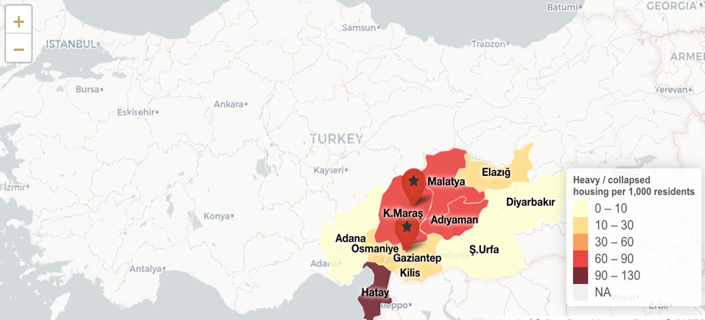

3.2 Damage Compositon Bar Chart

The graph below shows the percentages of homes with light damage, medium damage, and heavy/collapsed damage in the earthquake-affected provinces. The graph is color-coded by damage type, making it possible to observe the damage rates in each province. The total bar length indicates the overall damage intensity for that province. The size of the “heavy/collapsed” section shown in red on the graph indicates that physical destruction has reached a critical level in those provinces.

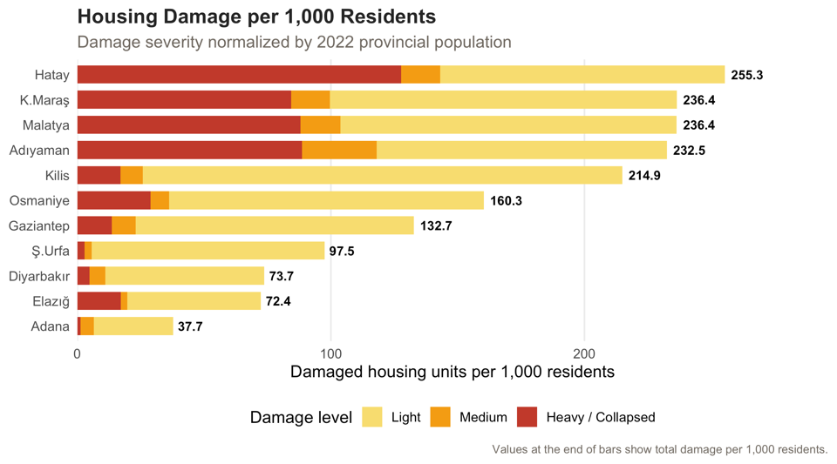

Accordingly, Hatay, Kahramanmaraş, Malatya, and Adıyaman stand out both in terms of total damage and the intensity of heavy/collapsed damage. The significant rate of heavy damage in Hatay has also had a major impact on migration patterns in that province.

3.3 Population Trends

The graph below shows the total population change in the 11 earthquake-affected provinces between 2018 and 2025. In 2023, significant population declines were observed particularly in provinces that sustained heavy damage in the earthquake, such as Hatay, Malatya, and Kahramanmaraş. Although signs of recovery were seen in some provinces following the earthquake year, this recovery is not at the same level across all provinces. This graph indicates that the earthquake-affected provinces are still in the process of demographic recovery.

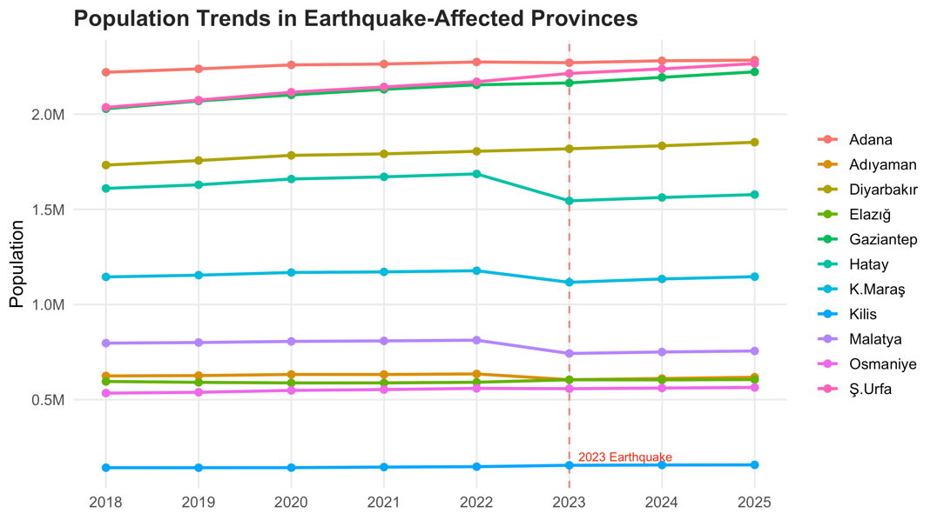

3.4 Net Migration Rate
The chart below compares the baseline year (2022), the earthquake year (2023), and the first recovery year (2024). An analysis of migration patterns in the earthquake-affected provinces during these years indicates that Malatya, Hatay, Kahramanmaraş, and Adıyaman experienced significant population loss in 2023.

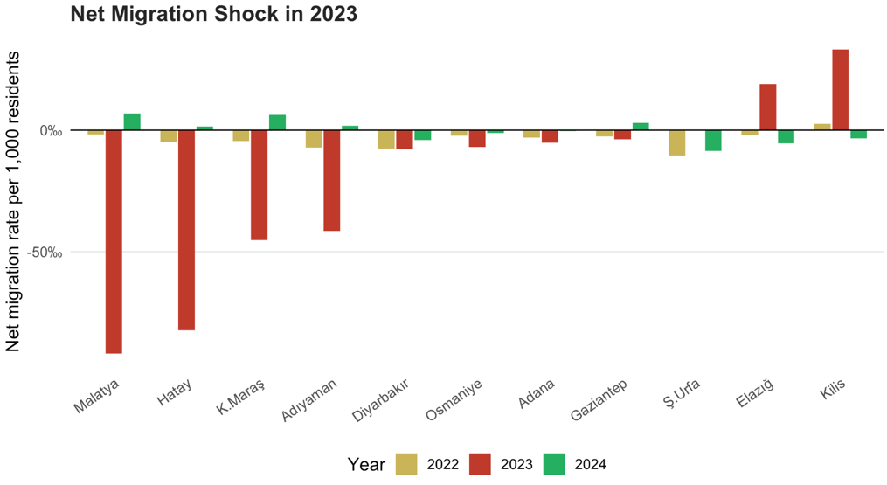

4. Main Analysis

In this section, detailed analyses were conducted to provide answers to the research questions. The analyses examine the destinations of population flows after the earthquake, changes in the population, and the demographic effects of physical damage.

In this context, migration movements from the earthquake-affected provinces were first examined to determine the destinations of these flows, and the provinces receiving the highest levels of migration were identified. One of the key assessments in the study evaluated the effects of the level of physical damage on population loss.

Finally, the recovery process was examined to assess the degree to which the earthquake-affected provinces have been able to return to expected population trends.

4.1 Interactive Migration Flow Map

The map below shows out-migration flows from provinces affected by the 2023 earthquake. By using the filters on the map, you can view out-migration flows from a selected earthquake-affected province.

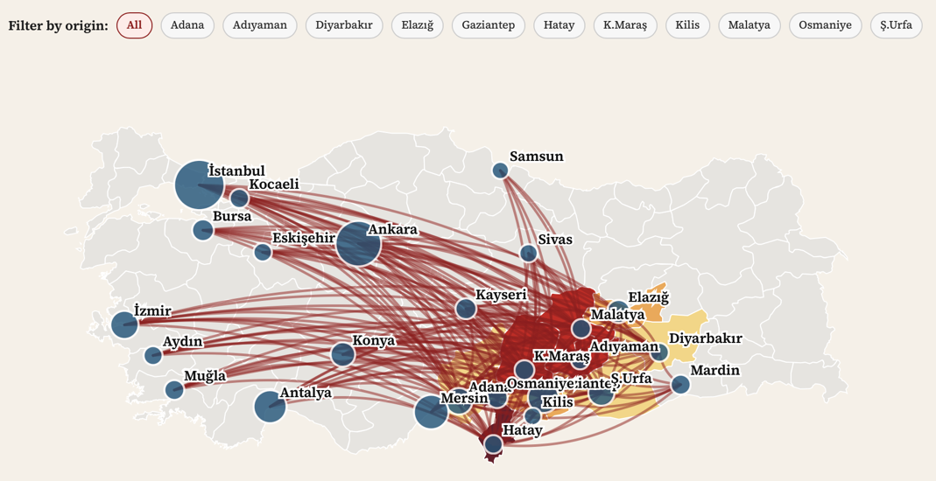

The blue dots on the map, which indicate destination provinces, increase in size based on the volume of migration to that province. It is evident that major cities such as Istanbul, Ankara, Izmir, Antalya, and Mersin serve as significant migration destinations and are highly preferred. Additionally, provinces located in the same geographical area as earthquake-affected regions, such as Konya, Kayseri, and Mardin, have also become important destinations.

4.2 Top Receiving Provinces

This chart shows the ranking of the provinces that receive the most migrants from earthquake-affected areas. Major cities such as Istanbul, Ankara, and Izmir stand out as the top destinations for migrants.

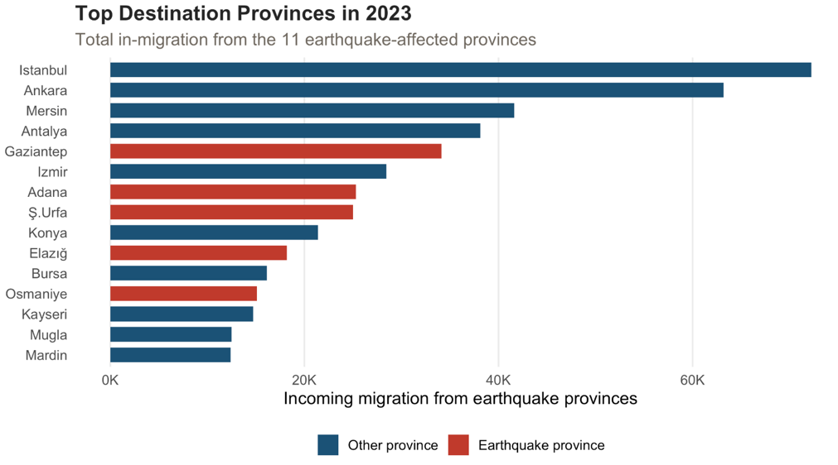

4.3 Migration Routes from the Three Hardest-Hit Provinces

Hatay, Malatya, and Kahramanmaraş are among the provinces most severely affected relative to their populations. These three provinces also account for a large portion of the migration flow from the provinces affected by the earthquake. The provinces to which people from these three provinces most frequently migrate are shown separately in the graph.

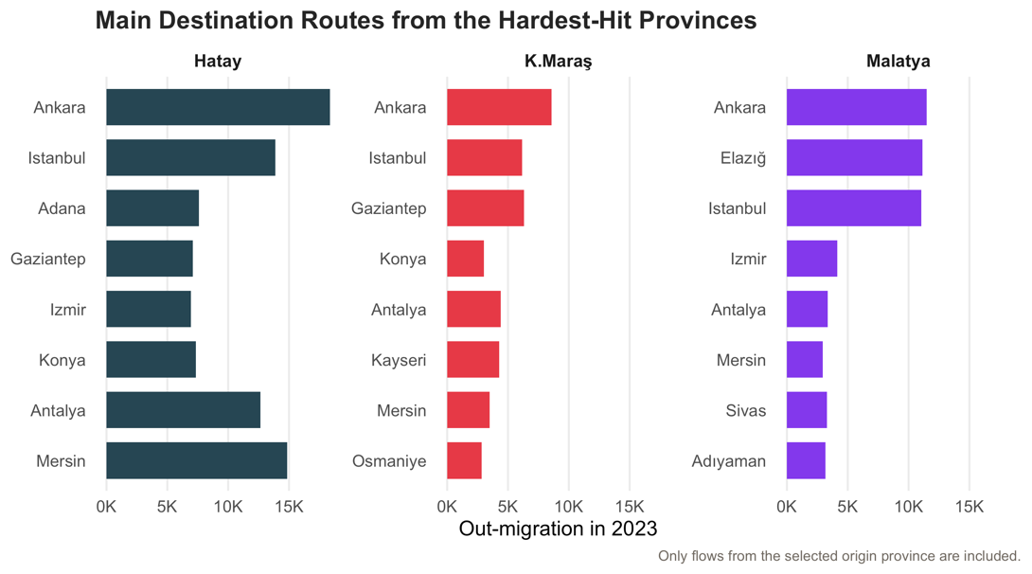

Istanbul consistently ranks highest for all three provinces, although significant differences in rankings are also observed. Migrants from Hatay tend to move more towards southern coastal provinces such as Mersin and Adana, while people from Malatya and Kahramanmaraş are more evenly distributed across large cities. These differences may reflect the geographical proximity of the cities and kinship ties.

5. Recovery Status by 2025

To assess the extent to which the provinces affected by the earthquake can recover demographically by 2025, a recovery gap metric has been created for each province. This difference is defined as the percentage difference between the actual population of the province in 2025 and the expected population in 2025, obtained by creating a linear trend from the pre-earthquake period (2018-2022).

Positive values indicate that the province has exceeded its expected population growth, while negative values indicate a persistent demographic deficit compared to the baseline trend. The results reveal significant heterogeneity in recovery outcomes.

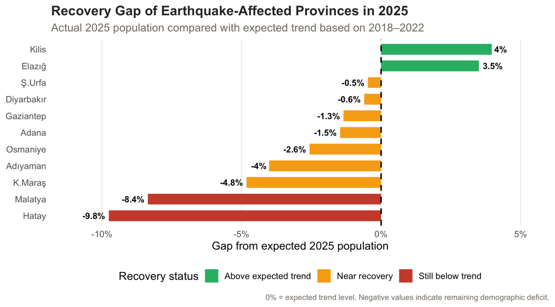

While some provinces may reach their pre-earthquake projected population levels by 2025, the most affected provinces, especially Hatay and Adıyaman, remain below these expectations. These findings indicate that demographic recovery in these provinces will be incomplete and uneven by 2025.

6. Supplementary Analysis: Ankara Migration

This below graph shows Ankara's net migration between 2018 and 2025. The dashed horizontal line shows the reference baseline representing the average total net migration for the period 2018-2022.

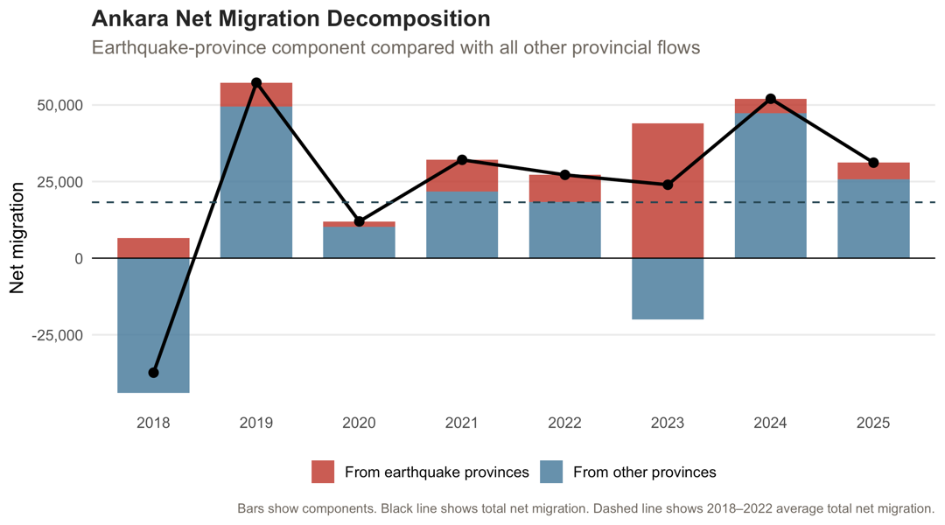

In 2023, the component from earthquake-affected provinces (shown in red) increased significantly compared to previous years. However, in the same year, the component from other provinces (shown in blue) turned negative, and the total net migration fell below the average. This pattern reveals that earthquake-related inflows should not be considered in isolation: migration movements with other provinces simultaneously followed a negative trend and largely offset the increase caused by the earthquake effect.

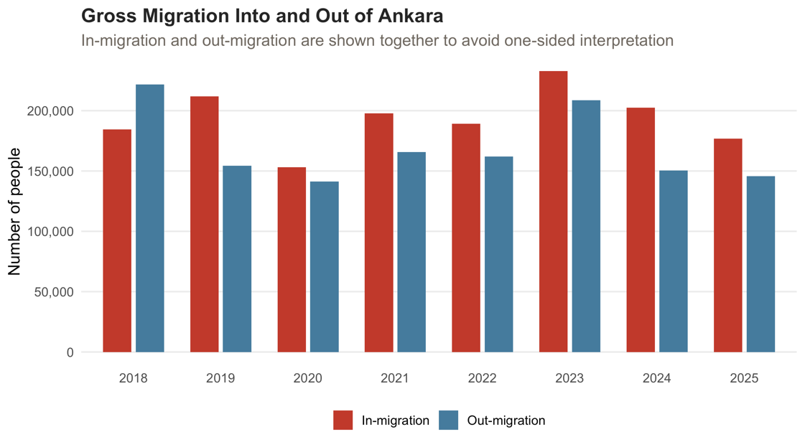

7. Key Takeaways

1. Damage intensity was not evenly distributed across the earthquake zone; Hatay, Malatya, Adiyaman, and Kahramanmaraş stood out with the highest rate of severe damage per 1,000 people.

2. The highest population losses in 2023 were observed in provinces with high severe damage intensity; this suggests a visible relationship between physical destruction and demographic decline.

3. People migrating from the earthquake-affected provinces have moved not only to major cities like Istanbul and Ankara, but also to nearby central provinces. This may indicate that geographical proximity and social networks also played a role in the choice of province to migrate to.

4. In the earthquake-affected provinces, post-earthquake demographic recovery is still ongoing as of 2025. The population lost through migration after the earthquake is still far below the expected population levels in some provinces, compared to the pre-earthquake trend.

5. Our analysis that specific to Ankara, shows that migration to Ankara increased significantly in 2023 after the earthquake. However, the amount of migration from other provinces decreased significantly in the same year, and these two movements balanced each other out. Looking at the general picture of the situation, the amount of migration to Ankara in 2023 remained below the general average.

It is important to note that the data used in this study is based on the TUIK ADNKS (address-based population registration system) data. This system only includes individuals who have made official registration declarations. It is known that in sudden displacement situations such as earthquakes, many people move temporarily or permanently to stay with relatives or acquaintances, and do not transfer their population registrations to the new provinces or postpone it. Considering this situation, it can be estimated that these figures are actually much higher.

8. Conclusion
The February 6 earthquake left lasting demographic traces in 11 provinces. Provinces with high damage density experienced significant population losses through migration. Metropolitan cities were the most preferred destinations for migration. As of 2025, the provinces most severely affected by the earthquake still lag behind their pre-earthquake expected population trends. On the other hand, it is important to remember that official data underestimates the true extent of displacement; people who moved to a new province without registering their residency are not reflected in these figures. All these findings indicate that demographic recovery is still ongoing

References
- Turkish Statistical Institute (TUIK). (2026). Address Based Population Registration System Results, 2025. TUIK Data Portal.

- Turkish Statistical Institute (TUIK). (2026). Internal Migration Statistics. TUIK Data Portal.

- Disaster and Emergency Management Presidency (AFAD). (2023). February 6, 2023 Kahramanmaras Earthquakes and Damage Assessment Data. Republic of Turkiye Ministry of Interior, AFAD.

- Presidency of Strategy and Budget. (2023). 2023 Kahramanmaras and Hatay Earthquakes Report. Republic of Turkiye Presidency of Strategy and Budget.

- Alpers, K. (n.d.). Turkey Maps GeoJSON: tr-cities.json. GitHub repository.

