Wire recognition method and apparatus.
(c) 2016 Patent by psxdev.ru project :)

Method of wire recogntion is based on pattern propagation.

Example image with wires:

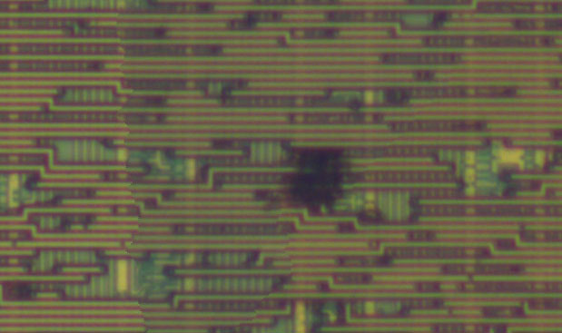
Solution:

1. Select seed wire pattern (image converted to Grayscale):

2. Algorithm recognizes wire direction, width and average color.

3. Algorithm propagate in both directions by small square samples of Width x Width size.

4. Calculate average color of propagated pattern. If average color has strong difference with seed average color – stop propagation.
Hand-drawn visualization of example method:

Nuff said.

