Computer Vision Homework 10

R08922079 資工所一 洪浩翔

**Part 0**

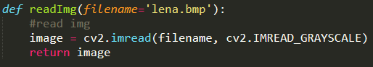

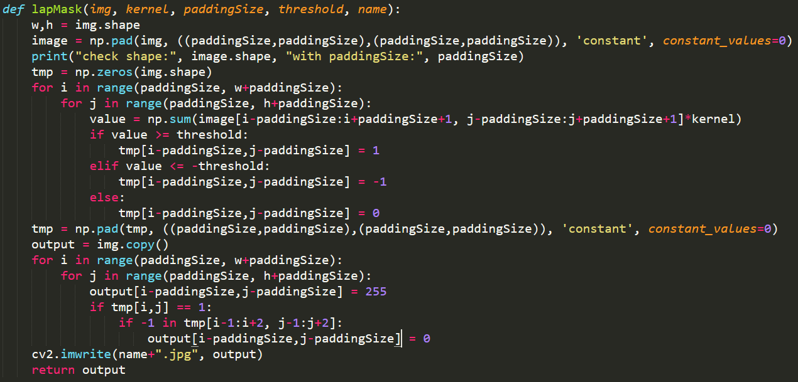

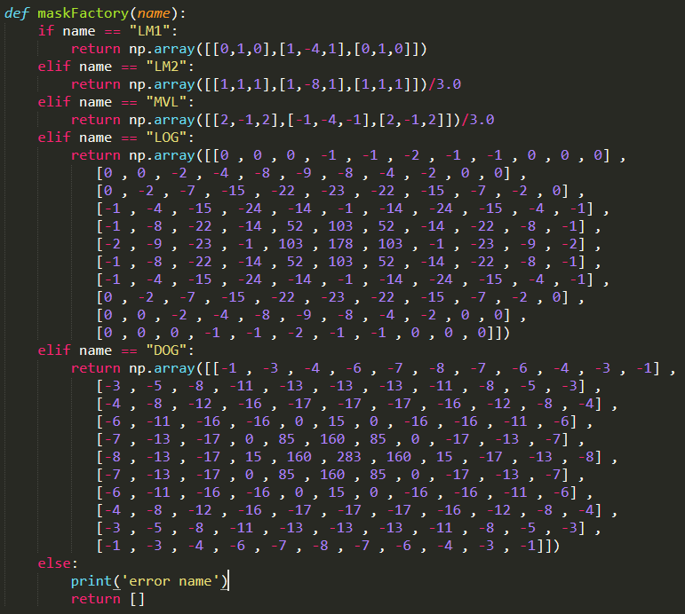

**Part 1**

|  |  |
| --- | --- |
|  | Laplacian Mask 1  Kernel:  Threshold: 15  Code: |
|  | Laplacian Mask 2  Kernel:  Threshold: 15  Code: |
|  | Minimum Variance Laplacian  Kernel:  Threshold: 20  Code: |
|  | Laplacian of Gaussian  Kernel:  Threshold: 3000  Code: |
|  | Difference of Gaussian  Kernel:    Threshold: 1  Code: |

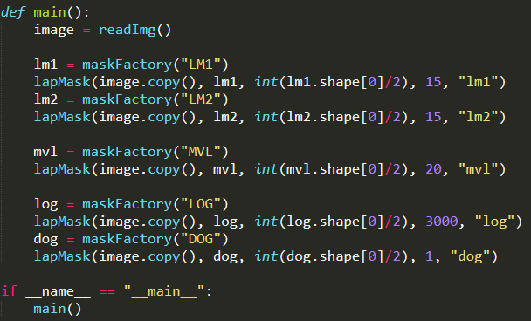

Main code fragment