Computer Vision Homework 4

R08922079 資工所一 洪浩翔

**Part 0**

|  |
| --- |
| Image reading and pre-processing |

**Part 1**

(a) Dilation

|  |  |
| --- | --- |
| Binary Lena | Dilation |
| Code for dilation | |

(b) Erosion

|  |  |
| --- | --- |
| Binary Lena | Erosion |
| Code for erosion | |

(c) Opening

|  |  |
| --- | --- |
| Binary Lena | Opening |
| Code for opening | |

(d) Closing

|  |  |
| --- | --- |
| Binary Lena | Closing |
| Code for closing | |

(e) Hit-and-miss transform

|  |  |
| --- | --- |
| Binary Lena | Hit and miss |
| Code for hit and miss | |

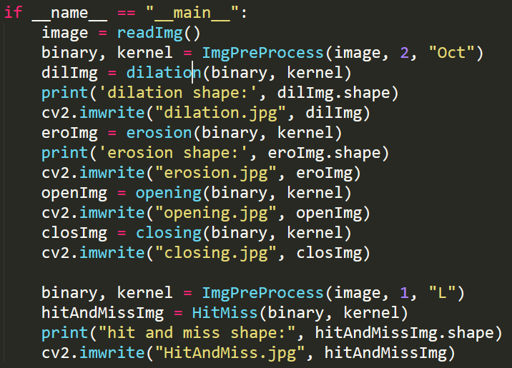

Code for main