Computer Vision Homework 5

R08922079 資工所一 洪浩翔

**Part 0**

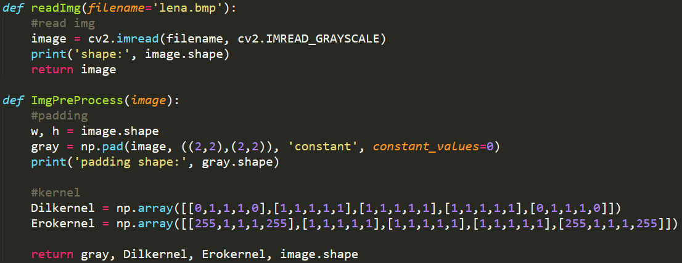

Image reading and pre-processing

**Part 1**

(a) Dilation

|  |  |
| --- | --- |
| Lena | Dilation |
| Code for dilation | |

(b) Erosion

|  |  |
| --- | --- |
| Lena | Erosion |
| Code for erosion | |

(c) Opening

|  |  |
| --- | --- |
| Lena | Opening |
| Code for opening | |

(d) Closing

|  |  |
| --- | --- |
| Lena | Closing |
| Code for closing | |

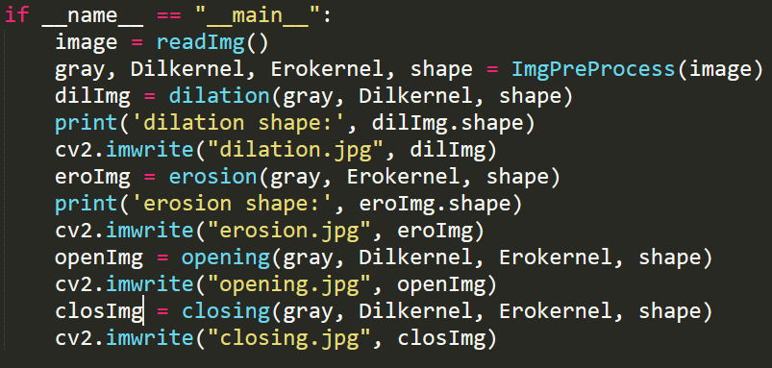

Code for main