Computer Vision Homework 6

R08922079 資工所一 洪浩翔

**Part 0**

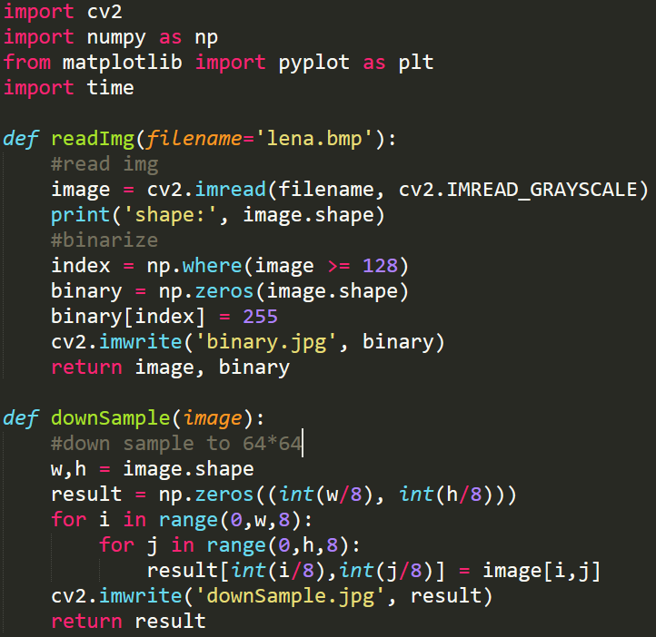

Pre-processing and down-sampling code fragment

**Part 1**

(a) Write a program which counts the **Yokoi connectivity number** on a down-sampled image (lena.bmp)

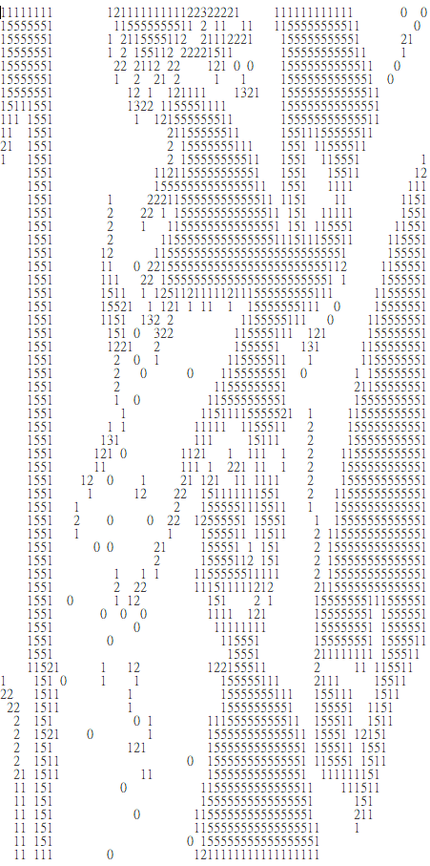

**Yokoi connectivity number of down-sampled Lena**

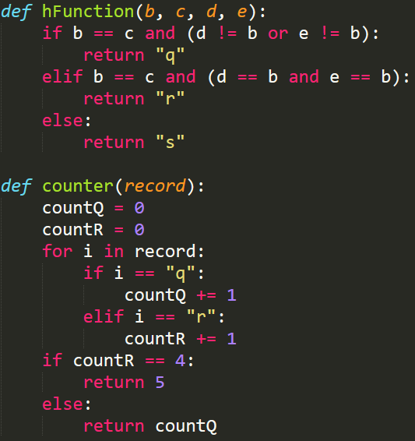

h(b,c,d,e) and counter for Yokoi connective number

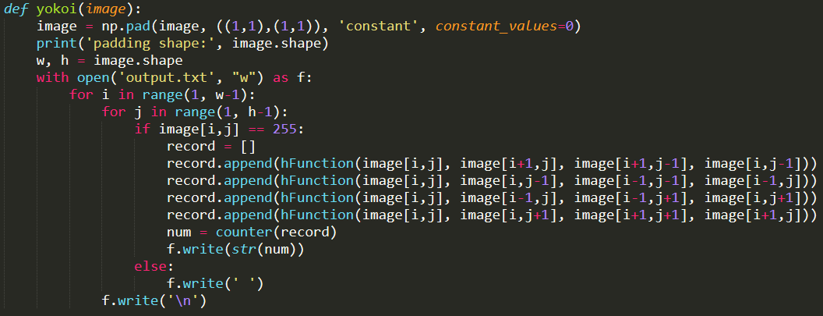

Code fragment for Yokoi

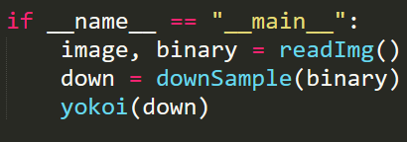

Main()