Computer Vision Homework 7

R08922079 資工所一 洪浩翔

**Part 0**

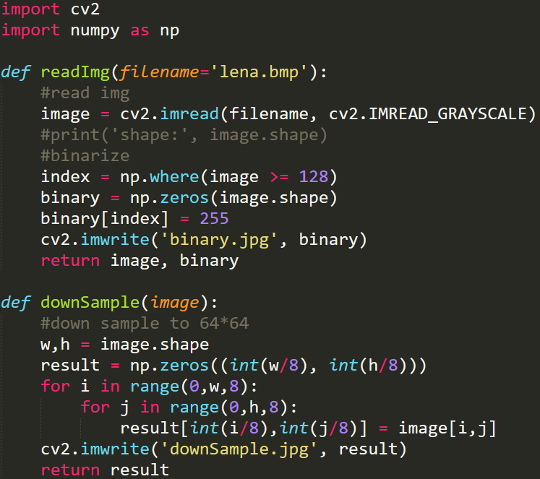

Pre-processing and down-sampling code fragment

**Part 1**

(a) Write a program which does **thinning** on a down-sampled image (lena.bmp).

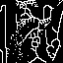

Result of thinning operator

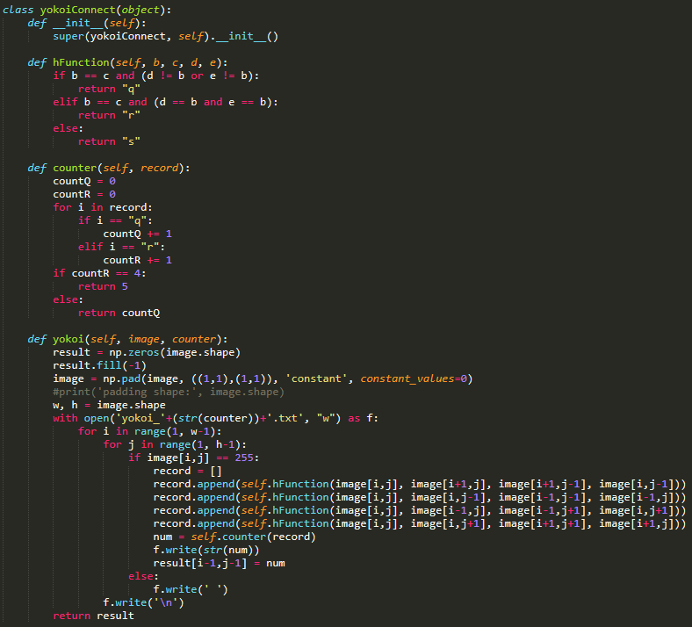

Code for Yokoi

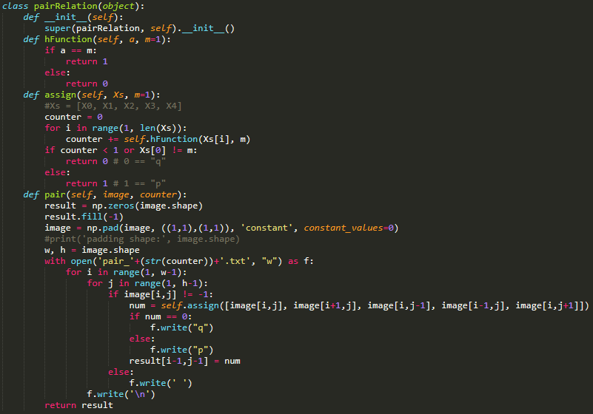

Code for pair relation mark

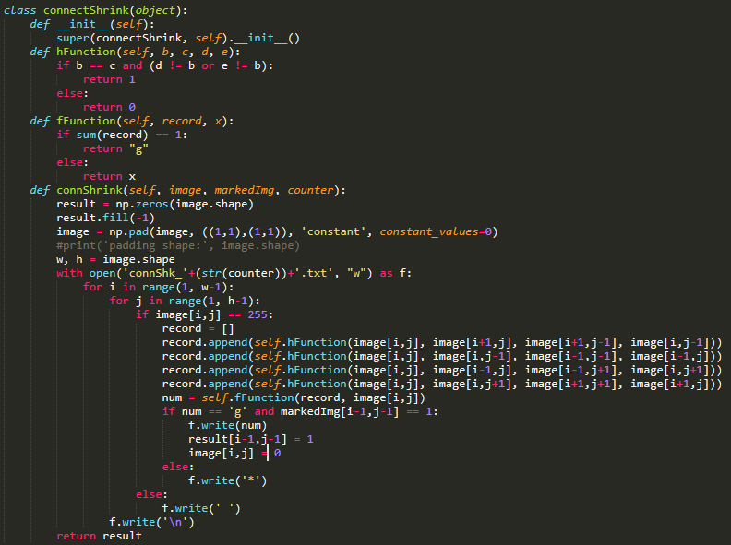

Code for connective shrink operator

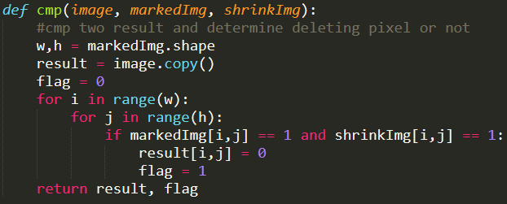

Code for comparing marked and shrunk images and determining whether to stop

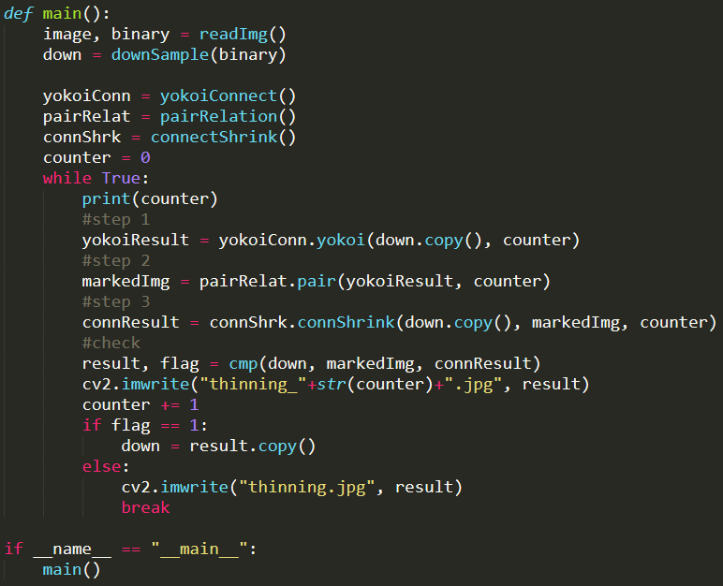

Main function for thinning

|  |  |  |  |  |  |  |
| --- | --- | --- | --- | --- | --- | --- |
|  |  |  |  |  |  |  |

Thinning result in each iteration