Computer Vision Homework 8

R08922079 資工所一 洪浩翔

**Part 0**

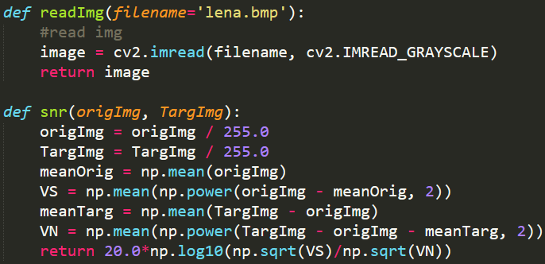

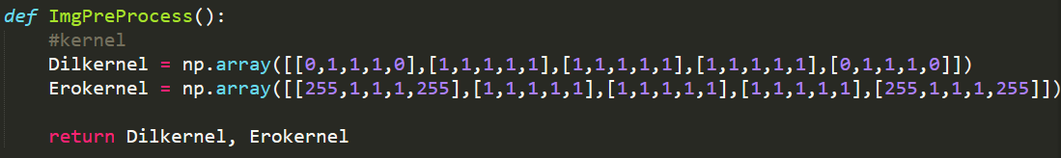

**Part 1**

|  |  |
| --- | --- |
| Gaussian noise with amp = 10  Snr = 13.939527234532092 | |
| 3x3 box filter  Snr = 16.44829523717587 | 5x5 box filter  Snr = 13.610520190975684 |
| 3x3 median filter  Snr = 17.8451064589486 | 5x5 median filter  Snr = 15.926188281486 |
| Close then open  Snr = 13.629515221968312 | Open then close  Snr = 13.276470198884061 |

|  |  |
| --- | --- |
| Gaussian noise with amp = 30  Snr = 2.2587622315879003 | |
| 3x3 box filter  Snr = 9.678335626876832 | 5x5 box filter  Snr = 10.341085646093909 |
| 3x3 median filter  Snr = 10.87033698053484 | 5x5 median filter  Snr = 12.328056376705522 |
| Close then open  Snr = 7.83100571664224 | Open then close  Snr = 7.924666447669075 |

|  |  |
| --- | --- |
| Salt and pepper noise with prob = 0.05  Snr = 0.8566596160998019 | |
| 3x3 box filter  Snr = 9.187921902215123 | 5x5 box filter  Snr = 10.520613442040286 |
| 3x3 median filter  Snr = 18.18777513278135 | 5x5 median filter  Snr = 15.7546116437436 |
| Close then open  Snr = 5.2034486799958195 | Open then close  Snr = 1.2508035238354342 |

|  |  |
| --- | --- |
| Salt and pepper noise with prob = 0.1  Snr = -2.1076175845166483 | |
| 3x3 box filter  Snr = 6.196176652696673 | 5x5 box filter  Snr = 8.149110532880508 |
| 3x3 median filter  Snr = 14.172461603058151 | 5x5 median filter  Snr = 14.229670526769135 |
| Close then open  Snr = -2.4451848886114664 | Open then close  Snr = -2.984293812855861 |

**Code**

