Computer Vision Homework 9

R08922079 資工所一 洪浩翔

**Part 0**

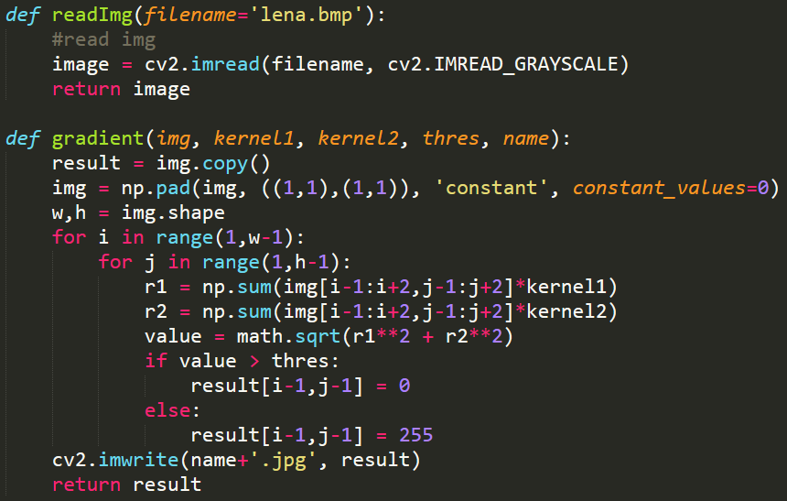

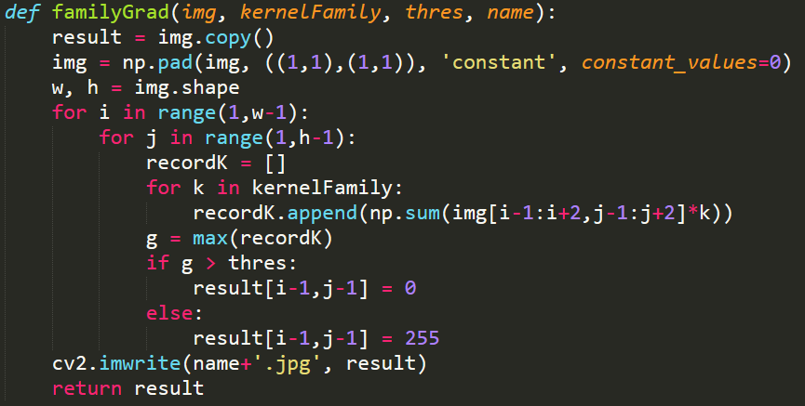

**Part 1**

|  |  |
| --- | --- |
| Original Lena | Robert's Operator: 12 |
| Prewitt's Edge Detector: 24 | Sobel's Edge Detector: 38 |
| Frei and Chen's Gradient Operator: 30 | Kirsch's Compass Operator: 135 |
| Robinson's Compass Operator: 43 | Nevatia-Babu 5x5 Operator: 12500 |

**Code**

