Computer vision homework 10

B04902028 資工三 洪浩翔

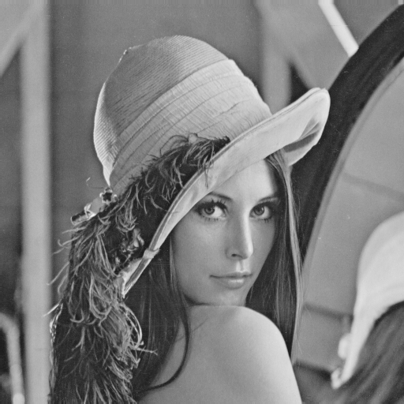

Original Lena Image

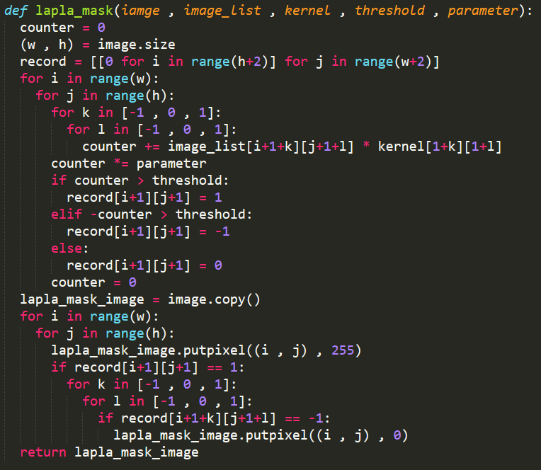

Main function 1 for (1)~(3) to dealing 3\*3 kernel

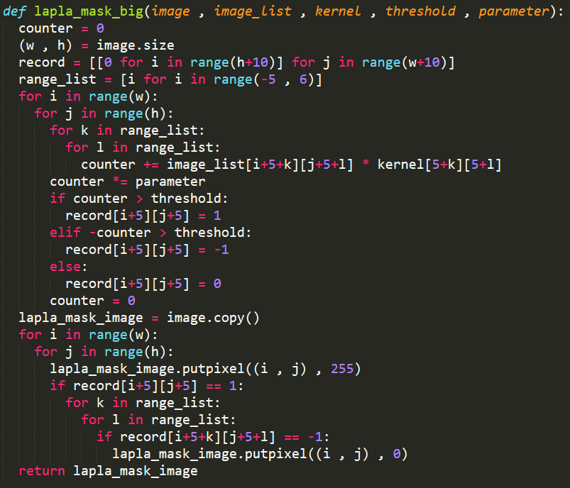

Main function 2 for (4)~(5) to dealing 11\*11 kernel

1. Laplacian Mask with kernel 1:

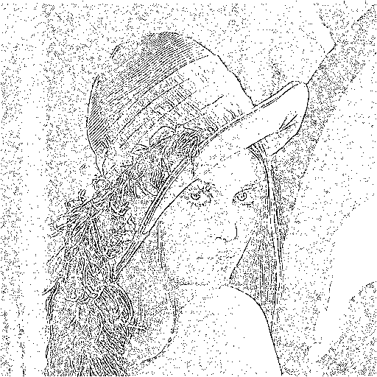

Result of using kernel 1 and threshold = 15



Kernel 1



Code of mask

2. Laplacian Mask with kernel 2:

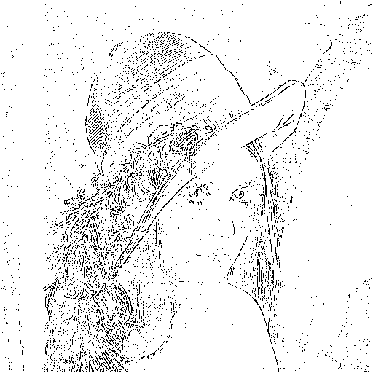

Result of using kernel 2 and threshold = 15

(1/3)\*

Kernel 2



Code of mask

3. Minimum Variance Laplacian:

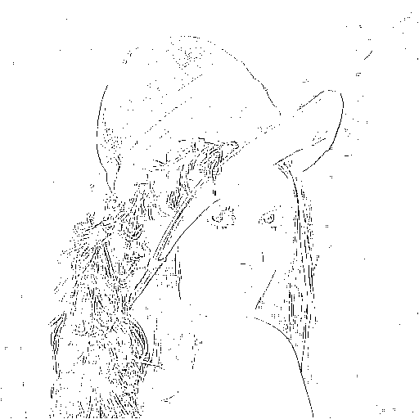

Result of Minimum Variance Laplacian with threshold = 20

(1/3)\*

Kernel



Code of Minimum Variance Laplacian

4. Laplacian of Gaussian:

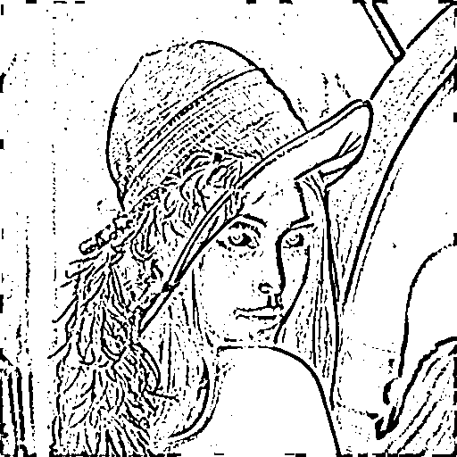

Result of Laplacian of Gaussian with threshold = 3000

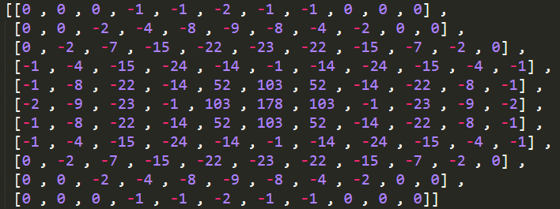

Kernel of Laplacian of Gaussian(mask1 in code)

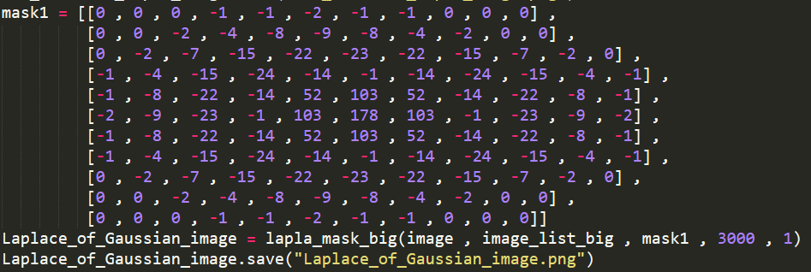

Code of Laplacian of Gaussian

5. Difference of Gaussian:

(nhibitory sigma=1, excitatory sigma=3, kernel size 11x11)

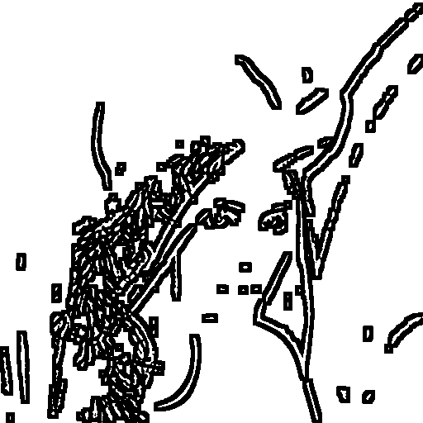

Result of Difference of Gaussian with threshold = 1

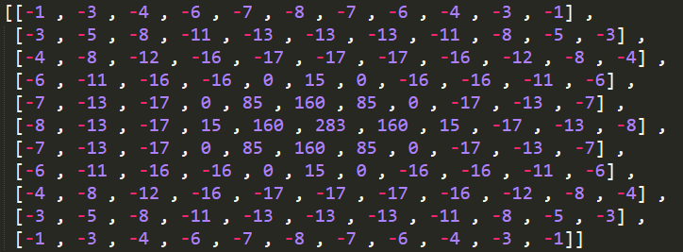

Kernel of Difference of Gaussian(mask2 in code)

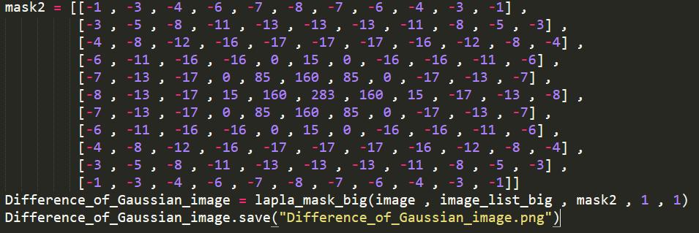

Code of Difference of Gaussian