Computer vision homework 2

B04902028 資工三 洪浩翔

1. a binary image:

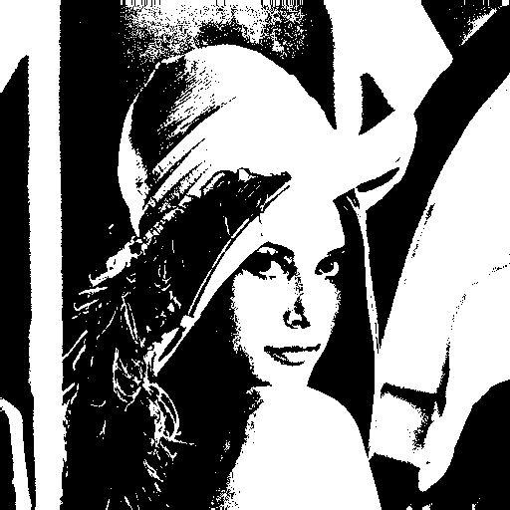

Binarized result

1. a histogram:

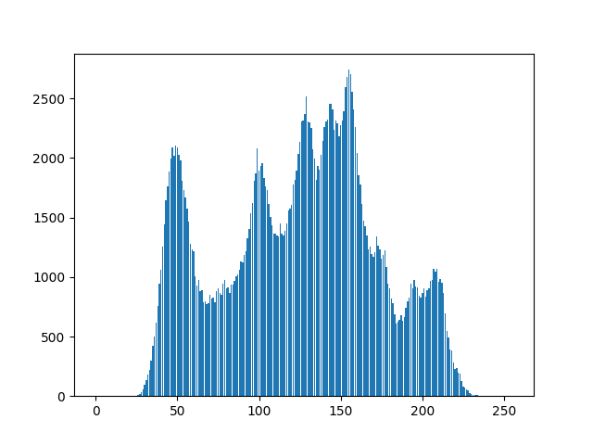

Histogram

Main code of binary image and histogram:

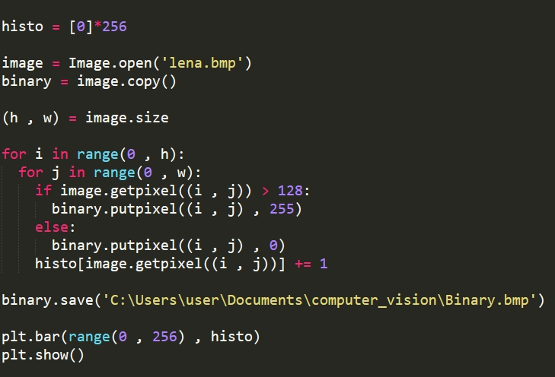

1. connected components with bounding box and centroid:

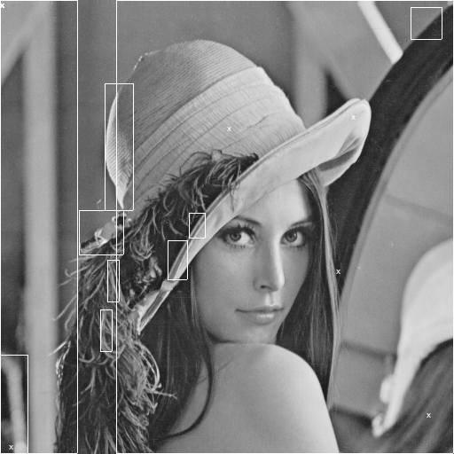

Result of connected components

Algorithm:   
Run-Length Implementation of the Local Table Method

With using 4-connected

Main code of implementation:

1. Create and set all the table we need

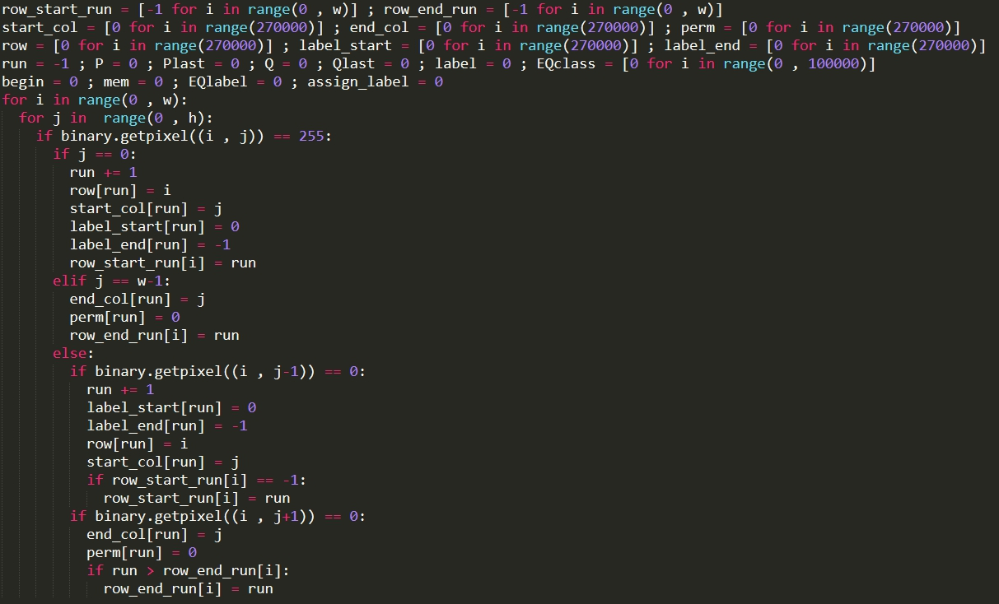

1. Top-down process:

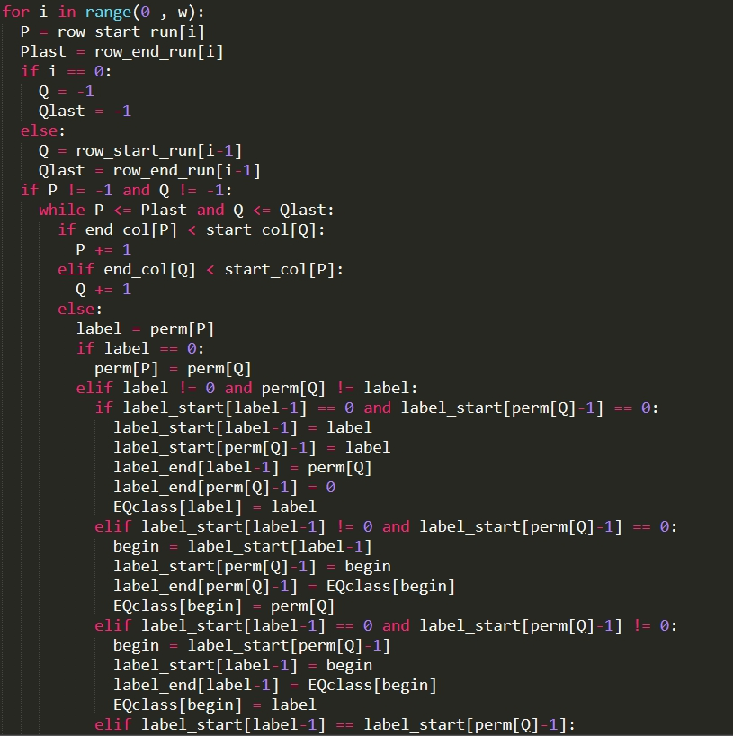

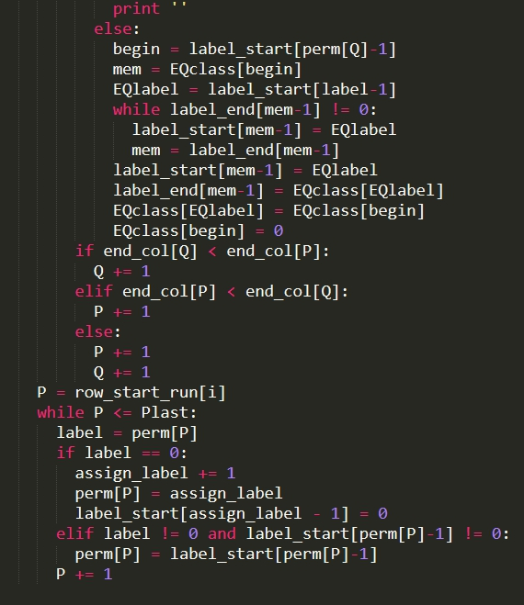

1. Bottom-up process:

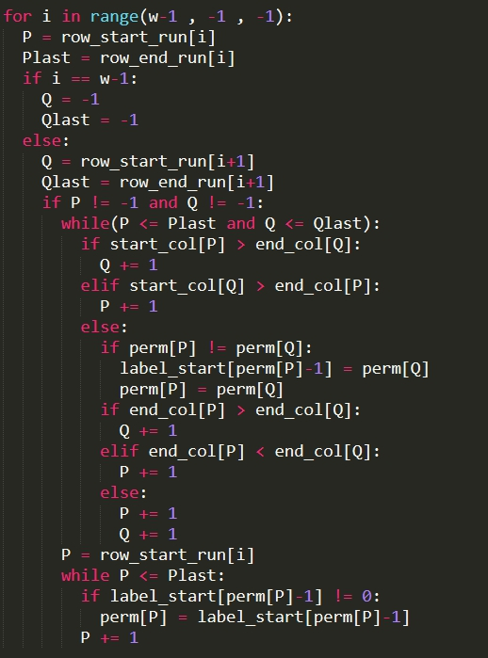

1. Bounding box and centroid process:

