Computer vision homework 3

B04902028 資工三 洪浩翔

1. Histogram Equalization:

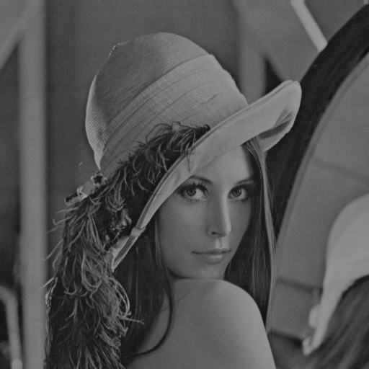

This is dark image we want to use Histogram Equalization

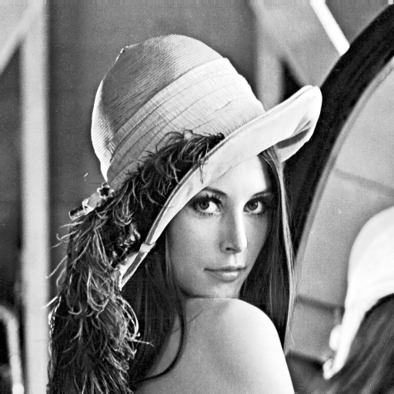

This is the image after Histogram Equalization

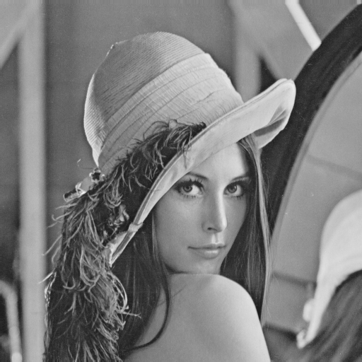

This is original lena image

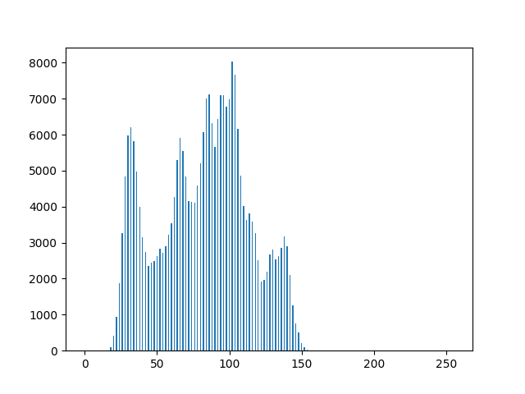

This is histogram of original dark image

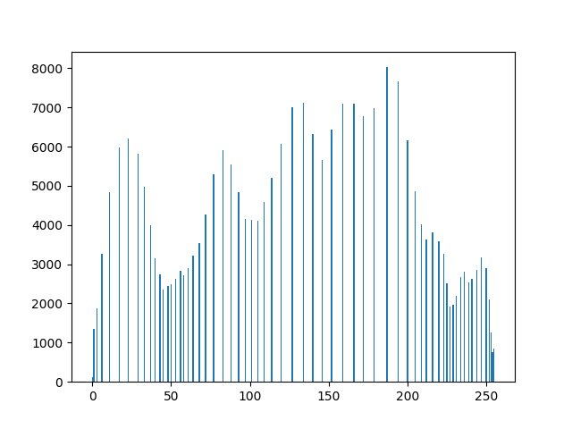

This is histogram after Histogram Equalization

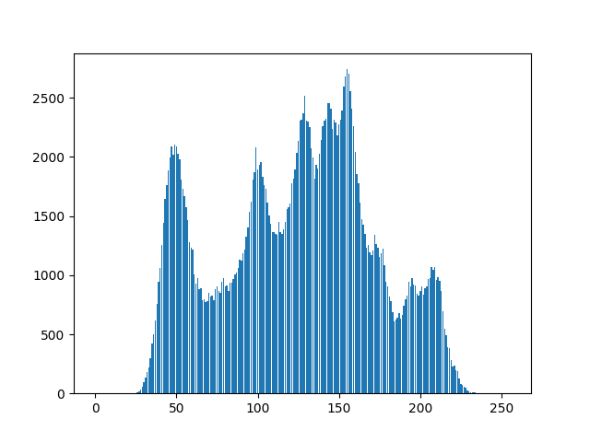

This is histogram of original lena image

Main code:

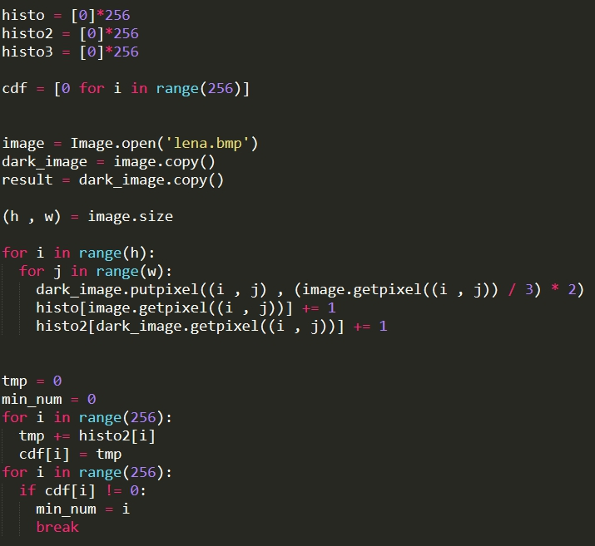

This part is dealing data structure and cdf counting with finding the min cdf

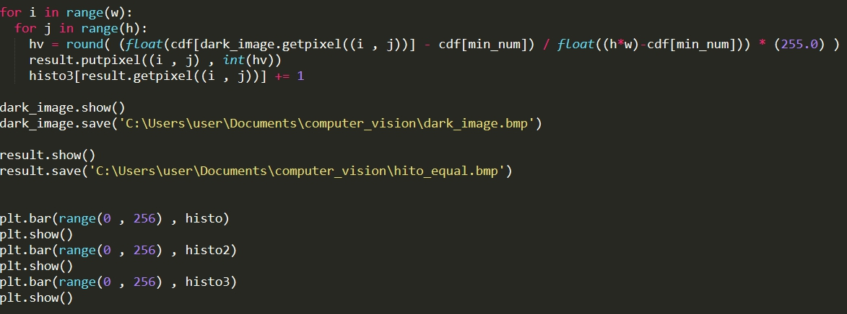

This part is dealing with Histogram Equalization and plot