Computer vision homework 5

B04902028 資工三 洪浩翔



Original Lena image

1. Gray-scale morphological dilation:



The result after dilation

Main code about dilation:

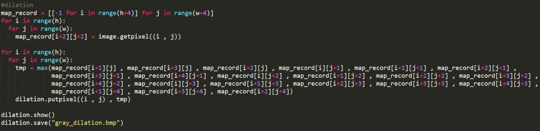

1. Gray-scale morphological erosion:

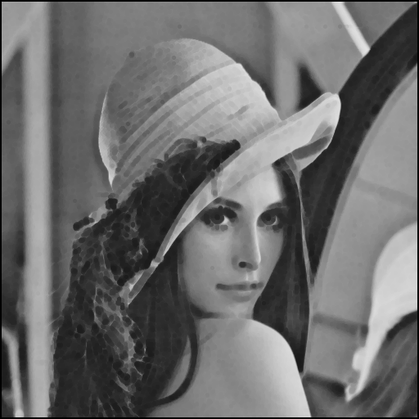

The result after erosion

Main code about erosion:

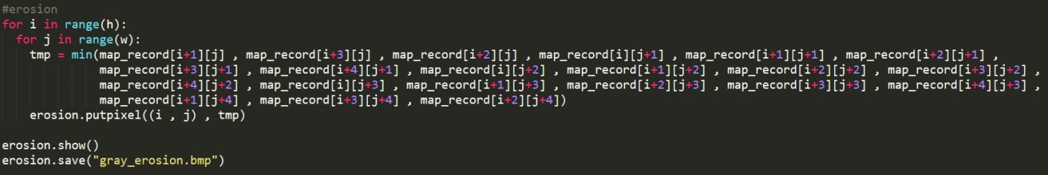

1. Gray-scale morphological opening:

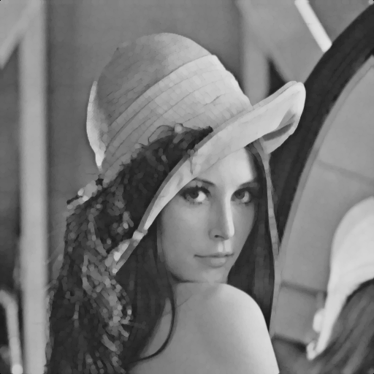

The result after opening

Main code about opening:

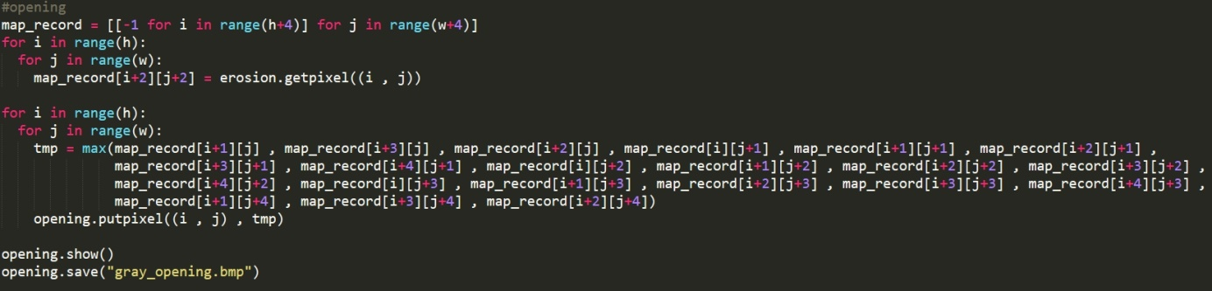

1. Gray-scale morphological closing:

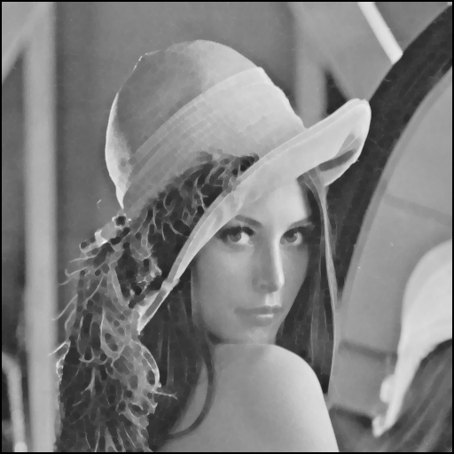

The result after closing

Main code about closing: