Computer vision homework 9

B04902028 資工三 洪浩翔

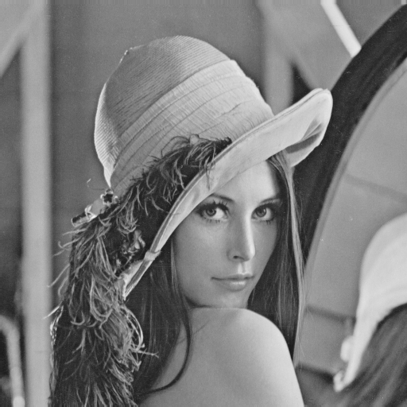

Original Lena image

1. Robert edge detection:

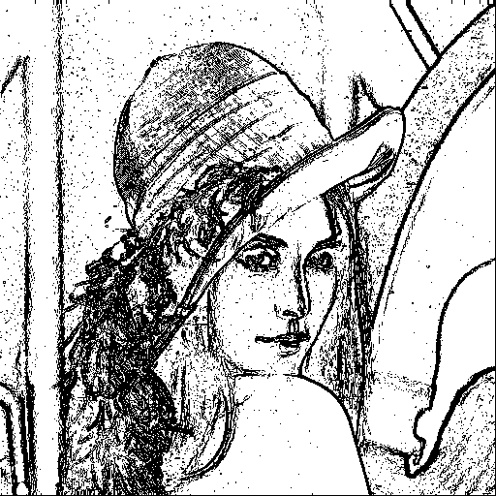

Robert edge detection with threshold = 12

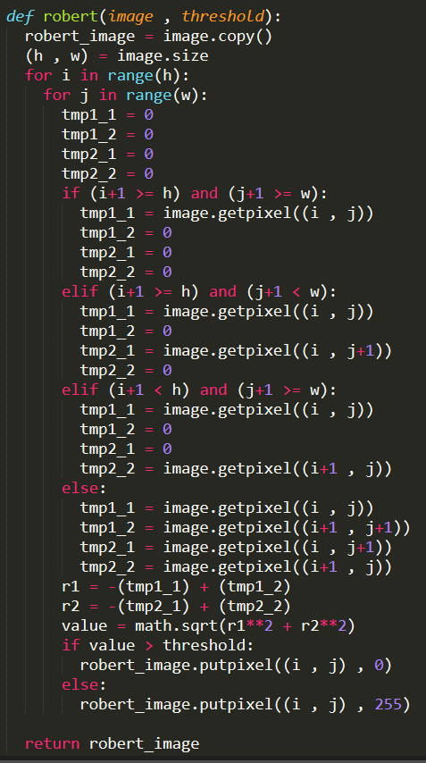

Code of Robert

2. Prewitt edge detection:

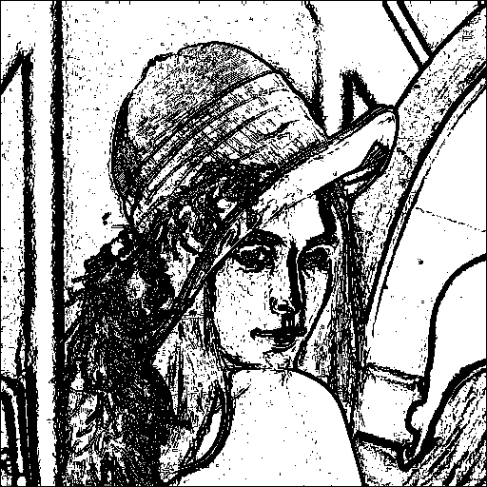

Prewitt edge detection with threshold = 24

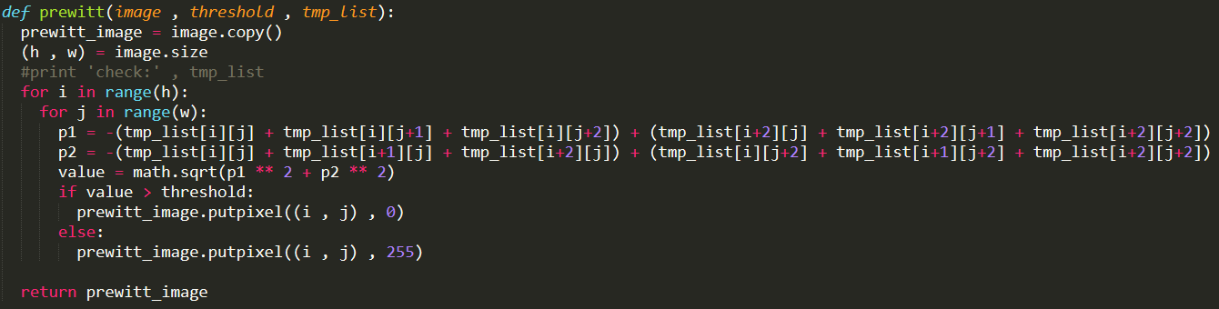

Code of prewitt

3. Sobel edge detection:

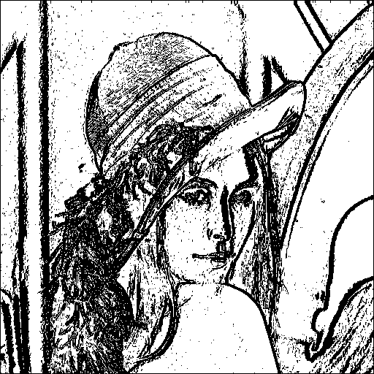

Sobel edge detection with threshold = 38

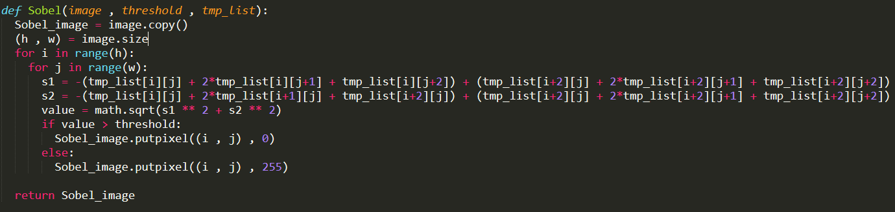

Code of sobel

4. Frei & Chen edge detection:

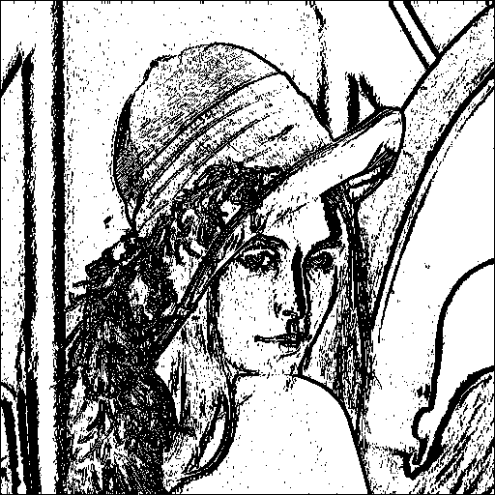

Frei & Chen edge detection with threshold = 30

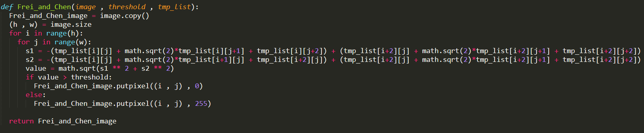

Code of Frei & Chen

5. Kirsch edge detection:

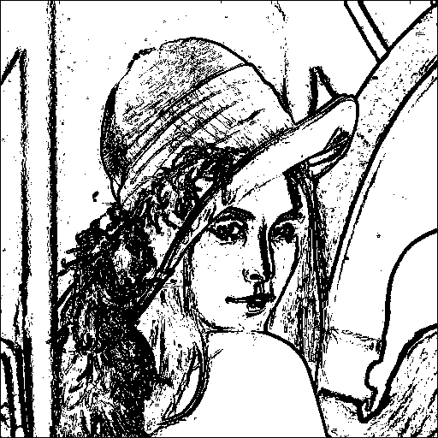

Kirsch edge detection with threshold = 135

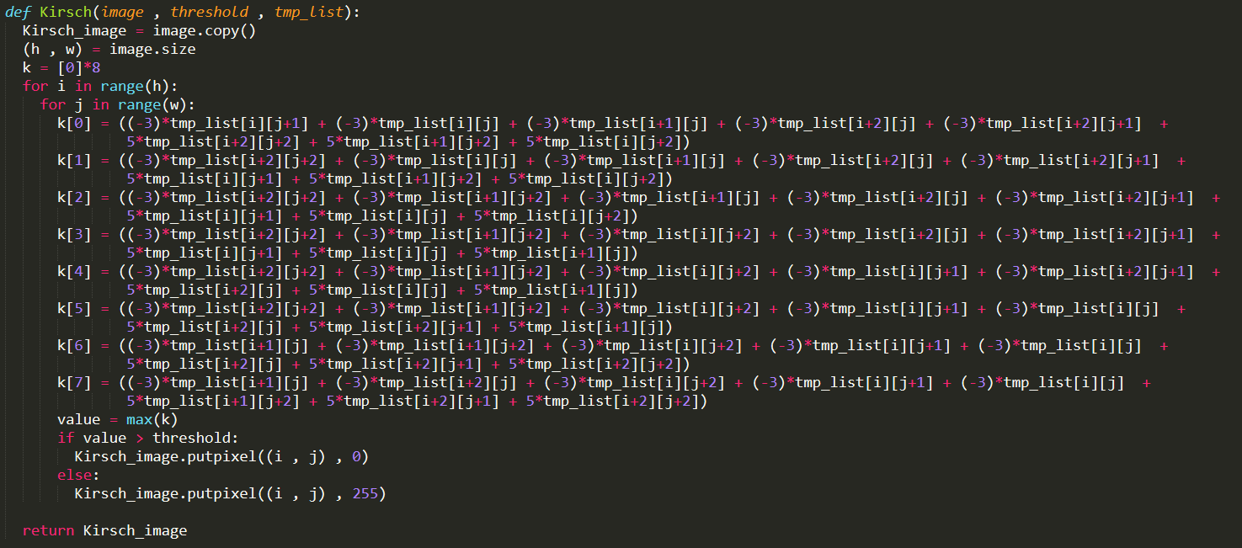

Code of Kirsch

6. Robinson edge detection:

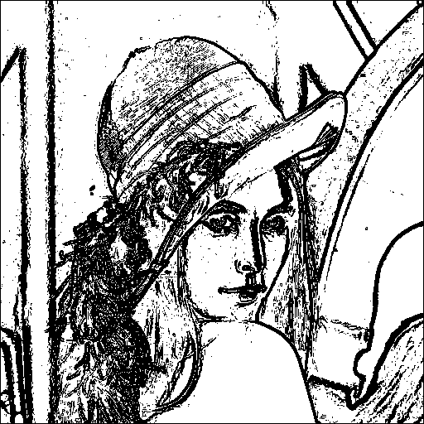

Robinson edge detection with threshold = 43

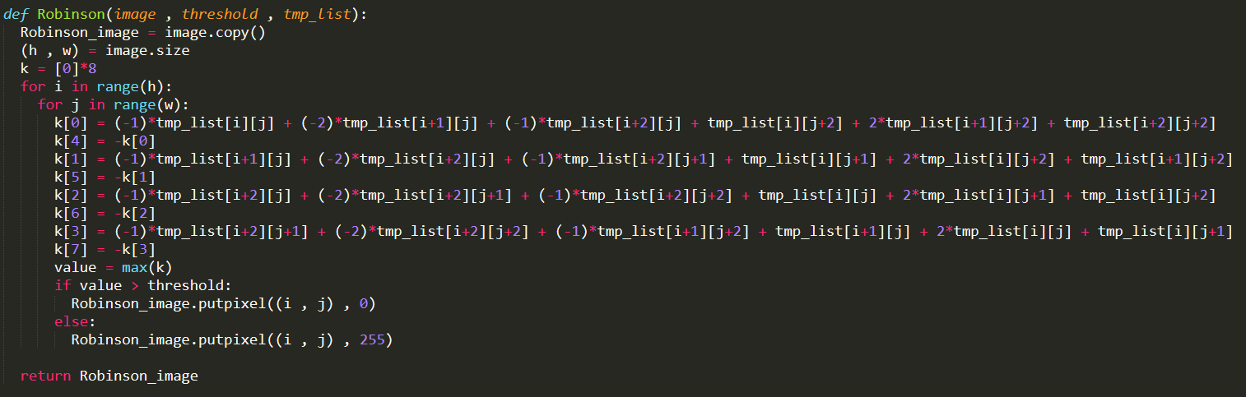

Code of Robinson

7. Nevatia-Babu's edge detectors:

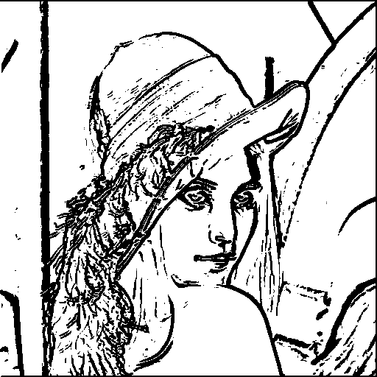

Nevatia-Babu's edge detection with threshold = 12500

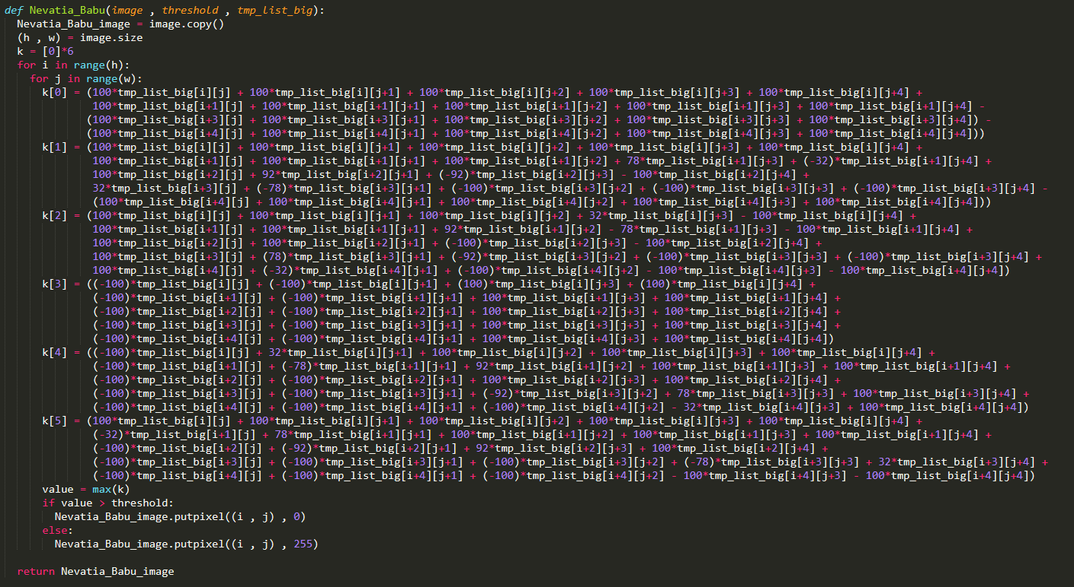

Code of Nevatia-Babu's