11.

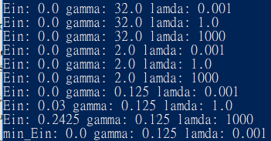

When (gamma, lamda) = (32 , 0.001) , (32 , 1) , (32 , 1000) , (2 , 0.001) , (2 , 1) , (2 , 1000) , (0.125 , 0.001), there is a minimal Ein 0.0

12.

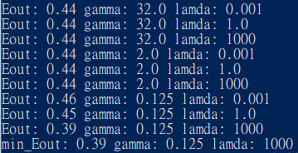

When gamma = 0.125 and lamda = 1000, there is a minimal Eout 0.39

13.

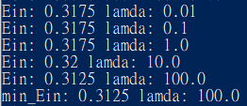

When lamda = 100, there is a minimal Ein 0.3125

14.

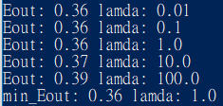

When lamda = 0.01 , 0.1 , 1, there is a minimal Eout 0.36

15.

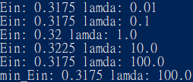

When lamda = 100, minimal Ein = 0.3175

Compare with Ein in Q13, it seems that using bagging may not result in a better performance. Bagging will slow down the executing performance and the enhancement of performance may not be obvious. Bagging may not be efficient in this condition.

16.

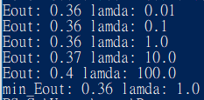

When lamda = 1, minimal Eout = 0.36

Compare with Eout in Q14, the conclusion will be the same as previous problem.

It seems that using bagging may not result in a better performance. Bagging will slow down the executing performance and the enhancement of performance may not be obvious. Bagging may not be efficient in this condition.