11.

Ein(g1): 0.24 alpha1: 0.576339754969

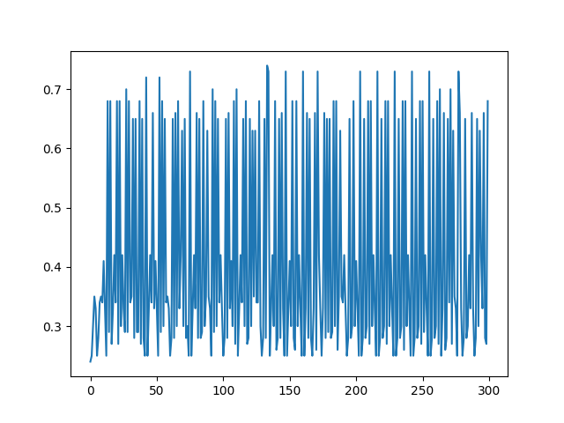

12.

According to the plot in previous problem, Ein(gt) may not always increase or decrease. The reason why Ein will be up and down obviously is that error data will be emphasized, so noise data will be emphasized as well. Therefore, the Ein(gt) value will be changed quickly.

13.

Ein(G): 0.0

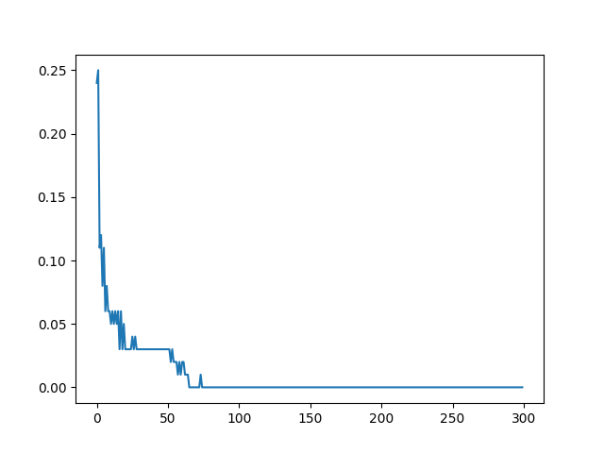

14.

U2: 0.854166260163 UT: 0.00540148658261

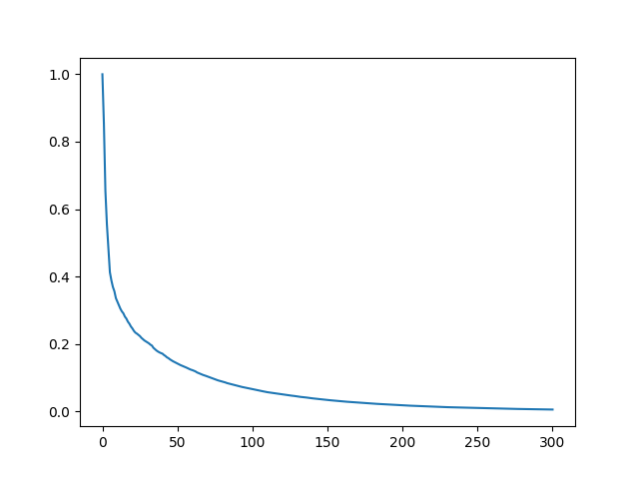

15.

Eout(g1): 0.29

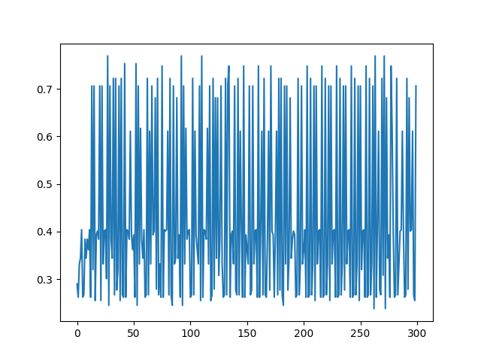

16.

Eout(G): 0.132

