# Refined Graphs for Proposal

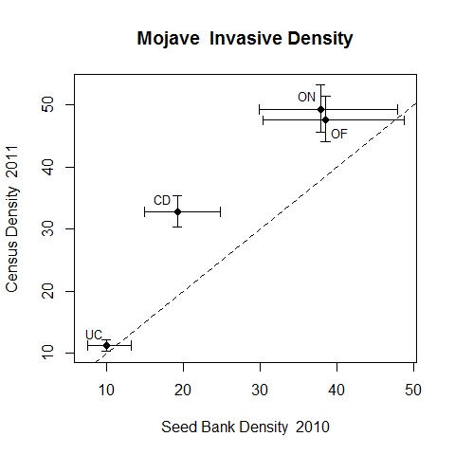

Graph compares seedbank densities to census densities at four microhabitat locations. Points are least squares means (and standard errors) from a generalized linear mixed model fitting densities based on microhabitat and density source (Seedbank vs. Census).

