**NCC IGNORE FIGURE NUMBERS**

Province wide – area of lcc, harvest, and fire

Hypothesis: lcc same, fire same, harvest different

Harvest is only included in disturbance things, not in LCC or structure

## INTRO FIGURES

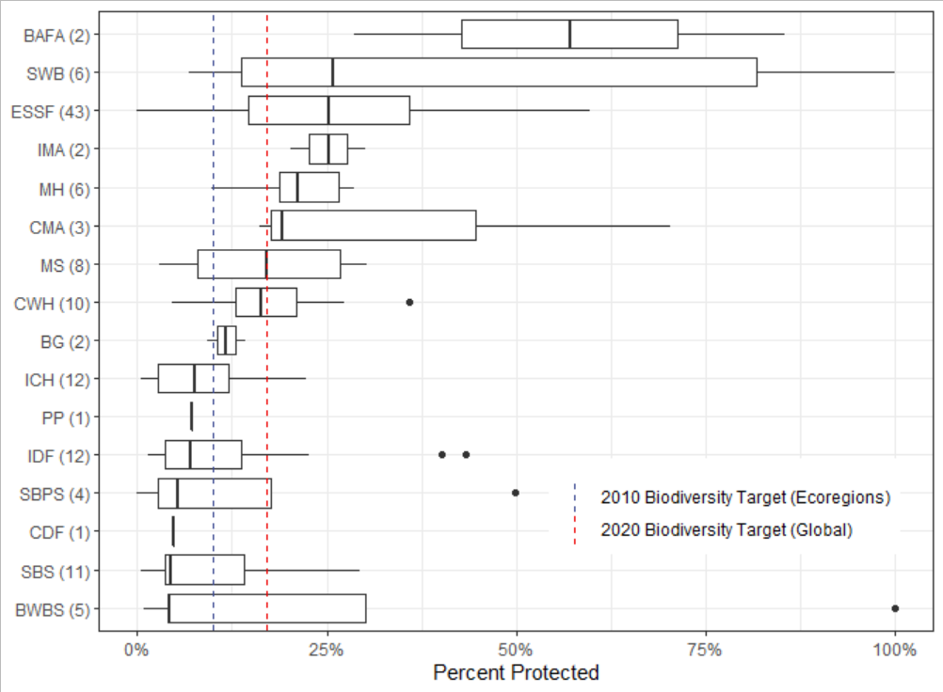

Figure 1: Boxplots of percent protected of each BEC subzone by BEC zone. Blue line indicates the 10% protection goal for every ecoregion outlined in Target 1.1 in the 2010 biodiversity targets, and the red line indicates the 17% of total area protected globally in the Aichi Target 11. Numbers to the right of the BEC labels indicate the number of subzones in the zone.

Study area figure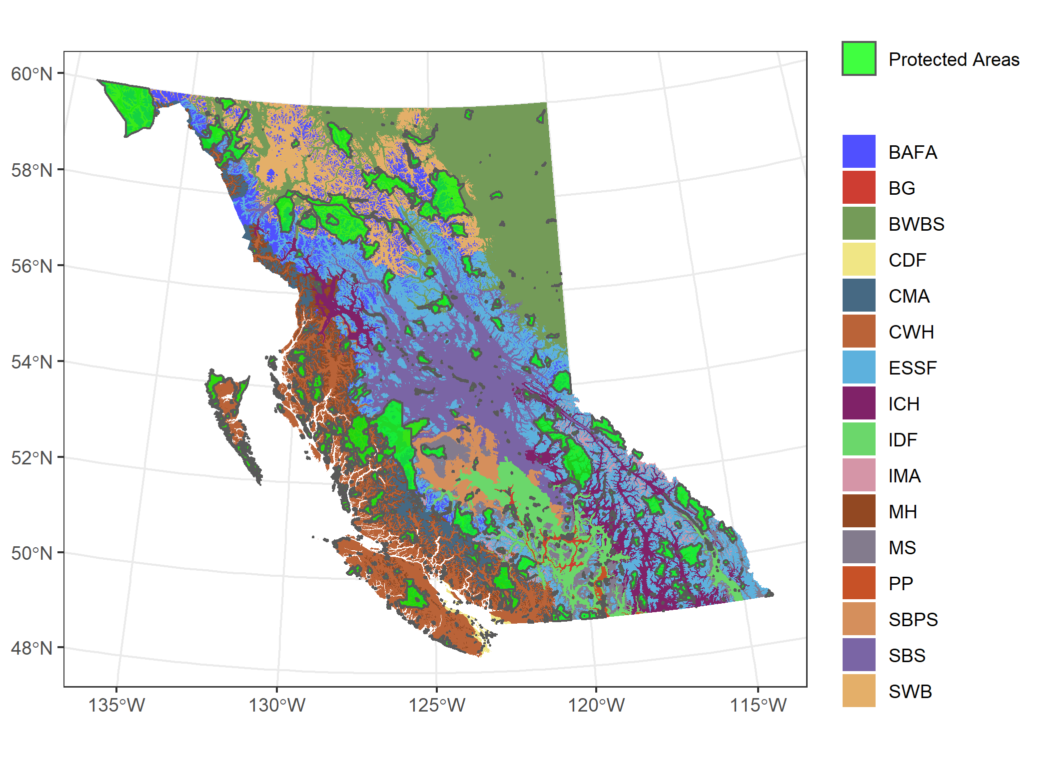

Figure 2: Map of BEC zones and protected areas in British Columbia (Data source: BC Government (2021) and Canada Wildlife Services (2020).

Data figure? Showcasing layers? Batlow palette

Not sure how exactly to do this. Map for each: land cover, disturbance, 1 structure attribute and an inset map of which park it is?

## Results Figures

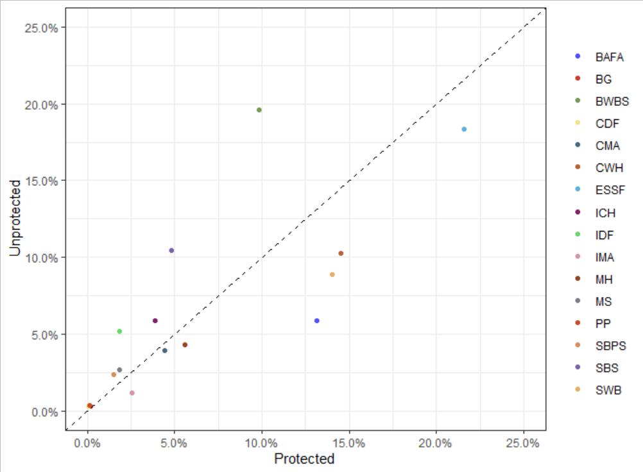

Figure 1: Proportion of protected and unprotected areas by BEC zone in terrestrial British Columbia.

Figure 1 shows the proportion of land for each BEC zone in protected and unprotected areas within the province of British Columbia. Most BEC zones comprise similar proportions of the province in both protected and unprotected areas. BAFA, SWB, and PP are overrepresented in protected areas. BWBS and SBS are both underrepresented in protected areas.

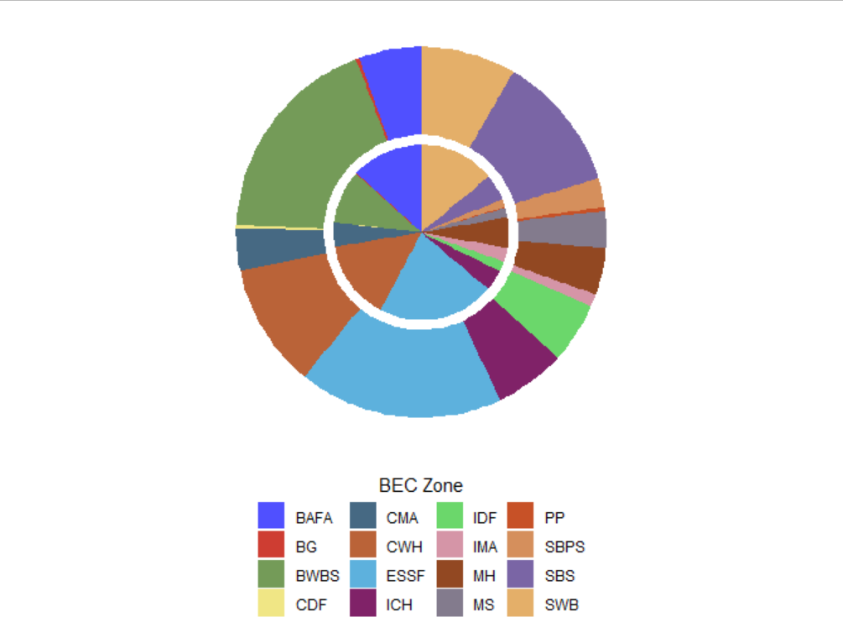

FIGURE 1: By bec zone, proportion of protected (inner circle) and unprotected (outer circle). (note to NCC there will be a label for this in the plot I just haven’t done it yet). I want to add a scatter plot of percentages as I think this will show it better.

Figure 1 shows the proportion of BEC zones within the province of British Columbia. Most BEC zones comprise similar proportions of the province. BAFA and SWB are both overrepresented in protected areas. BWBS and SBS are both underrepresented in protected areas.

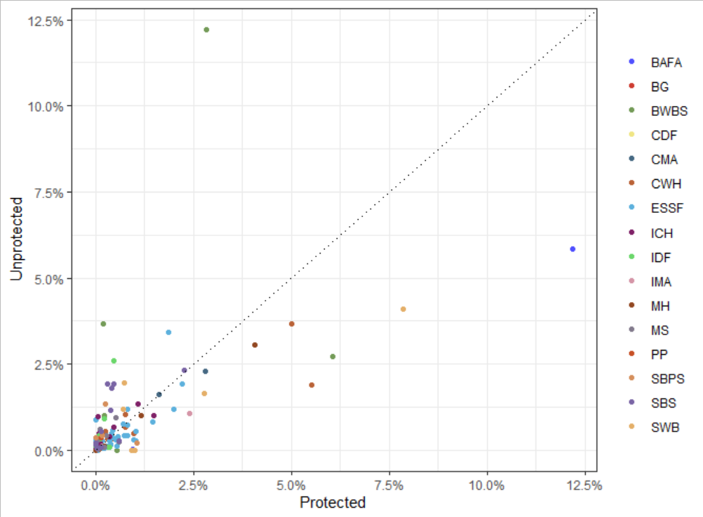

Figure 1: Proportion of protected and unprotected areas by BEC subzone in terrestrial British Columbia.

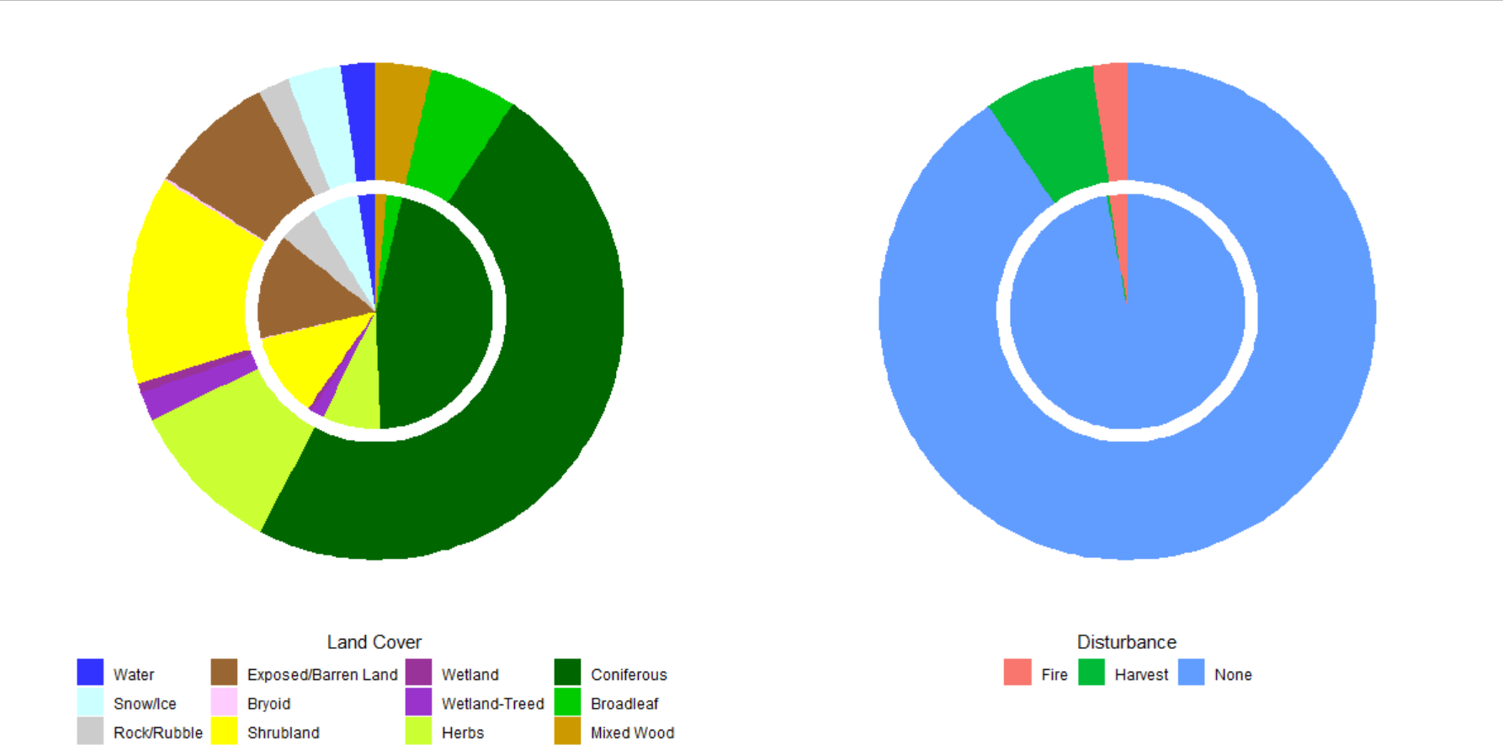

FIGURE 2: across province, pie charts of (A) lcc proportion, (B) disturbance

Figure 2 shows the proportion of land cover and disturbance across the province of British Columbia. Coniferous and herbs are more common in unprotected areas, while classes which often do not grow vegetation through sucession (water, snow/ice, rock/rubble, and exposed/barren land) are more common in protected areas. Fire disturbances are similarly common throughout the entire province, while harvesting disturbances are primarily found in the unprotected regions.

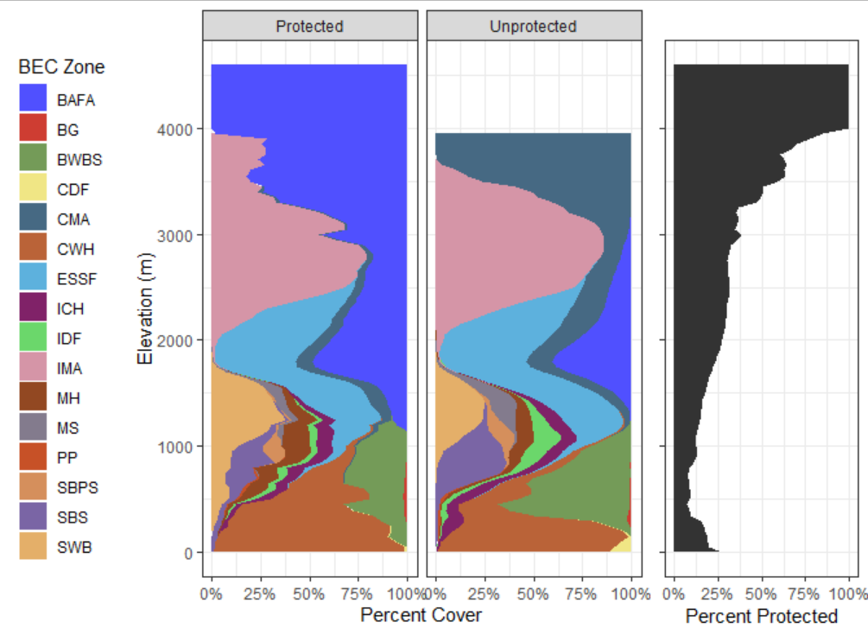

FIGURE 3: area of BEC based on elev

Figure 3 shows the area of each BEC zone in protected and unprotected areas as elevation increases, along with the percent of total terrestrial area protected at these elevations. As elevation increases, more of the land become protected until around 4000m, where 100% of the land becomes protected. BEC zone representation varies with protected status as well as elevation. In protected areas at high elevations, the BAFA zone dominates, whereas in unprotected areas, the majority of available land is CMA. Between 500-750m elevation, CWH is more prominent in protected areas, while BWBS takes this place in unprotected areas.

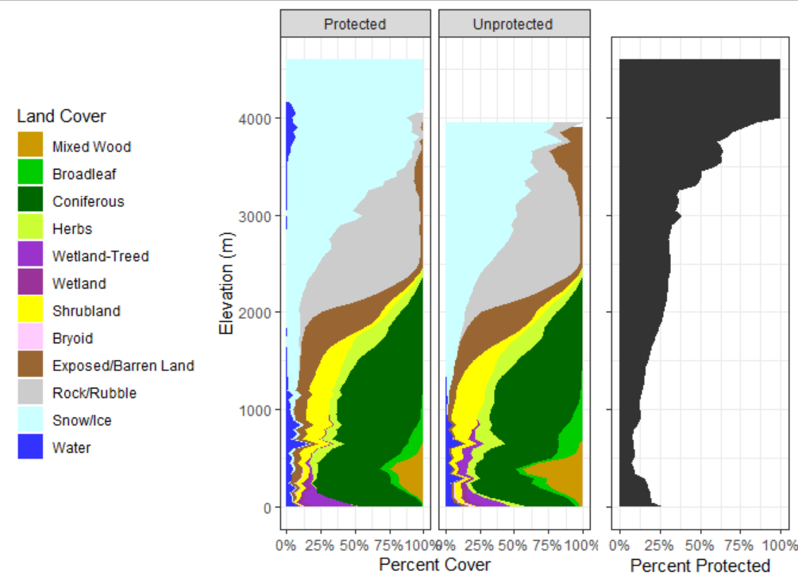

FIGURE 4: Land cover proportions across British Columbia by elevation.

Figure 4 shows land cover classes in the province of British Columbia as elevation changes. Generally, there are similar patterns in land cover classes across the elevation gradient. However, protected areas have more coniferous forest at low elevations, whereas unprotected areas have more mixed-wood forests. Wetland classes are found at similar elevations (up to 800m), however within protected areas wetlands are more dominant closer to sea level, and in unprotected areas wetlands are found at higher percentages until their max elevation. There is no high elevation (>2000m) water found in unprotected areas, it is all found within the protected regions of British Columbia.

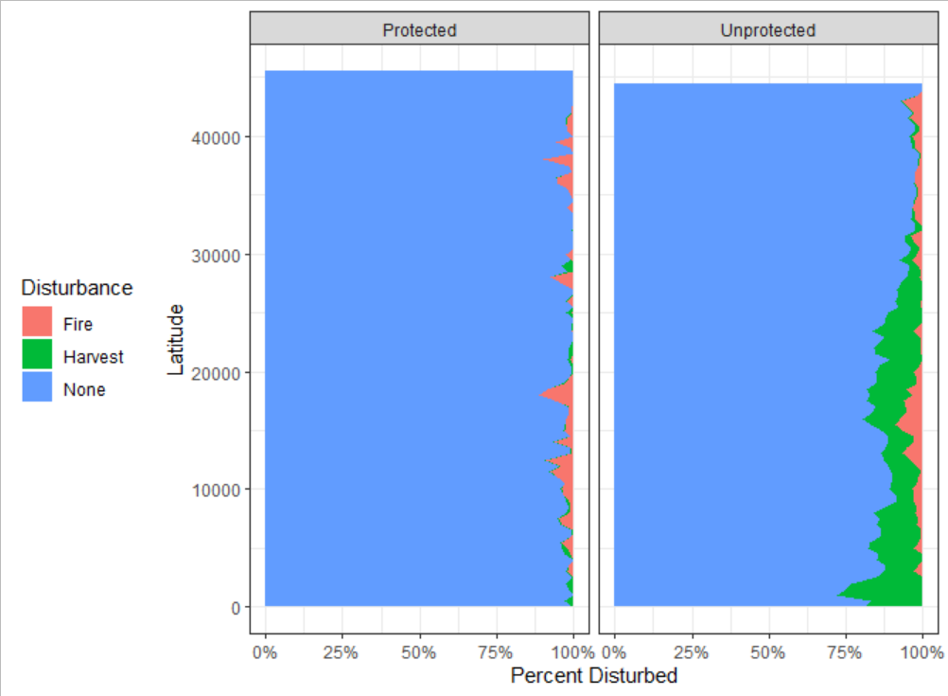

FIGURE 5: Disturbance proportions across British Columbia by latitude.

Figure 5 shows the percentage of area disturbed in protected and unprotected areas by latitude. Fire disturbances are found at similar rates across latitudes. Protected areas have much less harvesting than unprotected areas at all latitudes. Unprotected harvesting rates lower to those of protected areas above 30000 latitude.

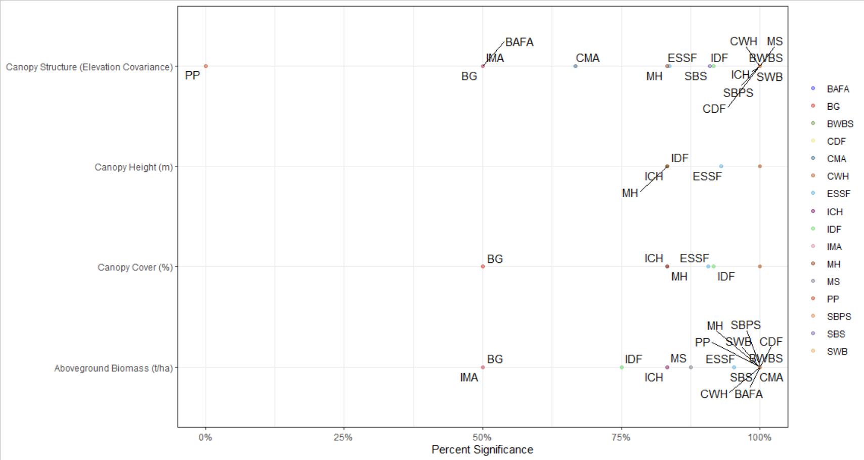

FIGURE 6: Proportion of significant two-tailed T-Tests comparing forest structural metrics for BEC subzones in protected and unprotected areas by BEC zone.

Known that bec area is generally well represented, but how does forest structure compare

Height, cover, biomass, elev_cv

What structures are missing?

Using 4 variables makes it VERY difficult to do the triple axis plot that would be very cool

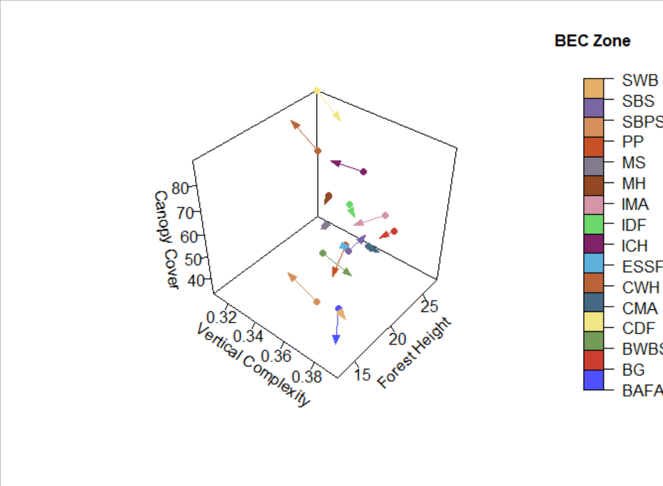

FIGURE 7: triple axis plot, 127 vectors in 3d space from protected mean to unprotected mean, coloured by bec zone

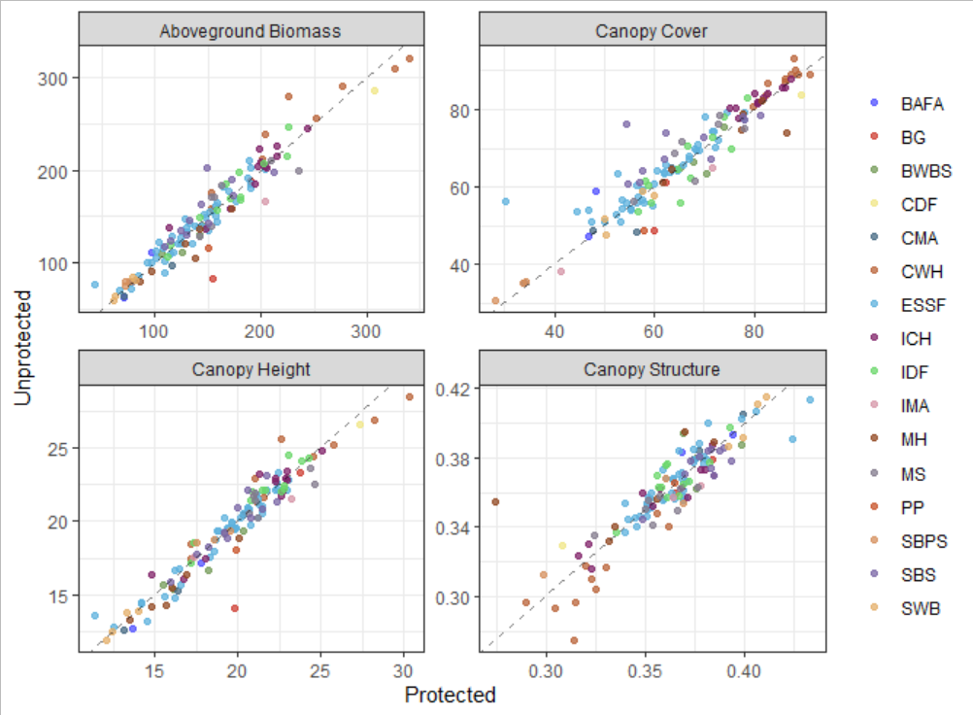

Figure 8: Scatterplots of forest structure metrics between protected and unprotected areas in British Columbia.

More figures: zoom in on 4 bec subzones, CDF, explore data associated with this, like boxplots of each variable and arrows for how things need to move

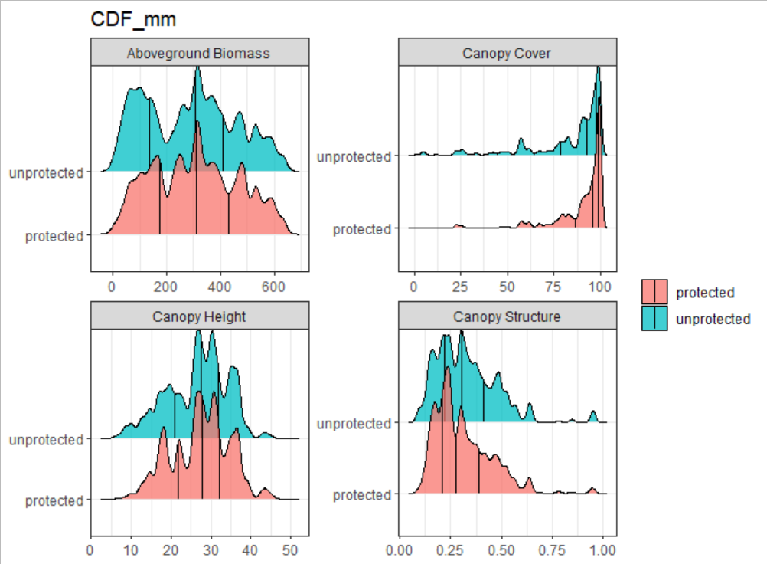

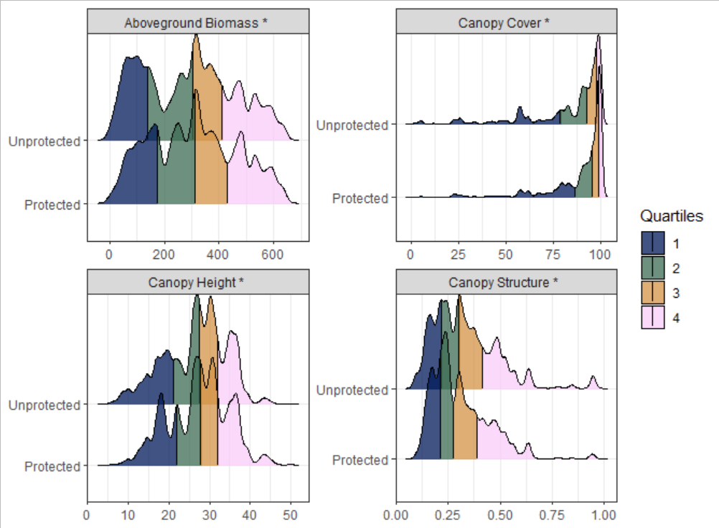

Figure 9: Density plots of forest structural attributes for protected and unprotected pixels in the Coastal Douglas Fir – Moist Maritime BEC subzone. * denotes p < 0.05 in a two-tailed t-test.

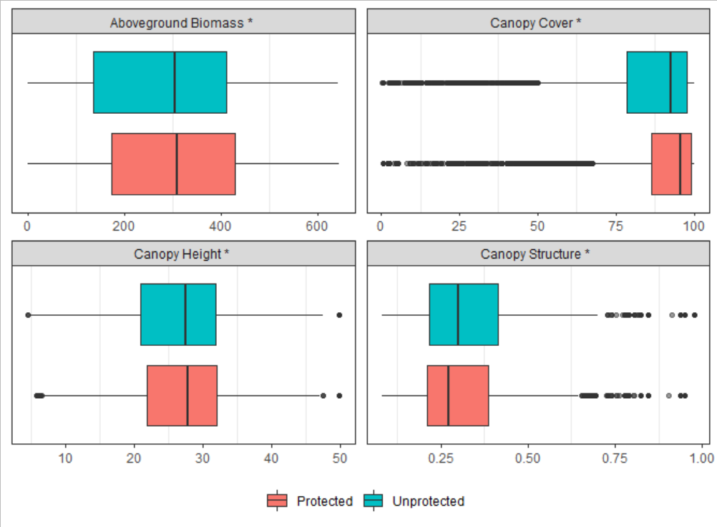

Figure 9 but boxplots.

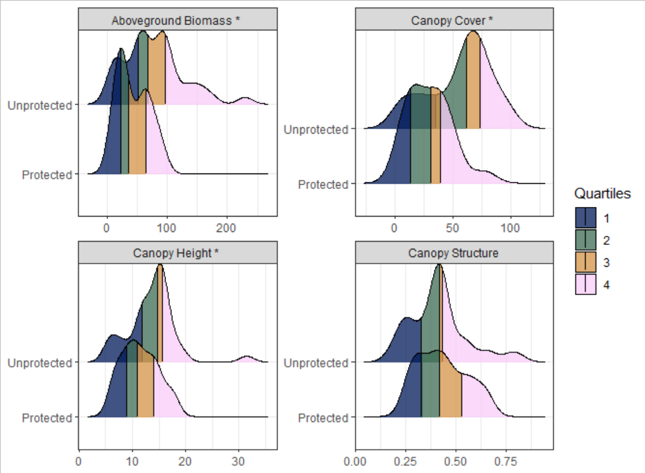

Figure 10 Density plots of forest structural attributes for protected and unprotected pixels in the Engelmann Spruce – Subalpine Fir Wet Very Cold Parkland BEC subzone. * denotes p < 0.05 in a two-tailed t-test.

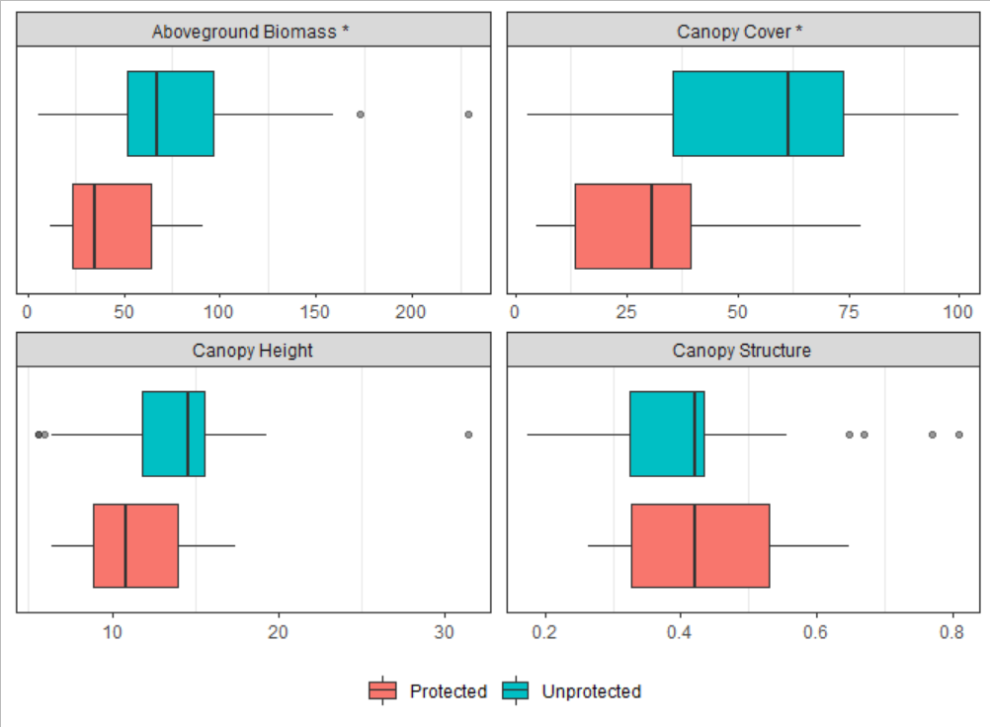

Figure 10 but boxplots.

Not sure what else to put in the vignette section. I’ve been trying to add significance bars but it is very difficult.