Assessing Representation of Remote Sensing Derived Forest Structure and Land Cover Across a Network of Protected Areas

Evan R. Muise1,✉, Nicholas C. Coops1, Txomin Hermosilla2, and Stephen S. Ban3

**Abstract:** Protected areas (PA) are an effective means of conserving biodiversity and protecting suites of valuable ecosystem services. Currently, many nations and international governments use proportional area protected as a critical metric for assessing progress towards biodiversity conservation. However, these metrics do not assess the effectiveness of protected area networks, nor do they assess how representative PA are at protecting the ecosystems they aim to protect. Within forest environments, topography, stand structure, and land cover are all key drivers of biodiversity, and are well suited as indicators to assess the representation of protected areas. Here we examine the British Columbian protected area network, through these drivers derived from freely available data and remote sensing products, across the provincial biogeoclimatic ecosystem classification (BEC) system. We examine biases in the protected area network by elevation, forest disturbances, and forest structural attributes, including height, cover, and biomass. Results indicate that parks are commonly biased towards high elevation and alpine land covers, and that forest structural attributes of the park network are often significantly different in protected vs an equal number of randomly selected unprotected pixels (426/496 of PA signficantly different; p < 0.01). Analysis of forest structural attributes suggests that additional PA are needed to ensure representation of various forest structure regimes across BC ecosystems. We conclude that these approaches using free and open remote sensing data are highly transferable, and can be accomplished using consistent datasets to assess PA representations globally.

**Keywords:** Protected Areas, Remote Sensing, Forest Structure, Disturbances, Land Cover, Ecological Classifications

**To be submitted to: Ecological Applications**

1 Department of Forest Resource Management, 2424 Main Mall, University of British Columbia, Vancouver, British Columbia, V6T 1Z4, Canada  
2 Canadian Forest Service (Pacific Forestry Centre), Natural Resources Canada, 506 West Burnside Road, Victoria, BC V8Z 1M5, Canada  
3 BC Parks, Ministry of Environment and Climate Change Strategy, Victoria, British Columbia, Canada.

✉ Correspondence: [Evan R. Muise <[evanmuis@student.ubc.ca](mailto:evanmuis@student.ubc.ca)>](mailto:evanmuis@student.ubc.ca)

# Introduction

Protected areas (hereafter PA) are an integral component of biological conservation, designed to preserve ecosystem services and biodiversity both inside the PA and in some cases the surrounding regions (Chape et al. 2005, Watson et al. 2014). In recent decades, there has been a growing consensus of the need to conserve varying portions of the terrestrial area of the globe, with areal goals increasing over time (CBD 2004, 2010). In the 2010’s, the Aichi biodiversity target sought to protect 17% of the entire globe (CBD 2010). Nationwide, the Canadian government has set the goal of protecting 25% of Canada’s terrestrial area by 2025 (ECCC 2021). While increasing proportional ecosystem protection does in turn increase conservation, it does not guarantee the representativeness of the entire ecosystem, nor that all biodiversity within the PA will be conserved.

Many conservation goals, both global and regional, are commonly based on the proportion of area protected due, in part, to its ease of use and calculation (Brooks et al. 2004, CBD 2010). However, while the area protected is a simple metric to report, other metrics can be more productive, with the potential to convey how effective a given PA is for protecting the inherent ecosystem services or biodiversity in the area (Chape et al. 2005, Butchart et al. 2015). Beyond areal extent, it is also relevant to consider the biases in PA placement, which are frequently located in cheaper, low productivity regions both globally (Joppa and Pfaff 2009, Venter et al. 2014, Venter et al. 2018) and regionally, as is the case in British Columbia (BC), Canada (Hamann et al. 2005, Environmental Reporting BC 2016, Wang et al. 2020). The area metric heavily underestimates the global protected area required to adequately protect biodiversity, which research indicates is up to 50% of each ecoregion (Dinerstein et al. 2017, Dinerstein et al. 2019).

In response, a number of other methodologies have been developed to evaluate the effectiveness of PAs before these larger global targets have been met (Parrish et al. 2003, Gaston et al. 2006, 2008, Hansen and Phillips 2018, Bolton et al. 2019). One recently identified concept in Canadian park management in particular is ecological integrity. Ecological integrity is defined as an ecosystem having the expected “living and non-living pieces for the region,” and that ecological processes should occur in the PA at the expected frequency and intensity for the region (Parks Canada 2019). Many potential ecological integrity indicators have been examined to capture biodiversity related processes within PA (Hansen and Phillips 2018). These indicators can then be interpreted manually or automatically, most often through examining temporal trends within the PA or by comparing the indicators to areas in known healthy reference ecosystems (Woodley 1993).

Frequently, comparisons between PA and unprotected areas (UA) have been drawn in order to assess PA performance and health (Defries et al. 2005). This allows for the PA or PA network to be taken in context of surrounding and/or similar ecosystems (Wiens et al. 2009). However, collecting field data across the large, often remote, regions covered by PA is time-and-cost prohibitive. The increasing prevalence of freely available imagery has led to satellite remote sensing becoming an essential tool for PA monitoring (Nagendra et al. 2013).

The opening of the Landsat archive in 2008 (Wulder et al. 2012a) has played a significant role in the use of satellite imagery in conservation monitoring (Nagendra 2008, Turner et al. 2015). The availability of the archive since 1972 allows for assessment of temporal trends in satellite derived indicators (Nagendra et al. 2013, Hansen and Phillips 2018, Bolton et al. 2019), while the global coverage allows for comparisons between similar and differing ecosystems (Nagendra 2008, Wulder et al. 2012a). Leveraging free and open-source optical remote sensing data products has allowed users to increasingly undertake comparisons across an entire jurisdiction’s PA network (Fraser et al. 2009, Soverel et al. 2010, Pôças et al. 2011, Bolton et al. 2019, Skidmore et al. 2021), comparing them to ecologically similar UAs (Turner et al. 2015, Buchanan et al. 2018). These comparisons allow for an assessment of the effectiveness of a given PA or the entire PA network at representing regional biodiversity trends (Soverel et al. 2010, Turner et al. 2015, Bolton et al. 2019).

Optical remote sensing technologies have offered a key approach to deriving indicators (Parmenter et al. 2003, Olthof et al. 2006, Nagendra 2008, Fraser et al. 2009, Soverel et al. 2010, Burkhard et al. 2012, Pereira et al. 2013, Bolton et al. 2019) and detecting key terrestrial processes (Turner et al. 2003) to assess PA effectiveness at conserving ecological integrity (Nagendra 2001, Nagendra et al. 2013). These indicators derived from remote sensing technologies can be categorized and monitored at broad spatial extents and across temporal scales. Commonly used indicators include land cover proportion (e.g. forest type, wetland, and unvegetated), tree species (Nagendra 2001), habitat classification (McDermid et al. 2005, Lucas et al. 2011), spectral information (Feeley et al. 2005, Gillespie 2005, Nagendra et al. 2010), spectral heterogeneity (Rocchini et al. 2010), and ecosystem structure (Cohen and Goward 2004, Goetz et al. 2007, Soverel et al. 2010, Pôças et al. 2011) and function (Skidmore et al. 2021). Moreover, remote sensing technologies enable the monitoring of terrestrial processes, such as natural and anthropogenic disturbance regimes (Kerr and Ostrovsky 2003, Alsdorf et al. 2007, Hermosilla et al. 2015b, Bolton et al. 2019), alongside biogeochemical cycles (Myneni et al. 2001), vegetation productivity (Running et al. 2004), and vegetation dynamics (Zhang et al. 2003). Diversity in forest structural attribute measurements, often derived from light detection and ranging (LiDAR) is also a strong indicator of biodiversity, providing habitat, influencing food quality, and mediating microclimates (Gao et al. 2014, Guo et al. 2017).

LiDAR enables the accurate characterization of treed vegetation structure (e.g. canopy height, canopy cover, basal area) across forested areas by measuring the time it takes for an emitted pulse of light to return to the sensor (Lim et al. 2003). While the natural variation in vertical and horizontal forest structure has been extensively explored using LiDAR, comparisons between PA and UA have been less frequently drawn using these methods when compared to optical remote sensing (Nagendra et al. 2013). The lack of previous comparisons has likely been due to the frequently limited extents of LiDAR acquisitions, a problem which has recently been solved by generating wall-to-wall metrics. These wall-to-wall metrics can be created combining LiDAR data with satellite optical remote sensing, generating forest structural attributes across large regions and even entire countries (Wulder et al. 2012b, Matasci et al. 2018a).

As Canada progresses towards the national goal of 25% of terrestrial area protected by 2025, there is a growing need to better understand how PA compare to UA with respect to location, ecological classifications, elevations, productivity, and forest structure. In this study, we (1) examine using free and open remote sensing data products existing hypothesis that the BC PA network is biased towards high-elevation, low-productivity regions of the province, and (2) identify missing forest structures in PA in the province. To accomplish this, we examined the bias in PA placement by comparing ecoregional PA coverage and land cover classes by elevation, and disturbances by latitude across protected and UA in BC. We examine representative forest structural attributes by comparing the distribution of key indicators by ecological zone to determine the differences between PA and UA to inform upon the most and least similar represented forest structures throughout the network. We conclude by highlighting the usefulness of these globally available, high quality, consistent, and transferable datasets and methods for assessing PA effectiveness.

# Methods

## Study Area

The province of British Columbia, Canada covers 94.4 million ha, of which approximately 64% is forested (BC Ministry of Forests, 2003), and encapsulates a wide variety of biomes and ecosystems. This diversity of ecosystems is due to the its large size as well as variations in topography and climate. The existing Biogeoclimatic Ecosystem Classification (BEC) system disaggregates BC ecosystems into zones (Pojar et al. 1987). The broadest classification delineates 16 zones, which are further broken down into subzones, variants, and phases based on microclimate, precipitation, and topography (Pojar et al. 1987, Meidinger and Pojar 1991). As a result BEC zones vary widely in size (ranging from .25 million ha to 17.5 million ha), and in the number of subzones (from 1 to 43; see Table 1).

Table 1: Number of subzones, total area, and percent protected by BEC Zone

| Zone | Zone Name | # of Subzones | Area (ha) | # Protected |
| --- | --- | --- | --- | --- |
| BAFA | Boreal Altai Fescue Alpine | 2 | 6,286,778 | 30.1% |
| BG | Bunchgrass | 2 | 257,072 | 11.8% |
| BWBS | Boreal White and Black Spruce | 5 | 16,404,142 | 8.6% |
| CDF | Coastal Douglas-fir | 1 | 251,232 | 4.8% |
| CMA | Coastal Mountain-heather Alpine | 3 | 3,574,039 | 17.9% |
| CWH | Coastal Western Hemlock | 10 | 10,795,067 | 19.5% |
| ESSF | Engelmann Spruce -- Subalpine Fir | 43 | 17,465,113 | 17.8% |
| ICH | Interior Cedar -- Hemlock | 12 | 5,538,842 | 10.2% |
| IDF | Interior Douglas-fir | 12 | 4,488,085 | 5.9% |
| IMA | Interior Mountain-heather Alpine | 2 | 1,257,949 | 29.2% |
| MH | Mountain Hemlock | 6 | 4,059,301 | 19.8% |
| MS | Montane Spruce | 8 | 2,863,394 | 9.4% |
| PP | Ponderosa Pine | 1 | 294,985 | 7.1% |
| SBPS | Sub-Boreal Pine -- Spruce | 4 | 2,265,365 | 9.5% |
| SBS | Sub-Boreal Spruce | 11 | 10,337,497 | 6.7% |
| SWB | Spruce -- Willow -- Birch | 6 | 8,655,855 | 23.3% |

Both the BC (BC Parks 2012), and Canada-wide (Government of Canada, 2019) PA mandates commit to conserving ecological integrity across the network. The PA network in BC is designed to serve both ecological conservation and human recreation aims (BC Parks 2012), and consists of a network of PA and PA complexes (multiple nearby PA which share the same conservation goals), with large variations in size, ranging from 0.02 to 987,899 ha (Figure 1). Protected areas in the BC network are frequently located in mountainous, high elevation areas, leading to underrepresentation in high productivity ecosystems (Environmental Reporting BC 2016, Wang et al. 2020).

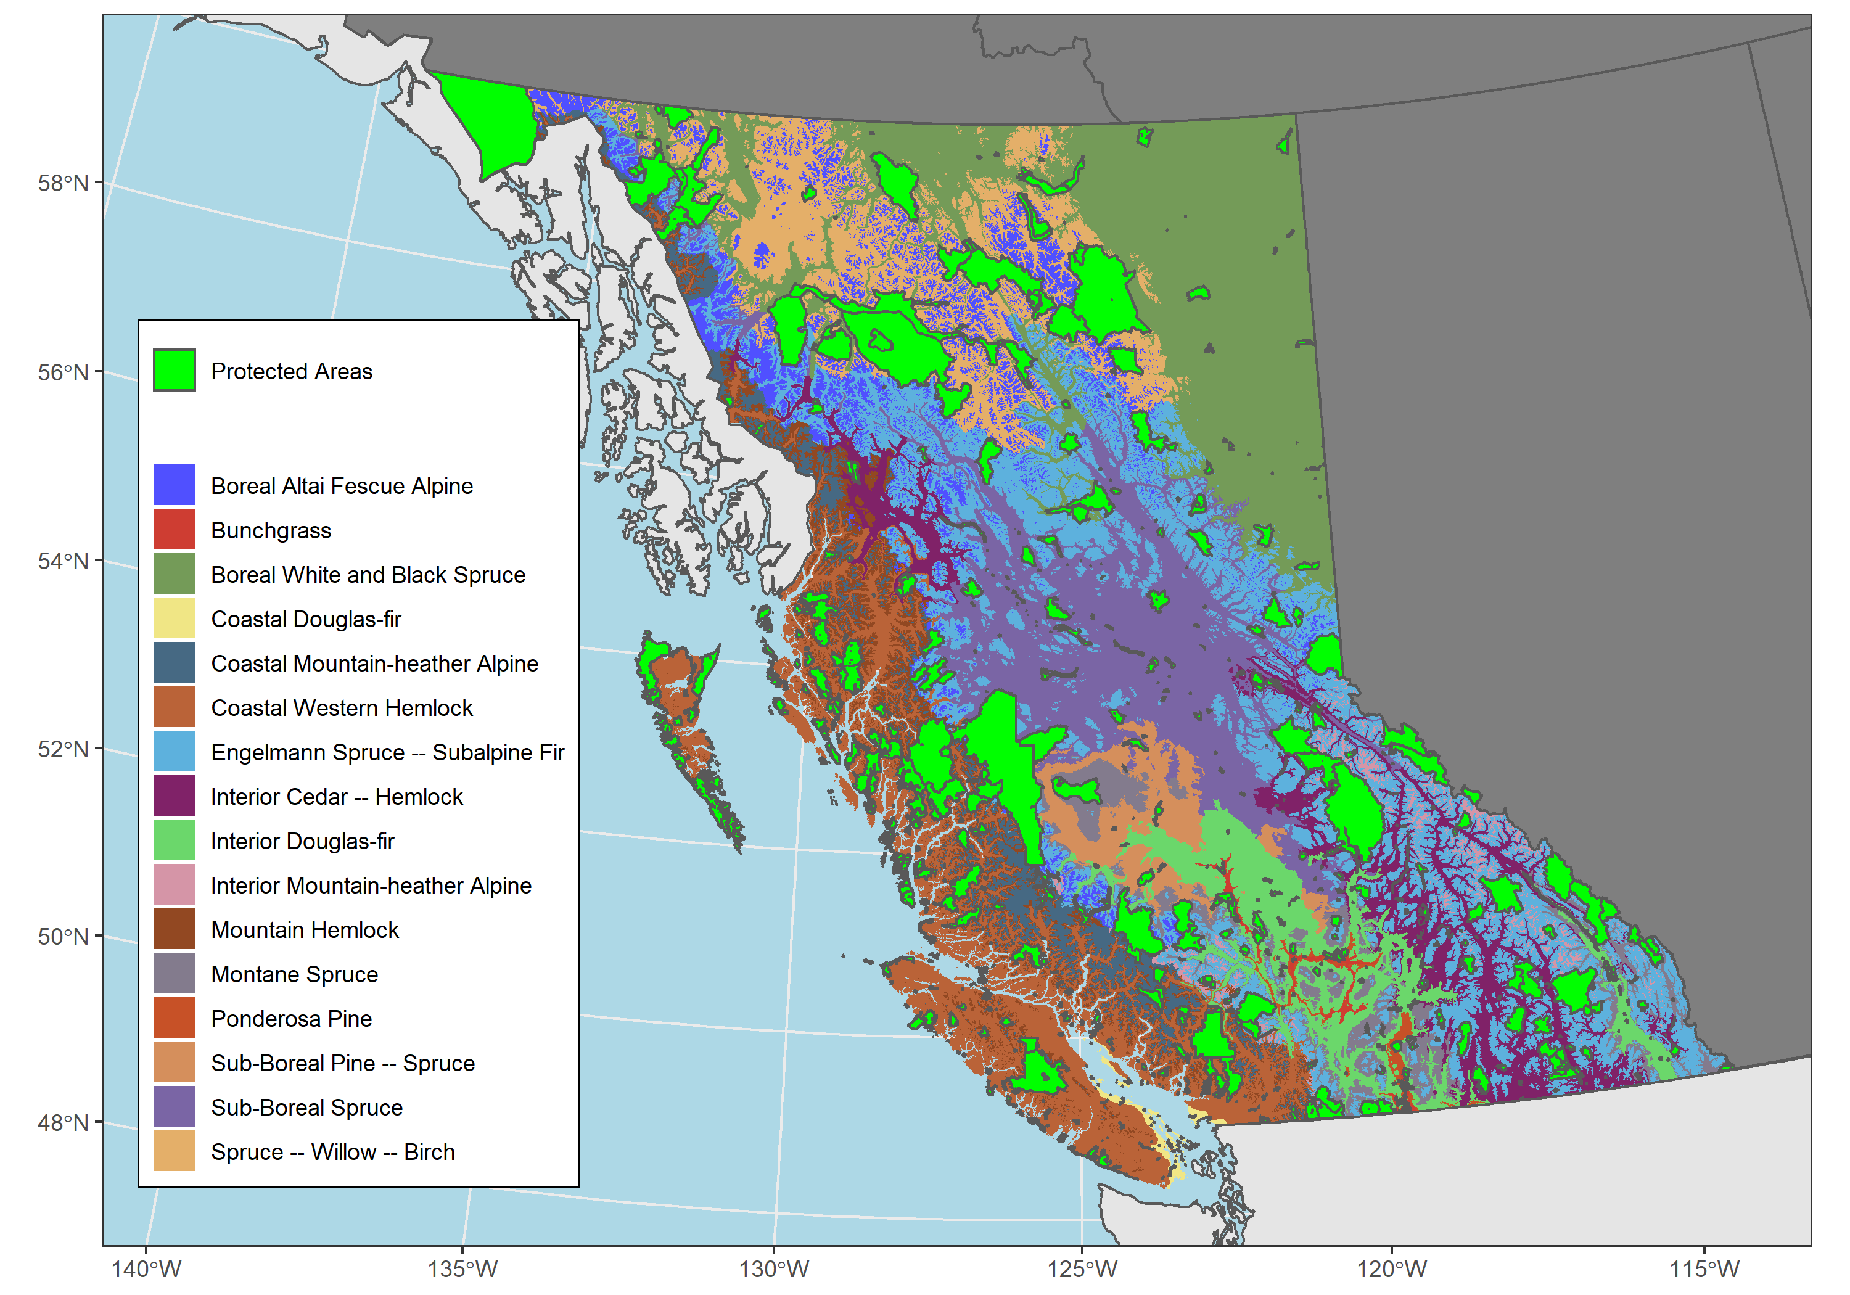

Figure 1: Terrestrial British Columbia including BEC zones and the location of PA selected in this study.

## Data

### Biogeoclimatic Ecosystem Classification and Protected Areas

Boundaries for BEC zones and subzones were acquired using the **bcmaps** R package (Teucher et al. 2021). Two BEC subzones were entirely subsumed by PA (Boreal White and Black Spruce - Very Wet Cool and Spruce – Willow – Birch - Very Wet Cool Shrub), whereas the Sub-Boreal Pine – Spruce - Moist Cool subzone has no PA representation.

Boundaries for all PA in BC were obtained from the Canadian Protected and Conserved Areas Database (available from <https://cws-scf.ca/CPCAD-BDCAPC_Dec2020.gdb.zip>), current as of December 2020, and includes the IUCN classification for each PA. Protected areas were selected for analysis following the criteria outlined in Bolton et al. (2019). Only parks which belonged to International Union for Conservation of Nature (IUCN) classes Ia, Ib, II, and IV were selected, as these categories are considered strictly protected. Protected areas < 100ha in size were also excluded from the analysis, as these mainly occurred in urbanized areas. After selection, 745 suitable parks managed under various jurisdictions (provincial, federal, NGOs) which comprise 15.4% of the total terrestrial area of British Columbia were studied (Environmental Reporting BC 2016).

### Digital Elevation Model

The Advanced Spaceborne Thermal Emission and Reflection Radiometer (ASTER) digital elevation model (GDEM V2, 30m) was used to examine biases in protected area land cover and ecological classification by elevation (Tachikawa et al. 2011).

### Landsat derived datasets

Land cover, forest disturbances, and forest structural attributes for BC were derived from the Landsat best-available-pixel (BAP) composites at 30m spatial resolution generated using the Composite2Change (C2C) approach (Hermosilla et al. 2016). These composites are generated by annually selecting the optimal observations, free from atmospheric effects (haze, clouds, cloud shadows), for each pixel from the catalog of available Landsat-5 Thematic Mapper (TM), Landsat-7 Enhanced Thematic Mapper Plus (ETM+), and Landsat-8 Operational Land Imager (OLI) imagery acquired during Canada’s growing season using the scoring functions defined in White et al. (2014). The annual BAP composites are further refined by applying a spectral trend analysis over the Normalized Burn Ratio (NBR) at pixel level in order to remove unscreened noise, detect changes and provide data gaps with temporally-interpolated values, resulting in annual, gap-free, surface-reflectance image composites from 1984 to 2019 (Hermosilla et al. 2015b). During this process forest disturbances are detected, characterized and attributed to a disturbance agent (i.e., wildfire, harvest, non-stand replacing disturbances) using a Random Forests classification model via the object-based analysis approach (Hermosilla et al. 2015a) with an overall accuracy of 92% ±2% (Hermosilla et al. 2016).

Annual land cover information for Canada from 1984-2019 was produced using the BAP composites following the Virtual Land Cover Engine framework (Hermosilla et al. 2018). This framework integrates post-classification probabilities, forest disturbance information and forest successional knowledge with a Hidden Markov Model to ensure logical land cover transitions between years. The classification comprises 12 land cover classes organized in non-vegetated and vegetated. Non-vegetated classes included water, snow/ice, rock/rubble, and exposed/barren land. Vegetated land cover classes discriminated among non-treed and treed vegetation (land-cover level). Vegetated non-treed classes comprised bryoids, herbs, wetland, and shrubs. Vegetated treed land cover classes included wetland-treed, coniferous, broadleaf, and mixedwood. Independent validation of the land cover maps indicated an overall accuracy of 70.3% ± 2.5%.

Wall-to-wall, 30-m forest structure metrics (i.e., lorey’s height, total aboveground biomass, elevation covariance, and canopy cover) were also annually derived from the BAP composites using the imputation method described in Matasci et al. (2018b, 2018a). This method uses LiDAR and field plot data to estimate forest structure metrics from topographic and Landsat spectral predictors, using a k-Nearest Neighbor approach.

## Analysis

We first examined ecozonal and land cover proportions within and outside the PA network, as a function of elevation and secondly compiled disturbance rates on a latitudinal gradient across the province. Lastly, forest structural attributes were examined at a finer ecosystem classification level, statistically comparing PA vs UA, and forest structural means by ecosystem subzones examined to determine which forest structures are poorly represented in the current BC PA network.

Forest cover classes (deciduous, broadleaf, mixed-wood, and wetland-treed) were used to generate land cover masks to restrict comparison of forest structural attributes to forested pixels. Pixels with harvest activity disturbances detected post-1985 were removed from forest structural attribute rasters in both PA and UA, in order to restrict analysis to non-anthropogenically disturbed areas.

BEC zones and land cover classifications were aggregated to both PA and UA in order to determine the proportion of each zone under the protected classifications. In this analysis, zones are used to examine categorical data (land cover and disturbance), while forest structure is compared at the subzone level between PA and their unprotected counterparts in British Columbia. Subzones with only PA or UA were excluded from hypothesis testing, but were included in zonal aggregations. Land cover and BEC zones were further examined along an elevation gradient, at 50m increments. Forest disturbances (including harvesting) were aggregated along a latitudinal gradient at 0.5°. The mean values for PA and UA forest structural attributes were calculated, in order to examine the differences in their distribution and determine which structures and zones differ between PA and UA. Values were also converted into z-scores to determine the greatest standardized vector magnitude when comparing canopy cover, elevation covariance, and forest height between PA and UA.

An equal sample of cells (equal to the total number of pixels in PA or UA, whichever was lower) was sampled from both PA and UA for each BEC subzone. For each forest structure variable and BEC subzone pair, a two-tailed t-Test was conducted, comparing protected and unprotected samples, and the Bonferroni correction was applied.

# Results

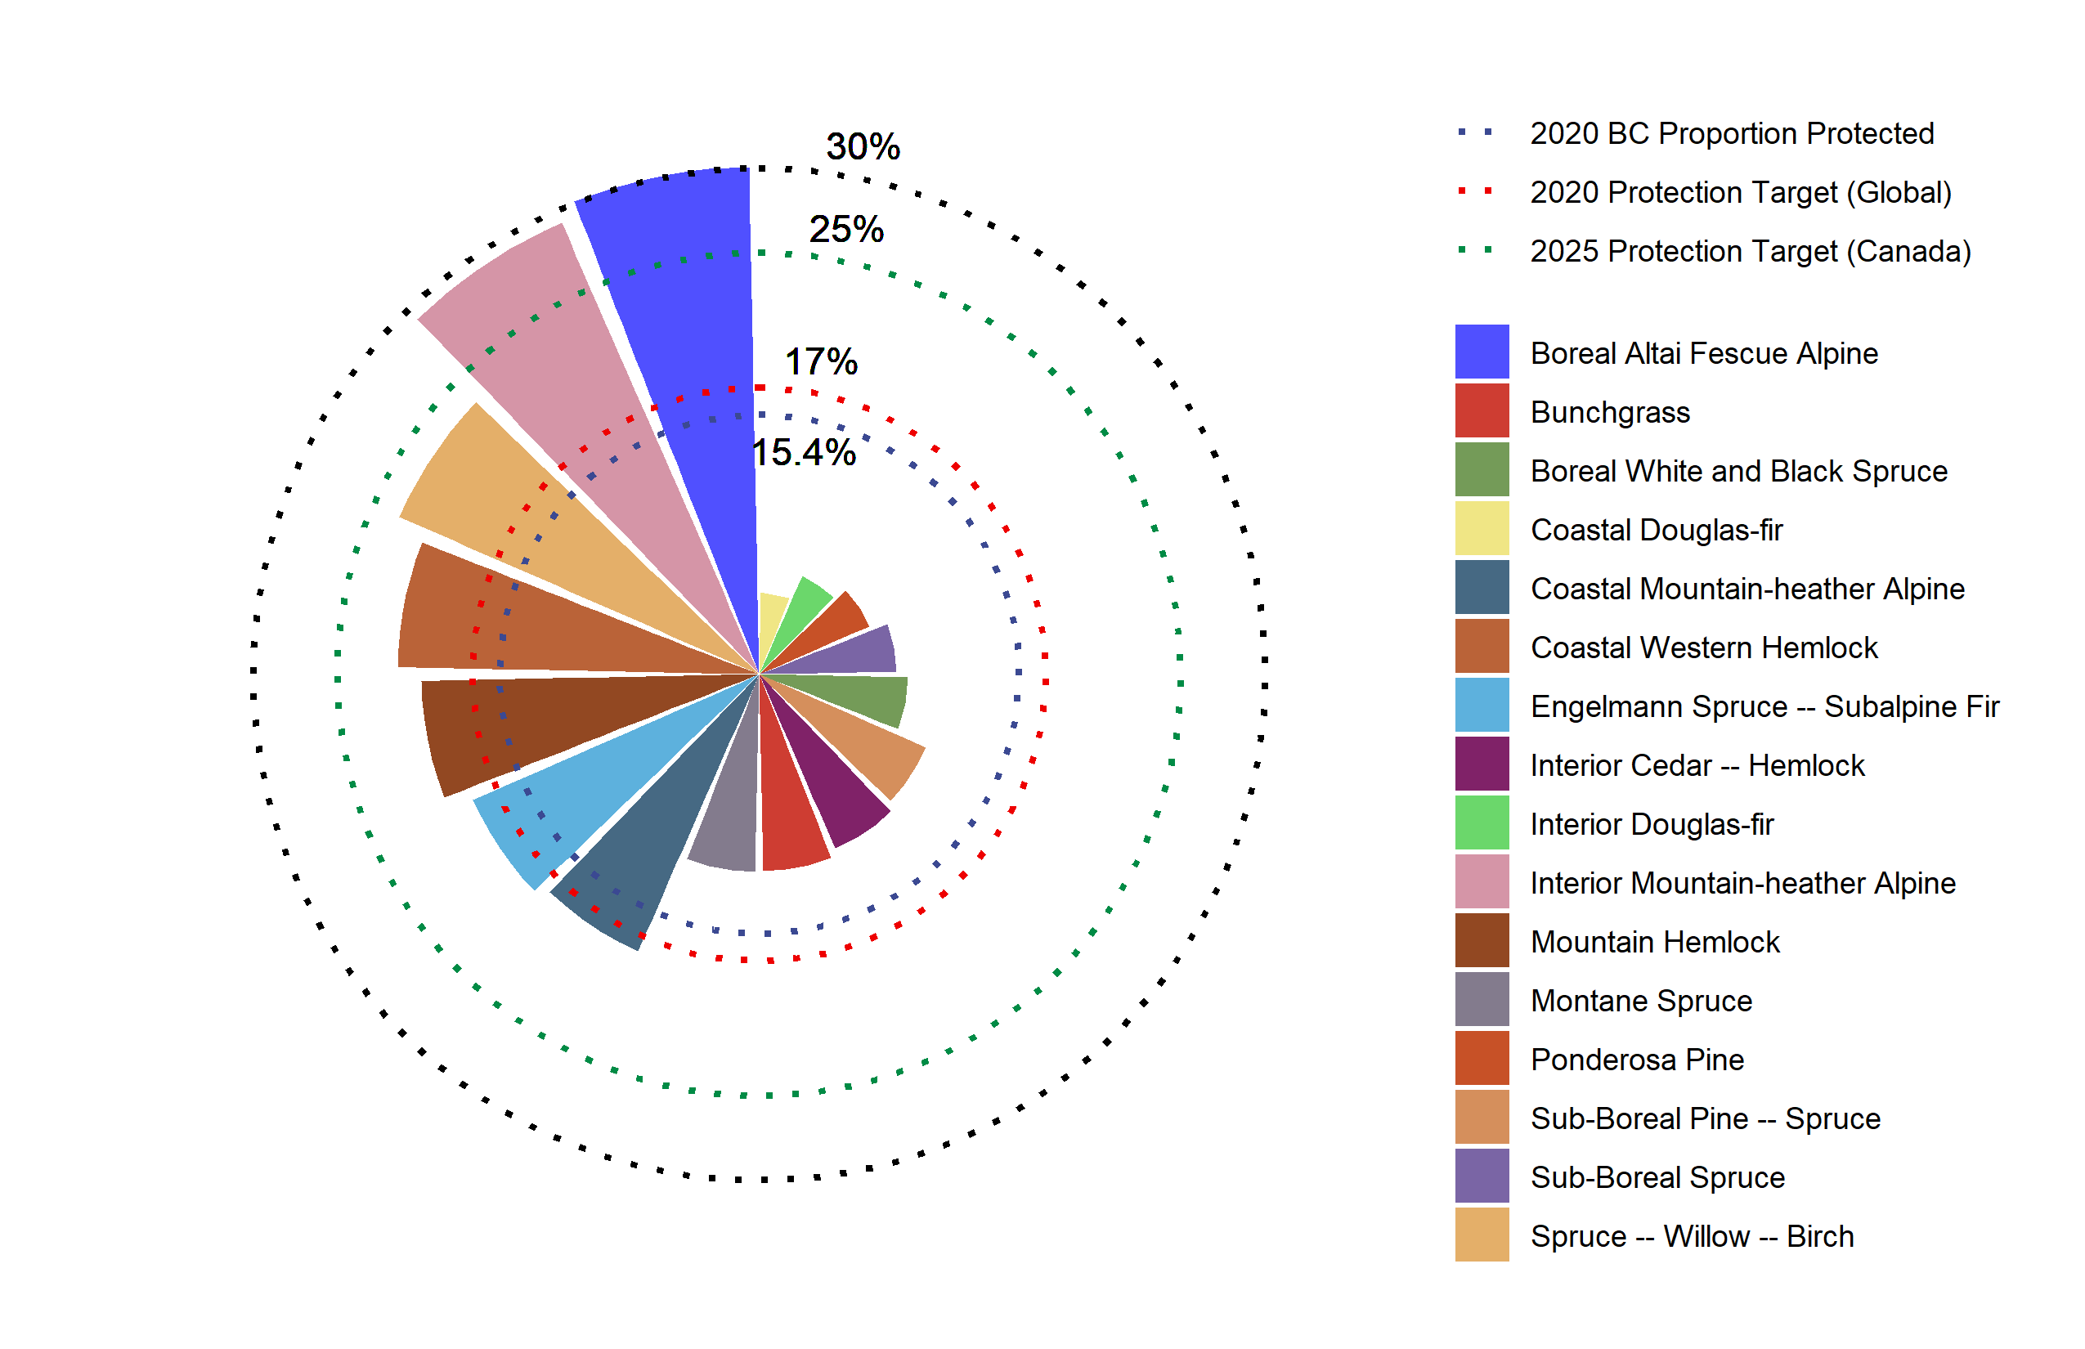

Figure 2: Areal proportion of protected BEC zones. Red dotted line indicates 2020 global protected area coverage goal, Blue dotted line indicates 2025 Canadian protected area coverage goal, and the green dotted line indicates the overall proportion of protected areas in British Columbia.

British Columbia’s ecosystems are protected at varying rates across the province (Figure 2). Of the 16 ecosystems present in BC, seven are protected at rates above the Aichi biodiversity target (10%). Only two zones (Boreal Altai Fescue Alpine and Interior Mountain-heather Alpine) are currently protected at rates above the Canadian 2025 protection targets (25%). Zones with Douglas-fir (*Pseudotsuga menziesii*) as a primary component (Coastal Douglas-fir and Interior Douglas-fir) are the least proportionally represented zones in British Columbia, with 4.9% and 6.4% protected, respectively (Figure 2).

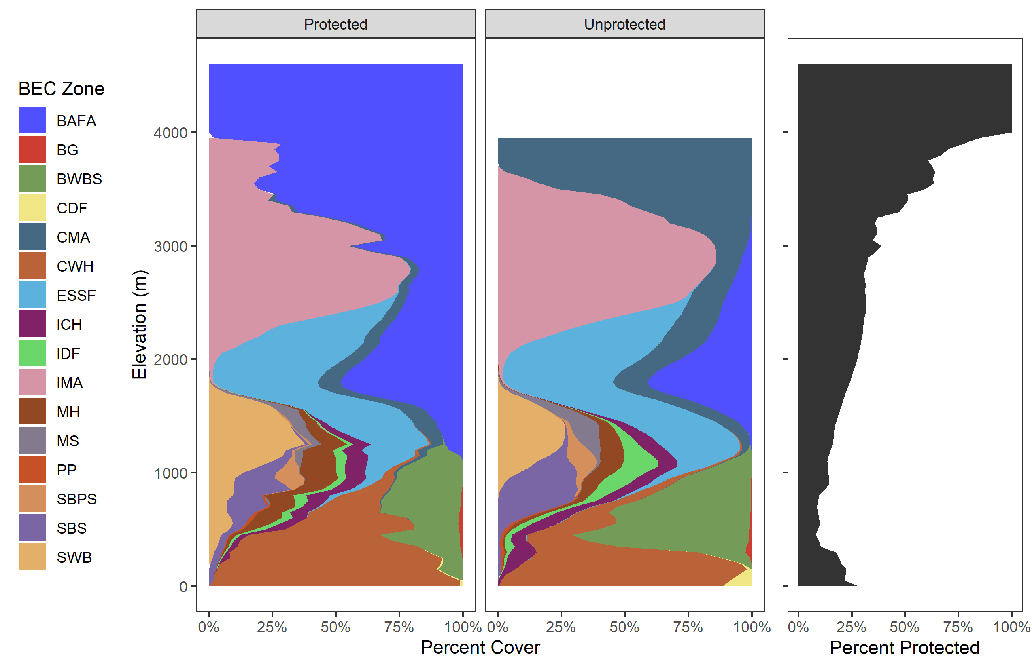

Figure 3: Proportion of BEC zone by elevation for both protected areas (left), and unprotected areas (centre). The rightmost figure represents the proportion of terrestrial area that is protected at each elevation.

As elevation increases in BC, increasing terrestrial area is protected within the PA network until ~4000m, upon which all terrestrial area is protected (Figure 3). When comparing between PA and UA, zones are protected at differing proportions. Zones commonly found at high elevations, such as the Boreal Altai Fesuce Alpine, are predominantly located in protected areas. Conversely, a greater proportion of the Coastal Western-hemlock ecosystem is protected at low elevations, while Boreal White and Black Spruce shows the opposite; with increasing area unprotected. Generally, the remaining ecosystems are found at similar rates in both PA and UA (Figure 3).

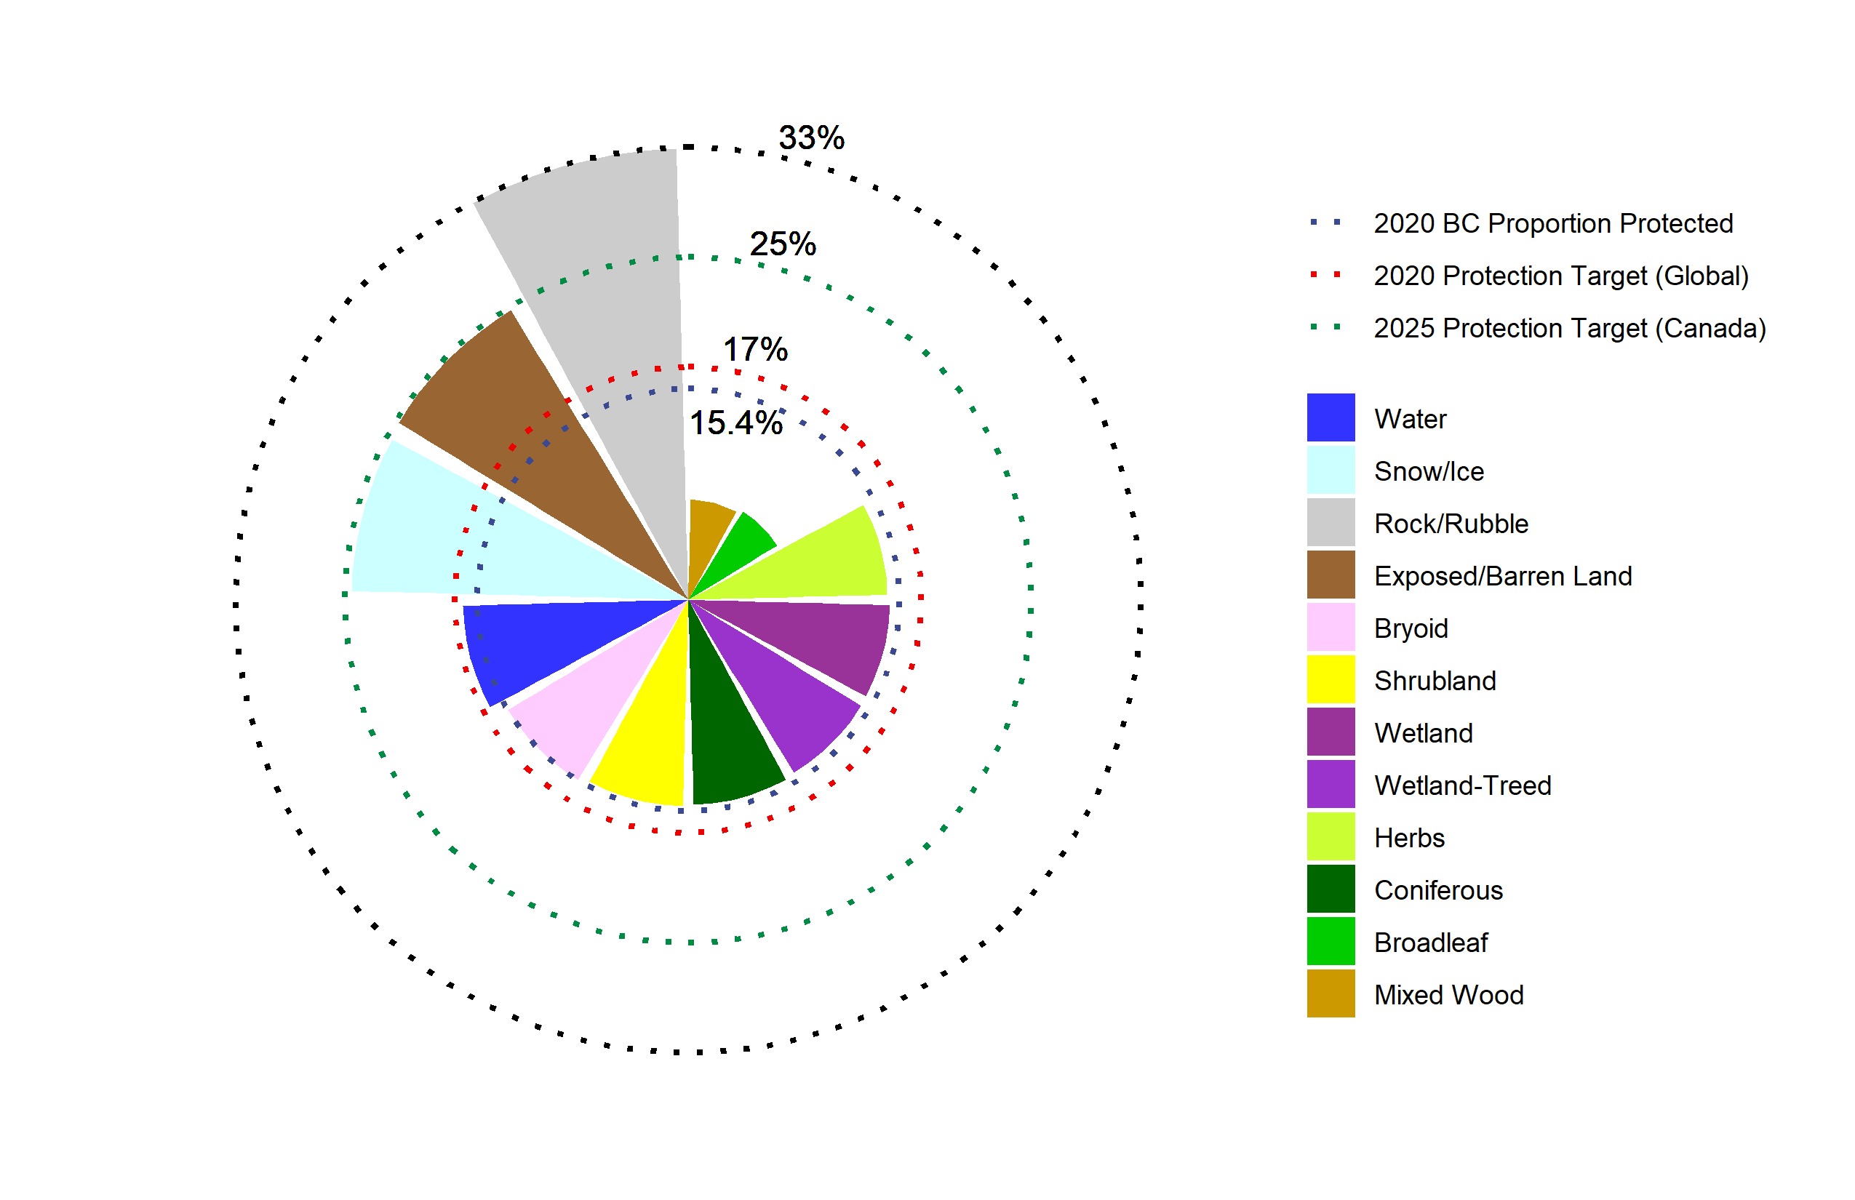

Figure 4: Diagram of proportion of the area of each land cover class protected. Red dotted line indicates 2020 global protected area coverage goal, Blue dotted line indicates 2010 ecoregional protected area coverage goal, and the green dotted line indicates the overall proportion of protected areas in British Columbia.

Protected land cover also varies by proportion (Figure 4). Non-vegetated classes of snow/ice, exposed/barren land, and rock/rubble have higher than average proportions protected while mixedwood and broadleaf land cover classes are underrepresented . All other classes are found at rates similar to the overall proportion of the province protected (Figure 4).

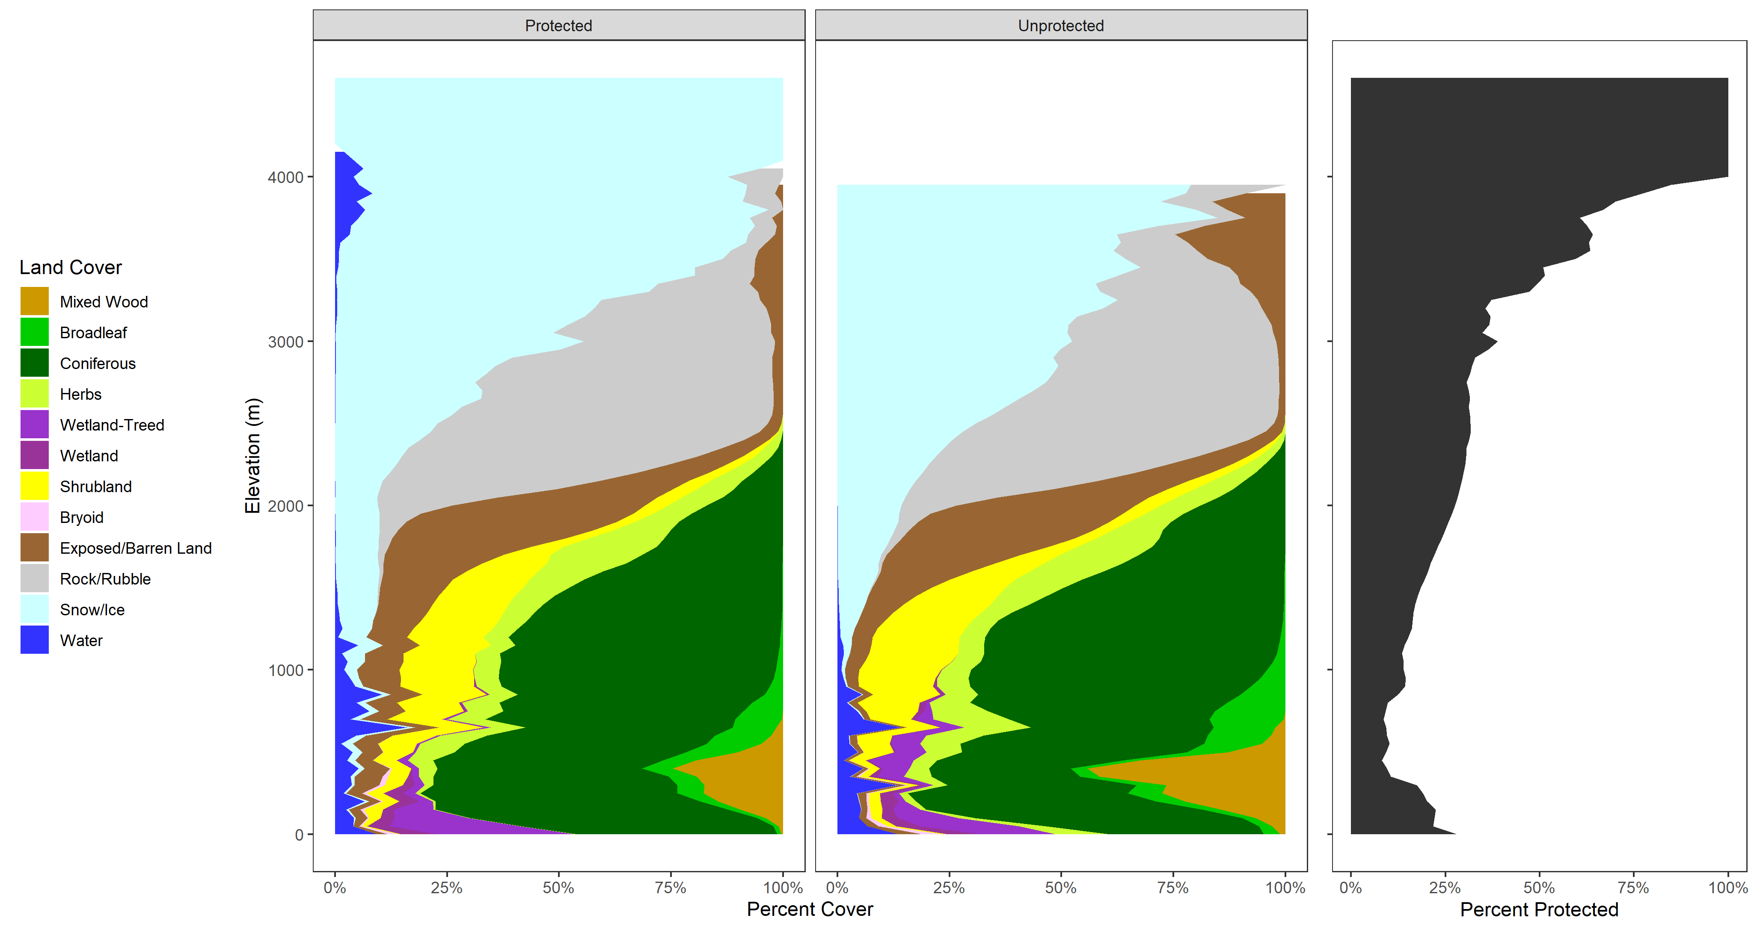

Figure 5: Proportion of each land cover class by elevation for both protected areas (left), and unprotected areas (centre). The rightmost figure represents the proportion of terrestrial area that is protected at each elevation.

Similar to BEC zones (Figure 3, land cover also varies with elevation (Figure 5. Expectedly, snow and ice make up a large proportion of PA at high elevations. At low elevations in UA, mixedwood forest is a more common forest type than in PA, while wetland classes (wetland, wetland-treed) are less frequent in the 400-900m elevation range in UA compared to PA.

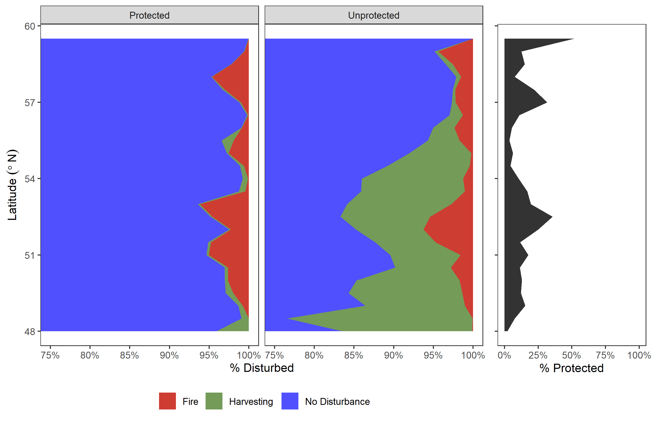

Figure 6: Proportion of area disturbed by latitude from 1984 to 2019 in protected areas (left), and unprotected areas (centre). The rightmost figure represents the proportion of terrestrial area that is protected at each latitude.

Overall, the burned area of forested cells is similar between protected areas (2.5% overall) and UA (2.3% overall), while harvesting is expectedly much higher in UA (7.2% overall) than in protected areas (0.33% overall), as anticipated by the IUCN designations. Harvesting is more common at lower latitudes in UA than at higher latitudes. Fire shows similar, but not identical patterns across varying latitudes, with higher wildfire proportions at high latitudes and between 51-53°N (Figure 6).

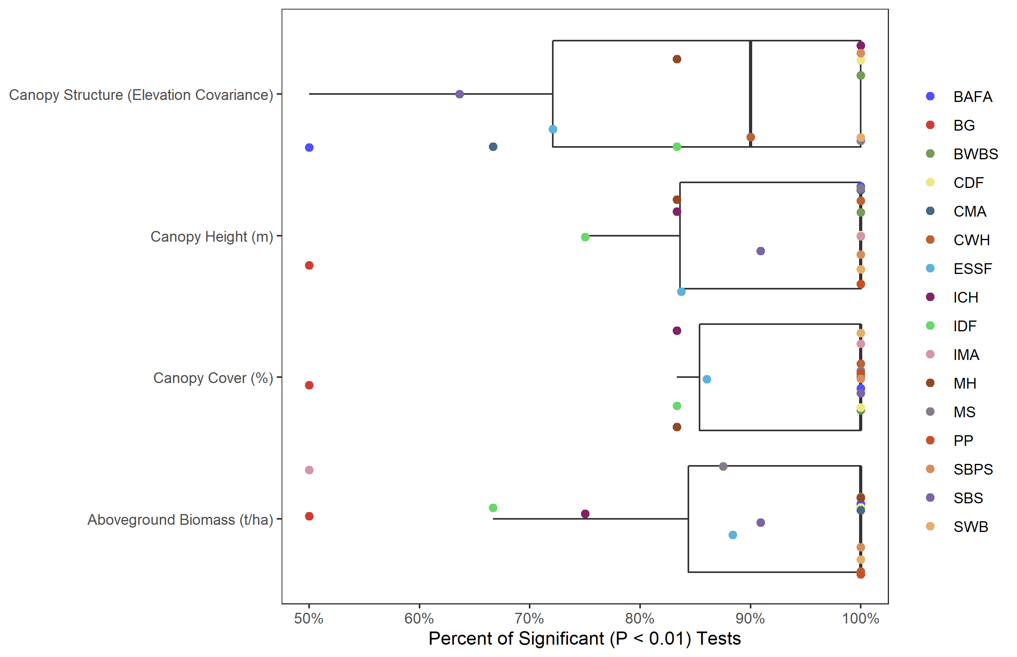

Figure 7: Boxplot of proportion of ecosystem subzone which have significant p-values from a two-tailed t-test with the Bonferroni correction (n = 496) applied at a significance level of 0.05.

Figure 7 shows the subzonal proportional significance (*p < 0.01*) grouped by ecosystem for the 496 comparisons of forest structural variables. Higher percentages confirm ecosystems which had increased number of dissimilar subzones for the specific indicator, and shows that at least half of all subzones in each ecosystem are significantly different (exception being Ponderosa Pine, which has one subzone that is not significantly different in canopy structure). Median proportional significance values for canopy height, canopy cover, and aboveground biomass are universally significantly different between PA and UA within the same ecosystem.

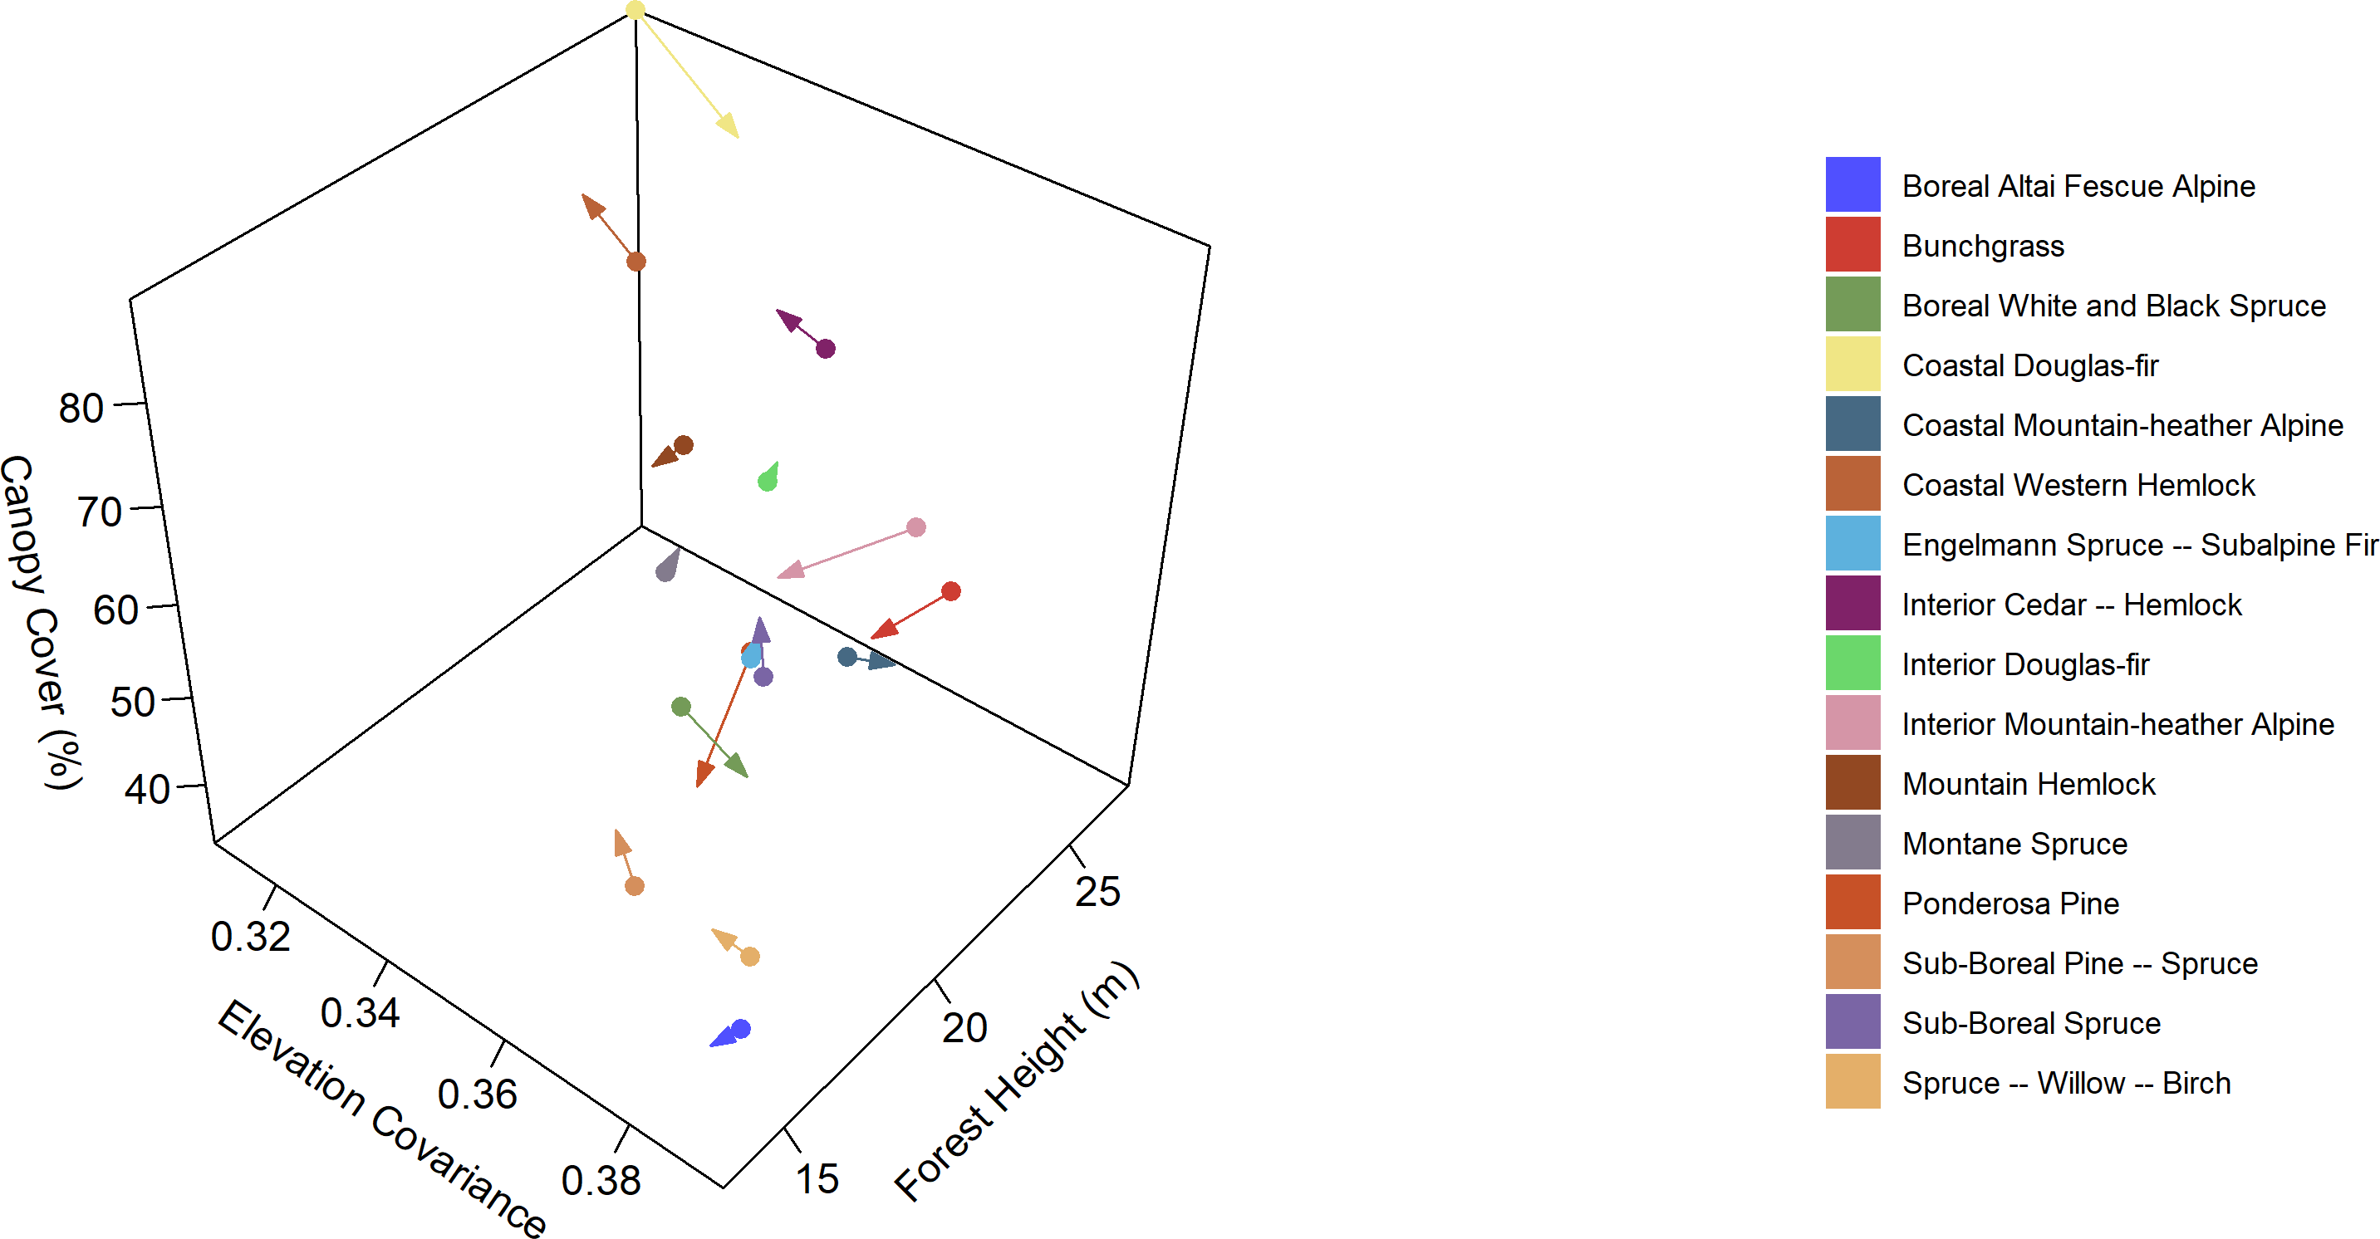

Figure 8: 3d vector diagram of BEC zones forest structure attributes across British Columiba. Dots indicate the protected area means, and arrowheads indicate unprotected area means.

Forest structural attributes vary between PA and UA in BC (Figure 8). As shown in Figure 7, forests are commonly significantly different when comparing PA vs UA across all attributes. When examining the forests on an ecozonal level, only one ecozone has a >5% difference in vertical forest structure (co-efficient of variation in vegetation returns), six ecozones have >5% difference in canopy cover, and five ecozones have a >5% difference in canopy height. Ponderosa pine has large differences in canopy cover and canopy height (>5%), but minor differences in elevation covariance (only 0.25%; Table 2). The largest overall difference between attributes of forest stands in PA vs UA was for the Coastal Douglas-fir zone, determined by examining the scalar distance of z-scores in the 3d space.

Table 2: Mean values of forest structural attributes in protected areas (PA), unprotected areas (UA), as well as the percent change between the means. Zones with more than a 5% difference are highlighted.

| **Zone** | **Elevation Covariance** | | | **Canopy Cover (%)** | | | **Canopy Height (m)** | | |
| --- | --- | --- | --- | --- | --- | --- | --- | --- | --- |
| **PA** | **UA** | **% Change** | **PA** | **UA** | **% Change** | **PA** | **UA** | **% Change** |
| BAFA | 0.39 | 0.39 | 0.01% | 46.94% | 48.47% | 3.17% | 14.03 | 13.11 | -7% |
| BG | 0.38 | 0.38 | -1.41% | 61.8% | 58.71% | -5.26% | 23.00 | 21.58 | -6.59% |
| BWBS | 0.37 | 0.38 | 2.62% | 67.18% | 64.72% | -3.8% | 15.83 | 15.69 | -0.9% |
| CDF | 0.31 | 0.33 | 6.35% | 89.38% | 83.69% | -6.79% | 27.35 | 26.58 | -2.89% |
| CMA | 0.38 | 0.39 | 1.63% | 62.65% | 64.01% | 2.13% | 19.91 | 20.01 | 0.48% |
| CWH | 0.34 | 0.33 | -3.83% | 83.94% | 85.26% | 1.55% | 21.58 | 22.34 | 3.4% |
| ESSF | 0.37 | 0.37 | 0.34% | 61.7% | 64.97% | 5.04% | 18.90 | 18.91 | 0.07% |
| ICH | 0.36 | 0.36 | -1.75% | 81.24% | 83.52% | 2.73% | 22.39 | 22.18 | -0.98% |
| IDF | 0.36 | 0.36 | -0.3% | 67.42% | 67.9% | 0.71% | 21.98 | 22.49 | 2.29% |
| IMA | 0.38 | 0.36 | -3.72% | 68.17% | 62.07% | -9.83% | 22.53 | 21.06 | -6.98% |
| MH | 0.36 | 0.36 | 0.25% | 76.87% | 77.85% | 1.26% | 19.42 | 18.31 | -6.07% |
| MS | 0.35 | 0.35 | 0.31% | 57.99% | 60.41% | 4.01% | 20.64 | 20.86 | 1.04% |
| PP | 0.36 | 0.37 | 0.25% | 57.92% | 48.93% | -18.36% | 19.88 | 18.03 | -10.24% |
| SBPS | 0.36 | 0.35 | -1.97% | 32.98% | 34.63% | 4.76% | 18.00 | 18.70 | 3.75% |
| SBS | 0.37 | 0.37 | -0.4% | 62.24% | 67.25% | 7.45% | 18.51 | 18.67 | 0.82% |
| SWB | 0.39 | 0.39 | -1.22% | 56.67% | 57.71% | 1.8% | 13.78 | 13.67 | -0.83% |

# Discussion

The recent global availability of freely available, open source, consistent, accurate remote sensing data products allow researchers to examine issues of representation of PA compared to UA, and regional ecosystems in novel ways. Additionally, the capacity to track forest structural attributes, a key indicator of forest biodiversity (Guo et al. 2017), across wide swaths allows for informed decisions on potential locations of new PA which capture previously missing forest structure conditions. By applying this analysis to an entire PA network, across ecozones, it becomes possible to determine not only which ecozones need additional representation (the proportional metric), but also what types of forest structures should be represented.

Internationally, biodiversity preservation targets aim to protect a proportion of the total terrestrial area (CBD 2010). Frequently, new protected areas are placed in high-elevation, low-productivity ecosystems both globally (Joppa and Pfaff 2009, Venter et al. 2014, Venter et al. 2018), and likely in BC (Wang et al. 2020). Our results confirm this is the case both across ecosystems (Figure 2), and land cover (Figure 4). Alpine ecosystems are more commonly protected, as are the land covers commonly likely to be present in them (rock/rubble, snow/ice, exposed/barren land). As elevation increases, these ecosystems and land covers begin to dominate the proportional representation (Figure 3 & Figure 5). Additionally, with elevation increases, areal protected proportions also increase, up to 100% of terrestrial area protected above 4000m.

We find disturbances similar to Bolton et al. (2019), specifically, area burnt is overall similar between PA and UA. Harvesting results are also similar, with little harvesting disturbances found in PA, and harvesting common at low latitudes in UA, reducing as latitude increases until it is the same as PA at 58°N (Figure 6). Conversely, we do not find that wildfires are increasingly common at higher latitudes, with the mid latitudes (51-53°N) having higher prevalence of fire in both PA and UA than high latitudes.

Our analysis shows that the majority of structural attributes were significantly different between the protected and unprotected forest stands across BEC subzones (Figure 7). In the south, Coastal Douglas-fir, a zone with a single subzone, had the largest variation between PA and UA in the three forest structural attributes examined. The unprotected forests were significantly less tall, had significantly less canopy cover, and significantly higher elevation covariance (vertical forest structure; Figure 8). In addition, it was the least protected ecozone by area, with only 4.8% of the total terrestrial area protected. In this specific ecozone, not only does additional area need to be protected to meet national goals, different forest structures need to be included in these new protected areas.

In high elevation ecosystems, boreal altai fescue alpine dominates the PA proportions above 3000m, replacing the coastal mountain-heather alpine ecosystem found in UA (Figure 3). These zones were still protected at rates above the average (Figure 2), and above the Aichi biodiversity targets. Interior mountain-heather alpine had large differences in canopy cover and canopy height, while boreal altai fescue alpine only showed large differences in height. The coastal mountain-heather alpine did not any have large forest structural attribute differences (Table 2).

Utilizing this information on the proportion of ecozones protected (Figure 2), as well as their forest structural attributes (Table 2), it is possible to identify which forest structures need to be added to the PA network in BC. Those ecozones with large differences (identified as being >5% change from PA to UA) suggest additionally protection is needed to encapsulate these missing forest structures. For example: the forests in the bunchgrass ecozone have large differences in both canopy cover and canopy height, with the PA having larger values in both attributes (Table 2). New PA in this ecozone should contain forests with shorter and more open forests. A future avenue of research could be to identify suitable locations to expand the PA network that incorporates this knowledge on missing forest structures.

The advent of free and open global datasets can allow for the monitoring of protected area health across the globe (Nagendra et al. 2013). Analyzing large amounts of free and open data using open source software approaches can give previously unseen perspectives into protected area representatives. Future research monitoring protected area health using satellite remote sensing could focus on implementing essential biodiversity variables (Pereira et al. 2013) into their monitoring scheme. Advancing research towards these variables would not only benefit PA monitoring projects, but also biodiversity monitoring projects across the globe. Other research avenues include comparing the areas directly outside of PA’s for forest structure using methodologies similar to Bolton et al. (2019) and Soverel et al. (2010). Beyond this, examining post-disturbance forest structural attribute recovery in both PA and UA could assess the effectiveness of PA for promoting regeneration.

# Acknowledgments

This research was funded through the Living Lab for Climate Change and Conservation program of the British Columbia Parks (grant ID: TP21JHQ011) and in part by NSERC support of Coops (RGPIN-2018-03851).

# References

Alsdorf, D. E., E. Rodriguez, and D. P. Lettenmaier. 2007. Measuring surface water from space. Reviews of Geophysics 45:RG2002.

BC Ministry of Forests,. 2003. British columbia’s forests and their management.

BC Parks. 2012. Ecological Integrity in British Columbia’s Parks and Protected Areas. Page 12.

Bolton, D. K., N. C. Coops, T. Hermosilla, M. A. Wulder, J. C. White, and C. J. Ferster. 2019. Uncovering regional variability in disturbance trends between parks and greater park ecosystems across Canada (1985). Scientific Reports 9:1323.

Brooks, T. M., M. I. Bakarr, T. Boucher, G. A. B. Da Fonseca, C. Hilton-Taylor, J. M. Hoekstra, T. Moritz, S. Olivieri, J. Parrish, R. L. Pressey, A. S. L. Rodrigues, W. Sechrest, A. Stattersfield, W. Strahm, and S. N. Stuart. 2004. Coverage Provided by the Global Protected-Area System: Is It Enough? BioScience 54:1081.

Buchanan, G. M., A. E. Beresford, M. Hebblewhite, F. J. Escobedo, H. M. D. Klerk, P. F. Donald, P. Escribano, L. P. Koh, J. Martínez-López, N. Pettorelli, A. K. Skidmore, Z. Szantoi, K. Tabor, M. Wegmann, and S. Wich. 2018. Free satellite data key to conservation. Science 361:139–140.

Burkhard, B., F. Kroll, S. Nedkov, and F. Müller. 2012. Mapping ecosystem service supply, demand and budgets. Ecological Indicators 21:17–29.

Butchart, S. H. M., M. Clarke, R. J. Smith, R. E. Sykes, J. P. W. Scharlemann, M. Harfoot, G. M. Buchanan, A. Angulo, A. Balmford, B. Bertzky, T. M. Brooks, K. E. Carpenter, M. T. Comeros-Raynal, J. Cornell, G. F. Ficetola, L. D. C. Fishpool, R. A. Fuller, J. Geldmann, H. Harwell, C. Hilton-Taylor, M. Hoffmann, A. Joolia, L. Joppa, N. Kingston, I. May, A. Milam, B. Polidoro, G. Ralph, N. Richman, C. Rondinini, D. B. Segan, B. Skolnik, M. D. Spalding, S. N. Stuart, A. Symes, J. Taylor, P. Visconti, J. E. M. Watson, L. Wood, and N. D. Burgess. 2015. Shortfalls and Solutions for Meeting National and Global Conservation Area Targets. Conservation Letters 8:329–337.

CBD. 2004. CoP 7 decision VII/30. Strategic plan: future evaluation of progress. Goal 1 promote the conservation of the biological diversity of ecosystems, habitats and biomes; Target 1.1.

CBD. 2010. The strategic plan for biodiversity 2011-2020 and the Aichi biodiversity targests.

Chape, S., J. Harrison, M. Spalding, and I. Lysenko. 2005. Measuring the extent and effectiveness of protected areas as an indicator for meeting global biodiversity targets. Philosophical Transactions of the Royal Society B: Biological Sciences 360:443–455.

Cohen, W. B., and S. N. Goward. 2004. Landsat’s role in ecological applications of remote sensing. Bioscience 54:535–545.

Defries, R., A. Hansen, A. Newton, and M. Hansen. 2005. Increasing isolation of protected areas in tropical forests over the past twenty years. Ecological Applications 15:19–26.

Dinerstein, E., D. Olson, A. Joshi, C. Vynne, N. D. Burgess, E. Wikramanayake, N. Hahn, S. Palminteri, P. Hedao, R. Noss, M. Hansen, H. Locke, E. C. Ellis, B. Jones, C. V. Barber, R. Hayes, C. Kormos, V. Martin, E. Crist, W. Sechrest, L. Price, J. E. M. Baillie, D. Weeden, K. Suckling, C. Davis, N. Sizer, R. Moore, D. Thau, T. Birch, P. Potapov, S. Turubanova, A. Tyukavina, N. de Souza, L. Pintea, J. C. Brito, O. A. Llewellyn, A. G. Miller, A. Patzelt, S. A. Ghazanfar, J. Timberlake, H. Klöser, Y. Shennan-Farpón, R. Kindt, J.-P. B. Lillesø, P. van Breugel, L. Graudal, M. Voge, K. F. Al-Shammari, and M. Saleem. 2017. An Ecoregion-Based Approach to Protecting Half the Terrestrial Realm. BioScience 67:534–545.

Dinerstein, E., C. Vynne, E. Sala, A. R. Joshi, S. Fernando, T. E. Lovejoy, J. Mayorga, D. Olson, G. P. Asner, J. E. M. Baillie, N. D. Burgess, K. Burkart, R. F. Noss, Y. P. Zhang, A. Baccini, T. Birch, N. Hahn, L. N. Joppa, and E. Wikramanayake. 2019. A Global Deal For Nature: Guiding principles, milestones, and targets. Science Advances 5:eaaw2869.

ECCC. 2021, May 3. Canada Target 1 Challenge.

Environmental Reporting BC. 2016. Protected Lands and Waters in British Columbia. http://www.env.gov.bc.ca/soe/indicators/land/protected-lands-and-waters.html.

Feeley, K. J., T. W. Gillespie, and J. W. Terborgh. 2005. The Utility of Spectral Indices from Landsat ETM+ for Measuring the Structure and Composition of Tropical Dry Forests. Biotropica 37:508–519.

Fraser, R. H., I. Olthof, and D. Pouliot. 2009. Monitoring land cover change and ecological integrity in Canada’s national parks. Remote Sensing of Environment 113:1397–1409.

Gao, T., M. Hedblom, T. Emilsson, and A. B. Nielsen. 2014. The role of forest stand structure as biodiversity indicator. Forest Ecology and Management 330:82–93.

Gaston, K. J., K. Charman, S. F. Jackson, P. R. Armsworth, A. Bonn, R. A. Briers, C. S. Q. Callaghan, R. Catchpole, J. Hopkins, W. E. Kunin, J. Latham, P. Opdam, R. Stoneman, D. A. Stroud, and R. Tratt. 2006. The ecological effectiveness of protected areas: The United Kingdom. Biological Conservation 132:76–87.

Gaston, K. J., S. F. Jackson, L. Cantú-Salazar, and G. Cruz-Piñón. 2008. The Ecological Performance of Protected Areas. Annual Review of Ecology, Evolution, and Systematics 39:93–113.

Gillespie, T. W. 2005. Predicting Woody-Plant Species Richness in Tropical Dry Forests: A Case Study from South Florida, Usa. Ecological Applications 15:27–37.

Goetz, S., D. Steinberg, R. Dubayah, and B. Blair. 2007. Laser remote sensing of canopy habitat heterogeneity as a predictor of bird species richness in an eastern temperate forest, USA. Remote Sensing of Environment 108:254–263.

Government of Canada,. 2019, September 4. Canada national park act.

Guo, X., N. C. Coops, P. Tompalski, S. E. Nielsen, C. W. Bater, and J. John Stadt. 2017. Regional mapping of vegetation structure for biodiversity monitoring using airborne lidar data. Ecological Informatics 38:50–61.

Hamann, A., P. Smets, A. D. Yanchuk, and S. N. Aitken. 2005. An ecogeographic framework for in situ conservation of forest trees in british columbia. Canadian Journal of Forest Research 35:2553–2561.

Hansen, A. J., and L. Phillips. 2018. Trends in vital signs for Greater Yellowstone: Application of a Wildland Health Index. Ecosphere 9:e02380.

Hermosilla, T., M. A. Wulder, J. C. White, N. C. Coops, and G. W. Hobart. 2015a. An integrated Landsat time series protocol for change detection and generation of annual gap-free surface reflectance composites. Remote Sensing of Environment 158:220–234.

Hermosilla, T., M. A. Wulder, J. C. White, N. C. Coops, and G. W. Hobart. 2015b. Regional detection, characterization, and attribution of annual forest change from 1984 to 2012 using landsat-derived time-series metrics. Remote Sensing of Environment 170:121132.

Hermosilla, T., M. A. Wulder, J. C. White, N. C. Coops, and G. W. Hobart. 2018. Disturbance-Informed Annual Land Cover Classification Maps of Canada’s Forested Ecosystems for a 29-Year Landsat Time Series. Canadian Journal of Remote Sensing 44:67–87.

Hermosilla, T., M. A. Wulder, J. C. White, N. C. Coops, G. W. Hobart, and L. B. Campbell. 2016. Mass data processing of time series Landsat imagery: Pixels to data products for forest monitoring. International Journal of Digital Earth 9:1035–1054.

Joppa, L. N., and A. Pfaff. 2009. High and Far: Biases in the Location of Protected Areas. PLOS ONE 4:e8273.

Kerr, J. T., and M. Ostrovsky. 2003. From space to species: ecological applications for remote sensing. Trends in Ecology & Evolution 18:299–305.

Lim, K., P. Treitz, M. Wulder, B. St-Onge, and M. Flood. 2003. LiDAR remote sensing of forest structure. Progress in Physical Geography: Earth and Environment 27:88–106.

Lucas, R., K. Medcalf, A. Brown, P. Bunting, J. Breyer, D. Clewley, S. Keyworth, and P. Blackmore. 2011. Updating the Phase 1 habitat map of Wales, UK, using satellite sensor data. ISPRS Journal of Photogrammetry and Remote Sensing 66:81–102.

Matasci, G., T. Hermosilla, M. A. Wulder, J. C. White, N. C. Coops, G. W. Hobart, D. K. Bolton, P. Tompalski, and C. W. Bater. 2018a. Three decades of forest structural dynamics over Canada’s forested ecosystems using Landsat time-series and lidar plots. Remote Sensing of Environment 216:697–714.

Matasci, G., T. Hermosilla, M. A. Wulder, J. C. White, N. C. Coops, G. W. Hobart, and H. S. J. Zald. 2018b. Large-area mapping of Canadian boreal forest cover, height, biomass and other structural attributes using Landsat composites and lidar plots. Remote Sensing of Environment 209:90–106.

McDermid, G. J., S. E. Franklin, and E. F. LeDrew. 2005. Remote sensing for large-area habitat mapping. Progress in Physical Geography: Earth and Environment 29:449–474.

Meidinger, D. V., and J. Pojar, editors. 1991. Ecosystems of British Columbia. Research Branch, Ministry of Forests, Victoria, B.C.

Myneni, R. B., J. Dong, C. J. Tucker, R. K. Kaufmann, P. E. Kauppi, J. Liski, L. Zhou, V. Alexeyev, and M. K. Hughes. 2001. A large carbon sink in the woody biomass of northern forests. Proceedings of the National Academy of Sciences of the United States of America 98:14784–14789.

Nagendra, H. 2001. Using remote sensing to assess biodiversity. International Journal of Remote Sensing 22:2377–2400.

Nagendra, H. 2008. Do parks work? Impact of protected areas on land cover clearing. Ambio 37:330–337.

Nagendra, H., R. Lucas, J. P. Honrado, R. H. G. Jongman, C. Tarantino, M. Adamo, and P. Mairota. 2013. Remote sensing for conservation monitoring: Assessing protected areas, habitat extent, habitat condition, species diversity, and threats. Ecological Indicators 33:45–59.

Nagendra, H., D. Rocchini, R. Ghate, B. Sharma, and S. Pareeth. 2010. Assessing Plant Diversity in a Dry Tropical Forest: Comparing the Utility of Landsat and Ikonos Satellite Images. Remote Sensing 2:478–496.

Olthof, I., D. Pouliot, R. Fraser, A. Clouston, S. Wang, W. Chen, J. Orazietti, J. Poitevin, D. Mclennan, J. Kerr, and M. Sawada. 2006. Using Satellite Remote Sensing to Assess and Monitor Ecosystem Integrity and Climate Change in Canadas National Parks. 2006 IEEE International Symposium on Geoscience and Remote Sensing. IEEE.

Parks Canada. 2019. Ecological Integrity. https://www.pc.gc.ca/en/nature/science/conservation/ie-ei.

Parmenter, A. W., A. Hansen, R. E. Kennedy, W. Cohen, U. Langner, R. Lawrence, B. Maxwell, A. Gallant, and R. Aspinall. 2003. Land use and land cover change in the Greater Yellowstone Ecosystem: 1975. Ecological Applications 13:687–703.

Parrish, J. D., D. P. Braun, and R. S. Unnasch. 2003. Are We Conserving What We Say We Are? Measuring Ecological Integrity within Protected Areas. BioScience 53:851.

Pereira, H. M., S. Ferrier, M. Walters, G. N. Geller, R. H. G. Jongman, R. J. Scholes, M. W. Bruford, N. Brummitt, S. H. M. Butchart, A. C. Cardoso, N. C. Coops, E. Dulloo, D. P. Faith, J. Freyhof, R. D. Gregory, C. Heip, R. Hoft, G. Hurtt, W. Jetz, D. S. Karp, M. A. McGeoch, D. Obura, Y. Onoda, N. Pettorelli, B. Reyers, R. Sayre, J. P. W. Scharlemann, S. N. Stuart, E. Turak, M. Walpole, and M. Wegmann. 2013. Essential Biodiversity Variables. Science 339:277–278.

Pojar, J., K. Klinka, and D. V. Meidinger. 1987. Biogeoclimatic ecosystem classification in British Columbia. Forest Ecology and Management 22:119–154.

Pôças, I., M. Cunha, and L. S. Pereira. 2011. Remote sensing based indicators of changes in a mountain rural landscape of Northeast Portugal. Applied Geography 31:871–880.

Rocchini, D., N. Balkenhol, G. A. Carter, G. M. Foody, T. W. Gillespie, K. S. He, S. Kark, N. Levin, K. Lucas, M. Luoto, H. Nagendra, J. Oldeland, C. Ricotta, J. Southworth, and M. Neteler. 2010. Remotely sensed spectral heterogeneity as a proxy of species diversity: Recent advances and open challenges. Ecological Informatics 5:318–329.

Running, S. W., R. R. Nemani, F. A. Heinsch, M. S. Zhao, M. Reeves, and H. Hashimoto. 2004. A continuous satellite-derived measure of global terrestrial primary production. Bioscience 54:547–560.

Skidmore, A. K., N. C. Coops, E. Neinavaz, A. Ali, M. E. Schaepman, M. Paganini, W. D. Kissling, P. Vihervaara, R. Darvishzadeh, H. Feilhauer, M. Fernandez, N. Fernández, N. Gorelick, I. Geijzendorffer, U. Heiden, M. Heurich, D. Hobern, S. Holzwarth, F. E. Muller-Karger, R. Van De Kerchove, A. Lausch, P. J. Leitão, M. C. Lock, C. A. Mücher, B. O’Connor, D. Rocchini, W. Turner, J. K. Vis, T. Wang, M. Wegmann, and V. Wingate. 2021. Priority list of biodiversity metrics to observe from space. Nature Ecology & Evolution.

Soverel, N. O., N. C. Coops, J. C. White, and M. A. Wulder. 2010. Characterizing the forest fragmentation of Canada’s national parks. Environmental Monitoring and Assessment 164:481–499.

Tachikawa, T., M. Kaku, A. Iwasaki, D. B. Gesch, M. J. Oimoen, Z. Zhang, J. J. Danielson, T. Krieger, B. Curtis, J. Haase, M. Abrams, and C. Carabajal. 2011. ASTER global digital elevation model version 2 - summary of validation results. Page 27.

Teucher, A., S. Hazlitt, and S. Albers. 2021. Bcmaps: Map layers and spatial utilities for british columbia.

Turner, W., C. Rondinini, N. Pettorelli, B. Mora, A. K. Leidner, Z. Szantoi, G. Buchanan, S. Dech, J. Dwyer, M. Herold, L. P. Koh, P. Leimgruber, H. Taubenboeck, M. Wegmann, M. Wikelski, and C. Woodcock. 2015. Free and open-access satellite data are key to biodiversity conservation. Biological Conservation 182:173–176.

Turner, W., S. Spector, N. Gardiner, M. Fladeland, E. Sterling, and M. Steininger. 2003. Remote sensing for biodiversity science and conservation. Trends in Ecology & Evolution 18:306–314.

Venter, O., R. A. Fuller, D. B. Segan, J. Carwardine, T. Brooks, S. H. M. Butchart, M. Di Marco, T. Iwamura, L. Joseph, D. O’Grady, H. P. Possingham, C. Rondinini, R. J. Smith, M. Venter, and J. E. M. Watson. 2014. Targeting Global Protected Area Expansion for Imperiled Biodiversity. PLoS Biology 12:e1001891.

Venter, O., A. Magrach, N. Outram, C. J. Klein, H. P. Possingham, M. Di Marco, and J. E. M. Watson. 2018. Bias in protected-area location and its effects on long-term aspirations of biodiversity conventions. Conservation Biology: The Journal of the Society for Conservation Biology 32:127–134.

Wang, T., P. Smets, C. Chourmouzis, S. N. Aitken, and D. Kolotelo. 2020. Conservation status of native tree species in British Columbia. Global Ecology and Conservation 24:e01362.

Watson, J. E. M., N. Dudley, D. B. Segan, and M. Hockings. 2014. The performance and potential of protected areas. Nature 515:67–73.

White, Joanne. C., M. A. Wulder, G. W. Hobart, J. E. Luther, T. Hermosilla, P. Griffiths, N. C. Coops, R. J. Hall, P. Hostert, A. Dyk, and L. Guindon. 2014. Pixel-Based Image Compositing for Large-Area Dense Time Series Applications and Science. Canadian Journal of Remote Sensing 40:192–212.

Wiens, J., R. Sutter, M. Anderson, J. Blanchard, A. Barnett, N. aguilar-amuchastegui, C. Avery, and S. Laine. 2009. Selecting and conserving lands for biodiversity: The role of remote sensing. Remote Sensing of Environment 113:1370–1381.

Woodley, S. 1993. Monitoring and Measuring Ecosystem Integrity in Canadian National Parks. Ecological Integrity and the Management of Ecosystems. Taylor & Francis.

Wulder, M. A., J. G. Masek, W. B. Cohen, T. R. Loveland, and C. E. Woodcock. 2012a. Opening the archive: How free data has enabled the science and monitoring promise of Landsat. Remote Sensing of Environment 122:2–10.

Wulder, M. A., J. C. White, R. F. Nelson, E. Næsset, H. O. Ørka, N. C. Coops, T. Hilker, C. W. Bater, and T. Gobakken. 2012b. Lidar sampling for large-area forest characterization: A review. Remote Sensing of Environment 121:196–209.

Zhang, X. Y., M. A. Friedl, C. B. Schaaf, A. H. Strahler, J. C. F. Hodges, F. Gao, B. C. Reed, and A. Huete. 2003. Monitoring vegetation phenology using MODIS. Remote Sensing of Environment 84:471–475.