*Ecological Applications: EAP21-0721*

**Assessing Representation of Remote Sensing Derived Forest Structure and Land Cover Across a Network of Protected Areas**

Evan R. Muise, Nicholas C. Coops, Txomin Hermosilla, and Stephen S. Ban

**General Comments**

**The authors appreciate the response from the reviewer and editor. The section on state-of-the-art approaches for comparing protective area effectiveness was especially relevant, and we thank the reviewer for their inclusion of helpful references. All line numbers refer to the track changes document.**

**Response to Reviewer 1**

**COMMENT**

Describe the accuracy/uncertainty of the remote sensing products used in the analyses. Given that these are largely derived by the authors, it is important that the reader be informed of the confidence that can be placed in the layers and thus the analyses presented in this paper.

**Response:**

**Full details on disturbance and land cover accuracies were reported in the original manuscript cited in this section. We added the following sentence to the paragraph on forest structural attributes:**

**Lines 232-234:**

***Reported accuracy for the structure metrics indicated a RMSE% ranging from 24.5% to 65.8% and a R2 ranging from 0.125 to 0.699 (Matasci et al. 2018a).***

**COMMENT**

Deal more explicitly with the challenges finding reasonable unprotected places for assessing PA representativeness and how your methods overcome these challenges. See the citations below.

Lines 77-78. Here or somewhere should be added a paragraph on the methodological challenges of assessing PA representativeness and the state of the science in dealing with these challenges. Some relevant citations are below. In the Methods, you should say how your approach for analysis fits within the state of the science approaches.

**Response:**

**Following reviewer’s suggestion we expanded the introduction to describe the methodological challenges of assessing PA representativeness, as follows:**

***Frequently, comparisons between PA and unprotected areas (UA) have been drawn in order to assess PA performance and health (Defries et al. 2005). This allows for the PA or PA network to be taken in context of surrounding and/or similar ecosystems (Wiens et al. 2009). There are, however, challenges associated with comparing the effectiveness of PA directly with UA. It can be difficult to identify suitable UA for comparison due to the increased prevalence of human pressure in UA (Geldmann et al., 2019), and the bias for PA to be in areas that would not have faced increased human pressure due to their remoteness (Joppa and Pfaff, 2009).***

***Ferraro (2009) prescribed the use of the counterfactual method based on comparing the outcomes following PA implementation with what would have happened if the PA was not implemented. The counterfactual method is widely used as a more accurate method for assessing protected area management effectiveness (Coad et al., 2015, Geldmann et al., 2019, Eklund et al, 2019, Terraube et al., 2020). This method is frequently employed by using matching methods, where treatment and control samples are similar with regards to topography, climate, land cover, or others, to select UA which directly correspond to the PA being analyzed (Geldmann et al., 2019, Ribas et al., 2020). Collecting field data across both the PA and its counterfactual UA is often time-and-cost prohibitive. Consequently, the increasing prevalence of freely available imagery has led to satellite remote sensing becoming an essential tool for PA monitoring (Nagendra et al. 2013).***

**And explicitly identified in the methods as follows:**

**Lines 193-195:**

***This sampling regime accounts follows the counterfactual approach, accounting for bias in topography, climate, and climax species due to the methods used to delineate BEC zones and subzones (Pojar et al., 1987).***

**Lines 241-246:**

**To determine bias in ecosystem representation in BC’s PA network, we compared BEC zone, and land cover, and disturbance proportions within and outside the PA network. We employ the counterfactual approach by examining BEC zone and land cover as a function of elevation, and secondly compiled disturbance rates on a latitudinal gradient across the province. Forest structural attributes were then examined at a finer ecosystem classification level, statistically comparing PA vs UA across similar ecosystems.**

**COMMENT**

Figures 4, 6, and 8 could be better explained to allow the reader to more easily grasp the information they convey.

**Response:**

**See comments broken down by figure below.**

**COMMENT**

Figure 4. It is not easy for the reader to compare panels b and c to evaluate landscape proportions protected vs not protected. Can some text be added to the legend that clarifies how to read the graphic to draw this inference?

**Response:**

**The figure captions of Figures 4 and 6 have been updated to include the aggregated bin widths, and an example of how to read the figures can be found in the results section.**

**Lines 283-285:**

For both Figure 4 and 6, values across a given elevation show the proportion of that elevation represented by each BEC zone or land cover class in both (b) PA and (c) UA.

**Figure 4: (a) Histogram of area protected in British Columbia by elevation. Proportion of Biogeoclimatic Ecosystem Classification (BEC) zone by elevation for both (b) protected areas, and (c) unprotected areasaggregated to a bin width of 50m. (d) Histogram of area unprotected in British Columbia by elevation.**

**Figure 6: (a) Histogram of area protected in British Columbia by elevation. Proportion of land cover by elevation for both (b) protected areas, and (c) unprotected areas aggregated to a bin width of 50m. (d) Histogram of area unprotected in British Columbia by elevation.**

**COMMENT**

Additionally, could a panel or graphic be added that has on the x axis the ratio of protected to nonprotected for each ecosystem type by elevation? This is also the case for Figure 6.

**Response:**

**Following reviewer’s suggestion, we have assessed different approaches for graphically representing this information. We found out that the graphical representation of ratios of coverage as an additional panel in Figures 4 & 6 was unsatisfactory due to: (i) large volumes of information conveyed (16 classes for ecosystems, 13 classes for land cover), and (ii) disparity on the range of ratio values. In lieu of this, we have included a new figure to the results section (Figure 7). Figure 7 shows using a box and whiskers chart of the distribution of elevation values by BEC zone and land cover class, as well as by PA and UA.**

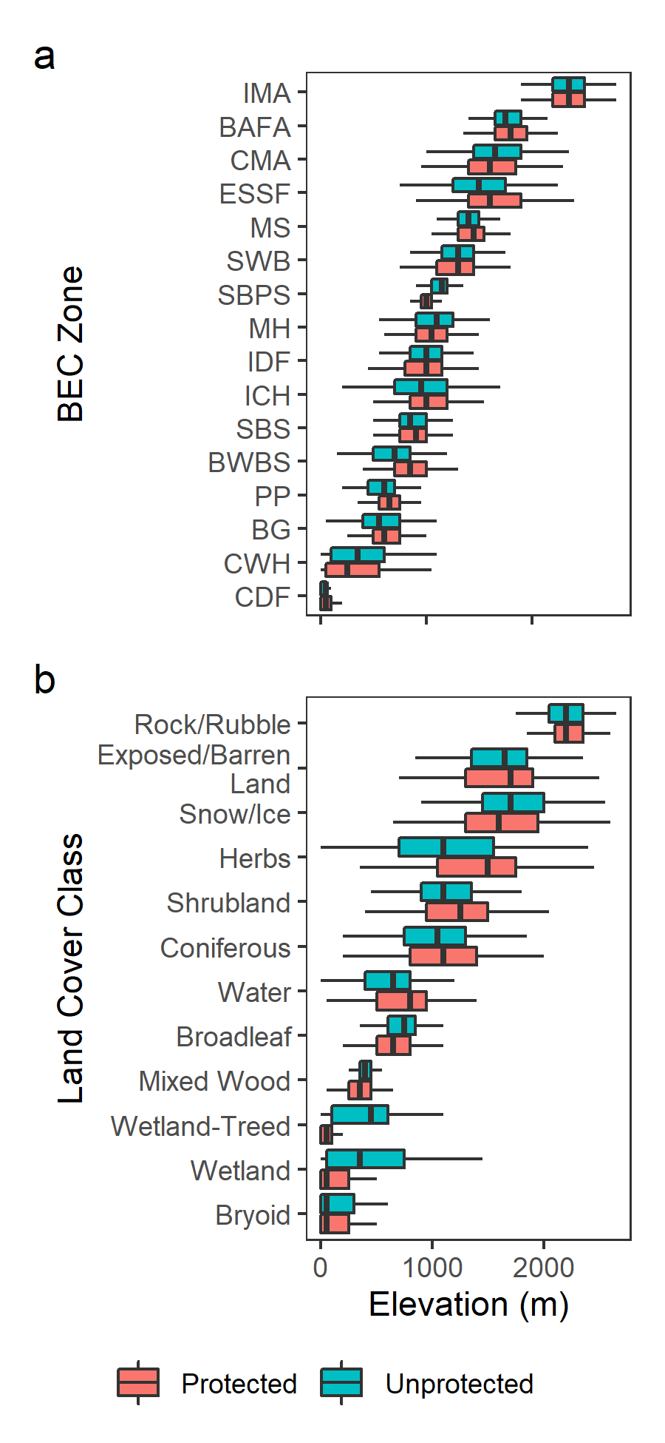

**Figure 7: Elev****ation boxplots for BEC zones (a), and land cover classes (b). Whiskers indicate first quartile minus the interquartile range and third quartile to the interquartile range. Box and interior vertical line indicate first quartile, median, and third quartile, respectively.**

**The following text was added to the results section from lines 299-305:**

**Figure 7 shows the elevation distributions of BEC zones and land cover classes. Generally, BEC zones are found at similar elevation profiles in both PA and UA. Alpine BEC zones (Interior Mountain-heather Alpine, Boreal Altai Fescue Alpine, and Coastal Mountain-heather Alpine) are found at similar elevations across PA and UA, while other zones such as Sub-Boreal Pine -- Spruce, Ponderosa Pine, and Bunchgrass vary in their elevation profiles. Land cover classes show differences in the wetland, wetland-treed, and mixed wood classes. The wetland classes are found at lower elevations in PA than UA, while the mixed wood class has more variation in PA**.

**Additionally, the following text was added to the discussion at lines 349-351:**

**Differences between elevation profiles in land cover classes and BEC zones were also found, with the largest difference being that wetland classes were found at lower elevations in PA (Figure 7).**

**COMMENT**

Figure 8. Add text to the legend that describes the meaning of the vertical and horizontal lines and the boxes within the graphic.

**Response:**

**Figure 8:**

**Figure 9:** **Summary of proportion of ecosystem subzone which have significant p-values from a two-tailed t-test with the Bonferroni correction (n = 496) applied at a significance level of 0.05. Boxplots represent median, interquartile range (IQR) and extreme values (1.5 × IQR).**

**COMMENT**

Line 72-73. Also consider citing Hansen, A.J., Noble, B.P., Veneros, J., East, A., Goetz, S.J., Supples, C., Watson, J.E.M., Jantz, P.A., Pillay, R., Jetz, W., Ferrier, S., Grantham, H.S., Evans, T.D., Ervin, J., Venter, O. & Virnig, A.L.S.. Towards monitoring ecosystem integrity within the Post-2020 Global Biodiversity Framework. Conservation Letters. 2021; 14:e12822.

**Response:**

**Hansen et al. (2021) has been added as a reference. Lines 82-83.**