# Hypotheses

While there are strong relationships between easily retrievable lidar metrics such as canopy height/canopy cover and productivity metrics, these effects are mediated through other forest structural variables. We specify two models examining the vertical and horizontal structural influences on yearly productivity summaries (Figure 1).

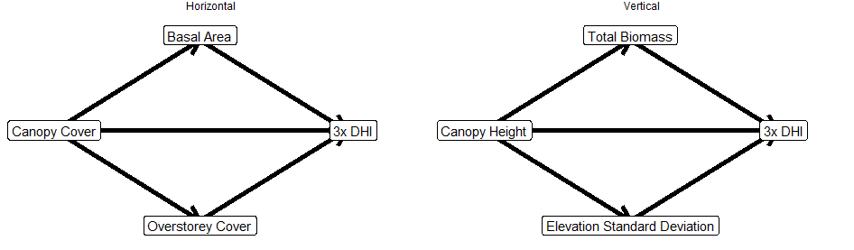

Figure Sample path diagrams for the six specified models. 3x DHI refers to three separate models, one for the cumulative, minimum, and variation DHI, respectively.

# Methods

## Data

We utilized six forest structural information datasets from the NTEMS catalog (horizontal; canopy cover, overstorey cover, and basal area. vertical; canopy height, elevation standard deviation, total biomass) . {Information on how these are created from Matasci et al (2018 a, b)}. The three DHI (cumulative, minimum, variation) were created at a Landsat spatial resolution (30 m) following methodologies from Razenkova et al. (In Press).

## Preprocessing

All layers (forest structure, DHI) were mosaiced to British Columbia, with non-forested pixels removed.

## Sampling

The minimum number of samples was calculated using the semPower R package, which balances α- and β-error risks while encouraging larger samples sizes. 855 samples per zone were required to meet the specifications of a p-value less than 0.05 and a power of 0.8 with our models.

To generate the samples, all non-forested regions of BC were sampled 855 times, per forested ecosystem. A consistency criterion like Shang et al. (2020) was applied to account for forest structural imputation processes. The criteria were as follows: for a given pixel, the coefficient of variance for both canopy height and cover must be less than 0.5, and a forested pixel must be surrounded by forested pixels of the same land cover class (i.e., a wetland-treed pixel must be surrounded by 8 wetland-treed pixels following queen’s contiguity). There was a 1km minimum sampling distance to account for spatial autocorrelation within the data layers (forest structure and DHIs).

## Analysis

We used path analysis to examine the direct and indirect relationships of frequently reported lidar derived structure metrics (canopy height and canopy cover) on yearly productivity summaries, at a Landsat pixel size, across British Columbia. Path analysis creates estimates the causal, directional relationship between variables, including direct and indirect effects. The direct and indirect effects of a causal input can be examined separately by “locking” the mediating variable to a set value and adjusting the causal input. All path analyses were conducted in R 4.2.0 (citation) using the lavaan package (citation). The ggplot2 package (citation) was used for visualization.Results

Figure 2 shows path diagrams for the six models in the Interior Douglas-fir BEC zone. I would like to focus on the top right model (vertical, cumulative DHI) to ensure that my interpretation is correct. Since all linkages are significant, canopy height has a direct, negative effect on cumulative DHI. Its positive effects are mediated through total biomass and elevation standard deviation.

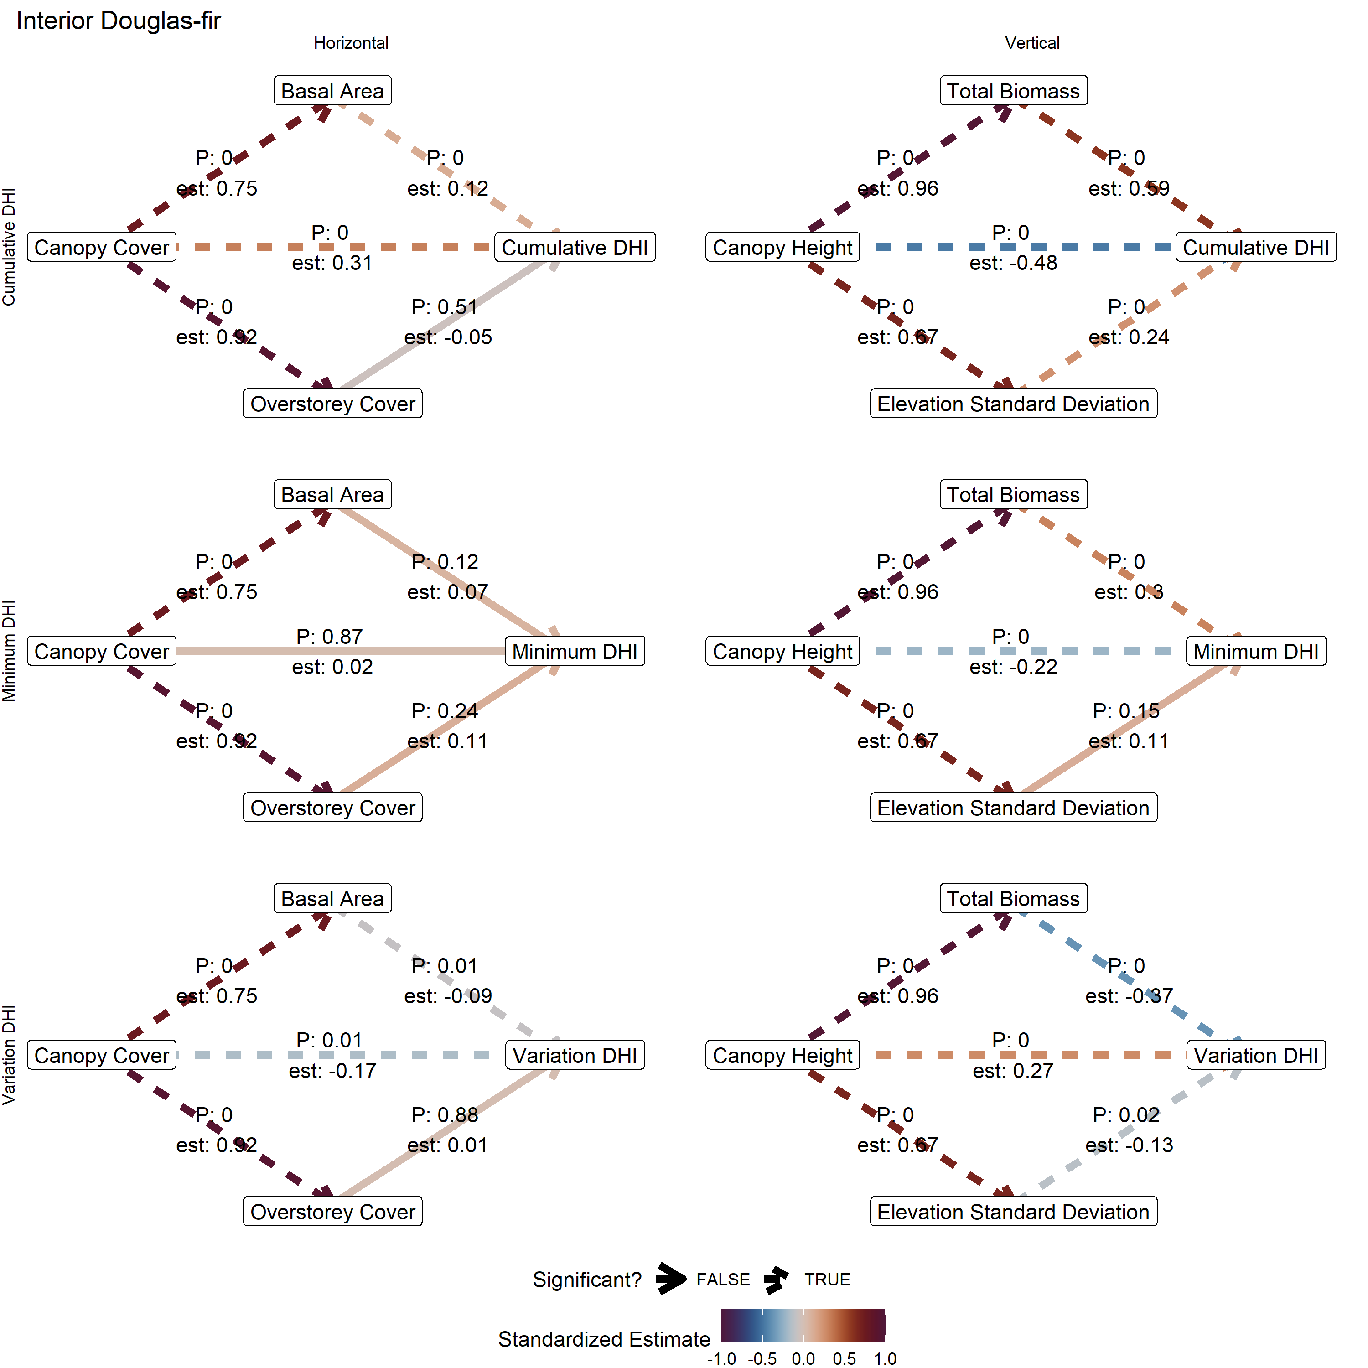

Figure Path diagrams for the six models including estimates and significance values for the Interior Douglas-fir BEC zone.

When aggregating all twelve forested BEC zones (Figure 3), the vertical, cumulative DI model shows that many of the paths are significant, with similar results to the IDF zone (Figure 2). There is a strong, negative direct effect from canopy height on cumulative DHI, but this is mediated to be overall positive through both total biomass and elevation standard deviation, the latter of which is less commonly significant, with a smaller, positive effect. There are no significant paths for the horizontal, minimum DHI model between overstorey cover and minimum DHI.

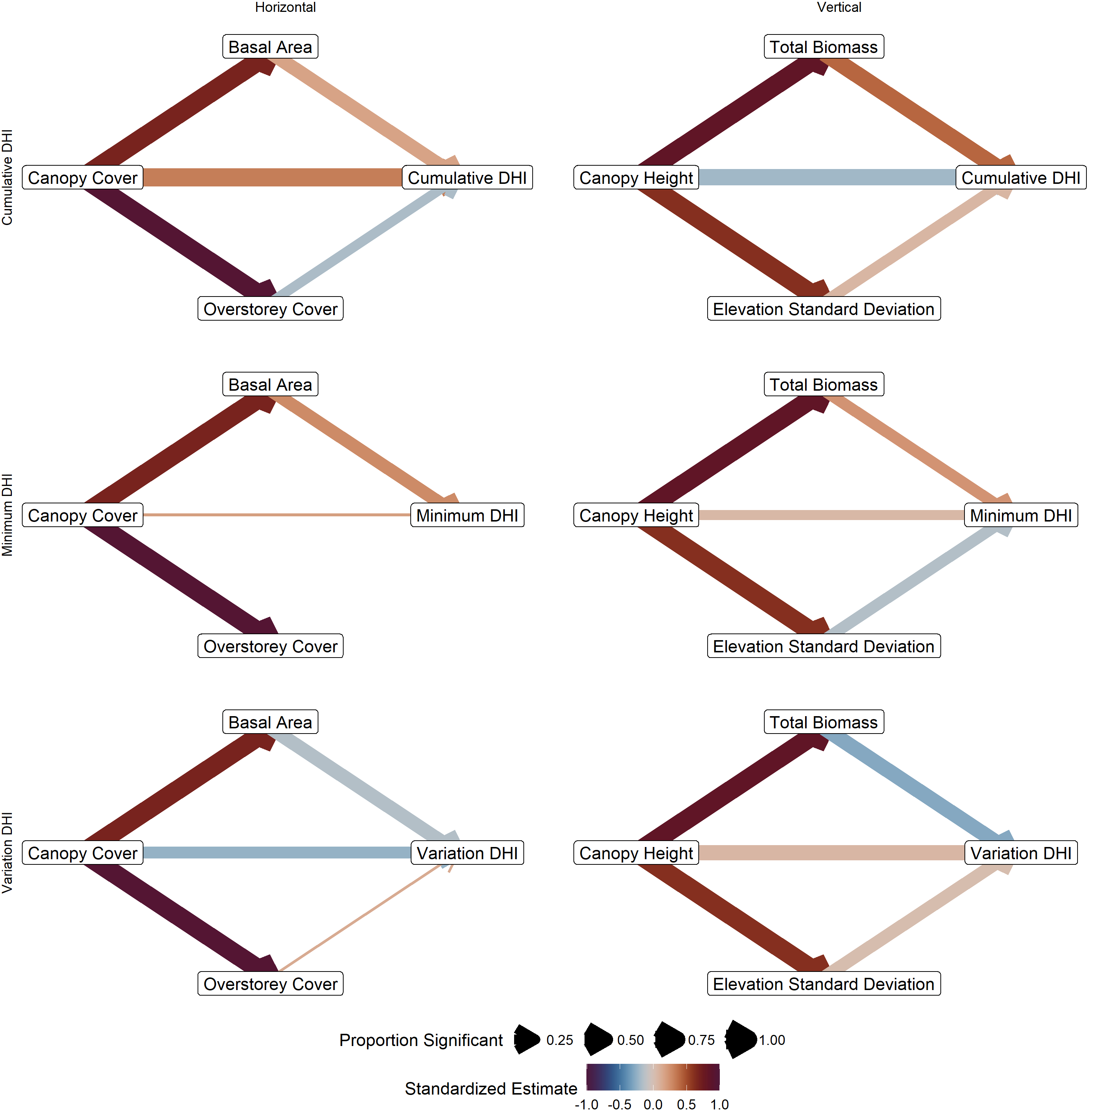

Figure Path diagrams for all six models summarized across the 12 forested BEC zones of British Columbia.