Furniture Management System Requirements Specification

Version 2.0

May 12, 2019

Documentation done by:

Dhimitraq Stambolliu

Eda Muka

Goldena Hoxhaj

Kejsi Kallmeti

Marina Piro

Pulia Letizia Naska

Accepted by:
Igli Hakrama

Table of Contents
1. Executive Summary 3
1.1 Project Overview 3
1.2 Purpose and Scope of this Specification 3
2. Product/Service Description 4
2.1 Product Context 4
2.2 User Characteristics 4
2.3 Assumptions 5
2.4 Constraints 5
2.5 Dependencies 6
3. Requirements 6
3.1 Functional Requirements 6
3.2 Non-Functional Requirements Error! Bookmark not defined.
3.2.1 User Interface Requirements 9
3.2.2 Usability 9
3.2.3 Performance 11
3.2.4 Manageability/Maintainability 12
3.2.5 System Interface/Integration 12
3.2.6 Security 13
3.2.7 Data Management 14
3.2.8 Standards Compliance 14
3.2.9 Portability 15
3.2.10 Other Non-Functional Requirements Error! Bookmark not defined.
3.3 Domain Requirements 15
4. User Scenarios/Use Cases 16
APPENDIX 18
Appendix A. Definitions, Acronyms, and Abbreviations 18
Appendix B. References 18
Appendix C. Requirements Traceability Matrix 18
Appendix D. Organizing the Requirements 20

Executive Summary

Project Overview
Taking in consideration the difficulties joineries cope with several tasks everyday, it seemed necessary to create a management system, which will consist of handling different tasks including those inside and outside of the furniture store. Furniture Management System intends to create a multitasking software for every employer at anytime while they are working.

The platform will be built in the way that it will join all the requirements putting those together and providing a practical and trustful way of managing their stopovers, purchases, payment history and order plans in a well-organized and functional system.

So, we think it is significant to have a well-built communication bridge between the administrator, user's needs and our conception. Since we aim to improve our system in a continuous time, these 3 elements need to be well-connected with each other.

Moreover, we have also thought to provide two users in our management system in that way it will be accessible easily by them. In order to ease the design components, the system should apply different technologies such as PHP, Android etc. FMS, the software which will be provided to them, will make every step of work easier to be executed and solve many issues relating to production, finance, human resources, sales.

Purpose and Scope of this Specification
The purpose of this specification is providing a detailed information, with all the components and elements for our web application. Regarding the target audience, it will be described in further details followed by the requirements and its interface.

Moreover, the intended audience of the software system is the administrator and the designer of the system. This software system will improve efficiency, effectiveness and productivity of the management system. FMS is built to:
- Grow e-commerce sales and drive innovation
- Improve control over purchasing and finance
- Reduce raw materials, inventory and labour costs
- Gain 360-degree visibility across its operations
- Reduce paperwork and to automate order processing

Product/Service Description

Product Context

Klajdi Furniture is a complex manufacturing company that includes many departments and it follows many operation processes to be a successful company. In order for the company to improve and to make its performance better, we will create a software.

Furniture Management System will be a system that collects and analyzes all the processes. This system will be of best interest to the company on the grounds it will help to keep their assets, their investment on their staff, materials, suppliers and on other business processes.

The software will facilitate the users of the system in decision making and will reduce time consumption. It will include information about suppliers, employees, products, sales, invoices, salary, customers, reports and production process.

User Characteristics

Users that are going to have access on the software are:
- Administrator:
  - Can add new users
  - Can manage the users’ login credentials
  - Will give access to those users
  - Will have access to everything in the system

- Chief Financial Officer (CFO):
  - Can register products
  - Can add brands
  - Can add category
  - Can register suppliers
  - Will generate monthly reports

- A human resources' specialist
  - Can add new employees
  - Can manage existing employees
  - Payroll management
  - Job evaluation

- Sales agent
  - Register customers
  - Will keep information of the customers
  - Will keep information for every sale
  - Will do reports regarding sales

- Operations manager
  - Add raw materials
  - Keep labor costs
  - Keep manufacturing overheads
  - Register machineries
  - Keep work instructions
  - Hold data of progress of the manufacturing process

Assumptions

- It is assumed that the system will be accessed from web browser on the computers, cell phones or tablets as long as they have connection to the internet.
- It is assumed the users are familiar with English language.
- It is assumed that the administrator will be the first user that can have access in the system , and afterwards the administrator will add the other users.
- It is assumed that the system will be easy to use from each user, even for those using the system for the first time.
- It is assumed that only sale agent will have access over customer information and this information is fully confidential.
- It is assumed that every month the CFO will prepare reports over the activities happened over this time.
- It is assumed that this reports will be viewed by the administrator for him to make managerial decisions.

Constraints

- Every user should have a personal device during working hours in order to access the web application.
- Since it will be a web application and get the data from database over the internet, it is essential to have stable internet connection to have a full time access in the system.
- There should exist real time communication between users in order to have the necessary information from each other , such as to prepare monthly reports.

Dependencies
Since the administrator has the main role, there exist some dependencies between him/her and other users where:
- If the admin is not registered in the system, other users will not be registered.
- If CFO does not make reports, admin will not be able to see them and make decisions.
- If HR specialist does not keep track of working days of each employee, then the CFO will not be able to calculate the wage of them.
- If sales agent does not keep good track of the sales, CFO will not make a correct income statement.
- If sales bill is not generated, the revenue will not be included in the balance sheet.

Requirements

Functional Requirements

Priority Definitions
- Priority 1 – The requirement is a “must have” as outlined by policy/law
- Priority 2 – The requirement is needed for improved processing, and the fulfillment of the requirement will create immediate benefits
- Priority 3 – The requirement is a “nice to have” which may include new functionality

The requirement numbering has a scheme - BR_0## (BR for Business Requirement).

Req# | Requirement | Comments | Priority | Date Reviewed | Approved
BR_01 | The system should have a web application  Which will be used by 5 users | They will be the administrator,CFO,HR,Sales Manager,OM. | 1 | 2/03/19 | Eda Muka,  Marina Piro
BR_02 | The administrator will give access to other user(CFO,HR,Sales Manager,OM.) | He/She will provide them with login information. | 1 | 2/03/19 | Eda Muka,  Marina Piro
BR_03 | The administrator will update users. | In case if the employees will change there will be a need for some updates | 1 | 2/03/19 | Eda Muka,  Marina Piro
BR_04 | Administrator will generate reports. | He will generate reports to see how is going the overall situation in company. | 1 | 2/03/19 | Eda Muka,  Marina Piro
BR_05 | Administrator will generate graphs. | They will help the administrator of the company to take best decision. | 1 | 2/03/19 | Eda Muka,  Marina Piro
BR_06 | CFO will generate and print weekly/monthly reports. | This is must to take decision in the company | 1 | 2/03/19 | Eda Muka,  Marina Piro
BR_07 | CFO will register every expense in the company. | As this is a manufacture company there are many expenses and is very important to keep track of them. | 1 | 2/03/19 | Eda Muka,  Marina Piro
BR_08 | CFO will register every sale in the company. | Every product that will be sold will be in the system | 1 | 2/03/19 | Eda Muka,  Marina Piro
BR_09 | CFO will register product. | First of all to make other operations, the products should be registered. | 1 | 2/03/19 | Eda Muka,  Marina Piro
BR_10 | Will be the responsibility of CFO to add new brand. | They manufacture lots of products but them import too so every product will be in the proper brand. | 2 | 2/03/19 | Eda Muka,  Marina Piro
BR_11 | Will be the responsibility of CFO to add new category. | As they have lots of products will be a need for new category so new products. | 2 | 2/03/19 | Eda Muka,  Marina Piro
BR_12 | CFO will add suppliers too. | Supply chain is very important for this company so there will be lots of information including prices during the times. | 1 | 2/03/19 | Eda Muka,  Marina Piro
BR_13 | The salaries will be  calculated by CFO. | CFO will calculate and then will pass to HR. | 1 | 2/03/19 | Eda Muka,  Marina Piro
BR_14 | CFO will view row materials. | He/She will have access to see them to calculate other stuffs. | 2 | 2/03/19 | Eda Muka,  Marina Piro
BR_15 | HR will add and delete new employees. | Every employee will be in the system with appropriate information. | 1 | 2/03/19 | Eda Muka,  Marina Piro
BR_16 | HR will update employees and information. | There can be some changes like address or phone number and everything will be updated. | 2 | 2/03/19 | Eda Muka,  Marina Piro
BR_17 | HR will make job evolution. | The work done by the employees will be put in the system in order to calculate salary,this includes even the days off. | 1 | 2/03/19 | Eda Muka,  Marina Piro
BR_18 | HR is responsible for the payroll management. |  | 1 | 2/03/19 | Eda Muka,  Marina Piro
BR_19 | Employee award. | Depending on the work done every month one employee will awarded as the best employee. | 3 | 2/03/19 | Eda Muka,  Marina Piro
BR_20 | Sales agent will add and print orders. | Every sale done will be added in the system by sales agent | 1 | 2/03/19 | Eda Muka,  Marina Piro
BR_21 | Sales agent will see reports. | In order to see how the sales are going or which product is sold more | 2 | 2/03/19 | Eda Muka,  Marina Piro
BR_22 | Sales person will register customers. | Every customer will be registered in system with their information | 1 | 2/03/19 | Eda Muka,  Marina Piro
BR_23 | Sales person will edit and view customers. | He/She will have the possibility to edit customers and to see them. | 1 | 2/03/19 | Eda Muka,  Marina Piro
BR_24 | Operation manager will add row materials | All materials like textile,wood etc will be added in system by operation manager. | 1 | 2/03/19 | Eda Muka,  Marina Piro
BR_25 | Operation manager will calculate labor cost | All cost will be added in the software in order to calculate the revenue. | 1 | 2/03/19 | Eda Muka,  Marina Piro
BR_26 | Operation manager will register machineries. | We are thinking to put them alone or to add machineries as a categories at the labor cost. | 2 | 2/03/19 | Eda Muka,  Marina Piro
BR_27 | Operation manager will put all work instruction. | All work that should be done by employees will be posted in the system by operation manager. | 1 | 2/03/19 | Eda Muka,  Marina Piro
BR_28 | Achievement of production | All work done by employees will be posted in the system by operation manager. | 1 | 2/03/19 | Eda Muka,  Marina Piro

Non-Functional Requirements

User Interface Requirements
Our application will be a web application; thus, it will be accessed from all web browsers on all computers having an internet connection.

The first page is going to be a login page, where the username and the password of the user will be required. In case of wrong login information, the user will be promptly alerted. Otherwise, the appropriate webpage will be opened. There will be 4 users: administrator, chief finance officer, human resource specialist and sales agent.

Our system will consist of several modules, providing that it will manage the whole company. These modules are the employee module, the order or sales module, the customer module, the supplier module and the report module.
The administrator is responsible for adding new users, such as CFO, HR specialist, sales agent or operations manager, to the system, managing the existing ones and viewing their details. After registering a new user, he/she will provide them with their login information so that they can access the system.

On the other hand, the CFO is responsible for keeping track of everything that happens in the company and updating the system. He/she will register products, add brands or category, generate monthly reports to give to the manager. The CFO will also register suppliers with their respective information.
The HR specialist will add new employees, manage existing ones and also manage departments. Other important features will be job evaluation and payroll management.

The sales agent will keep information of the customers of the company and every sale associated with each customer. At the end of each month, he/she will see the reports regarding the most sold products. After each sale, he/she will register new customers and keep track of the old ones.
The operations manager will add raw materials, labor and other costs associated with the production process. He/she will also register machineries, keep data on work instructions and achievement of production.

Usability
- Learnability
- The system is easy to use and understand.
- It will be built in such a way that every operation will be context sensitive and obvious to what it is achieving, in order to make it clearer to the user.

- Performance
- Users will have a high performance in completing a specific task of the management system.
- Most of the them will be able to use the system for the first time without assistance needed.

- Productivity
- The system will be productive meaning that all the tasks will be accomplished easily with the least amount of work and time.
- There will be few or no user errors.

- Accessibility
- The system will be accessible at any time by every registered user having a computer or mobile phone with internet connection

- User friendliness
- The system will be delightful to use.
- It shall not be intimidating, frustrating and look as though it demands a lot of time and effort to complete a simple task.

- Error tolerance
- The system shall be created in such a way that it will leave no room for error.
- It will be difficult for a simple task to go wrong.

- Effectiveness
- The software will aid the administrator and economist in doing their job effortlessly by providing easy tools of managing the system.
- Efficiency
- The system shall provide to the users a fast and reliable way of completing their respective tasks promptly with no difficulties and errors.

Performance

Capacity
- Being a web application, it will be stored in a web server.
- It will have a size of approximately 150 MB, whereas the database will probably be much less as it will be simple one.
- The number of simultaneous users will be limited to the number of users registered in the system.
- It will use no more than 3 GB of bandwidth a month.

Availability

The application will be available anytime and anywhere.
- It can be accessed by the users as long as they have internet connection.

The system is not geographically restricted, only language restricted (available only in English)

Downtime will be quite low and thus have low adverse impact on the business operations.

Latency

Latency is critical for web applications.

It shall depend on the speed on the internet connection, size of database.

The login module should load within 100ms.

The employee module should load within 300ms.

The sales or order modules should load within 300ms.

The customer module should load within 300ms

The supplier module should load within 400ms.

The report module should load within 400ms.

Manageability/Maintainability

Monitoring
The system will be built in such a way that there will be no room for system crashes.
The login interface requires a username and password as inputs. These inputs will be validated to be of the correct form. In case of wrong login information or invalid inputs, an error message will be displayed.
In the employee module, there will be a registration form to register new employees, a modification form to edit employees and a delete option. Putting invalid input into a field, for example putting a number in the name field, will result in a error. Leaving necessary fields empty will also lead to an error.
A failure condition is also added when data being added is not compatible with data in the database.

Maintenance
In case of a system crush, the web application is going to restart and it will be directed to the page where the crush occurred.
The web application will have a speed test system . It will be a download speed test, which is mostly crucial in printing financial reports.
Furthermore, in order to maintain the system, we will add back up, meaning that before any changes, the page shall back up in order not to lose progress.

Operations
There are certain operations that the application will aid the user with:
- Add new users (CFO, HR specialist, sales agent, operations manager)
- Change login credentials of the users
- Register suppliers
- Edit/delete suppliers
- Register products
- Edit/delete products
- Add brands
- Add categories
- Add a new employee
- Edit/delete employees
- Job evaluation
- Payroll management
- Add a new customer
- Edit/delete customers
- Create a sales report
- Create financial reports
- Add raw materials
- Keep track of labor costs and manufacturing overhead
- Register machineries

System Interface/Integration

Network and Hardware Interfaces
The application being a web application needs to be stored in a web server, so that the browser user agent would be able to create a TCP connection with server.

Systems Interfaces
System use protocol of HTTP and HTTPS. Also, the system will use SQL technologies and as networking protocol, UDP, TCP/IP. The user is not allowed to make any sort of changes to the database.

The system will use WIFI, mobile data, internet as networking interface.

The users will be able to authenticate using their: username and password. Users will be able to access the system and will have different User Interface based on their role and will show different functionalities.

The system is suitable to different time zones

Security

Protection
To protect data in system from destruction, malicious or accidental access, modification, disclosure, or misuse is required validation of data before entering to the database.
Functions by using regular expressions, will check for validation of:
- password
- Email address
- Username
- Name
We will keep track of the activity of each user.
By encrypting the most sensitive information such as password, using hash methods to protect privacy.
Each employee will see only the information related to him and admin can control information of other users.
Some measures are taken when added new employee or when changing employee data.
Security of the system will be achieved by:
- Encryption
- Activity logging
- Data integrity check

Authorization and Authentication
Each user will access only the respective information. The users which are connected to internet will be able to get into the system. Every user must put his credentials which are authenticate to access the interface and get into their account.
Authentication can be achieved by using sessions and by using cookies.

Data Management
Certain data will be accessed by certain users according to their task assigned.
Validation will be provided to some of information.
There will be data for the users, field that are covered are: name, surname, email, address, phone number.
There will be data for all services in this system.
Also, in this Furniture Management System will provide all necessary financial data.
Databases that are included in this system are:

- Users (id, username, name, password, email, phone number, address, cv, Joining date)
- Product (id, name, type, color, price, qty, description, parameters, size, brand, category, availability)
- Suppliers (id, name, address)
- Invoices (id, NIPT, name, address, contacts)
- Order ( orderID, cusName, OrderDate, price, total, qty, price)
- Brand (BrandID, BrandName, Status)
- Category (catName, Status)
- Departments (departmentID, deparmentJobs)
- Purchase (purchaseID, purchaseDate, supplier, prodName, qty, price, total, description)
- Customer (custID, custName, custPhone, custAddress)
- Production Details (Raw materials, labor cost, register Machineries, work instructions)

Standards Compliance
The application will respect the rules and regulations determined by “Ligji nr 25/2018 PER KONTABILITETIN DHE PASQYRAT FINANCIARE” to provide higher proficiency and efficiency.

The system must have all the field that the company maintain information about all the departments. The system will generate reports requested by the accountant and will generate bills based on orders according to the “Drejtoria e Pergjithshme e Tatimeve”.

Portability
- Our software will be web-based, since it will be developed using PHP language.
- Hence its operations will work with no difference whatever the operating system of the user will be.
- Can easily undertake cross-platform development.

Domain Requirements
The program that we will develop will make possible the digitalization of the jobs in a furniture store. More specifically, it will help the company to organize better its work by basing their decisions in well-detailed reports that the program will provide. Since the main goal of the software will be showing the monthly performance of the company, then this information shall be accessed by all the users. In this way, both the manager and the CFO of the furniture store can make better decisions in the future, based on the previous performance of the company.

In addition, HR should handle only the employees of the company, hence all their detailed information should be available to him/her. For the other users this part will not be fully disclosed.

The information about all the departments will be handled by the administrator of the company.
The economist will handle the financial statements, products, suppliers, reports and salary part of the program.

The sales agent duty is to manage the orders and customers of the company through this program.

User Scenarios/Use Cases

User Scenarios

Nr | User Scenario | Description
 | Register users | Admin registers users.
 | Login as user | The users: admin, economist, HR, OM successfully login into the software.
 | Fail to Login | User fails to login using his username and password.
 | Add a new customer | The sales agent registers the customer into the system.
 | Customers’ list | View all the customers of the company.
 | Update customer details | Sales agent updates customer details.
 | Add a new supplier | CFO adds new supplier in the database.
 | Suppliers’ list | View all suppliers.
 | Update supplier | CFO updates new details of supplier.
 | Add a new purchase | CFO adds details of purchases done by the company.
 | Purchases’ list | View all the purchases details that are stored in the database.
 | Update purchase | CFO can modify the purchases details.
 | View inventory | CFO can access details of inventory.
 | Add new employee | HR adds new employee in the database.
 | Employees’ list | View all employees of the company.
 | Update employee | HR updates employee’s information.
 | Add new product | CFO adds new product in the system.
 | Products’ list | View all products.
 | Update product | CFO updates new details of product.
 | Generate financial statement | CFO manages the financial statements of the company.
 | Add new order | Sales agent adds new order in the system.
- 0 | Orders’ list | View all orders of a month.
 | Update order | Sales agent updates an order in case of errors.
 | Add new invoice | The sales agent creates a new invoice.
 | Invoices’ list | View all the invoices.
 | Update invoice | The sales agent may update the invoice.
 | Calculate salary of employee | The CFO makes use of HR department information to calculate the salary of an employee.
 | Update salary | The CFO updates the salary in case it changes.
 | Reports | The CFO, HR, sales agent and Operation Manager generate reports, which are accessible to the Administrator of the company.
 | Manufactured products | The Operations Manager adds information about the manufactured products.
 | Manage work instructions | The operation manager may add, edit or delete work instructions of different processes in the system.
 | Update achievement of production | In the end of the day, the operation manager shall update the achievement of production for each category of furniture.

User scenarios extended

- Register users.
- Admin logs in the system using his/her credentials.
- When successfully logged in, s/he is redirected to his home page.
- Admin selects the “Register user” button.
- Admin is directed to a form page that gathers information about each user registration.
- The “Submit” button is selected.
- The data inserted follows a validation process.
- If data are:
- Correctly inserted, the alert message “User is successfully registered” is shown and data are automatically registered in the database.
  - Admin is directed to his/her home page.
- incorrect, alert messages for the specific errors in the fields of the form are displayed.
  - Admin corrects the fields then resubmits the data. Steps 6 and 7 are repeated until 7/a is fulfilled.

US_02 and US_03 - Login as user and Fail to Login.
- User chooses from the main page the department where he/she operates such as: Human Resources, Finance, Customer Relations, Operations Management and Manager.
- According to the selected department, user is redirected to the login page where he/she inserts his credentials.
- If username and password are:
  - correctly inserted, user successfully logs in.
    - user is directed to his/her home page.
  - not right, user fails to log in.
    - user is directed to the login page and all the above-mentioned steps are repeated until user is successfully logged in.
US_04 - Add a new customer.
- Sales manager logs in following the steps of US_01.
- The “Customers” section is selected.
- After a table with previous customers is displayed, sales agent may select the “Add new Customer” button.
- Sales manager fills in the form displayed to gather customer data.
- The “Submit” button is selected.
- The data inserted follows a validation process.
- If data are:
  - correctly inserted, the message “Customer is successfully registered” is displayed and data are automatically registered in the database.
    - Sales manager is directed to the table of customers.
  - incorrect, alert messages for the specific errors in the fields of the form are displayed.
    - Sales manager corrects the fields then resubmits the data. Steps 6 and 7 are repeated until 7/a is fulfilled.

US_05 - View customers’ list.
- Sales manager logs in following the steps of US_01.
- The “Customers” section is selected.
- A table with all customers’ details is displayed.

US_06 - Update customer details.
- Sales manager logs in following the steps of US_01.
- The “Customers” section is selected.
- After table with the customers’ details is displayed, the sales manager may choose the “Update” button in the end of each row.
- Sales manager is directed to the form page, where he/she can edit the fields that has to be changed to that specific customer.
- The “Submit” button is selected
- Data follows a validation process
- If data are:
  - correctly inserted, the message “Customer’s details are successfully updated” is displayed and data are automatically updated in the database too.
    - Sales manager is directed to the table of customers.
  - incorrect, alert messages for the specific errors in the fields of the form are displayed.
    - Sales manager corrects the fields then resubmits the data. Steps 6 and 7 are repeated until 7/a is fulfilled.

US_07 - Add a new supplier.
- CFO logs in following the steps of US_01.
- The “Supplier” section is selected.
- After a table with previous suppliers is displayed, CFO may select the “Add new supplier” button.
- CFO fills in the form displayed to gather supplier data.
- The “Submit” button is selected.
- The data inserted follows a validation process.
- If data are:
  - correctly inserted, the message “Supplier is successfully registered” is displayed and data are automatically registered in the database.
    - CFO is directed to the table of suppliers.
  - incorrect, alert messages for the specific errors in the fields of the form are displayed.
    - CFO corrects the fields then resubmits the data. Steps 6 and 7 are repeated until 7/a is fulfilled.
US_08 - View suppliers’ list.
- CFO logs in following the steps of US_01.
- The “Suppliers” section is selected.
- A table with all suppliers’ details is displayed.

US_09 - Update supplier’s details.
- CFO logs in following the steps of US_01.
- The “Supplier” section is selected.
- After table with the suppliers’ details is displayed, the CFO may choose the “Update” button in the end of each row.
- CFO is directed to the form page, where he/she can edit the fields that has to be changed to that specific supplier.
- The “Submit” button is selected.
- Data follows a validation process
- If data are:
  - correctly inserted, the message “Supplier’s details are successfully updated” is displayed and data are automatically updated in the database too.
    - CFO is directed to the table of suppliers.
  - incorrect, alert messages for the specific errors in the fields of the form are displayed.
    - CFO corrects the fields then resubmits the data. Steps 6 and 7 are repeated until 7/a is fulfilled.
US_10 - Add a new purchase.
- CFO logs in following the steps of US_01.
- The “Purchases” section is selected.
- After a table with previous purchases is displayed, CFO may select the “Add new purchase” button.
- CFO fills in the form displayed to gather purchase data.
- The “Submit” button is selected.
- The data inserted follows a validation process.
- If data are:
  - correctly inserted, the alert message “Purchase is successfully registered” is displayed and data are automatically registered in the database.
    - CFO is directed to the table of purchases.
  - incorrect, alert messages for the specific errors in the fields of the form are displayed.
    - CFO corrects the fields then resubmits the data. Steps 6 and 7 are repeated until 7/a is fulfilled.
US_11 - View purchases’ list.
- CFO logs in following the steps of US_01.
- The “Purchases” section is selected.
- A table with all purchases’ details is displayed.

US_12 - Update purchase.
- CFO logs in following the steps of US_01.
- The “Purchases” section is selected.
- After table with the purchases’ details is displayed, the CFO may choose the “Update” button in the end of each row.
- CFO is directed to the form page, where he/she can edit the fields that has to be changed to that specific purchase.
- The “Submit” button is selected.
- Data follows a validation process
- If data are:
  - correctly inserted, the message “Purchase’s details are successfully updated” is displayed and data are automatically updated in the database too.
    - CFO is directed to the table of purchases.
  - incorrect, alert messages for the specific errors in the fields of the form are displayed.
    - CFO corrects the fields then resubmits the data. Steps 6 and 7 are repeated until 7/a is fulfilled.
US_13 - View inventory.
- CFO logs in following the steps of US_01.
- The “Inventory” section is selected.
- CFO can select the month for the purchased products or produced products, which represent the inventory of the company.
- A table with all inventory details is displayed.

US_14 - Add a new employee.
- HR manager logs in following the steps of US_01.
- The “Employees” section is selected.
- After a table with previous employees is displayed, HR manager may select the “Add new employee” button.
- HR manager fills in the form displayed to gather employee data.
- The “Submit” button is selected.
- The data inserted follows a validation process.
- If data are:
  - correctly inserted, the alert message “Employee is successfully registered” is displayed and data are automatically registered in the database.
    - HR manager is directed to the table of employees.
  - incorrect, alert messages for the specific errors in the fields of the form are displayed.
    - HR manager corrects the fields then resubmits the data. Steps 6 and 7 are repeated until 7/a is fulfilled.

US_15 - View employees’ list.
- HR manager logs in following the steps of US_01.
- The “Employees” section is selected.
- A table with all employees’ details is displayed.

US_16 - Update employee’s details.
- HR manager logs in following the steps of US_01.
- The “Employees” section is selected.
- After table with the employees’ details is displayed, the HR manager may choose the “Update” button in the end of each row.
- HR manager is directed to the form page, where he/she can edit the fields that has to be changed to that specific employee.
- The “Submit” button is selected.
- Data follows a validation process
- If data are:
  - correctly inserted, the message “Employee’s details are successfully updated” is displayed and data are automatically updated in the database too.
    - HR manager is directed to the table of employees.
  - incorrect, alert messages for the specific errors in the fields of the form are displayed.
    - HR manager corrects the fields then resubmits the data. Steps 6 and 7 are repeated until 7/a is fulfilled.

US_17 - Add a new product.
- CFO logs in following the steps of US_01.
- The “Products” section is selected.
- After a table with registered products is displayed, CFO may select the “Add new product” button.
- CFO fills in the form displayed to gather product data.
- The “Submit” button is selected.
- The data inserted follows a validation process.
- If data are:
  - correctly inserted, the alert message “Product is successfully registered” is displayed and data are automatically registered in the database.
    - CFO is directed to the table of products.
  - incorrect, alert messages for the specific errors in the fields of the form are displayed.
    - CFO corrects the fields then resubmits the data. Steps 6 and 7 are repeated until 7/a is fulfilled.

US_18- View products’ list.
- CFO logs in following the steps of US_01.
- The “Products” section is selected.
- A table with all products’ details is displayed.

US_19 - Update product’s details.
- CFO logs in following the steps of US_01.
- The “Products” section is selected.
- After table with the products’ details is displayed, the CFO may choose the “Update” button in the end of each row.
- CFO is directed to the form page, where he/she can edit the fields that has to be changed to that specific product.
- The “Submit” button is selected.
- Data follows a validation process
- If data are:
  - correctly inserted, the message “Product’s details are successfully updated” is displayed and data are automatically updated in the database too.
    - CFO is directed to the table of products.
  - incorrect, alert messages for the specific errors in the fields of the form are displayed.
    - CFO corrects the fields then resubmits the data. Steps 6 and 7 are repeated until 7/a is fulfilled.

US_20 – Generate income statement.
- CFO logs in following steps of US_01.
- The “Income statement” section is selected.
- The monthly revenue and expenses are shown by selecting a month.
- CFO fills in with the appropriate numbers the fields of the income statement that is generated bellow.
- Data follows a validation process
- If data are:
  - correctly inserted, the alert message “Income statement successfully created” is displayed and data are automatically registered in the database too.
    - CFO is directed to the “Income statement” section.
  - incorrect, alert messages for the specific errors in the fields of the form are displayed.
    - CFO corrects the fields then resubmits the data. Steps 5 and 6 are repeated until 6/a is fulfilled.
- After filling in the appropriate numbers, the “Save” or “Print” button can be selected.

US_21 - Add a new order.
- Sales agent logs in following the steps of US_01.
- The “Orders” section is selected.
- After a table with previous orders is displayed, sales agent may select the “Add new order” button.
- Sales agent fills in the form displayed to register details about the order.
- The “Submit” button is selected.
- The data inserted follows a validation process.
- If data are:
  - correctly inserted, the alert message “Order is successfully registered” is displayed and data are automatically registered in the database.
    - Sales agent is directed to the table of orders.
  - incorrect, alert messages for the specific errors in the fields of the form are displayed.
    - Sales agent corrects the fields then resubmits the data. Steps 6 and 7 are repeated until 7/a is fulfilled.
US_22 - View orders’ list.
- Sales agent logs in following the steps of US_01.
- The “Orders” section is selected.
- A table with all orders’ details is displayed (divided monthly).

US_23 - Update order’s details.
- Sales agent logs in following the steps of US_01.
- The “View orders” button is selected.
- After table with the orders’ details is displayed, the sales agent may choose the “Update” button in the end of each row.
- Sales agent is directed to the form page, where he/she can edit the fields that has to be changed to that specific order.
- The “Submit” button is selected.
- Data follows a validation process
- If data are:
  - correctly inserted, the alert message “Order’s details are successfully updated” is displayed and data are automatically updated in the database too.
    - Sales agent is directed to the table of orders.
  - incorrect, alert messages for the specific errors in the fields of the form are displayed.
    - Sales agent corrects the fields then resubmits the data. Steps 6 and 7 are repeated until 7/a is fulfilled.

US_24 - Add a new invoice.
- Sales agent logs in following the steps of US_01.
- Under the “Orders” section, the “Add invoice” sub-section is selected
- Sales agent fills in the form displayed to register details about the invoice.
- The “Submit” button is selected.
- The data inserted follows a validation process.
- If data are:
  - correctly inserted, the alert message “Invoice is successfully registered” is displayed and data are automatically registered in the database.
    - Sales agent can print the invoice by selecting the “Print” button
OR
    - Sales agent cane be directed to his/her home page by selecting the “Back” button.
  - incorrect, alert messages for the specific errors in the fields of the form are displayed.
    - Sales agent corrects the fields then resubmits the data. Steps 5 and 6 are repeated until 6/a is fulfilled.

US_25 - View invoices’ list.
- Sales agent logs in following the steps of US_01.
- The “Invoices” subsection is selected.
- A table with all invoices’ details is displayed (divided monthly).

US_26 - Update invoice’s details.
- Sales agent logs in following the steps of US_01.
- The “Invoices” subsection is selected.
- After table with the invoices’ details is displayed, the sales agent may choose the “Update” button in the end of each row.
- Sales agent is directed to the form page, where he/she can edit the fields that has to be changed to that specific invoice.
- The “Submit” button is selected.
- Data follows a validation process
- If data are:
  - correctly inserted, the alert message “Invoice’s details are successfully updated” is displayed and data are automatically updated in the database too.
    - Sales agent is directed to the table of invoices.
  - incorrect, alert messages for the specific errors in the fields of the form are displayed.
    - Sales agent corrects the fields then resubmits the data. Steps 6 and 7 are repeated until 7/a is fulfilled.

US_27 – Calculate salary of employee.
- CFO logs in following the steps of US_01.
- The “Salaries” section is selected.
- A table is displayed containing employee details (provided by the HR department) about their performance during a month.
- CFO may use a given formula to calculate salary of employee, or edit the given formula.
- Changes in the table of salaries (payrolls) are saved.

US_28 – Update salary.
- CFO logs in following the steps of US_01.
- The “Salaries” section is selected.
- A table is displayed containing employee details (provided by the HR department) including their salary.
- CFO selects “Update” button located in the end of each row.
- CFO makes the required updates to the salaries.
- Changes in the table of salaries(payrolls) are saved.

US_29 – Reports.
- Each user log in following the steps of US_01.
- The “Reports” section is selected.
- Each user may generate reports based on the data that they can access.

US_30 – Manufactured products.
- Operations’ manager logs in following the steps described in US_01.
- The “Manufactured products” section is selected.
- At the end of each working day, operations’ manager reports about the details of the produced furniture.
- The “Save” button is selected.

US_31 – Manage work instructions.
- Operations’ manager logs in following the steps of US_01.
- “Work instructions” section is selected.
- A web page is displayed that shows work instruction for different processes.
- Operations’ manager may edit or delete information displayed.

US_32 – Update achievement of production.
- Operations’ manager logs in following the steps of US_01.
- “Achievements of production” section is selected.
- Based on the advancement of work during the day, the operations’ manager reports in percentage the progress for each category of products.

Use cases

Name | Register Users
Summary | Admin logs in the system and register other Users of FMS
Actor | Admin
Description | Admin needs to login first in order to access the module. Admin must enter valid name/ username. Must Register a User by filling valid data about them
Precondition | Admin who loges in, must have first an existing account, with a specific username and password.
Alternative | There are no alternative options. This is done in order to protect confidential information.
Post Condition | To gain access to the modules provided by the software system.

Name | User Login
Summary | The user enters the system by entering valid credentials
Actor | Sales Agent, Human Resource, Finance, Operation Manager, Administrator
Description | User needs to login first in order to access the module. The user must enter valid name/ username.
Precondition | The user who loges in, must have first an existing account, with a specific username and password.
Alternative | There are no alternative options. This is done in order to protect confidential information.
Post Condition | To gain access to the modules provided by the software system.

Name | Customer Registration
Summary | Sales Agent register a customer with needed information
Actor | The primary actor is Sales Agent
Description | Sales Agent is able to create a new customer. This is done by completing a form with customer information, completed by sales agent.
Precondition | Sales agent must be logged in into the system
Alternative | There are no alternative options.
Post Condition | Be aware of the customer activities, by keeping track their activity.

Name | View and Search Customer
Summary | Sales Agent can search and view all the customer list that are registered
Actor | The primary actor is Sales Agent
Description | Sales Agent can search for a customer and its details in order to easily access the necessary information.
Precondition | Sales agent must be logged in into the system and must have registered customer
Alternative | The new data added to the customer is not valid.
Post Condition | Be aware of missing of necessary information of customers.

Name | Customer Updated
Summary | Sales Agent updates customer information
Actor | The primary actor is Sales Agent
Description | Sales Agent is able to update existing customer. This is done by updating the form of customer information which are based on the purchase of customers.
Precondition | Sales agent must be logged in into the system and must be registered a customer
Alternative | There are no alternative options.
Post Condition | To update necessary information

Name | Add Supplier
Summary | CFO make the registration of a supplier when a new raw material is purchased
Actor | The primary actor is CFO (Finance)
Description | CFO log in into the system and fill the registration form for a new supplier. Enter all necessary details
Precondition | CFO must be logged in into the system and must be purchased a raw material from supplier
Alternative | There is an existing supplier
Post Condition | After finishing this task CFO may access other functionalities

Name | View/ Update Suppliers
Summary | CFO search and view all the necessary information for a supplier
Actor | The primary actor is CFO (Finance)
Description | CFO log in into the system and see all the list of suppliers. CFO clicks the name of the supplier that want to make changes and edit them. CFO makes the changes also in database
Precondition | User must be logged in.
Alternative | The new data entered to the supplier is not valid. System gives the opportunity to enter the new data.
Post Condition | After finishing this task CFO may access other functionalities

Name | Add Purchase
Summary | CFO manages purchases for the company. He/she register all products that enters in the company
Actor | The primary actor is CFO
Description | CFO manager log in into the system and select the option to add a new Purchase. Fills in the form to gather purchase data and select submit.
Precondition | CFO manager must be logged in into the system
Alternative | There is no alternate form
Post Condition | After finishing this task CFO manager may access other functionalities

Name | View/ Update Purchase
Summary | CFO manages purchases for the company. He/she register all products that enters in the company
Actor | The primary actor is CFO
Description | CFO manager logs in into the system and is directed to the form page, where he/she can edit the fields that has to be changed to  that specific purchase.
Precondition | CFO manager must be logged in into the system
Alternative | There is no alternate form
Post Condition | After finishing this task CFO manager may access other functionalities

Name | View inventory
Summary | CFO can access information in the Inventory section
Actor | The primary actor is CFO
Description | CFO manager logs in into the system and selects the Inventory section, where he/she can see monthly availability of purchased products or manufactured products.
Precondition | CFO manager must be logged in into the system
Alternative | There is no alternate form
Post Condition | After finishing this task CFO manager may access other functionalities

Name | Register employee
Summary | HR manager fills in the form displayed to gather employee data such as name, surname, ID, photo, CV…
Actor | The primary actor is HR manager
Description | HR manager log in into the system and select the option to add a new employee. Fills in the form the personal data of the employee, upload to the employee data the CV in pdf format, upload photo and finishes the process of entering employee data
Precondition | HR manager must be logged in into the system
Alternative | There is no alternate form
Post Condition | After finishing this task HR manager may access other functionalities

Name | View/Update employee data
Summary | HR manager has the right to view and update the employee data. They can edit and show all the necessary data
Actor | The primary actor is HR manager
Description | HR manager log in into the system and require to view all the list of employees. He fills in the form the personal data, CV and photo. HR makes changes also in the database
Precondition | HR manager must be logged in into the system.
Alternative | There is not an alternate form
Post Condition | After finishing this task HR manager may access other functionalities

Name | Add Product
Summary | CFO make the registration of a product when a new raw material is purchased
Actor | The primary actor is CFO (Finance)
Description | CFO log in into the system and require to register a new product. Fill the registration form for a new product. Enter all necessary details in a valid form
Precondition | CFO must be logged in into the system and must be purchased a product
Alternative | There is not an alternate form
Post Condition | After finishing this task CFO may access other functionalities

Name | View/ Update product
Summary | CFO has the right to view and update all the products.
Actor | The primary actor is CFO (Finance)
Description | CFO log in into the system and require to view all the list of products. CFO can click the name of the product that want and update the necessary of data in the valid form. CFO makes changes also in database.
Precondition | CFO must be logged in into the system
Alternative | There isn’t an alternate form
Post Condition | After finishing this task CFO may access other functionalities

Name | Generate Income Statement
Summary | CFO logs in the system and the “Income statement” section is selected which show the current finance state.
Actor | The primary actor is CFO (Finance)
Description | The monthly revenue and expenses are shown by selecting a month. CFO fills in with the appropriate numbers the fields of the income statement that is  generated bellow. Data follows a validation process
Precondition | CFO must be logged in into the system
Alternative | There isn’t an alternate form
Post Condition | After finishing this task CFO may access other functionalities

Name | Add new Order
Summary | Sales Agent has the right to make a new order according to customer request.
Actor | The primary actor is Sales Agent
Description | Sales Agent log in into the system and the “Orders” section is selected. After a table with previous orders is displayed, sales agent may select the “Add new order”  button. Sales agent fills in the form displayed to register details about the order. The “Submit” button is selected. The data inserted follows a validation process.
Precondition | CFO must be logged in into the system
Alternative | There isn’t an alternate form
Post Condition | After finishing this task CFO may access other functionalities

Name | View order list
Summary | Sales agent has the right to view order list
Actor | The primary actor is sales agent
Description | Sales Agent log in into the system and require to view orders in order to see if they are accomplished since it is a manufacture company and it needs time to be done.
Precondition | Sales Agent must be logged in into the system.
Alternative | There is no alternate form
Post Condition | After finishing this task sales agent may access other functionalities

Name | Update Order
Summary | Sales agent has the right to update the order
Actor | The primary actor is sales agent
Description | Sales Agent log in into the system and the “View orders” button is selected. After table with the orders’ details is displayed, the sales agent may choose the “Update”  button in the end of each row. Sales agent is directed to the form page, where he/she can edit the fields that has to be  changed to that specific order.
Precondition | Sales Agent must be logged in into the system. Also, CFO should have registered in system name of products, brands and categories.
Alternative | Sales agent may cancel the order
Post Condition | After finishing this task sales agent save as pdf format or may access other functionalities

Name | Add invoice
Summary | Sales Agent has the right to generate an invoice
Actor | The primary actor is Sales Agent
Description | Sales Agent log in into the system and Under the “Orders” section, the “Add invoice” sub-section is selected. Sales agent fills in the form displayed to register details about the invoice. The “Submit” button is selected.
Precondition | Sales Agent must be logged in into the system.
Alternative | CFO may show the financial statement to admin.
Post Condition | After finishing this task CFO may download it and may access other functionalities

Name | View Invoice
Summary | Sales Agent has the right to view all the invoices.
Actor | The primary actor is Sales Agent
Description | Sales Agent log in into the system and require to view all the invoices. A table with the invoices details is displayed.
Precondition | Sales Agent must be logged in into the system
Alternative | There isn’t an alternate form
Post Condition | After finishing this task CFO may access other functionalities

Name | Update Invoice
Summary | Sales agent has the right to update invoices.
Actor | The primary actor is sales agent
Description | Sales agent log in into the system and require to update an invoice. Sales agent can click the name of the invoice that want and update the necessary of data in the valid form. Sales Agent makes changes also in database.
Precondition | Sales Agent must be logged in into the system
Alternative | There isn’t an alternate form
Post Condition | After finishing this task Sales Agent may access other functionalities

Name | Calculate salary of employee
Summary | CFO has the right to calculate the salary of employee.
Actor | The primary actor is CFO
Description | CFO log in into the system and require to calculate the salary of employee. A table is displayed containing employee details (provided by the HR department) about  their performance during a month. CFO may use a given formula to calculate salary of employee, or edit the given formula.
Precondition | CFO must be logged in into the system and HR manager must have registered employees
Alternative | There isn’t an alternate form
Post Condition | After finishing this task CFO may access other functionalities

Name | Update Salary
Summary | CFO has the right to update the employee’s salary
Actor | The primary actor is CFO
Description | CFO log in into the system and require to update the salary of employee. A table is displayed containing employee details (provided by the HR department) about  their performance during a month. CFO selects “Update” button located in the end of each row.
Precondition | CFO must be logged in into the system and HR manager must have registered employees
Alternative | There isn’t an alternate form
Post Condition | After finishing this task CFO may access other functionalities

Name | Reports
Summary | Each user may generate reports based on the data that they can access.
Actor | The primary actor is Admin, CFO, HR, Sales agent, Operation Manager
Description | Each user logs in into the system and require report according to the module that they are responsible. Each user may generate reports based on the data that they can access.
Precondition | Each user must be logged in into the system
Alternative | There isn’t an alternate form
Post Condition | After finishing this task each user may access other functionalities

Name | Add Manufactured Product
Summary | Operation manager enter details about the manufactured products.
Actor | The primary actor is Operation Manager
Description | Operation Manager log in into the system and choose the option to enter Manufactured Product details. OM fill in the form displayed all the information
Precondition | OM must be logged in into the system
Alternative | There isn’t an alternate form
Post Condition | After finishing this task OM may access other functionalities

Name | Add Work Instructions
Summary | Operation manager enter details about the work instructions
Actor | The primary actor is Operation Manager
Description | Operation Manager log in into the system and choose the option to enter details about the work instructions. Enter details about machine hour used.
Precondition | OM must be logged in into the system
Alternative | There isn’t an alternate form
Post Condition | After finishing this task OM may access other functionalities

Name | Update achievement of production
Summary | Operation manager enter details about the achievement of production
Actor | The primary actor is Operation Manager
Description | Operation Manager log in into the system and choose the option to enter details about the achievement of production. Based on the advancement of work during the day, the operations’ manager reports for  each product of different categories how much they are completed.
Precondition | OM must be logged in into the system
Alternative | There isn’t an alternate form
Post Condition | After finishing this task OM may access other functionalities

Diagrams

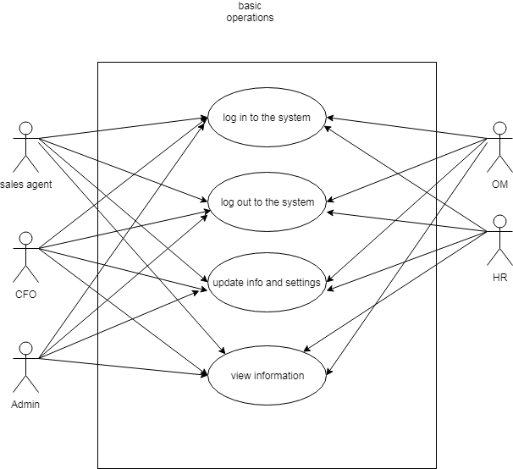
Use case diagrams

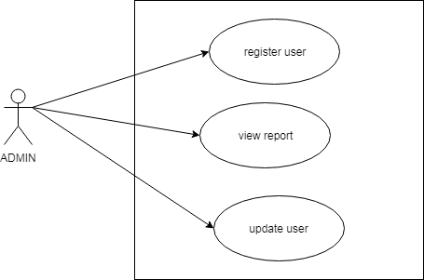

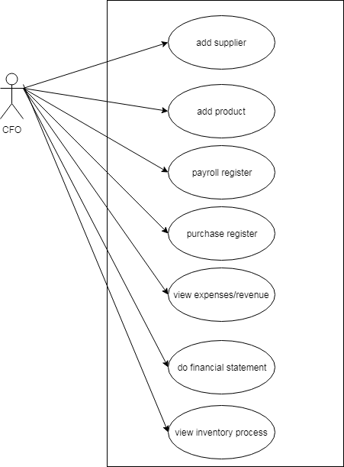

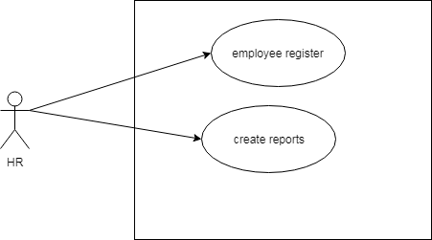
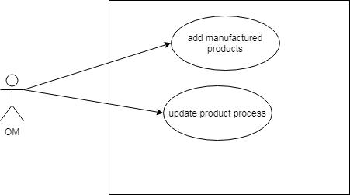

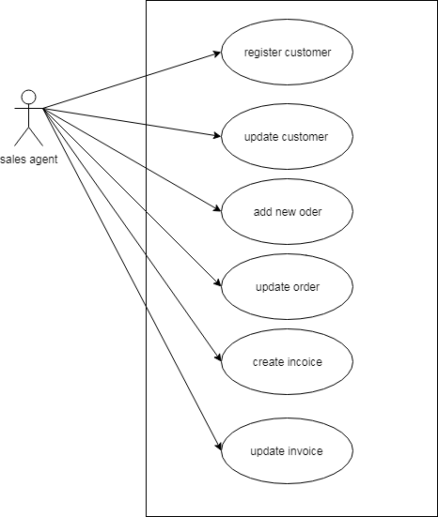

5.2 Activity Diagrams
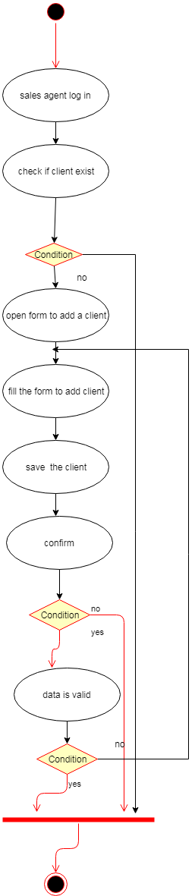
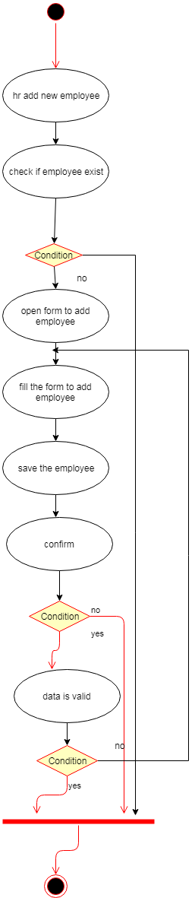
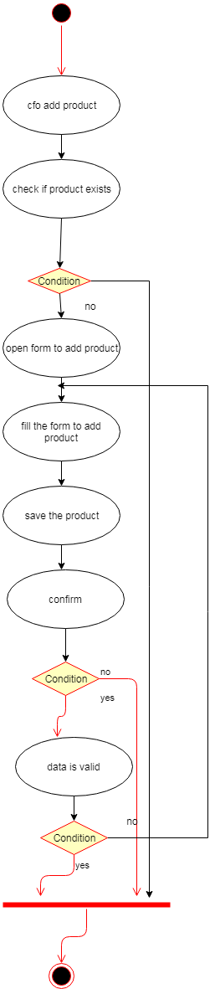

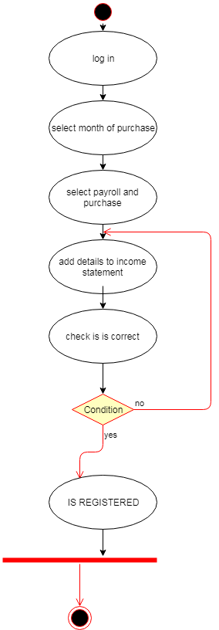
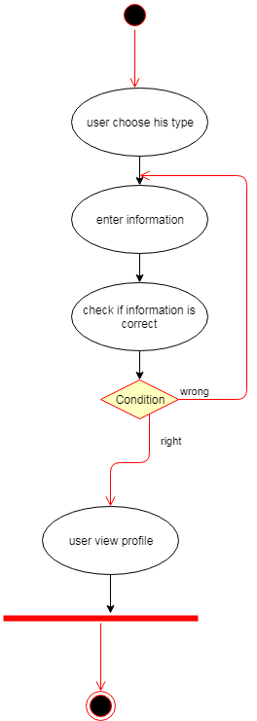
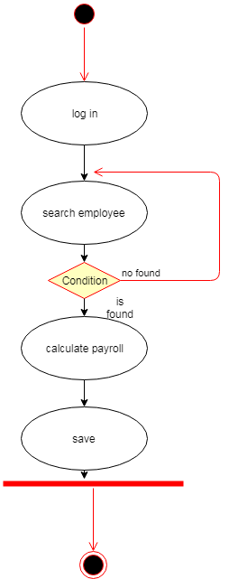

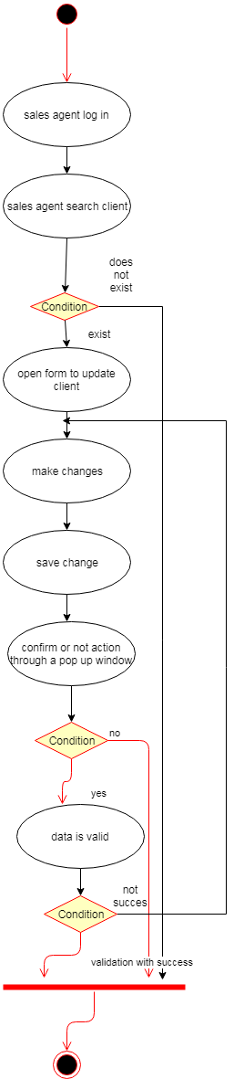
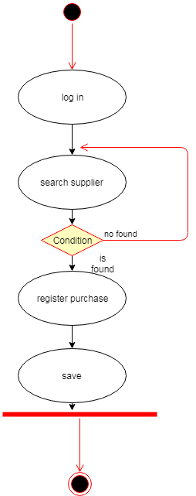
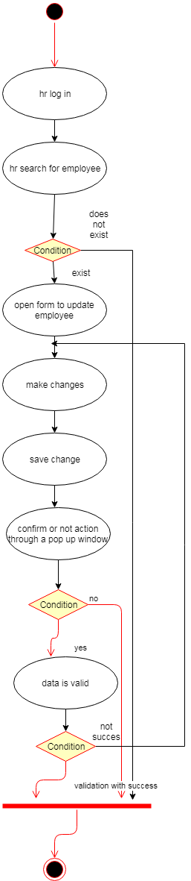
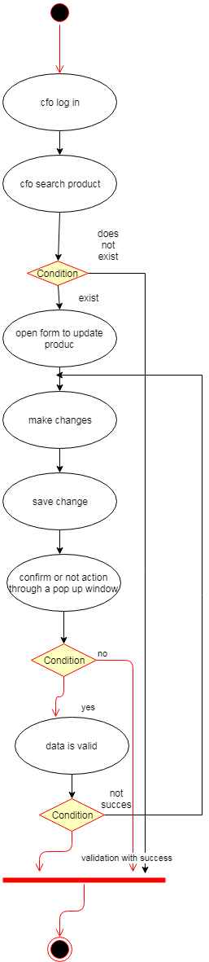

State Diagrams

Admin state diagram

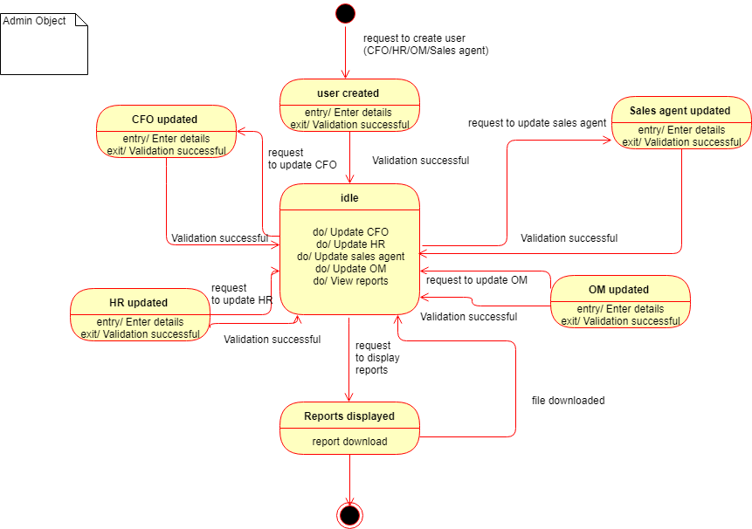

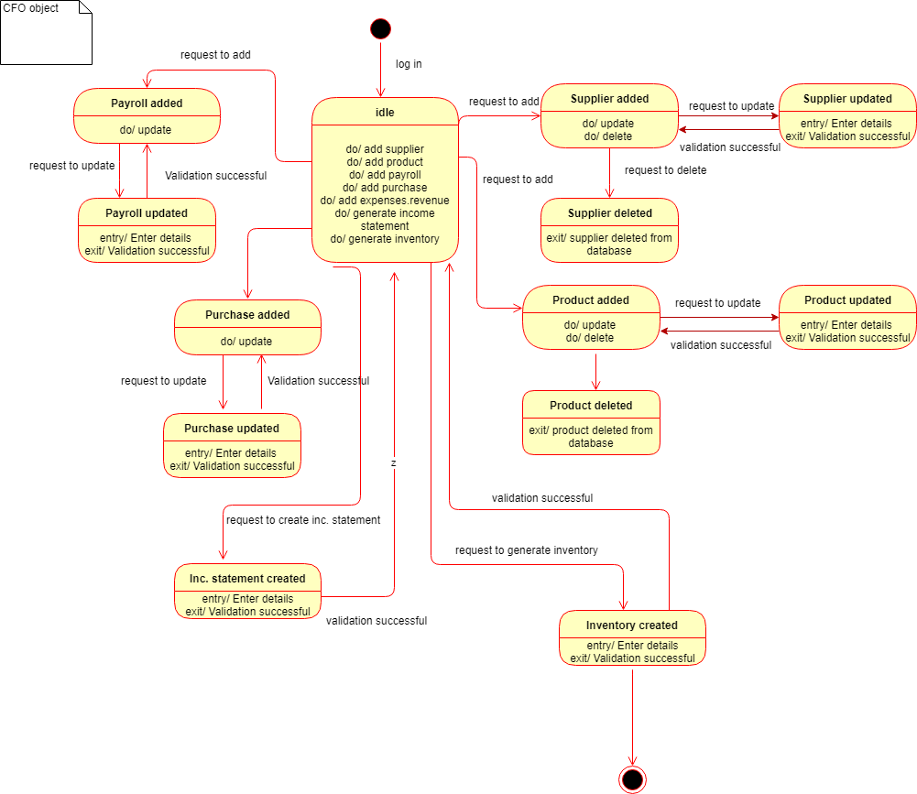
5.3.2 CFO state diagram

HR state diagram

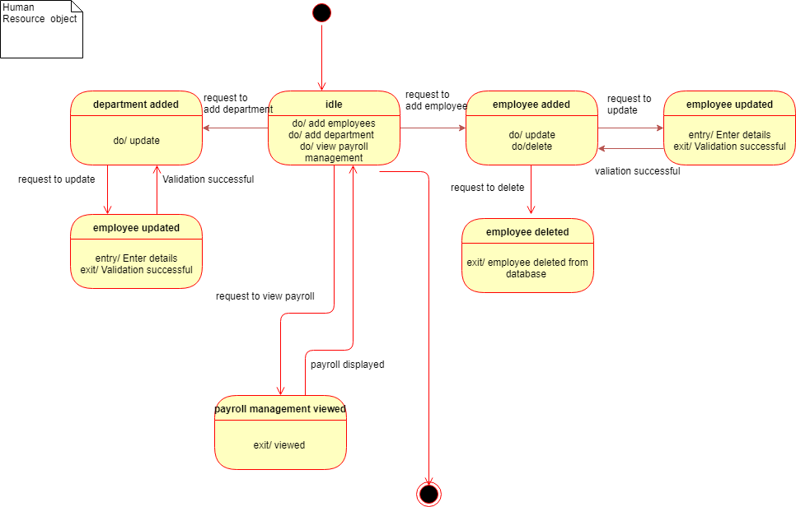

5.3.4 Sales agent state diagram

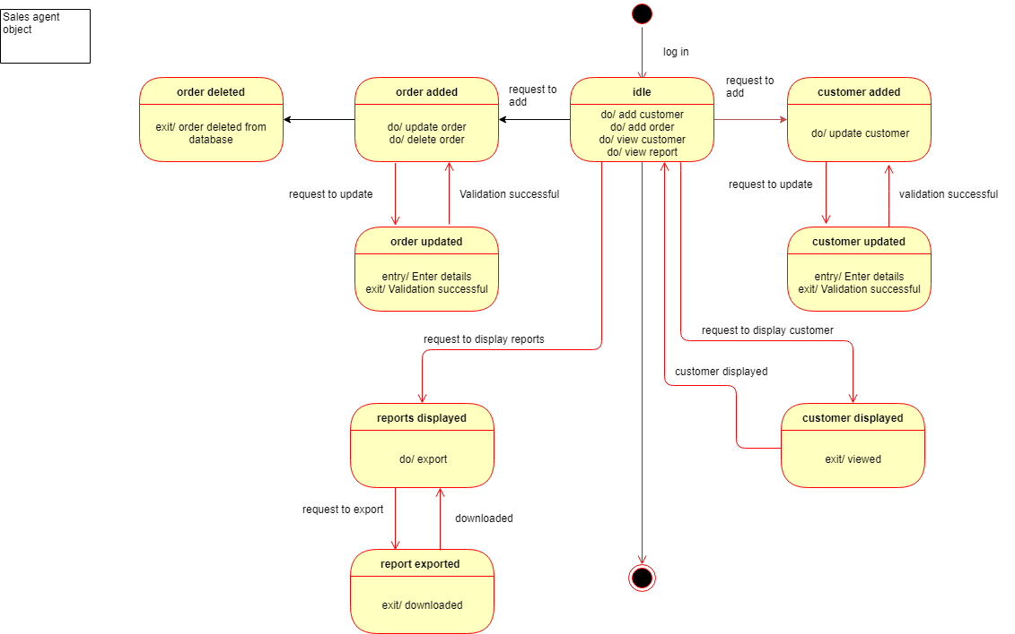

5.3.5 Operations’ manager state diagram

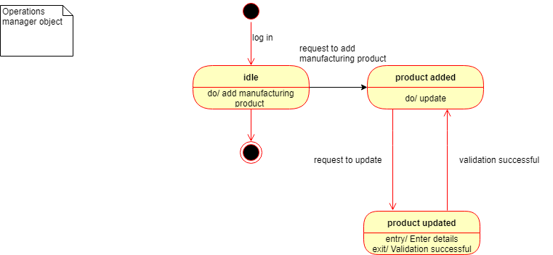

5.4 Sequence diagrams

5.4.1 Create income statement sequence diagram
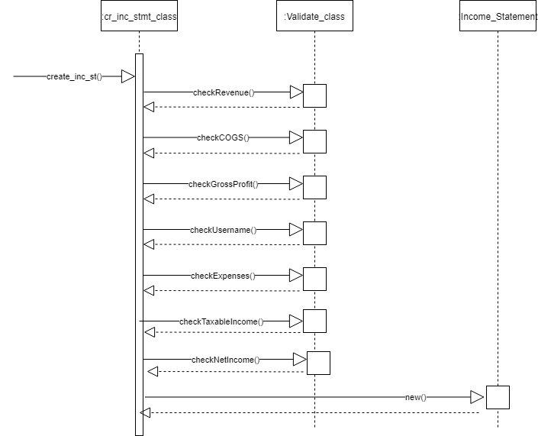

5.4.2 Create inventory sequence diagram
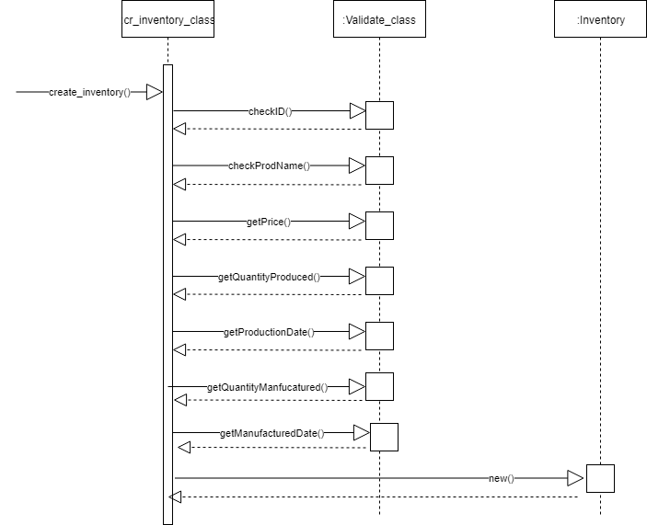

5.4.3 Create user sequence diagram
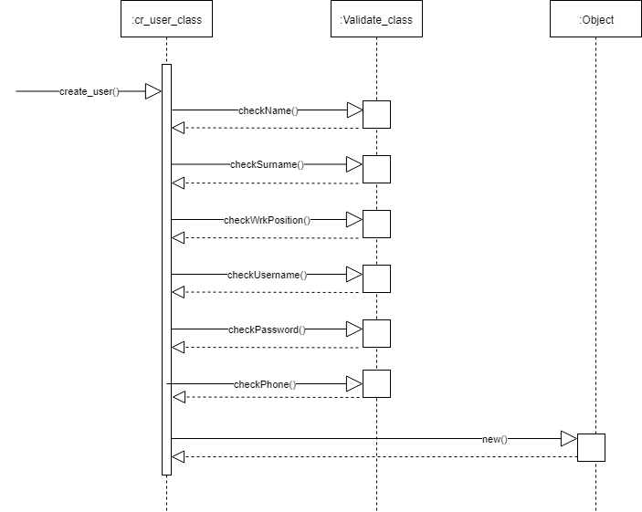

5.4.5 Update user sequence diagram
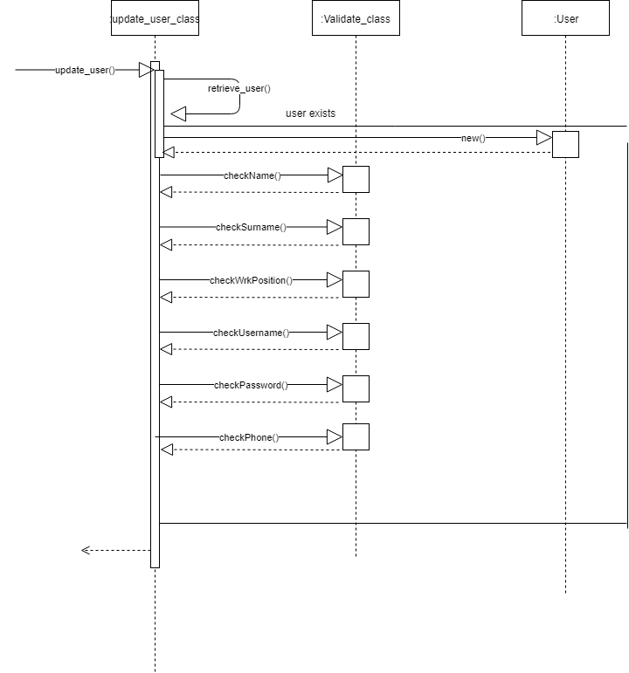

5.5 Collaboration diagrams

5.5.1 Generating income statement collaboration diagram

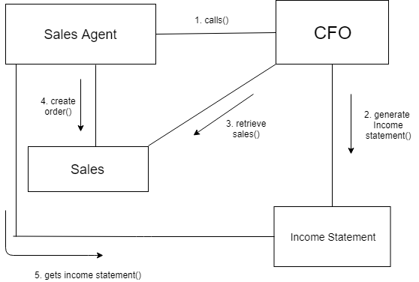

5.5.2 Access inventory collaboration diagram
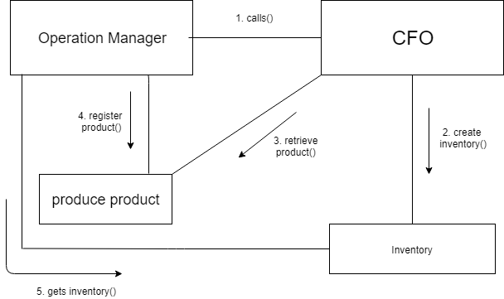

5.6 Data Flow Diagram:

5.6.1 Data Flow – Level 0
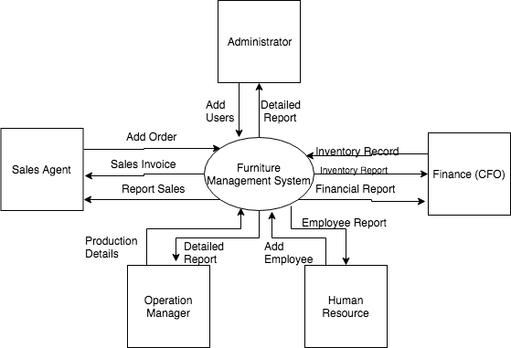

5.6.2 DFD Level 1
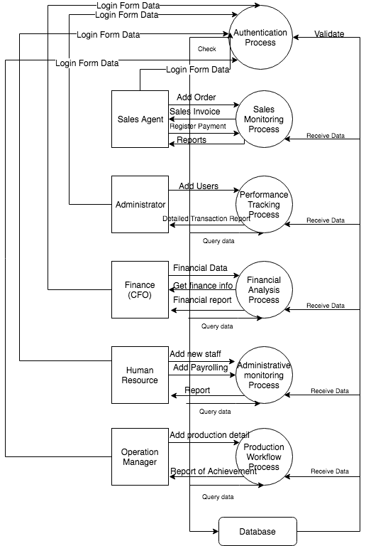

5.6.3 Data Flow – Level 2
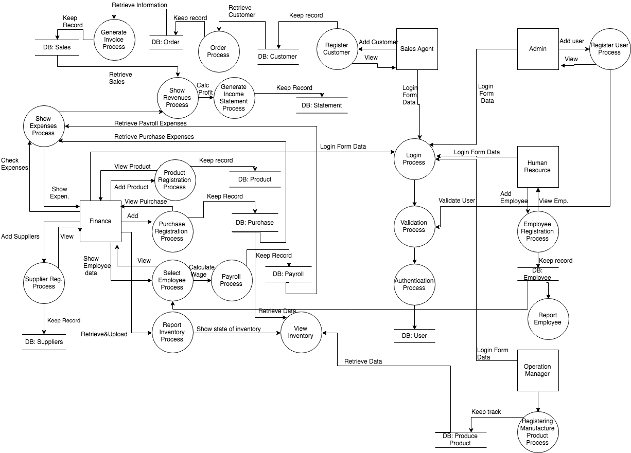

5.7 Entity Relationship Diagram
5.7.1 Entity Relationship Diagram without attributes
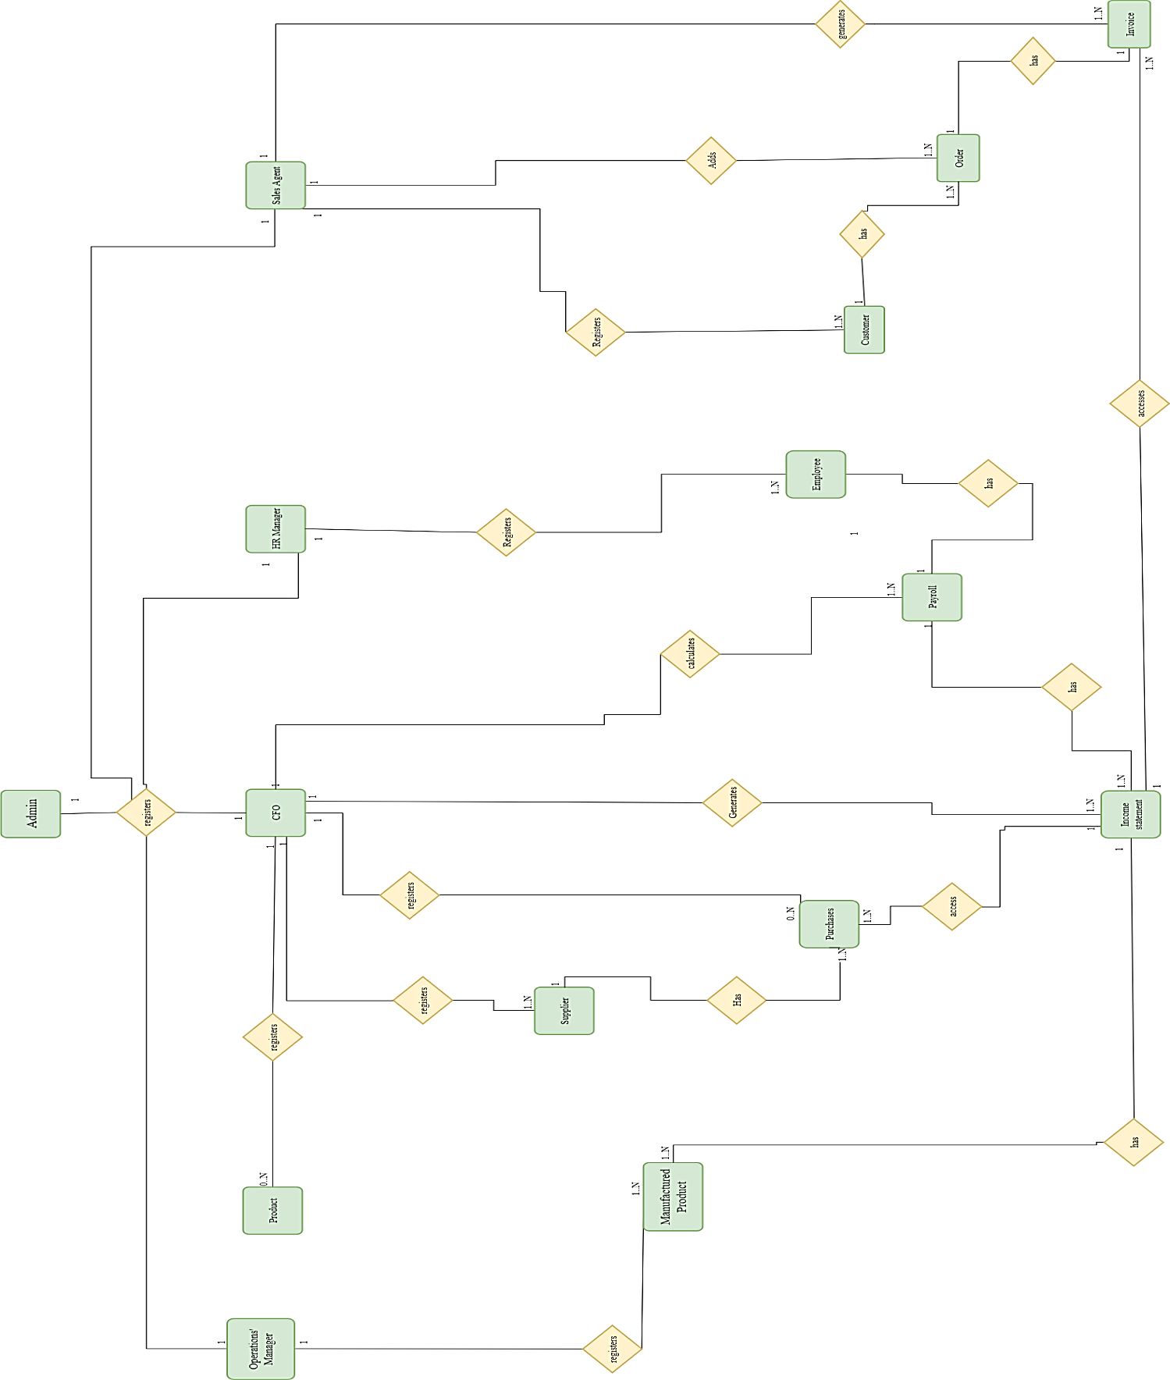
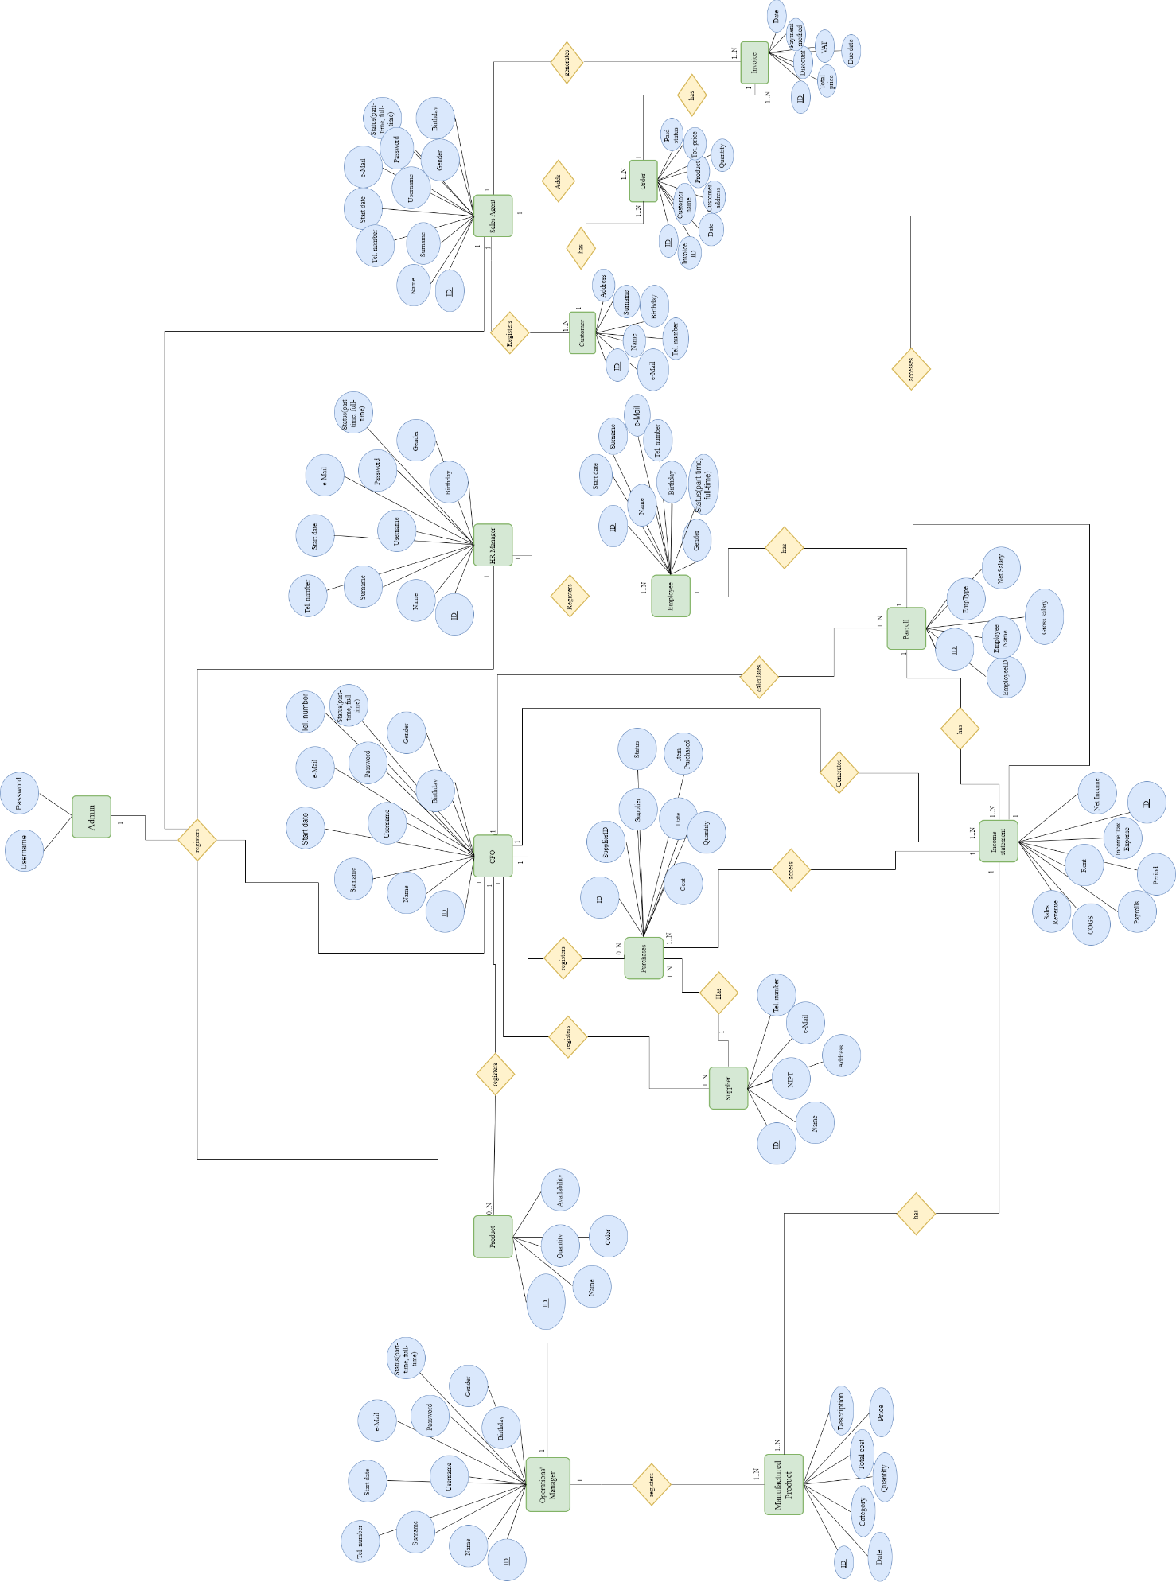
5.7.2 Entity Relationship Diagram with attributes

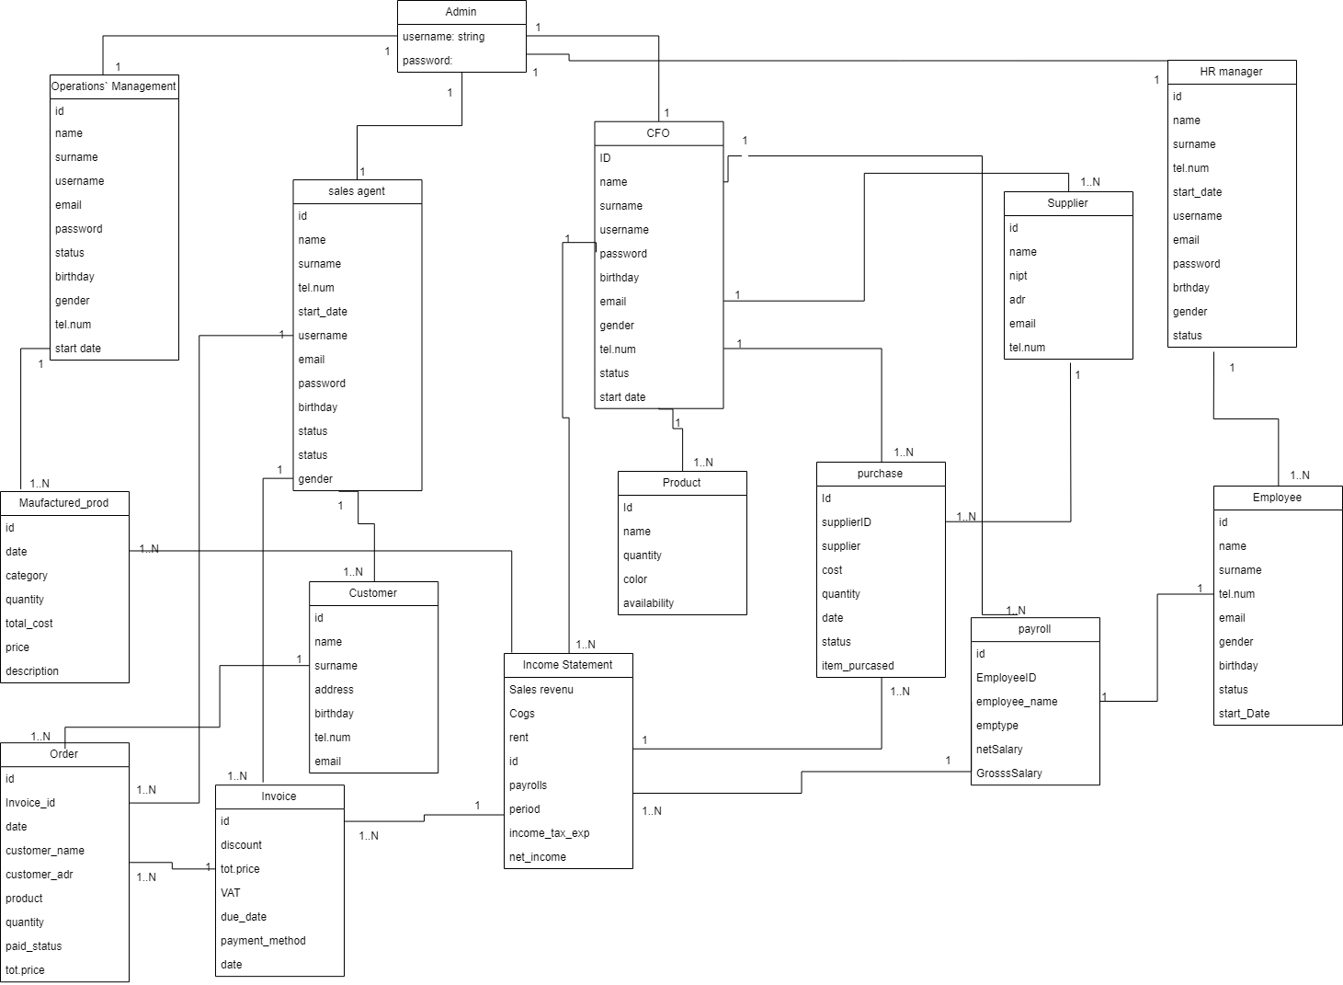
5.8 Class diagram

5.9 Object diagram
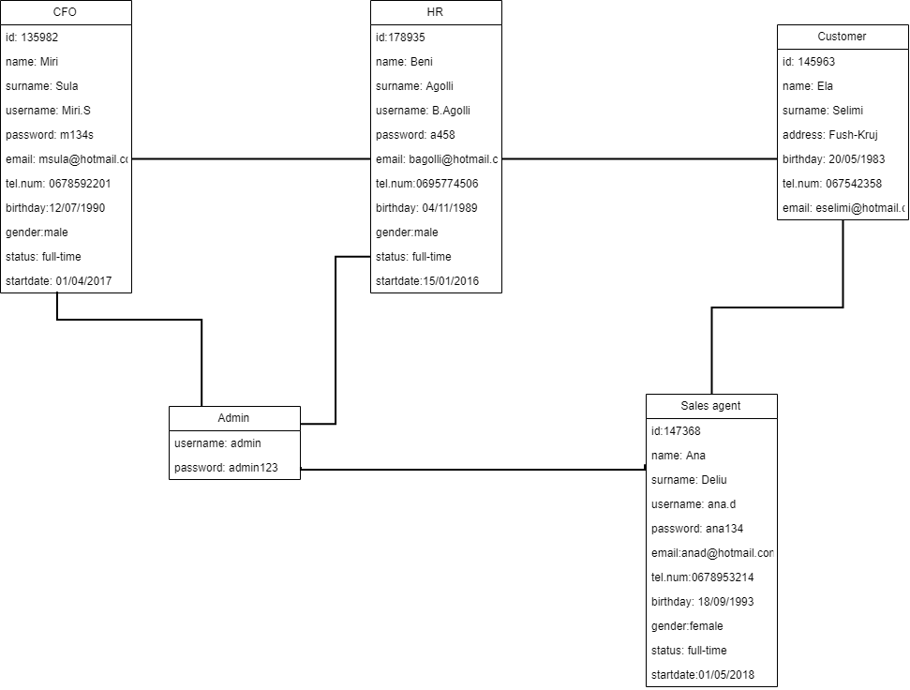

5.10 Deployment diagram

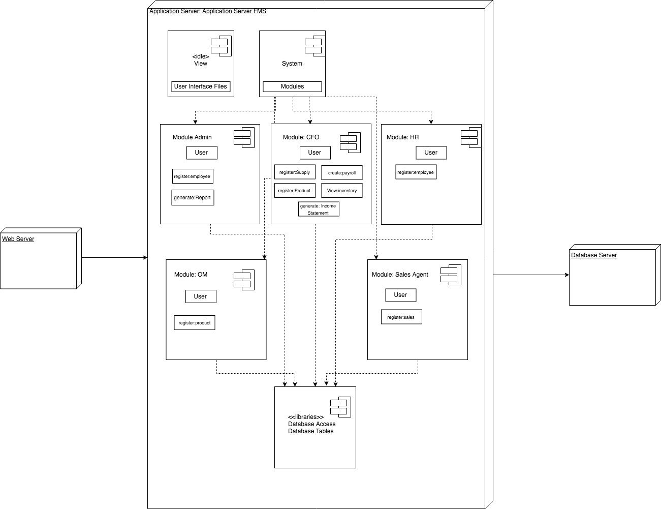

5.11 Component diagram
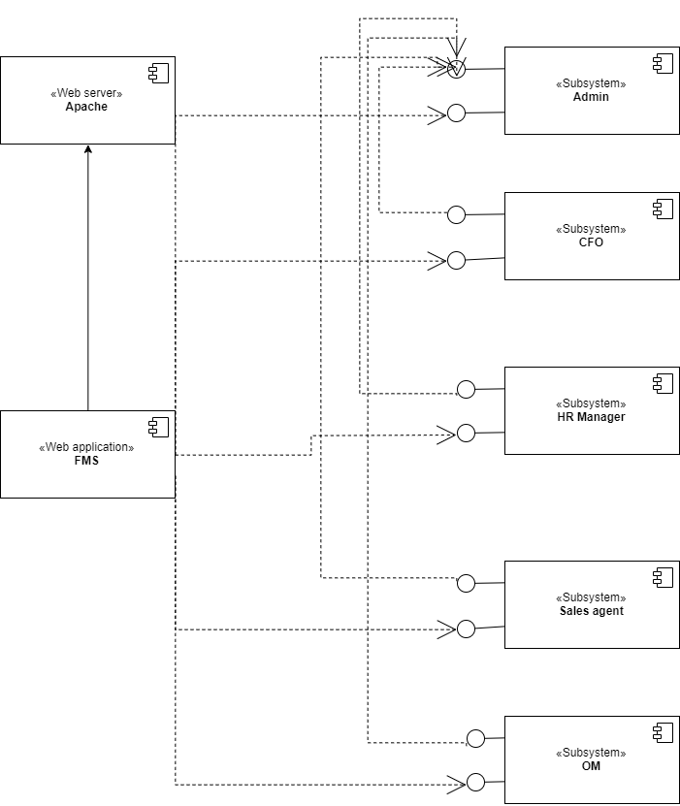

APPENDIX
The appendixes are not always considered part of the actual Requirements Specification and are not always necessary. They may include
- Sample input/output formats, descriptions of cost analysis studies, or results of user surveys;
- Supporting or background information that can help the readers of the Requirements Specification;
- A description of the problems to be solved by the system;
- Special packaging instructions for the code and the media to meet security, export, initial loading, or other requirements.
When appendixes are included, the Requirements Specification should explicitly state whether or not the appendixes are to be considered part of the requirements.
- Definitions, Acronyms, and Abbreviations
Define all terms, acronyms, and abbreviations used in this document.
- References
List all the documents and other materials referenced in this document.
- Requirements Traceability Matrix
The following trace matrix examples show one possible use of naming standards for deliverables (FunctionalArea-DocType-NN). The number has no other meaning than to keep the documents unique. For example, the Bargaining Unit Assignment Process Flow would be BUA-PF-01.
For example (1):
Business Requirement | Area | Deliverables | Status
BR_LR_01  The system should validate the relationship between Bargaining Unit/Location and Job Class.---Comments: Business Process = "Assigning a Bargaining Unit to an Appointment" (Priority 1) | BUA | BUA-CD-01  Assign BU Conceptual Design | Accepted
 | BUA | BUA-PF-01  Derive Bargaining Unit-Process Flow Diagram | Accepted
 | BUA | BUA-PF-01  Derive Bargaining Unit-Process Flow Diagram | Accepted
BR_LR_09  The system should provide the capability for the Labor Relations Office to maintain the job class/union relationship.---Comments: Business Process = "Maintenance" (Priority 1) | BUA | BUA-CD-01  Assign BU Conceptual Design | Accepted
 | BUA | BUA-PF-02  BU Assignment Rules Maint Process Flow Diagram | ReadyForReview
For example (2):
BizReqID | Pri | Major Area | DevTstItems DelivID | Deliv Name | Status
BR_LR_01 | 1 | BUA | BUA-CD-01 | Assign BU Conceptual Design | Accepted
BR_LR_01 | 1 | BUA | BUA-DS-02 | Bargaining Unit Assignment DB Modification Description | Accepted
BR_LR_01 | 1 | BUA | BUA-PF-01 | Derive Bargaining Unit-Process Flow Diagram | Accepted
BR_LR_01 | 1 | BUA | BUA-UCD-01 | BU Assign LR UseCase Diagram | ReadyForReview
BR_LR_01 | 1 | BUA | BUA-UCT-001 | BU Assignment by PC UseCase - Add Appointment and Derive UBU | Reviewed
BR_LR_01 | 1 | BUA | BUA-UCT-002 | BU Assignment by PC UseCase - Add Appointment (UBU Not Found) | Reviewed
BR_LR_01 | 1 | BUA | BUA-UCT-006 | BU Assignment by PC UseCase - Modify Appointment (Removed UBU) | Reviewed
BR_LR_09 | 1 | BUA | BUA-CD-01 | Assign BU Conceptual Design | Accepted
BR_LR_09 | 1 | BUA | BUA-DS-02 | Bargaining Unit Assignment DB Modification Description | Accepted
BR_LR_09 | 1 | BUA | BUA-PF-02 | BU Assignment Rules Maint Process Flow Diagram | Accepted
BR_LR_09 | 1 | BUA | BUA-UCD-03 | BU Assign Rules Maint UseCase Diagram | Reviewed
BR_LR_09 | 1 | BUA | BUA-UCT-045 | BU Assignment Rules Maint: Successfully Add New Assignment Rule | Reviewed
BR_LR_09 | 1 | BUA | BUA-UCT-051 | BU Assignment Rules MaintUseCase: Modify Rule | Reviewed
BR_LR_09 | 1 | BUA | BUA-UCT-053 | BU Assignment Rules MaintUseCase - Review Assignment Rules | Reviewed
BR_LR_09 | 1 | BUA | BUA-UCT-057 | BU Assignment Rules MaintUseCase: Inactivate Last Rule for a BU | Reviewed
BR_LR_09 | 1 | BUA | BUA-UI-02 | BU AssignRules Maint UI Mockups | ReadyForReview
BR_LR_09 | 1 | BUA | BUA-TC-021 | BU Assignment Rules Maint TestCase: Add New Rule (Associated Job Class Does Not Exist) - Success | ReadyForReview
BR_LR_09 | 1 | BUA | BUA-TC-027 | BU Assignment Rules Maint TestCase: Modify Rule - Success | ReadyForReview
BR_LR_09 | 1 | BUA | BUA-TC-035 | BU Assignment Rules Maint TestCase: Add New Rule (Associated Job Class Does Not Exist) - Error Condition | ReadyForReview
BR_LR_09 | 1 | BUA | BUA-TC-049 | BU Assignment Rules Maint TestCase: Modify Rule - Error Condition | ReadyForReview
For example (3):
BizReqID | CD01 | CD02 | CD03 | CD04 | UI01 | UI02 | UCT01 | UCT02 | UCT03 | TC01 | TC02 | TC03 | TC04
BR_LR_01 |  |  | X |  | X |  | X |  |  | X |  | X
BR_LR_09 | X |  |  | X |  | X |  |  | X |  | X |  | X
BR_LR_10 | X |  |  | X |  |  |  |  | X |  | X
BR_LR_11 |  | X
- Organizing the Requirements
This section is for information only as an aid in preparing the requirements document.
Detailed requirements tend to be extensive. Give careful consideration to your organization scheme. Some examples of organization schemes are described below:
By System Mode
Some systems behave quite differently depending on the mode of operation. For example, a control system may have different sets of functions depending on its mode: training, normal, or emergency.
By User Class
Some systems provide different sets of functions to different classes of users. For example, an elevator control system presents different capabilities to passengers, maintenance workers, and fire fighters.
By Objects
Objects are real-world entities that have a counterpart within the system. For example, in a patient monitoring system, objects include patients, sensors, nurses, rooms, physicians, medicines, etc. Associated with each object is a set of attributes (of that object) and functions (performed by that object). These functions are also called services, methods, or processes. Note that sets of objects may share attributes and services. These are grouped together as classes.
By Feature
A feature is an externally desired service by the system that may require a sequence of inputs to affect the desired result. For example, in a telephone system, features include local call, call forwarding, and conference call. Each feature is generally described in a sequence of stimulus-response pairs, and may include validity checks on inputs, exact sequencing of operations, responses to abnormal situations, including error handling and recovery, effects of parameters, relationships of inputs to outputs, including input/output sequences and formulas for input to output.
By Stimulus
Some systems can be best organized by describing their functions in terms of stimuli. For example, the functions of an automatic aircraft landing system may be organized into sections for loss of power, wind shear, sudden change in roll, vertical velocity excessive, etc.
By Response
Some systems can be best organized by describing all the functions in support of the generation of a response. For example, the functions of a personnel system may be organized into sections corresponding to all functions associated with generating paychecks, all functions associated with generating a current list of employees, etc.
By Functional Hierarchy
When none of the above organizational schemes prove helpful, the overall functionality can be organized into a hierarchy of functions organized by common inputs, common outputs, or common internal data access. Data flow diagrams and data dictionaries can be used to show the relationships between and among the functions and data.
Additional Comments
Whenever a new Requirements Specification is contemplated, more than one of the organizational techniques given above may be appropriate. In such cases, organize the specific requirements for multiple hierarchies tailored to the specific needs of the system under specification.
There are many notations, methods, and automated support tools available to aid in the documentation of requirements. For the most part, their usefulness is a function of organization. For example, when organizing by mode, finite state machines or state charts may prove helpful; when organizing by object, object-oriented analysis may prove helpful; when organizing by feature, stimulus-response sequences may prove helpful; and when organizing by functional hierarchy, data flow diagrams and data dictionaries may prove helpful.

