This is chess program, made using C#. It has used object oriented concepts and design patterns like Flyweight, Factory and Decorator.

Following is the overview of the classes and relationship among them.

Block Diagram

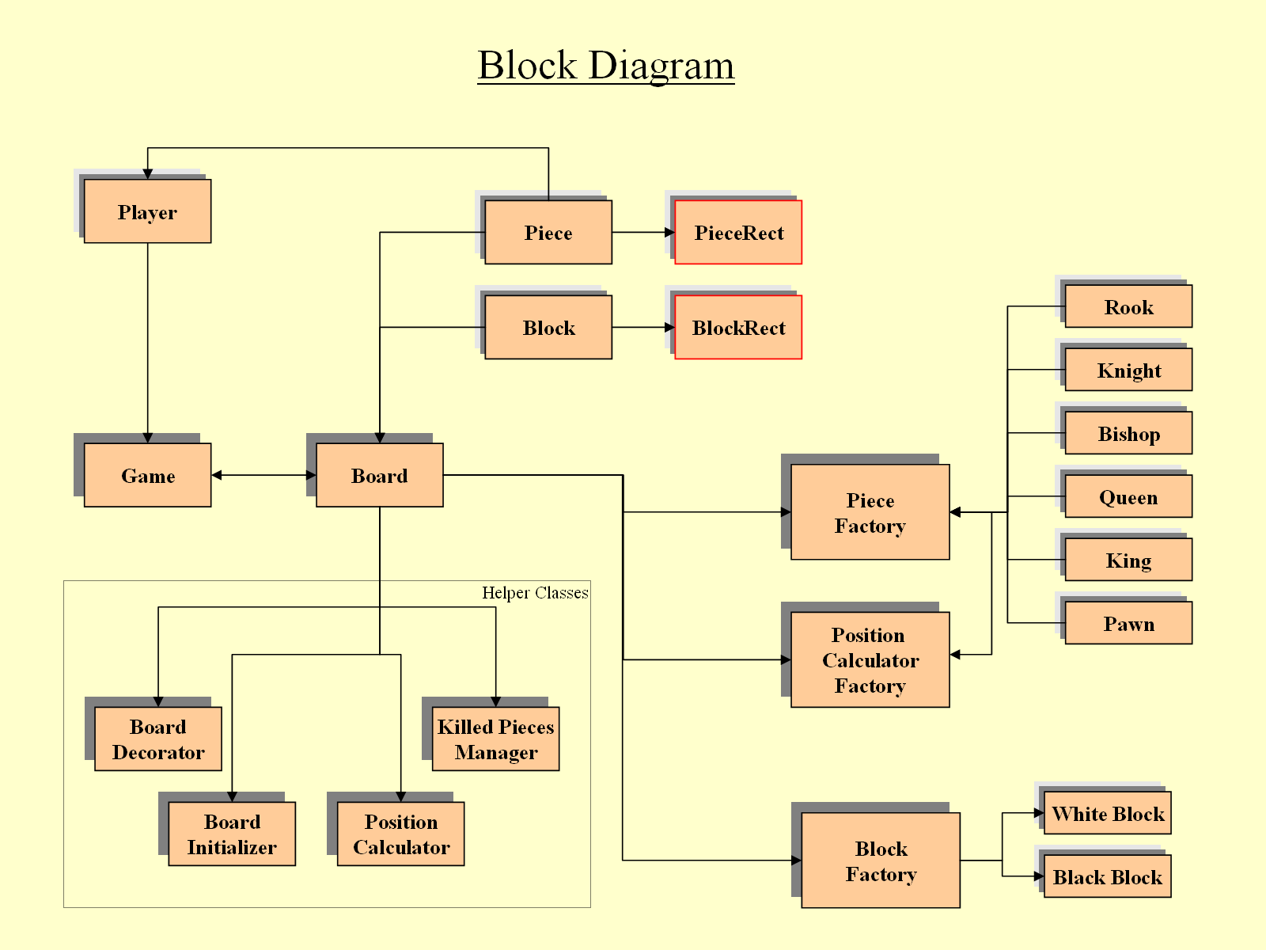

Screenshots

