Chip 1 Report

Simulation bandwidth setting for silicon oxide is set to 1.2um to 1.8um with a fit tolerance of 0.001 to best fit the data as shown in Figure x.

Figure x: Material index curvature for silicon oxide plot.

Simulation bandwidth setting for Silicon is set to 1.2um to 1.4um with a fit tolerance of 0.001 to best fit the data as shown in Figure x.

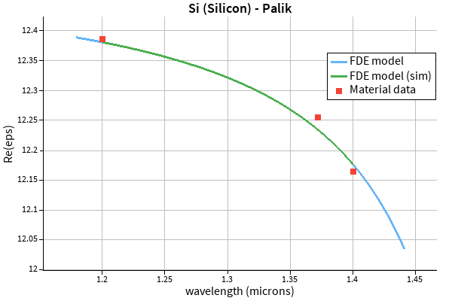

Figure x: Material index curvature for silicon plot.

The y simulation span is set to 2.2um and the x simulation span is set to 2.5um so the metal boundary is not interfering with the field in both directions as shown in Figure 1.

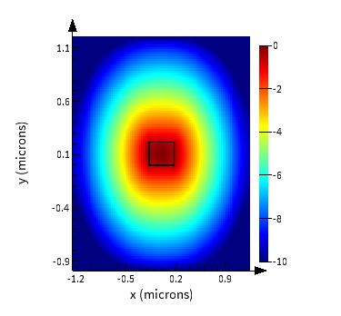

Figure 1: E-Intensity log scale plot.

There are discontinuities in the electric field at the Si-SiO2 interface as expected from the boundary condition in Maxwell’s equation. This is shown in Figure 2.

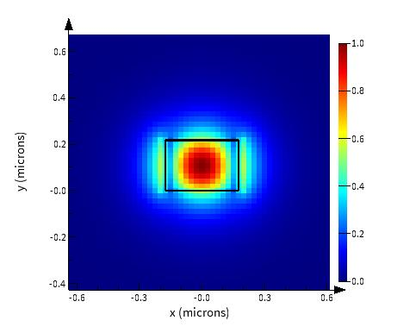

Figure 2: Ex component for the quasi-TE polarized light plot.

Most of the light is travelling inside the waveguide as shown in Figure 3.

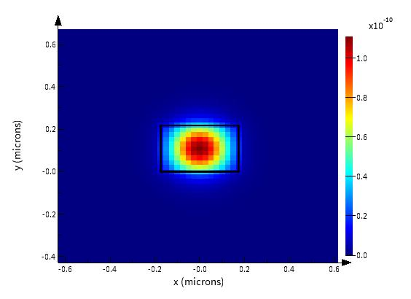

Figure 3: Energy density plot.

A frequency sweep was done from 1.31um to 1.41um. The group index at a wavelength of 1.31um is found to be 4.478.

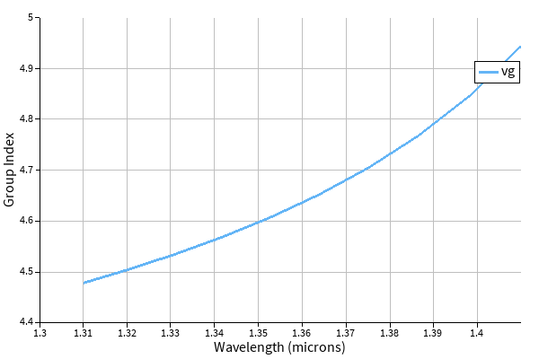

Figure x: Group index plot.

Delta L of 2.6797mm is calculated using the equation below.

Loss at 1310nm is 9.8427dB/cm

Figure x: Loss vs wavelength plot.

The MZI on the left (MZI1) has a delta L of 2679.807um giving a FSR of 23.326GHz. The MZI in the middle (MZI2) has a delta L of 2653.732um giving a FSR of 25.368GHz. The MZI on the right (MZI3) has a delta L of 2679.733um giving a FSR of 25.368GHz.

MZI2 uses a group index of 4.552 (this is the group index for a waveguide width of 335nm to account for manufacturing error) with a delta L of 2.653mm. MZI3 uses the same group index as MZI1, but it is designed to have less bends than MZI1 to see the effects of bends. There is a de-embedding structure to subtract the losses of the grating couplers and experimental setup from the MZI measurements. Therefore, I can plot the MZI without the losses.

