A Study on Mach-Zehnder Interferometer  
Yufan Zhou  
Department of Electrical and Computer Engineering  
University of British Columbia, Vancouver, BC V6T 1Z4, Canada

## Abstract

This report presents the design, simulation, and testing of a photonic circuit integrating a commercial Distributed Feedback (DFB) laser with a Mach-Zehnder Interferometer (MZI). The objective is to characterize the interferometer using both an external laser source and an on-chip DFB laser, evaluating circuit performance through optical transmission measurements.

The project begins with optical waveguide design and modeling in Lumerical MODE, incorporating a 350 nm-wide strip waveguide. Due to the absence of oxide cladding, air-clad waveguide properties, including group index variations, are carefully analyzed. A complete circuit model is developed in Lumerical INTERCONNECT and rate equations are used to simulate laser behavior. The design includes one input waveguide from the laser and up to three output fiber grating couplers for measurement.

The chip layout is created following SiEPIC fab_EBeam_ZEP PDK specifications and submitted for fabrication at UBC (ZEP Shuksan). Post-fabrication testing involves fiber array alignment, optical transmission spectrum measurements using a swept tunable laser, and direct DFB laser characterization through current sweeps. Additionally, performance data from last year’s fabricated chip is analyzed for comparison.

The final report presents design insights, simulation results, and experimental findings, including transmission spectra and extracted waveguide parameters. Fabrication variations and their impact on device performance are discussed, providing recommendations for optimizing future designs.

## Introduction

## Theoretical Background

## Modelling and Simulation

***A. Waveguide Modelling***

Based on fabrication bias requirements and available components in the SiEPIC PDK, the waveguide is designed as a 350nm×220nm strip waveguide. Simulations were conducted in Lumerical MODE Solutions using the Palik material dataset, with air cladding.

The fundamental mode profile of the 350 nm × 220 nm waveguide at λ = 1310 nm, calculated using Lumerical MODE Solutions, exhibits 98% TE polarization:

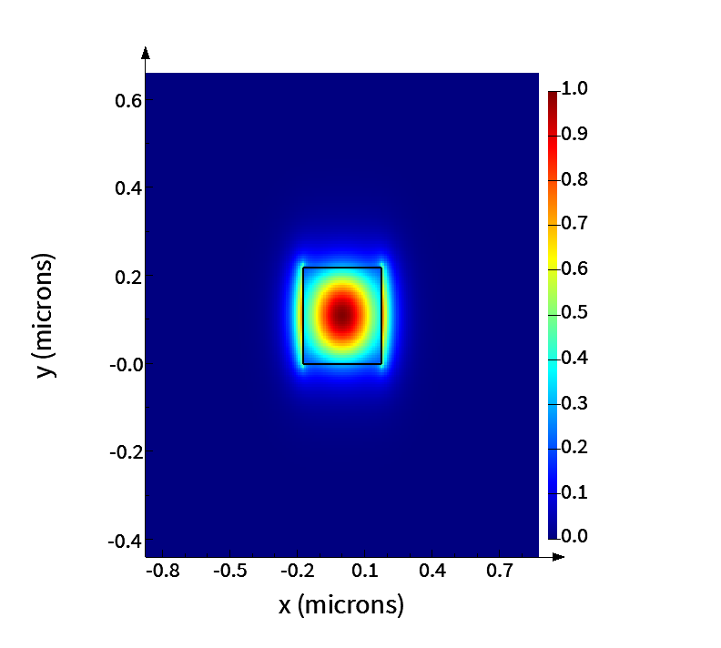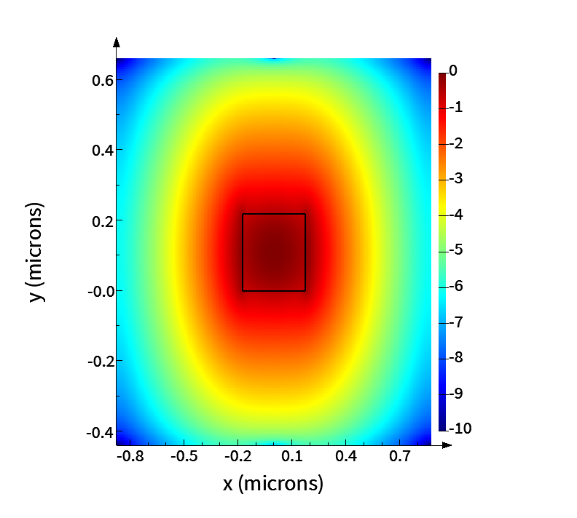

Fig. 1. E Intensity Plot, Linear Scale(left) and Log Scale(right)

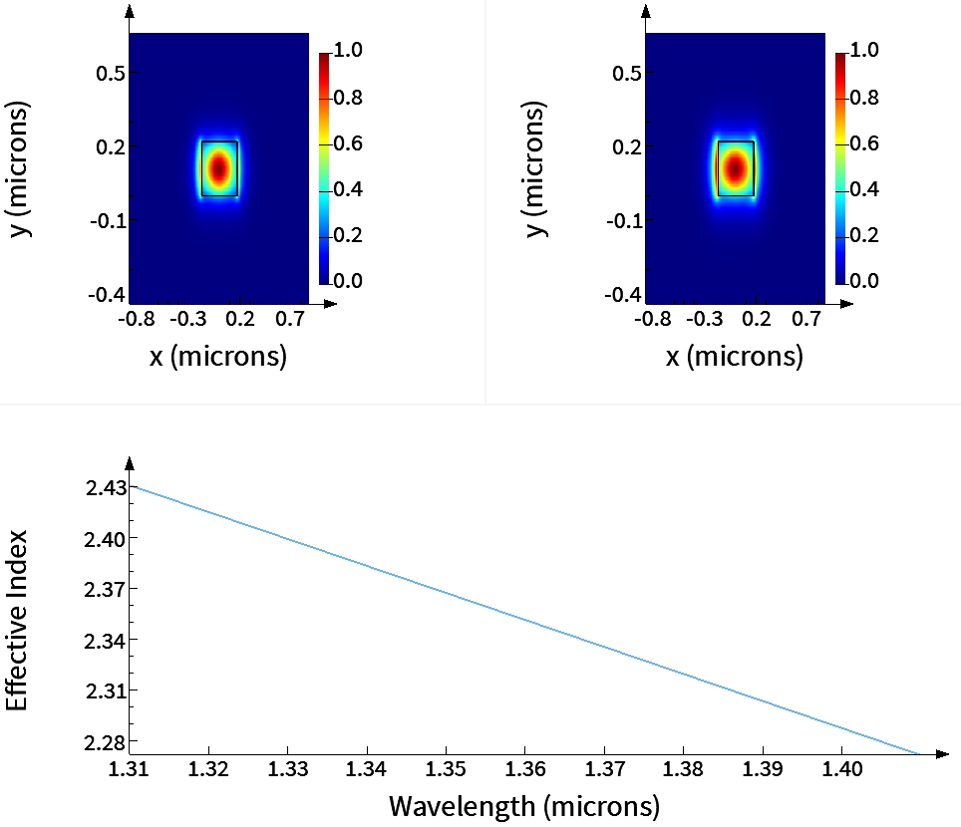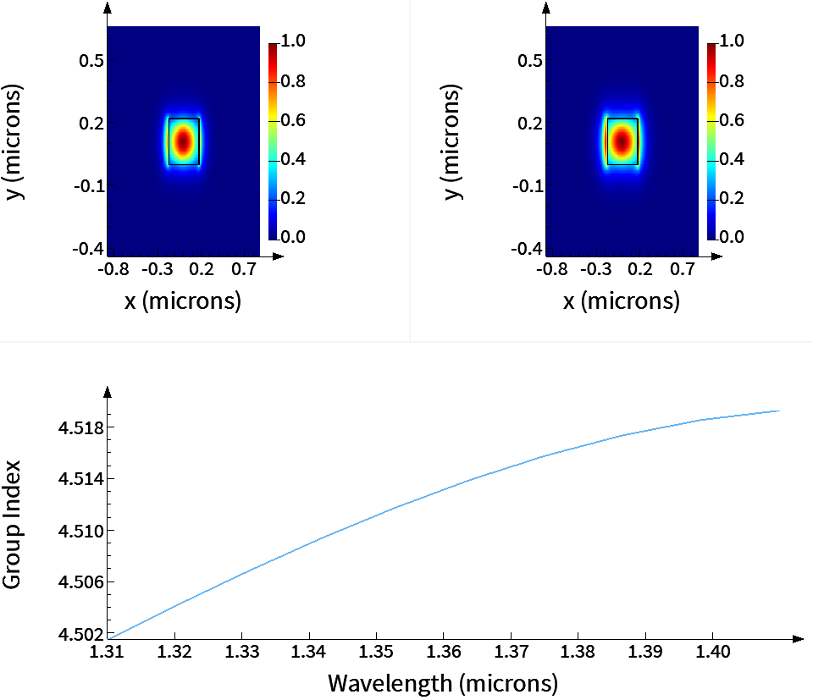

Fig. 2. Effective Index and Group Index Plot with Wavelength Sweep Starting at 1310nm

Simulation bandwidth setting: min = 1.01 μm, max = 1.61 μm.

Group index ng = 4.8966 when wavelength = 1310nm

## Design and Fabrication

Proposed design layout and fabrication details.

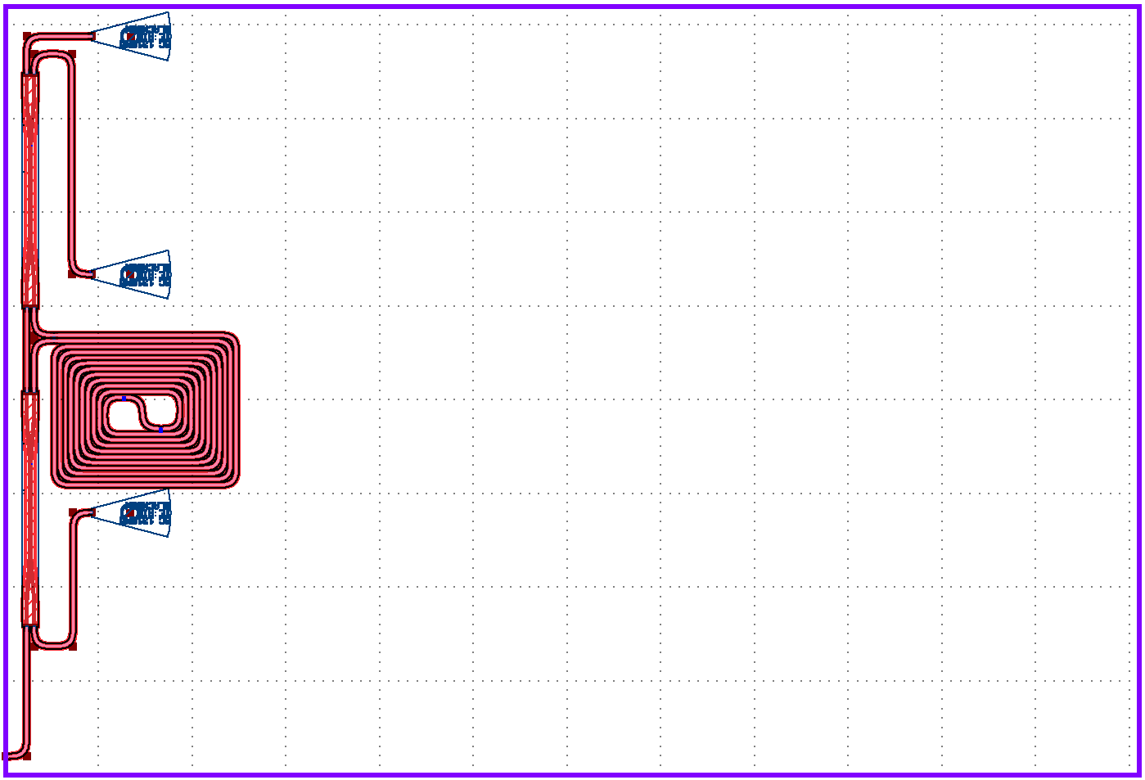

Fig. .Mask layout of the MZI,

## Conclusion and Future Work

## References