**USER GUIDE**

**ADMIN ACCOUNT**

1. First of all we need to create pupils for that class

Click “Admissions” and an interface like below will appear

Student Number is auto generated every time the page loads

When you are through entering the students details click “Submit” When you do so the Guardian will receive an email through the email address you entered.

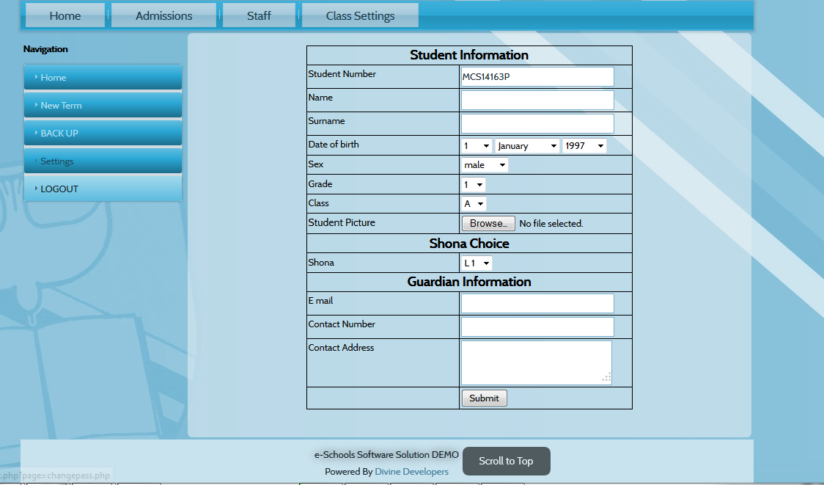

**TEACHERS ACCOUNT**

1. **Marksbook**
2. To upload the marksbook click “Marksbook”
3. After that you would need to download the excel sheet
4. Where it is written [>>>>DOWNLOAD YOUR MARKS BOOK FOR Grade 1 A class<<<<](http://localhost/test/scripts/marksbook_csv.php)

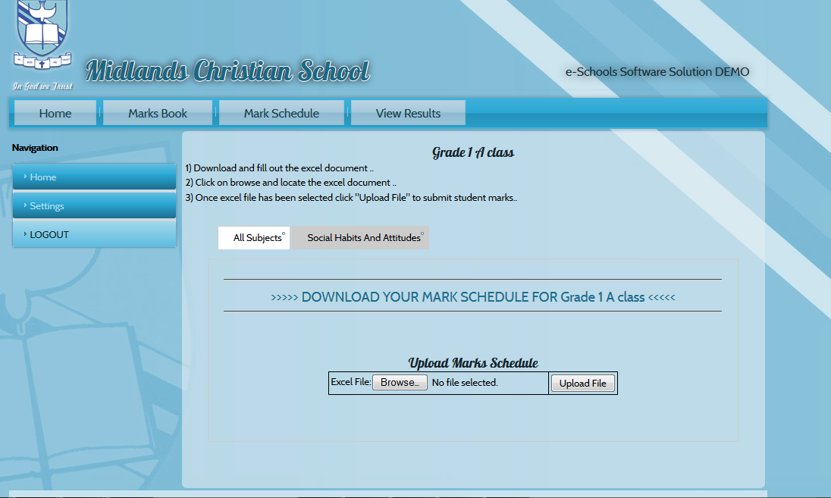

When you click [>>>>DOWNLOAD YOUR MARKS BOOK FOR Grade 1 A class<<<<](http://localhost/test/scripts/marksbook_csv.php) this will appear. Please click OK

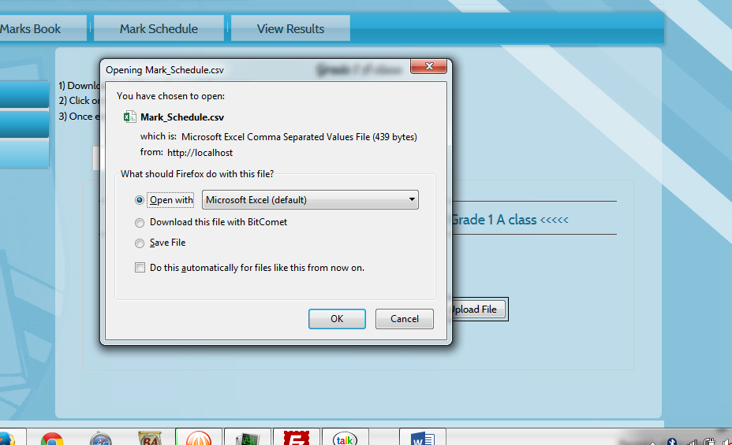

After doing that the excel document which is a .csv file will be downloaded

1. After the download is complete .Please go to you downloads and open it by double clicking the file. It will then open like this with a list of your class pupils to the left hand side and the subject listed horizontally at the top

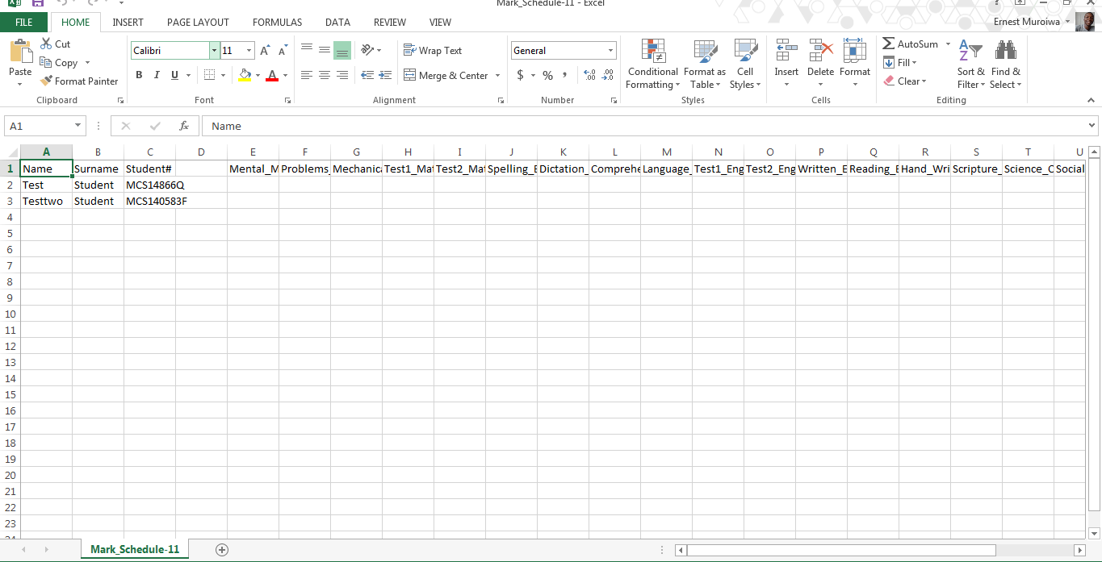

1. When you finish filling out all the marks go to the menu tab of the excel file and click FILE the go to SAVE AS and save the document on your desktop or any other location that is ok for you.

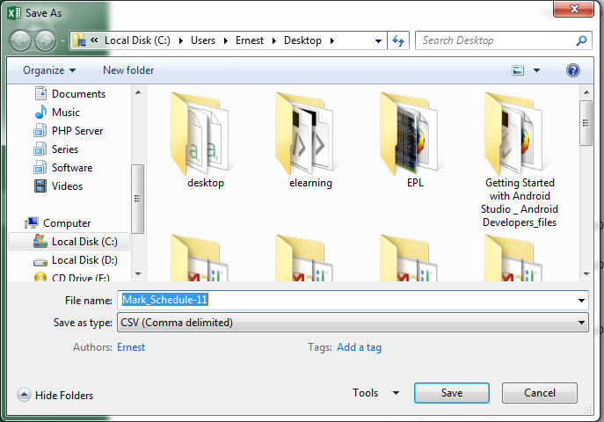

************ NB********************

1)PLEASE MAKE SURE THAT ……. The save as type is CSV(Comma delimited)

2) PLEASE CLICK yes when the dialog below appears when you save the excel sheet

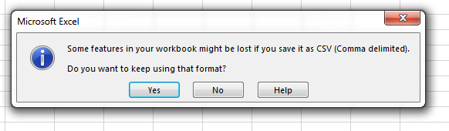

After that go ahead and upload the file like below

Click open after selecting the excel file

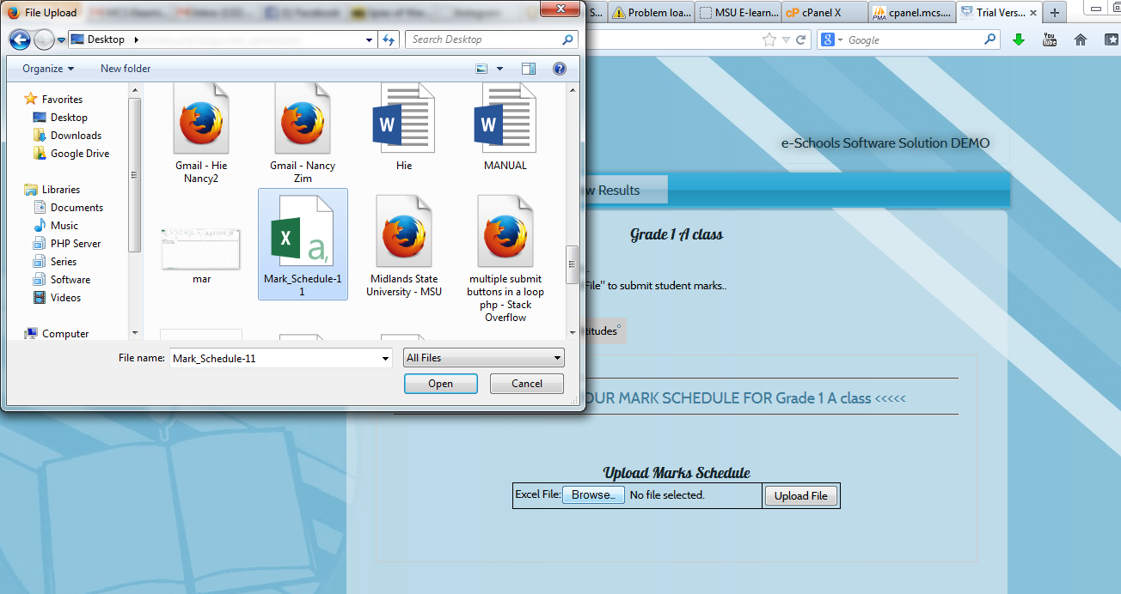

After doing so this should appear

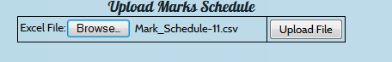

**************NB************************

To the right of the button named Browse it should read like this

“The filename.csv”

Example as above Mark_Schedule-11.csv

Then click Upload File

**NB**

The downloading and upload of excel sheets are the same for all three excel sheets on the system that is:

1. The Marksbook sheet
2. The Mark Schedule sheet
3. The Social habits and attitudes sheet