***README***

**Requirements:**

OS: Windows 10

Internet connection

**Required Libraries:**

google-generativeai, pywhatkit, subprocess, pyttsx3, SpeechRecognition (import speech_recognition, pyperclip, playsound3, ttkbootstrap, pycaw

**Query instructions:**

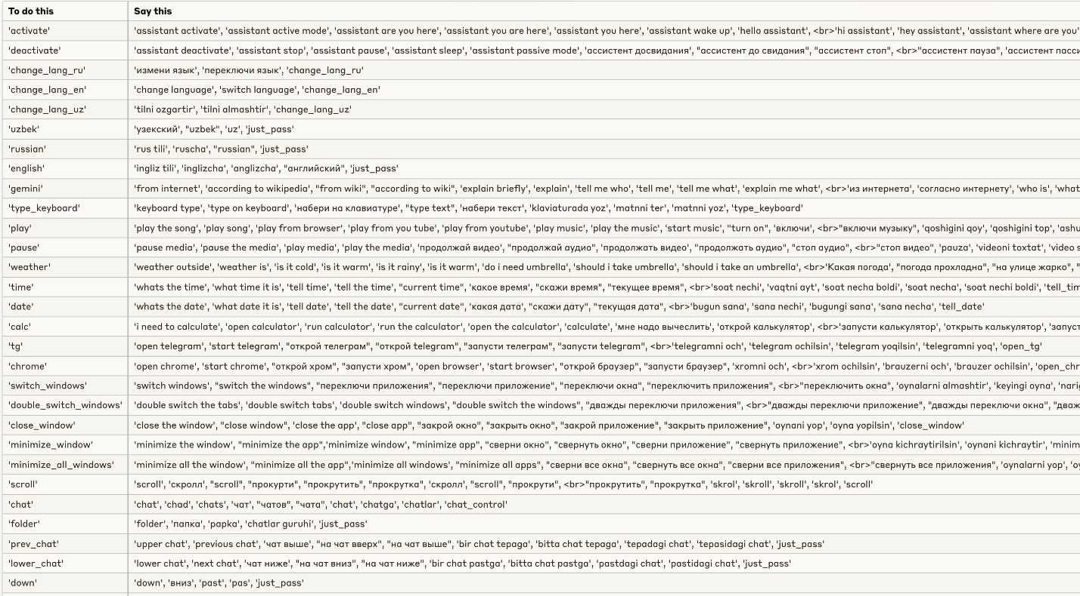



**In order to make the file run along with the system setup (uploading to startup folder):**

1. Press Win + R
2. Type “shell:startup”
3. Press Enter
4. Upload the file to this window