Motor Position Control

System Description

Bonden i Nol
hakanbrolin@hotmail.com
Rev PA1, 2018-01-04, Håkan Brolin

Table of Contents
1 Introduction 3
1.1 Purpose 3
1.2 Platform 3
1.3 Resources 3
2 PID controller 4
2.1 Theory 4
2.2 References 4
2.3 Motor position controller 5
3 Development tools 6
3.1 Development system 6
3.2 Toolchain 6
3.3 OpenOCD 6
4 Software 7
4.1 Startup 7
4.2 BootROM 8
4.3 AT91Bootstrap 8
4.4 U-Boot 8
4.5 MPC 8
5 Development board 9
5.1 Board 9
5.2 MCU 9
5.3 Jumpers 9
5.4 NAND Flash 9
5.5 External connector EXT 10
5.6 External connector AEXT 10
6 DC motor components 11
6.1 DC motor 11
6.2 DC motor driver 11
7 MPC 12
7.1 Software layout 12
7.2 Startup 12
7.3 Flowchart 13
7.4 State machine 13
8 PID controller test#1 14
8.1 Conditions 14
8.2 PID controller test#1.1 15
8.3 PID controller test#1.2 16
9 PID controller test#2 17
9.1 Conditions 17
9.2 PID controller test#2.1 18
9.3 PID controller test#2.2 19

Introduction

Purpose
This project investigates how to control the position of a DC motor shaft using PID controller.

Platform
Controller application is implemented in C and executes on a ARM9 32bit micro-controller (MCU).
A “bare metal” application approach was selected to get low latency and overhead, and to achieve high real-time performance. This decision made the application more complex then when using an operating system (Linux). The learning curve is steeper and the lack of support of system resources makes it harder to get up and running in a small amount of time.
But the “bare metal” approach makes it possible to customize the application with a minimum use of system resources. It's also an interesting way to get to know the hardware and increases your knowledge about various aspects of the system, like start-up sequence, interrupt handling and more.

Resources
All resources for this project, including source code and documentation can be found at:
https://github.com/emwhbr/dcmotor

PID controller

Theory
A closed-loop embedded PID control system:
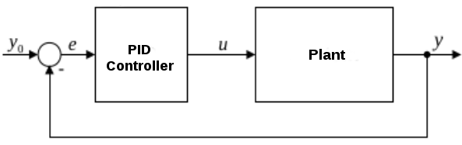
The PID controller function is described as:
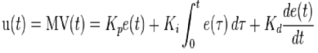
The discrete form of the algorithm is:
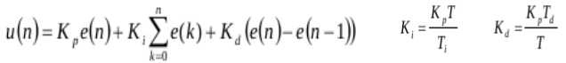
The derivate on error e(t) is identical to the negative of the derivate on process variable y(t), except when set point changes. When set point changes, derivate on e(t) results in an undesirable action on controller output which is called the “derivate kick”. Basing the derivate term on the process variable only results in an improved PID controller.
This controller lacks the impact of the “derivate kick” when the set point changes:
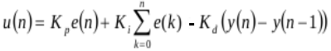
This formula is used in the motor position controller software.

References
References on PID controller theory and how to apply them in an embedded system:
- PID control and derivate on measurements.
http://controlguru.com/pid-control-and-derivative-on-measurement
- PID without a PhD, Tim Wescott.
http://www.wescottdesign.com/articles/pid/pidWithoutAPhd.pdf
http://m.eet.com/media/1112634/f-wescot.pdf

Motor position controller
The motor position controller system is implemented according to figure below:
DC motor driver
PWM
Commanded Position
MCU
DC motor
PID
Controller
DIR

Position
EncA
Optical encoder
Quadrature
encoder
Motor shaft rotation
EncB

The DC motor driver hardware controls the direction and speed of the DC motor.
The output from the PID controller software is a PWM duty cycle value ranging from -65000 .. 65000. The absolute value of this output is feed as a PWM signal to the motor driver hardware. Positive values results in a clockwise direction signal and negative values results in an anti-clockwise signal being generated.
Motor shaft rotation is transformed by the optical encoder hardware into two output channels that indicates both position and direction of the rotation. The quadrature encoder software transforms these signals back to an absolute position. This is an interrupt driven process where both encoder outputs generates an interrupt to the MCU.
The PID controller software executes at a constant frequency by a timer interrupt. This means that the sampling of the actual position is done at a consistent interval with a minimum of variations.

Development tools

Development system
The development host is a PC running Linux Mint 17 (64-bit).
The host software includes a cross-toolchain and other utilities for target system development.

PC
(host)
ARM-USB-OCD
(JTAG debugger)
USB
OpenOCD

arm-eabi-gcc
JTAG
arm-eabi-gdb
MCU
(target)
RS232
picocom

Toolchain
Linaro GCC bare-metal ARM cross-toolchain (6.3.1, 2017-05) with the following features:
- 32-bit
- little-endian
- soft-float
This version was downloaded from:
https://releases.linaro.org/components/toolchain/binaries/6.3-2017.05/arm-eabi/gcc-linaro-6.3.1-2017.05-x86_64_arm-eabi.tar.xz
Other versions are available at:
https://releases.linaro.org/components/toolchain/binaries/

OpenOCD
Debugging and programming of the target is performed via JTAG, using the ARM-USB-OCD (Olimex) as interface between OpenOCD and the target system.
Further information can be found at:
https://www.olimex.com/Products/ARM/JTAG/ARM-USB-OCD/

Software

Startup
The boot sequence of the system software is shown in the figure below.
BootROM

Load AT91Bootstrap
internal SRAM

AT91Bootstrap
(internal SRAM)

Low level
HW init

BUT
pressed?
Yes

No

Load MPC
SDRAM
Load U-Boot
SDRAM

U-Boot
(SDRAM)
MPC
(SDRAM)

The different software components are described in the following sections.

BootROM
BootROM is resident in the MCU AT91SAM9260 (stored in ROM). This “first stage” boot loader can launch a “secondary stage” loader from different locations (SPI Data Flash, NAND Flash or USB).
The source code for this component is not included in the project.

AT91Bootstrap
AT91Bootstrap is the “secondary stage” loader, stored in NAND Flash. The code is downloaded into the internal SRAM by BootROM, followed by a jump to the first address of the SRAM . The binary image size must be less than 4K, corresponding to the SRAM size for the AT91SAM9260 . The code needs to be kept small and only performs basic hardware initialization tasks. This includes initialize peripheral I/O, enabling I-cache, setup clock speed and configuration of the SDRAM controller.
AT91Bootstrap initializes the clock speeds according to:
Master clock: 102.4 MHz
CPU clock: 204.8 MHz
The source code for this component is included in the project.

U-Boot
U-Boot is the “third stage” loader, stored in NAND Flash. The code is downloaded into SDRAM by AT91Bootstrap, followed by a jump to the start address (0x23F0_0000). U-Boot continues the more complex hardware initialization of the board (e.g. Ethernet, USB, SD/MMC). It includes support for several commands and different communication protocols.
The source code for this component is not included in the project (binary image is included).

MPC
MPC is the actual “bare metal” application, stored in NAND Flash. The code is downloaded into SDRAM by AT91Bootstrap, followed by a jump to the start address (0x2220_0000).
MPC (Motor Position Control) performs the positioning of the DC motor shaft. It includes the PID controller algorithm and other software functions that are needed for the project objectives.
The source code for this component is included in the project.

Development board

Board
SAM9-L9260 development board (Olimex). Further information can be found at:
https://www.olimex.com/Products/ARM/Atmel/SAM9-L9260

MCU
MCU: AT91SAM9260 (Atmel), 32 bit
Core: ARM9 core family (ARM926EJ-S)
Architecture: ARMv5TE

Jumpers
Jumpers on the board needs to be configured according to:
BMS_LOW State: Open
Forces the BMS-pin (Boot Mode Select) of the CPU to high state.
This selects embedded ROM as boot device after reset, thus activating BootROM.
DF_E State: Open
Forces the CS-pin of the SPI Data Flash to high state so that the chip can't be used.
When no Data Flash is found, BootROM will look for the “secondary stage” loader
in the NAND Flash instead.
NANDF_E State: Closed
Allows the CE-pin of the NAND Flash memory to be controlled by software.
If this jumper is open, the chip can't be enabled or used.

NAND Flash
The NAND Flash memory is organized according to the table below:
Software component | Address range (hex) | Size
AT91Bootstrap | 0x0000_0000 - 0x0000_0fff | 4 KB
Spare | 0x0000_1000 - 0x0001_ffff | 124 KB
MPC | 0x0002_0000 - 0x0003_ffff | 128 KB
Spare | 0x0004_0000 - 0x1cef_ffff | 462,75 MB
U-Boot | 0x1cf0_0000 - 0x1cfd_ffff | 896 KB
U-Boot environment | 0x1cfe_0000 - 0x1cff_ffff | 128 KB
Spare | 0x1d00_0000 - 0x1fff_ffff | 48 MB
The memory is 512 MB, with “block” size of 128 KB (0x20000) and “page” size of 2 KB (0x800).

External connector EXT

Pin | MCU pin | MCU function | Application
1, 2 | - | - | 3.3V
4 | - | - | 5V
39, 40 | - | - | GND
5 | PB0 | PIO Controller B  Peripheral B  TC3, TIOA3 | PWM duty output control signal.  Frequency=781.3Hz (T=1.28ms)  Connected to MAX14780 speed control input.
7 | PB1 | PIO Controller B  PIO  output | Motor direction control signal.  High: clockwise, Low: counterclockwise  Connected to MAX14780 direction input.
9 | PB2 | PIO Controller B  PIO  output | Debug pin#1.  Indicates DC motor shaft position error +- 1.5%.
11 | PB3 | PIO Controller B  PIO  output | Debug pin#2.  Indicates stop state entered due to a request to change motor direction.
13 |  | PIO Controller B  PIO  input | Encoder A input.  Interrupt enabled on pin.
15 |  | PIO Controller B  PIO  input | Encoder B input.  Interrupt enabled on pin.

External connector AEXT
Pin | MCU pin | MCU function | Application
1 | GNDANA | Analog ground | GND
2 | - | - | -
3 | PC0 | PIO Controller C  Peripheral A  AD0 | Analog input channel (10-bit, ADC=0..1023).  Connected to external potentiometer.  Determines PID set point for motor shaft during calibration.
4 | - | - | -
5 | ADVREF | Analog reference | 3.3V
6 | VDDANA | Analog power supply | 3.3V

DC motor components

DC motor
Brushed DC (12V) motor with gearbox and quadrature encoder: Pololu, part#3240.
https://www.pololu.com/product/3240
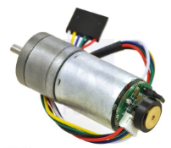

Specifications:
Free-run current: 200 mA (stall current: 2100 mA)
Free-run speed: 220 rpm (3.67 rev/s, 273 ms/rev)
Gear ratio: 34.014:1
Encoder: 48 CPR, quadrature (34.014 x 48 = 1632,672 counts per revolution)

DC motor driver
Motor driver carrier board for MAX14870: Pololu, part#2961.
https://www.pololu.com/product/2961
Specifications:
Motor supply voltage: 4.5 – 36 V
Output current: 1.7 A (2.5 A peak)
PWM frequency: 50 kHz (max)
Application circuit:
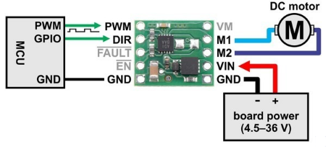

MPC

Software layout
The “bare metal” software is organized in the following directory structure:
sw/motor_position_control
|
|-------- bsp
|
|-------- core
|
|-------- proc
Directory bsp includes board support functionality.
Directory core includes application specific functionality.
Directory proc includes processor specific functionality.

Startup
The startup sequence for the “bare metal” application:
proc/startup.s
Link address:0x2220_0000 (SDRAM)
Entry point:_reset

jump to
bsp_low_level_init
Implemented in C (bsp/bsp.c)
Setup ARM exception vectors
Remap SRAM to address 0x0000_0000

clear BSS
Unitialized data set to zero

setup stack
Fill stack with known pattern
Initialize stack pointers

jump to
c_main
Implemented in C (core/main.c)

The application layout is controlled by the linker script core/mpc.ld.

Flowchart
The application main flow is depicted in the flowchart below:
core/main.c
Entry point:c_main

Implemented in (bsp/bsp.c)
Initialize board hardware components
Setup timer interrupts
Setup interrupt controller (AIC)
bsp_high_level_init

check user button
Button value controls the state machine

execute state machine
Implemented in (core/mpc_fsm.c)

delay 100ms

State machine
The value of the user button controls the state machine:
BUT_RELEASED

STATE_INIT
STATE_POS
STATE_CALIB
BUT_RELEASED
BUT_RELEASED

NONE
BUT_PRESSED
NONE
BUT_PRESSED
NONE
BUT_PRESSED

mpc_core_initialize

Disable PID controller
mpc_core_calibrate

Disable PID controller
Update PID set point
BUT_PRESSED ==> zero shaft
mpc_core_position

Enable PID controller
The actual update of the PID controller is executed by a timer interrupt at constant frequency.

PID controller test#1

Conditions
- PID controller frequency: 100Hz (T=10ms)
- PID parameters:
P=250
I=0
D=700

PID controller test#1.1
Conditions:
- Motor shaft position set point: 0x330 = 816 (180°)
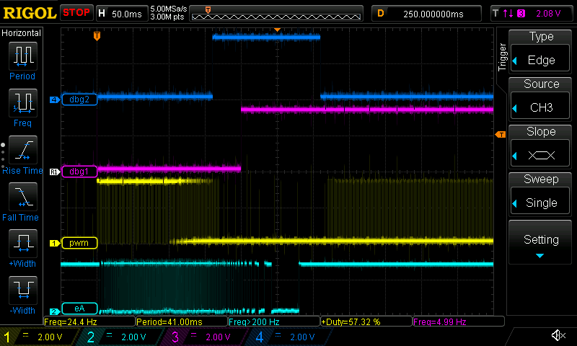
1
2
3
4
5
Description:
- T=0ms
First PID controller cycle after calibration.
Motor shaft starts moving 3.2ms after PWM activation.
- T=160ms
Entering stop state due to request to change motor direction.
Duration of stop state is 150ms.
- T=200ms
Motor shaft position is within set point ±1.5%.
This position keeps stable within limits.
- T=280ms
Motor shaft completely stopped 120ms after entering stop state.
- T=310ms
Leaving stop state with very low PWM duty, not enough to move motor shaft.

PID controller test#1.2
Conditions:
- Motor shaft position set point: 0x4c8 = 1224 (270°)
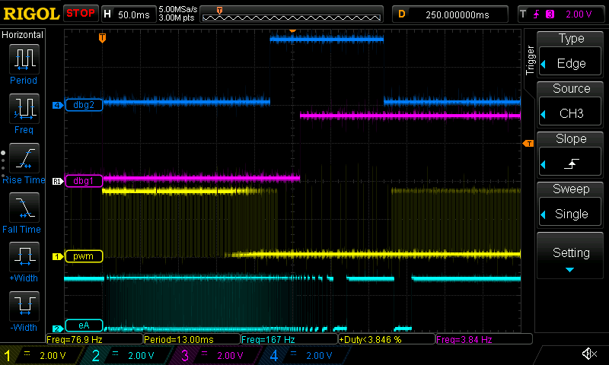
1
2
3
4
5
Description:
- T=0ms
First PID controller cycle after calibration.
Motor shaft starts moving 4ms after PWM activation.
- T=220ms
Entering stop state due to request to change motor direction.
Duration of stop state is 150ms.
- T=260ms
Motor shaft position is within set point ±1.5%.
This position keeps stable within limits.
- T=320ms
Motor shaft completely stopped 100ms after entering stop state.
- T=370ms
Leaving stop state with low PWM duty, just enough to move motor shaft.

PID controller test#2

Conditions
- PID controller frequency: 200Hz (T=5ms)
- PID parameters:
P=300
I=0
D=1650

PID controller test#2.1
Conditions:
- Motor shaft position set point: 0x330 = 816 (180°)
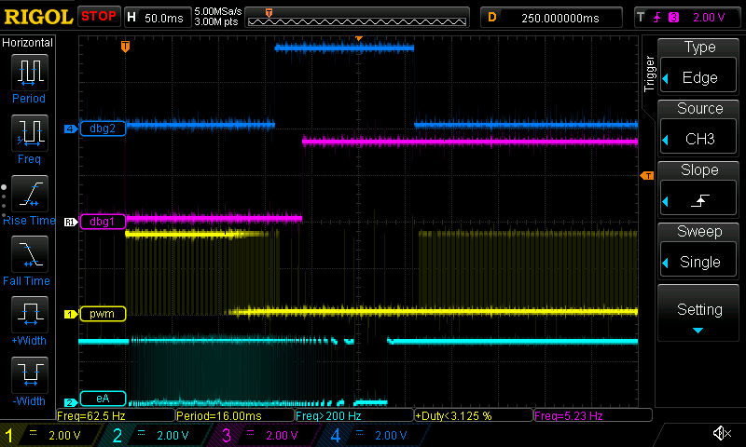
1
2
3
4
5
Description:
- T=0ms
First PID controller cycle after calibration.
Motor shaft starts moving 4ms after PWM activation.
- T=160ms
Entering stop state due to request to change motor direction.
Duration of stop state is 150ms.
- T=190ms
Motor shaft position is within set point ±1.5%.
This position keeps stable within limits.
- T=280ms
Motor shaft completely stopped 120ms after entering stop state.
- T=310ms
Leaving stop state with very low PWM duty, not enough to move motor shaft.

PID controller test#2.2
Conditions:
- Motor shaft position set point: 0x4c8 = 1224 (270°)
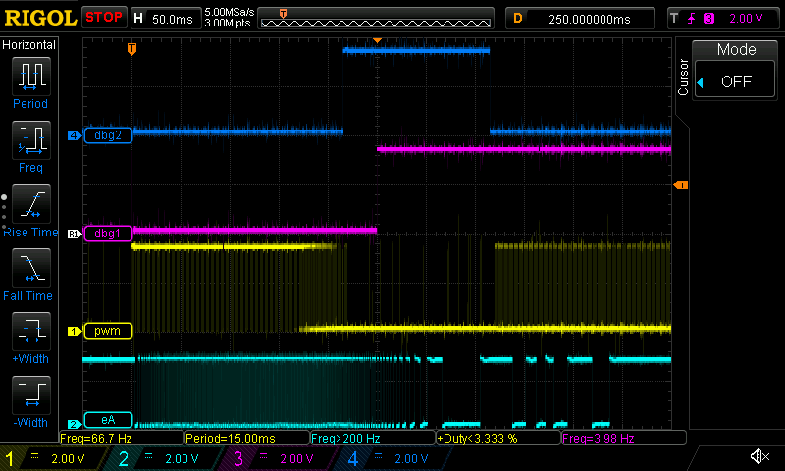
1
2
3
4
5
Description:
- T=0ms
First PID controller cycle after calibration.
Motor shaft starts moving 4ms after PWM activation.
- T=215ms
Entering stop state due to request to change motor direction.
Duration of stop state is 150ms.
- T=250ms
Motor shaft position is within set point ±1.5%.
This position keeps stable within limits.
- T=355ms
Motor shaft completely stopped 100ms after entering stop state.
- T=365ms
Leaving stop state with low PWM duty, just enough to move motor shaft.

