EYEBOOKED

Your eye care, booked.
Mobile App Preview
Eye-care booking · AI frame recommendations · Glasses shop · Rewards
English · Français · العربية · Morocco (MAD)
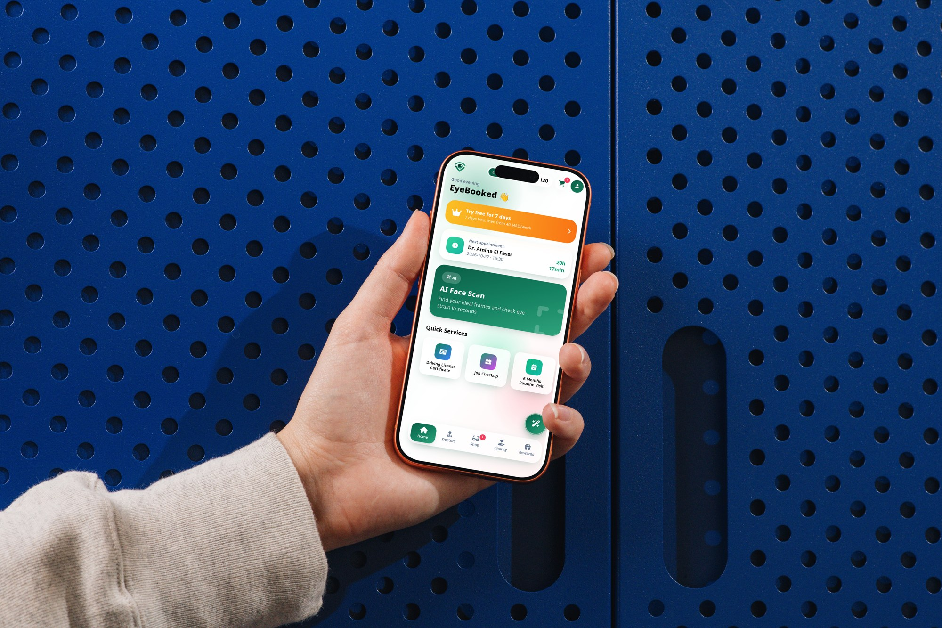
Product concept preview · Demo only · No real payments

The Product
EyeBooked brings everyday eye health, local care and eyewear discovery into one phone-first experience.
- Find services and book appointments
- Explore AI-assisted frame inspiration and eye-strain tips
- Shop ready-made frames or explore custom design
- Return through rewards and practical eye-health tools
- English, French and Arabic with RTL support; prices in MAD

1 · Login & Home
A simple sign-in followed by a dashboard for appointments, discovery and useful eye-care actions.
- Email or phone · Password · Sign in
- Try free for 7 days
- AI Face Scan and Quick Services
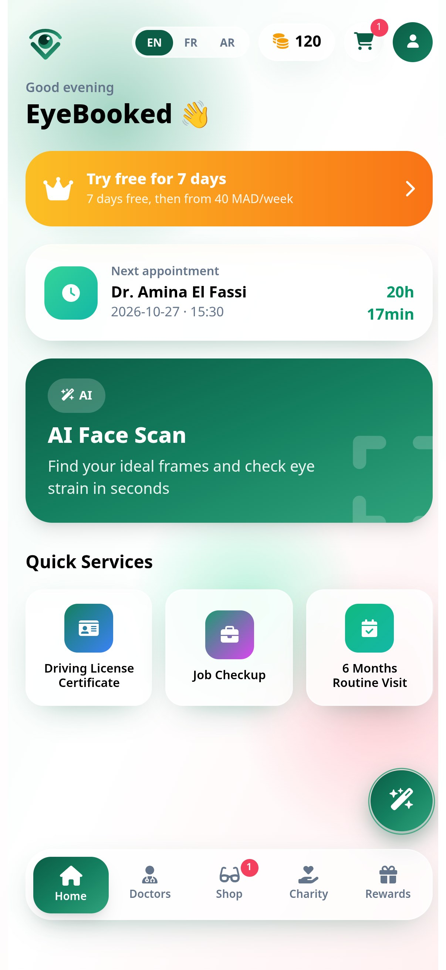

2 · Find Doctors
Search by proximity and city, then review sample profiles and ratings. The product concept targets a catalog of 30+ ophthalmologists across major Moroccan cities; current screen profiles are sample data.
- Casablanca and Rabat examples
- Sort by nearest · Browse by city · Book
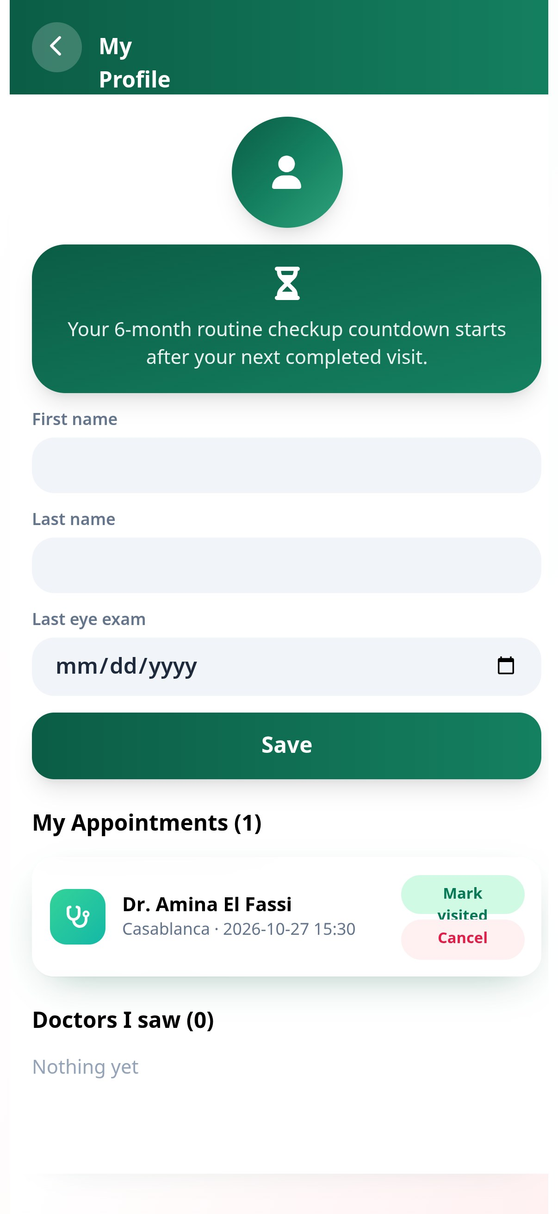

3 · Glasses Shop
Browse ready-made eyewear or explore custom frame design, including progressive lens options.
- Ray-Ban RX6489 · 1,090 MAD
- Persol PO3007V · 1,690 MAD
- Clubmaster · 950 MAD
- Oakley OX8046 · 890 MAD
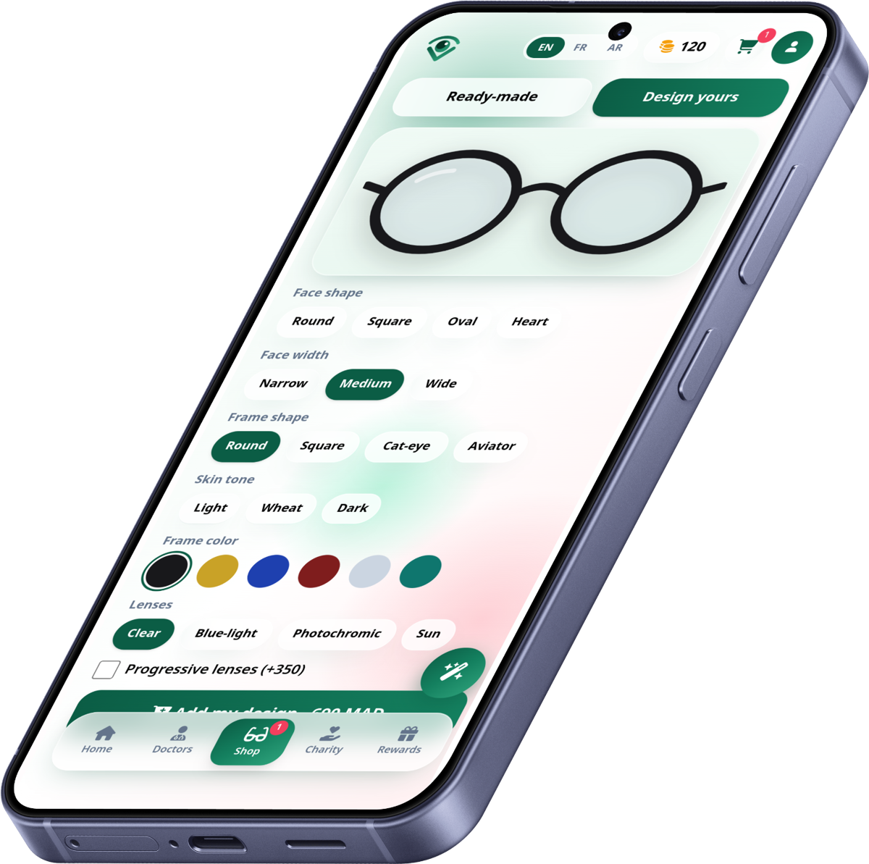

4 · Rewards & Eye Health
A loyalty layer and practical eye-health tools help make routine care easier to revisit.
- Daily streaks, coupons and free-Friday consultation promotions
- 20-20-20 rest timer and Amsler grid self-check
- Charity concept: sponsor free eye exams for low-income patients
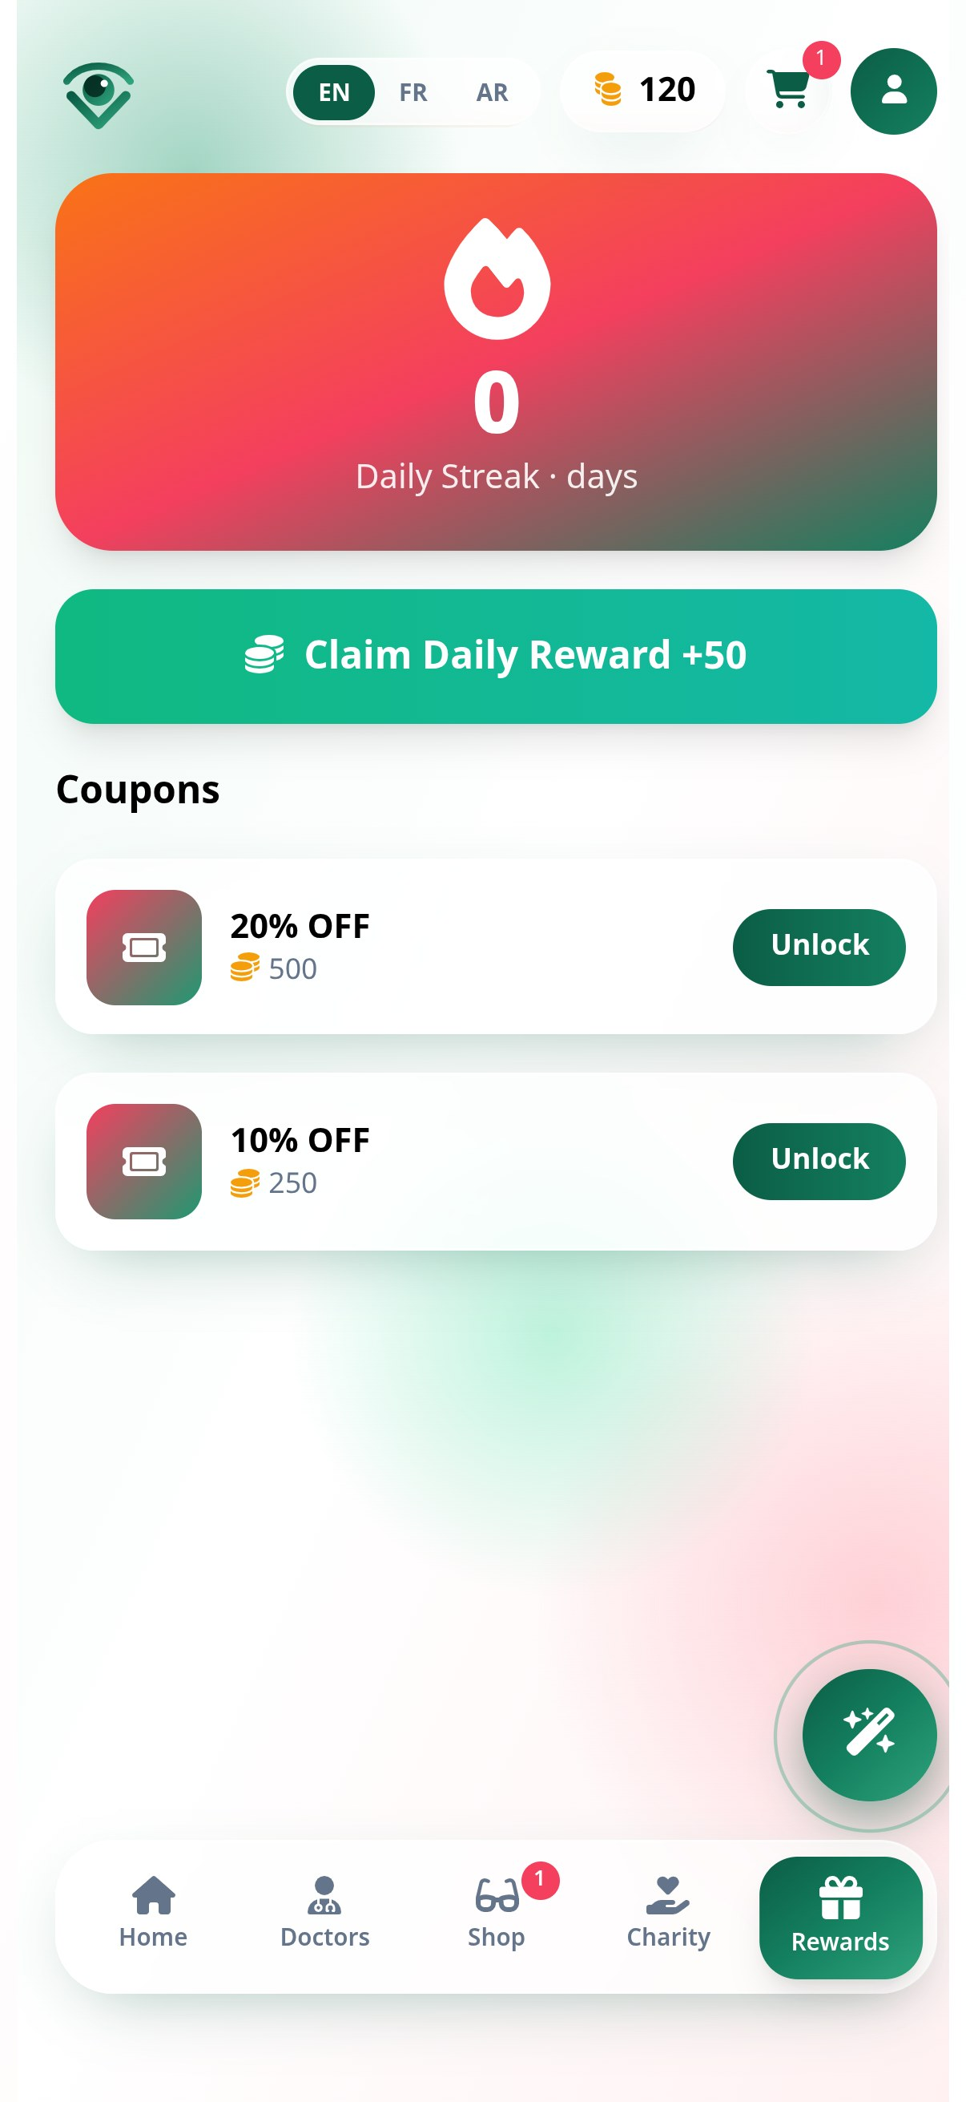

5 · Checkout & Order Tracking
A guided cart experience for eyewear orders, with order status stages envisioned from preparation through delivery.
- Live order tracking requires production service integration.


Mobile-first & Product Scope
Designed for a phone-sized experience, with English, French and Arabic support, including right-to-left layout. Examples are Morocco-focused and shown in MAD.
- Demo · No real payments
- The current build is a front-end prototype. Authentication, booking, AI recommendations, checkout, rewards, and live order tracking require production services and integrations before launch.

