**Planning Poker**

**\*First user story:-**

**AS an airline passenger,**

**I want to**

**Log in in airline online website**

**So that**

**I can know the flights that have the best Price and route.**

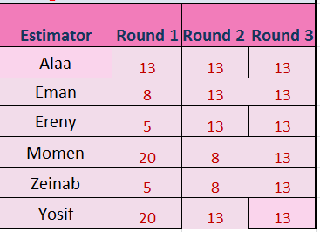

**\*\*\*\*\*\*\*\*\*\*\*\*\*\*\*\*\*\*\*\*\*\*\*\*\*\*\*\*\*\*\***

**\*Second user story:-**

**AS a Traveler,**

**I want to**

**Have many payment methods**

**So that**

**I can choose the best way to pay.**

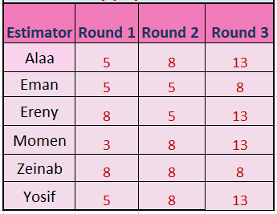

**\*\*\*\*\*\*\*\*\*\*\*\*\*\*\*\*\*\*\*\*\*\*\*\*\*\*\***

**\*Third user story:-**

**AS a Customer,**

**I want to**

**Give client card information if pay online**

**So that**

**I can feel safe.**

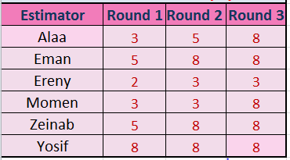

**\*Fourth user story:-**

**AS a Traveler,**

**I want to**

**Get company’s offers**

**So that**

**I can travel more with less money.**

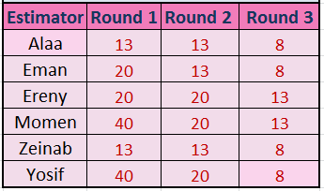

**\*\*\*\*\*\*\*\*\*\*\*\*\*\*\*\*\*\*\*\*\*\*\*\*\*\*\***

**\*Fifth user story:-**

**AS a Traveler,**

**I want to**

**Get map clarify**

**So that**

**I can clarify all hotels in my destination and to check its offers.**

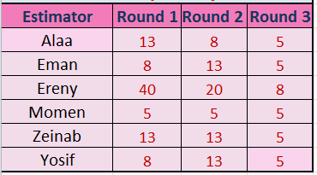

**\*Sixth user story:-**

**AS an airline passenger,**

**I want to**

**Send massage to the main center.**

**So that**

**I can contact with them if i face a problem.**

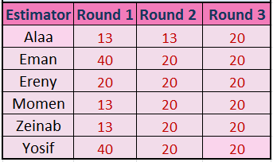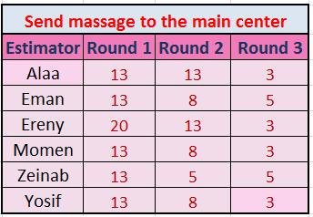

**\*\*\*\*\*\*\*\*\*\*\*\*\*\*\*\*\*\*\*\*\*\*\*\*\*\*\***

**\*Seventh user story:-**

**AS an airline passenger,**

**I want to**

**Make customer evaluation**

**So that**

**I can give my opinion.**

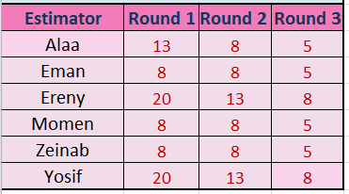

**\*Eighth user story:-**

**AS a Customer,**

**I want to**

**Be able to search for flights between two cities**

**So that**

**I can see which ones have the best price and route.**

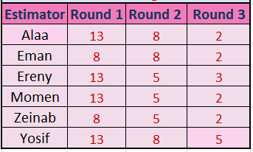

**Story Point Table**

