ARDOVA ENERGY PLC
TRADE AND SUPPLY MANAGEMENT SYSTEM
Solution Architecture and Technical Design Document

Prepared by : WYZE Solutions - SAP Practice
Document Ref : WYZE-ARDOVA-SAD-001
Version : 2.0
Classification: Confidential - Client Restricted
Date : March 2026

DOCUMENT CONTROL
Version Date Author Change Description
1.0 March 2026 WYZE SAP Practice Initial draft
2.0 March 2026 WYZE SAP Practice Full revision - scoped exclusively to SAP
S/4HANA Public Cloud Edition. Architecture
realigned to Clean Core principles.
Removed all on-premise and ECC-specific

TABLE OF CONTENTS
1.0 Executive Summary
2.0 Scope, Constraints, and Platform Declaration
3.0 Architectural Philosophy - Clean Core on S/4HANA Public Cloud
4.0 High-Level Solution Architecture
5.0 Component 1 - Trade Card (Custom Business Object)
6.0 Component 2 - Trade Finance (Treasury Management)
7.0 Component 3 - Trade Operations (Transportation Management)
8.0 Data Flow and Cross-Component Integration
9.0 SAP BTP - Side-by-Side Extensions and Analytics
10.0 Authorization and Access Control
11.0 Workflow and Approval Design
12.0 Edge Cases and Resilience Design
13.0 Non-Functional Requirements
14.0 Glossary

ARDOVA ENERGY PLC
TRADE AND SUPPLY MANAGEMENT SYSTEM
Solution Architecture and Technical Design Document
Prepared by : WYZE Solutions — SAP Practice
Document Ref : WYZE-ARDOVA-SAD-001
Version : 2.0
Classification: Confidential — Client Restricted
Date : March 2026
DOCUMENT CONTROL
TABLE OF CONTENTS
1.0 Executive Summary
2.0 Scope, Constraints, and Platform Declaration
3.0 Architectural Philosophy — Clean Core on S/4HANA Public Cloud
4.0 High-Level Solution Architecture
5.0 Component 1 — Trade Card (Custom Business Object)
6.0 Component 2 — Trade Finance (Treasury Management)
7.0 Component 3 — Trade Operations (Transportation Management)
8.0 Data Flow and Cross-Component Integration
9.0 SAP BTP — Side-by-Side Extensions and Analytics
10.0 Authorization and Access Control
11.0 Workflow and Approval Design
12.0 Edge Cases and Resilience Design
13.0 Non-Functional Requirements
14.0 Glossary
1.0 EXECUTIVE SUMMARY
This document establishes the definitive solution architecture for the Ardova
Trade and Supply Management System, implemented entirely on SAP S/4HANA Public Cloud Edition. It supersedes all prior architectural drafts and reflects the decisions reached during the solution design workshops conducted with Ardova's Trading Desk, Trade Finance, and Trade Operations leadership.
The system addresses a commercially critical gap in Ardova's current operating model: the absence of a single, integrated platform that connects the negotiation of petroleum cargo contracts with the financial instruments that fund those contracts and the logistics operations that deliver them. Today, these three
functions operate with significant information latency between them — a condition that introduces pricing risk, operational delays, and an inability to monitor the company's real-time trading position with any degree of confidence. The architecture adopted here is built around three purposefully designed components, each mapped to an existing or extensible capability within
S/4HANA Public Cloud:
(i) A Custom Business Object, referred to throughout this document as the Trade Card, serves as the master record for every trade transaction.
It is created at the moment a contract is agreed at the Trading Desk and assigned a unique transaction identifier in the format PM/YYYY/NNN.
This identifier becomes the common reference across all three components.
(ii) The Treasury Management module, native to S/4HANA Public Cloud, is configured and extended to handle all Trade Finance activities — from Form M application through to Letter of Credit issuance, Bills for Collection, Bank Guarantee management, and cargo insurance documentation.
Users access Trade Finance by entering the Trade Card ID, which immediately surfaces the relevant contract data without re-entry.
(iii) The Transportation Management module, equally native to S/4HANA Public Cloud, is configured and extended to manage Trade Operations — covering vessel deployment, cargo movement, service provider coordination, regulatory notifications, multi-point volume capture, and a real-time view of the trading position for each active transaction.
The system is designed in strict alignment with SAP's Clean Core principle meaning all extensions are implemented through the designated extensibility channels provided by S/4HANA Public Cloud — Key User Extensibility for field and logic additions to standard objects, and SAP Business Technology Platform (BTP) for analytics, workflow automation, and any capability that sits outside
the core system. No modifications are made to standard SAP code.
2.0 SCOPE, CONSTRAINTS, AND PLATFORM DECLARATION
2.1 Platform Declaration
This document applies exclusively to SAP S/4HANA Public Cloud Edition. All architectural decisions, configuration approaches, extensibility mechanisms, and integration patterns described herein are valid for and restricted to the Public Cloud edition of S/4HANA.
The distinction matters for the following reasons:
- S/4HANA Public Cloud enforces a strictly managed extensibility model. Customers extend the system through approved channels only: the Custom Business Objects application, the Custom Fields and Logic application, and side-by-side extensions on SAP BTP. Direct modification of SAP
standard objects, programs, or database structures is neither permitted nor possible in the Public Cloud edition.
- System configuration in S/4HANA Public Cloud is performed through Fiori-based configuration applications accessed within the system, primarily through the "Configure Your Solution" application and the relevant module setup apps. There is no direct access to the traditional ABAP customizing environment (IMG) as an open development tool.
- All custom user interfaces are built as SAPUI5 applications deployed on SAP BTP Cloud Foundry, consuming OData services exposed by the S/4HANA system. They are not developed as additions to the core system itself.
- Workflow and business process automation is handled through SAP Build Process Automation on BTP — not through any classical SAP workflow engine.
3.0 ARCHITECTURAL PHILOSOPHY — CLEAN CORE ON S/4HANA PUBLIC CLOUD
3.1 What Clean Core Means for this Implementation
SAP's Clean Core principle, which is foundational to the Public Cloud edition, establishes a clear contract between the customer and the platform: the standard system remains untouched and upgradeable, while customer-specific requirements are addressed through structured extensibility.
3.2 Implications for Long-Term Supportability
By adhering strictly to these extensibility channels, the Ardova implementation maintains a system that can receive SAP quarterly updates without the risk of custom code being overwritten or broken. This is not merely a theoretical benefit
- in practice, it means the Ardova team can stay current with S/4HANA Public Cloud innovations (new analytical capabilities, updated module features, security patches) without a costly upgrade project each time. For a trading business operating in a volatile commodity environment, the ability to adopt new platform capabilities quickly represents a genuine competitive consideration.
3.3 The Principle of Standard Before Custom
Throughout this design, every requirement was first evaluated against available standard functionality. Custom development was introduced only where no standard configuration path could meet the requirement within an acceptable tolerance.
The result is a solution where the core transaction and financial logic sits in standard SAP modules (TRM and TM), while the Trade Card CBO provides the connective layer and master reference that binds them together. The effort and risk of custom development is therefore confined to where it genuinely adds value — not distributed across the system as a default approach.
4.0 HIGH-LEVEL SOLUTION ARCHITECTURE
4.1 The Three-Component Model
The solution is structured around three interconnected components. The Trade Card is the origin point — it is where every transaction begins and where the authoritative contract record lives. The Treasury Management module and the Transportation Management module each consume that master record, adding the depth of detail appropriate to their respective functions.
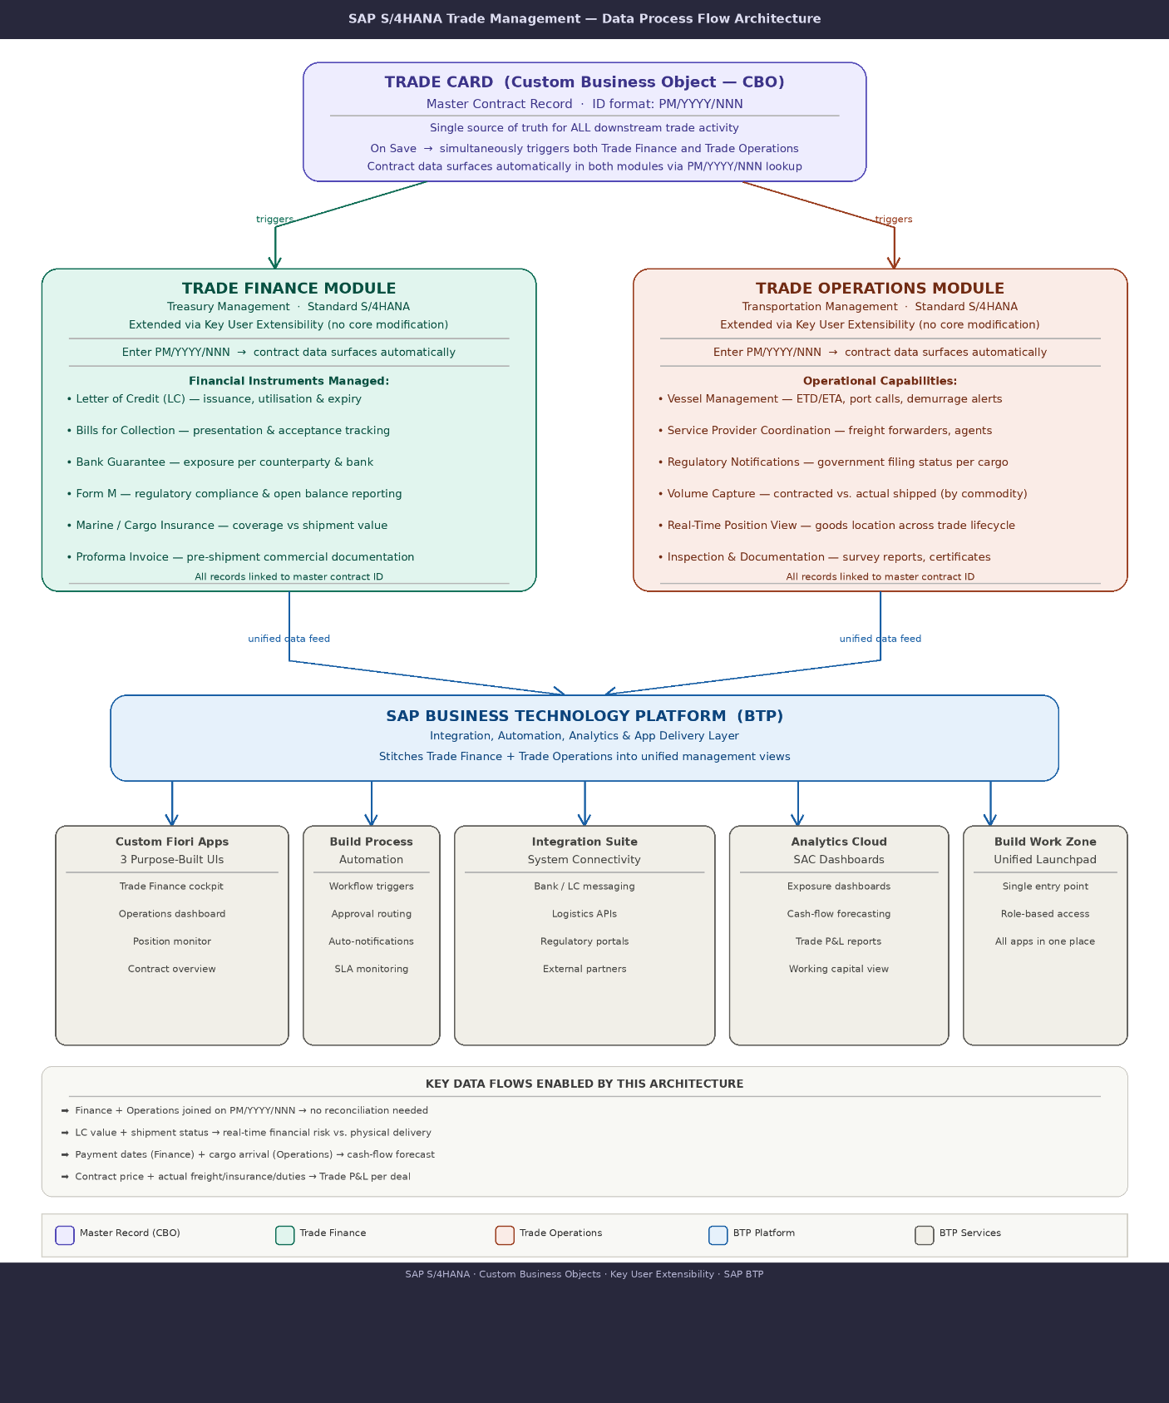
4.2 Transaction Lifecycle
Every trade transaction in this system moves through a defined sequence. The sequence is enforced through status management on the Trade Card CBO, and it reflects the actual operational reality of how Ardova's business functions:
Stage 1 — Contract Origination (Trading Desk)
The Trading Desk creates a Trade Card in the Custom Business Objects app. All key commercial parameters are recorded: product type, supplier, contracted volume, pricing type, delivery terms, and Laycan window. On saving the record, the system assigns the unique transaction ID in the
format PM/YYYY/NNN. From this point, the transaction ID is the universal
reference across all activities.
Stage 2 — Trade Finance (Treasury Management)
The Trade Finance team opens the Treasury Management application and enters the transaction ID. The system surfaces all contract data from the Trade Card immediately. The Finance team then proceeds to establish the appropriate payment instrument (LC, Bank Guarantee, Bills for Collection, or Advance Payment), apply for Form M where required, obtain insurance coverage, and manage all associated documentary processes. Completion of this stage and its approval gate is recorded against the Trade Card status.
Stage 3 — Trade Operations (Transportation Management)
The Trade Operations team opens the Transportation Management application and enters the same transaction ID. Contract and finance data already recorded against this ID are displayed. The Operations team maintains vessel information, nominates service providers, manages regulatory notifications, records all volume measurements across the cargo journey, and monitors the real-time trading position. Final cargo closure, once all costs are confirmed and reconciled, is executed here and posts the transaction to FI/CO.
Note on Parallelism: While the standard process sequence places Trade Finance before Trade Operations, the system does not technically prevent the Operations team from beginning their data entry in parallel. In practice, certain operational activities — particularly vessel positioning and agent nomination — must commence well before Finance documentation is complete, given shipping lead times. The architecture accommodates this operational reality while preserving the Finance approval gate as a precondition for final cargo closure.
5.0 COMPONENT 1 — TRADE CARD (CUSTOM BUSINESS OBJECT)
5.1 Design Rationale
The Trade Card is the architectural cornerstone of this solution. In S/4HANA Public Cloud, the appropriate and supported mechanism for creating a net-new business object — one that does not exist in any standard module — is the Custom Business Objects application, available in the Fiori Launchpad. This application provides a structured, upgrade-safe way to define a new data object with its own
fields, business logic, user interface, and number determination, all without modifying any standard SAP object. The Trade Card is deliberately designed to be a summary and master record rather
than a data-entry-heavy screen. Its purpose is to capture the essential contract parameters, generate the unique transaction ID, and provide the reference that all downstream activity will anchor to. The detailed functional work — the specifics of the LC terms, the vessel scheduling, the volume measurements — lives in the respective standard module applications.
5.2 Creating the Trade Card in the Custom Business Objects Application
In S/4HANA Public Cloud, the Custom Business Objects application is accessed directly from the Fiori Launchpad. A Key User or an administrator with the appropriate business role opens this application and creates the object through a guided interface. No development environment, no programming IDE, and no ABAP workbench access is required or appropriate for this step. The object creation process in the application involves:
- Defining the object name (Trade Card) and its technical identifier
- Configuring number determination (the PM/YYYY/NNN sequence)
- Defining all field nodes (the Trade Card header with its field list)
- Configuring the generated UI (which fields appear, in what order)
- Publishing the object to make it available to users
5.3 Trade Card Field Model
The Trade Card header node contains the following fields. All fields are defined within the Custom Business Objects application using the available field types (Text, Number, Date, Checkbox, Code List, Amount).
IDENTIFICATION AND STATUS
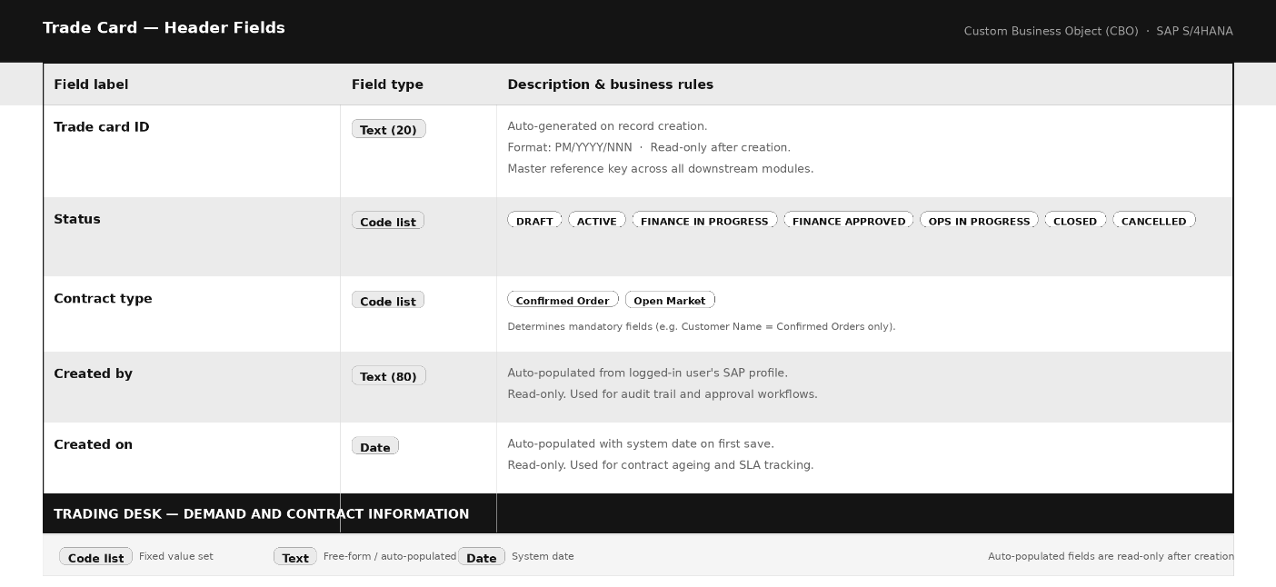
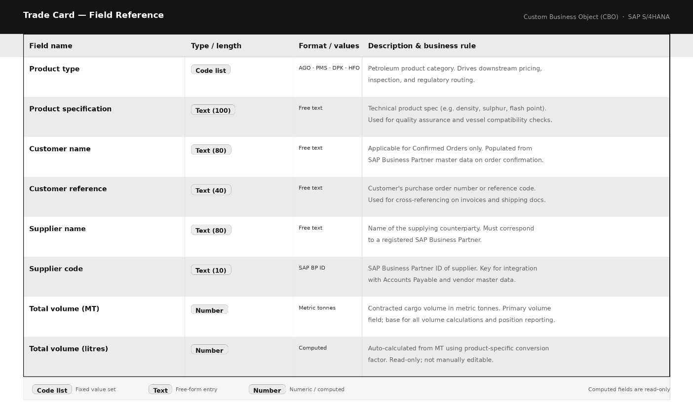

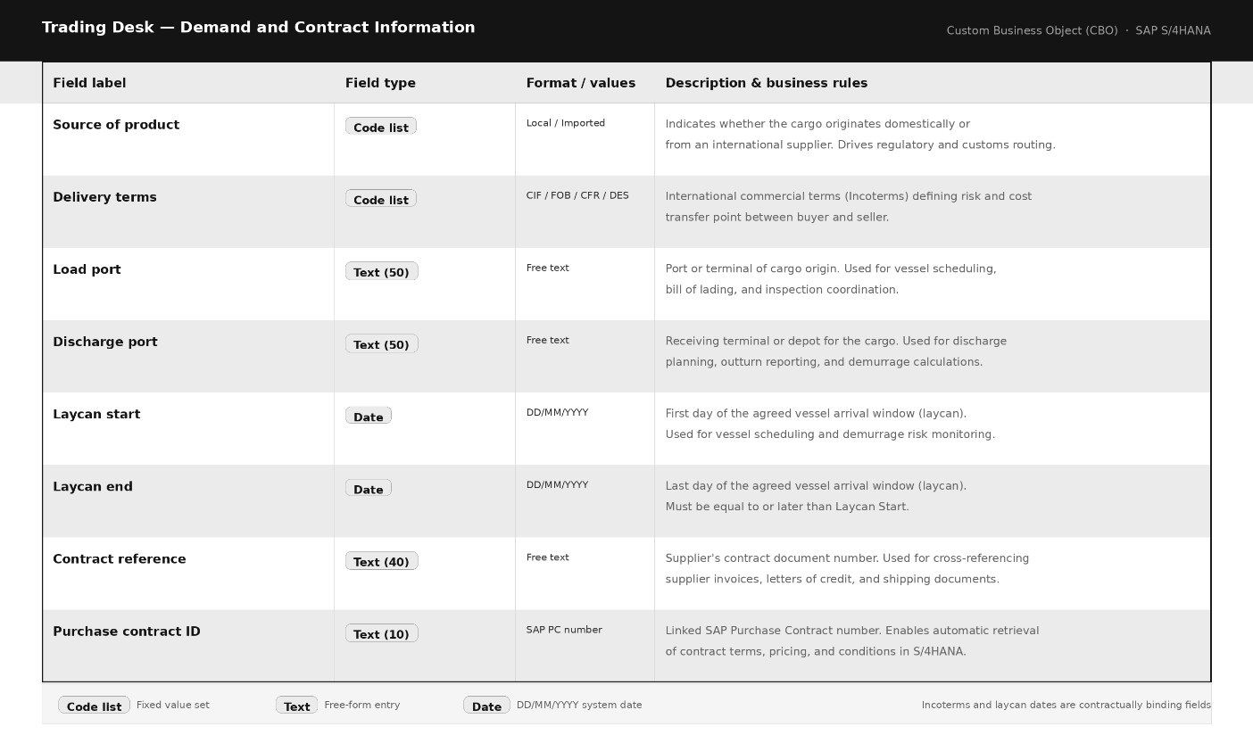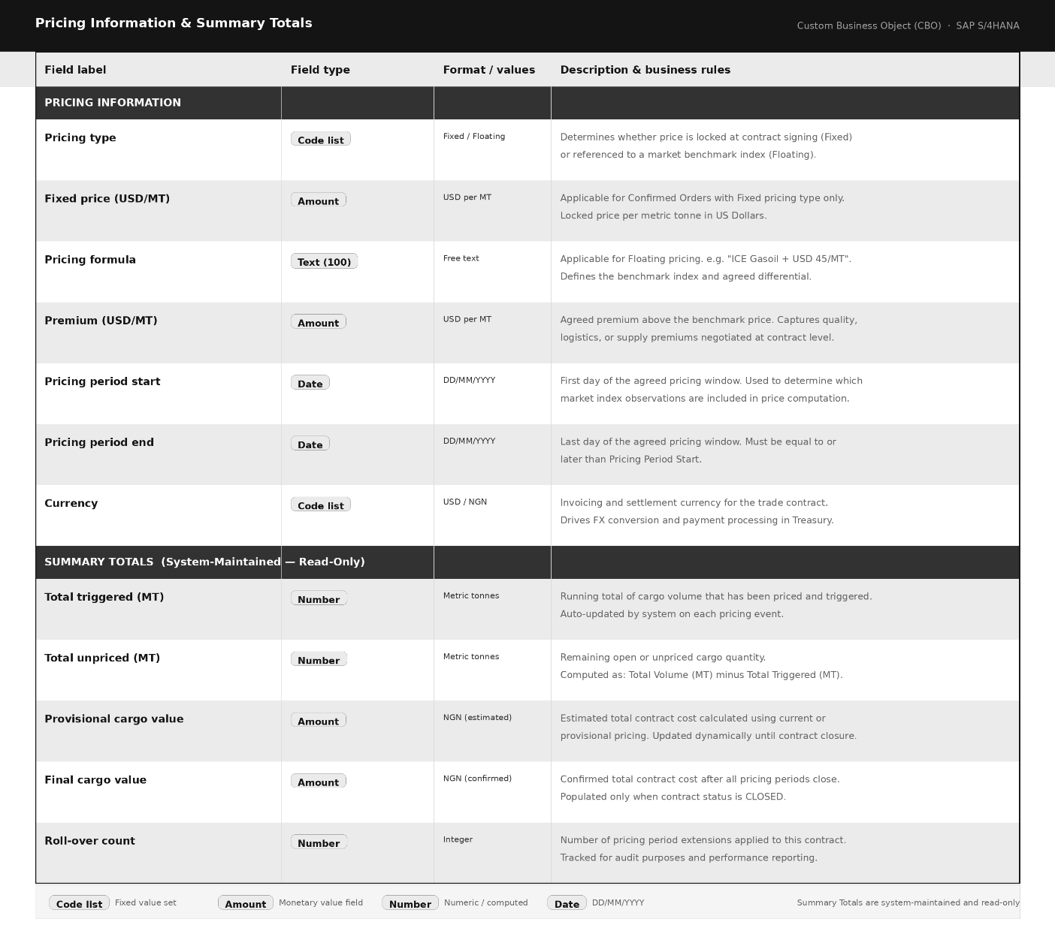
TRADE FINANCE SUMMARY (Cross-Reference Fields)

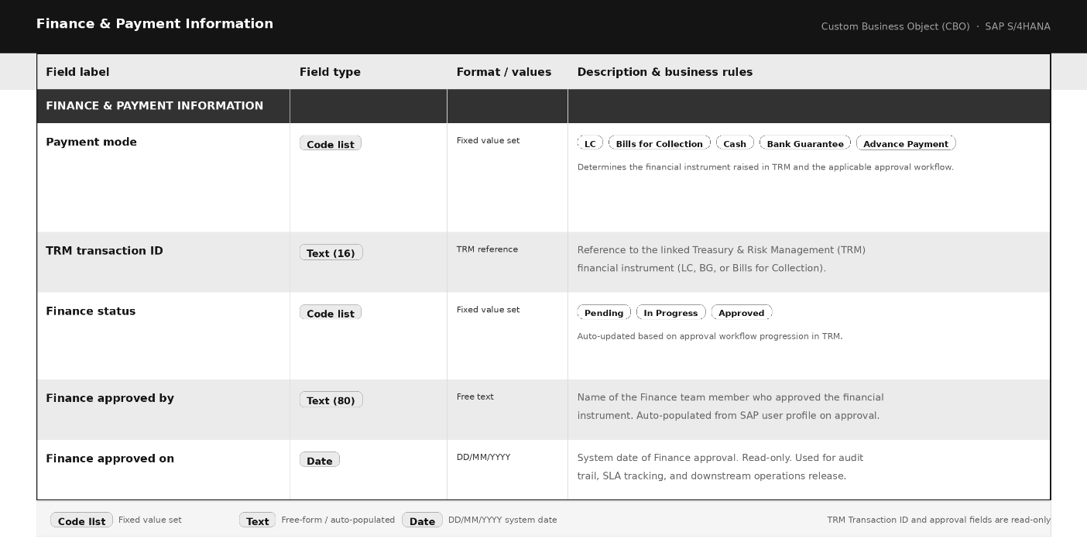
TRADE OPERATIONS SUMMARY (Cross-Reference Fields)
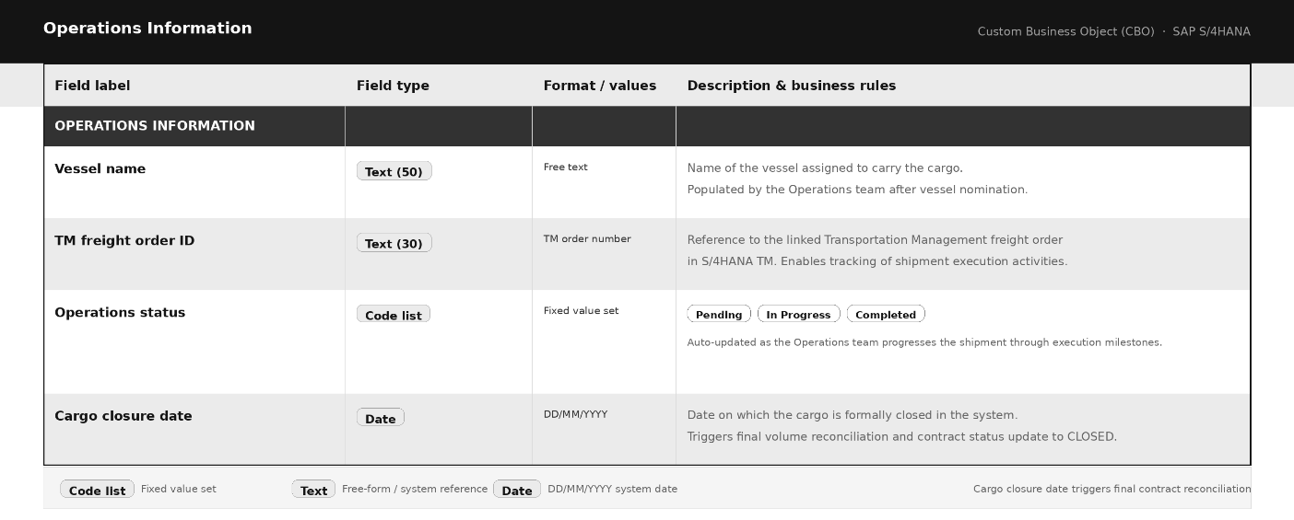5.4 Unique Transaction ID — Number Determination
The transaction ID format PM/YYYY/NNN is configured within the Custom Business Objects application under the number determination settings of the Trade Card object. The configuration specifies:
Prefix: PM Year Segment: Derived from the system date at time of creation
Sequence Number: Configured as a three-digit incrementing counter, reset annually
Format Assembly: PM / {YEAR} / {SEQUENCE}
Example Output: PM/2026/001, PM/2026/002 ... PM/2026/130
The numbering resets at the beginning of each calendar year. This means PM/2026/130 and PM/2027/001 can coexist in the system without conflict, as the year forms part of the unique key. All downstream references in Treasury Management and Transportation Management store and display this full identifier.
5.5 Custom Logic on the Trade Card
Within the Custom Business Objects application, the Custom Logic section allows business rules to be implemented using a cloud-compliant subset of ABAP statements. These rules execute at defined trigger points — Before Save, After Save, On Field Change — and are maintained entirely within the application,
not in an external development environment.
The following custom logic is defined for the Trade Card:
Trigger: Before Save — New Entry
- If Contract Type is "Confirmed Order" and Customer Name is empty, raise a validation error: "Customer Name is mandatory for Confirmed Orders." - If Pricing Type is "Fixed" and Fixed Price (USD/MT) is empty, raise a validation error: "Fixed Price must be specified."
- If Pricing Type is "Floating" and Pricing Formula is empty, raise a validation error: "Pricing Formula is required for floating-price contracts."
- Compute Total Volume (Litres) from Total Volume (MT) using the applicable product conversion factor (configurable per Product Type in a supporting Code List or lookup).
Trigger: After Save — New Entry
- Set Status to "Active"
- Set Total Triggered (MT) to zero
- Set Total Unpriced (MT) equal to Total Volume (MT)
- Write an entry to the audit log child node recording the creation event, the creating user, and the timestamp
Trigger: On Field Change — Status
- If Status changes to "Finance Approved", record Finance Approved By and Finance Approved On automatically from the current session
- If Status changes to "Closed", record Cargo Closure Date from the system date
5.6 Trade Card User Interface
The Custom Business Objects application generates a standard Fiori list and object page interface for the Trade Card automatically. This generated UI is the primary interface for Trading Desk users and provides:
- A list view of all Trade Cards with filtering by Status, Contract Type, Product Type, and date ranges
- A detail page (object page) displaying all field groups in a structured layout, with the transaction ID prominently displayed in the page header
- Section groupings matching the field model above (Identification, Contract Information, Pricing, Trade Finance Summary, Trade Operations Summary)
- An audit log section at the bottom showing all status changes and key events with timestamps and user names
For users of the Trade Finance and Trade Operations modules, the Trade Card detail page also acts as a quick-reference summary — they can always open a Trade Card by its PM/YYYY/NNN reference to see the full contract picture before proceeding with their specific activities.
6.0 COMPONENT 2 — TRADE FINANCE (TREASURY MANAGEMENT)
6.1 Why Treasury Management
The Treasury Management module in S/4HANA Public Cloud provides a mature, audit-ready framework for managing financial instruments and cash flows. For Ardova's Trade Finance function, the module's Transaction Manager component — specifically its capability to define, track, and manage financial instruments through their full lifecycle — covers the majority of what Trade Finance needs
without requiring custom development. The investment required here is primarily in configuration and targeted field extension, rather than building from scratch.
The match between TRM capabilities and Ardova's Trade Finance requirements is strong:
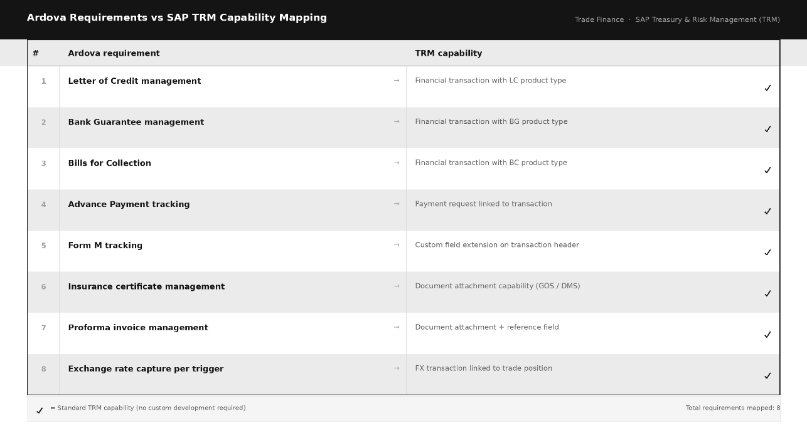
6.2 Configuration Approach
In S/4HANA Public Cloud, the Treasury Management module is configured through the Fiori-based configuration applications available within the system. The primary path is through the "Configure Your Solution" application, where the relevant configuration activities for Financial Supply Chain Management and Treasury are organised by topic. This is the correct and supported configuration
channel for Public Cloud — all settings made here are preserved across system updates and are transported via adaptation transports within the managed system landscape.
Key configuration activities for this solution:
PRODUCT TYPES
Custom product types are defined to represent each financial instrument used in Ardova's Trade Finance operations:
ARDLC — Ardova Letter of Credit
ARDBG — Ardova Bank Guarantee
ARDBC — Ardova Bills for Collection
ARDAP — Ardova Advance Payment
For each product type, the system configuration specifies the applicable transaction types, flow categories, partner roles, and condition types that govern how the instrument behaves through its lifecycle.
TRANSACTION TYPES PER INSTRUMENT
Under each product type, specific transaction types define the distinct events in an instrument's life:
For ARDLC (Letter of Credit):
LC100 — LC Application and Issuance
LC110 — LC Amendment
LC120 — LC Utilisation (drawdown upon document presentation)
LC130 — LC Cancellation
For ARDBG (Bank Guarantee):
BG100 — BG Issuance
BG110 — BG Extension
BG120 — BG Return or Cancellation
For ARDBC (Bills for Collection):
BC100 — BC Presentation
BC110 — BC Settlement

BUSINESS PARTNER ROLES
All counterparties in Trade Finance transactions are maintained as Business Partners in S/4HANA. The following partner roles are configured:
ARDSUP — Supplier / Seller (the commodity counterparty)
ARDBNK — Issuing / Negotiating Bank
ARDCBN — Central Bank of Nigeria (for regulatory tracking)
CONDITION TYPES
Financial charges associated with trade instruments are captured as condition types on each transaction. For Letters of Credit:
LCCOM — LC Commission (bank fee, typically a percentage of face value)
LCSTMP — Stamp Duty
LCINSUR — Insurance Premium linked to the LC
6.3 Key User Field Extensions on Treasury Management
Several data points that are specific to Nigerian petroleum trade regulations are not present in the standard Treasury Management screens. These are added using the Custom Fields and Logic application in S/4HANA Public Cloud — the supported extensibility path for adding fields to existing standard objects. The following custom fields are added to the Financial Transaction object:
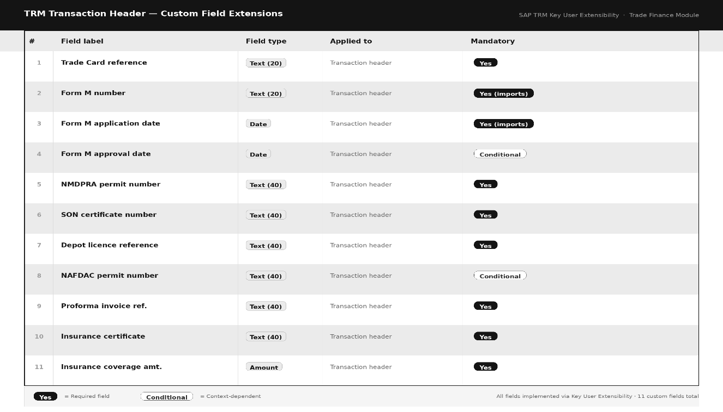
The Trade Card Reference field is the integration key. When a Trade Finance user enters a value in this field, a custom logic rule (defined in the Custom Logic section of the Custom Fields and Logic application) triggers a lookup to the Trade Card CBO and populates the following fields automatically on the screen:
- Supplier Name and Supplier Code - Pricing Type and Pricing Formula
- Product Type and Specification - Laycan Start and Laycan End dates
- Total Volume (MT) and Total Volume (Litres) - Delivery Terms
- Load Port and Discharge Port
This automatic population eliminates re-keying of contract data, ensures consistency between the Trade Card and the TRM transaction record, and reduces the risk of discrepancies between what the Trading Desk agreed and what the Finance team submits to the bank.
6.4 Trade Finance Application Flow
The experience for a Trade Finance officer using this system follows a deliberate sequence. Upon receiving notification that a Trade Card has been created and activated, the officer opens the Treasury Management application from the SAP Build Work Zone (the BTP-hosted Fiori Launchpad):
Step 1 — Locate Transaction
Open the Manage Financial Transactions application. Create a new financial transaction. In the Trade Card Reference field, enter the PM/YYYY/NNN identifier received from the Trading Desk. Contract data auto-populates.
Step 2 — Regulatory Prerequisites
Confirm that all mandatory regulatory permits are in place before proceeding. The NMDPRA Import Permit, SON Certificate, and Depot Licence fields must be completed before the system allows the payment instrument section to be saved. Document scans of each permit are attached directly to the transaction record.
Step 3 — Select Payment Mode
The product type selected (ARDLC, ARDBG, ARDBC, or ARDAP) determines the payment instrument workflow. The screen adapts dynamically to show the fields relevant to the selected instrument.
For Letter of Credit: The Form M number is entered and the Form M status confirmed. The LC face
value, LC expiry date, and issuing bank are recorded. A draft LC document may be attached for review. Once the Trade Finance team confirms the draft is consistent with the contract, the LC is marked as issued.
For Bills for Collection:
The Form M is still required for imports. The BC Presentation date, presenting bank, and collection reference are recorded.
For Cash Payment (Local Purchases):
The payment reference, remittance confirmation number, and payment date are recorded. No Form M is required for local purchases.
For Bank Guarantee:
The BG reference, face value, issuing bank, and expiry date are recorded.
Step 4 — Proforma Invoice and Insurance
The proforma invoice reference and amount are entered. The insurance certificate reference and coverage amount are entered, with the certificate document attached. These two items are prerequisites for the Finance approval action to become available.
Step 5 — Finance Approval
When all required documentation is complete, the Trade Finance officer submits the transaction for approval. An approval workflow (managed in SAP Build Process Automation) routes the record to the designated Trade Finance Approver. The approver receives a task notification in their
Fiori inbox, reviews the record, and confirms or rejects the approval.
On approval, the Trade Card status is updated automatically to "Finance Approved", and the Trade Operations team is notified.
6.5 Floating Price Management Within TRM
For Open Market transactions where the cargo price is determined in stages through pricing triggers, Treasury Management is used in conjunction with the FX management capability to record each trigger event as a discrete pricing action. Each trigger records the ICE Gasoil benchmark rate, the agreed premium, and the exchange rate prevailing on the trigger execution date.
A custom pricing log — implemented as a sub-node within the Trade Card CBO —maintains the full history of all triggers, their volumes, prices, and exchange rates. The TRM transaction for a floating-price cargo remains open until the final trigger is confirmed, at which point the cumulative product cost is established and the transaction can be settled.
The distinction between the ICE Gasoil price at each trigger date and the exchange rate applied at each trigger date is maintained with precision in the trigger log. These are two separate variable inputs that change independently, and the system records both explicitly for each tranche of the cargo that is priced. This level of granularity is essential for accurate financial reporting and for satisfying any audit inquiry into the final cost attribution of a given cargo.
7.0 COMPONENT 3 — TRADE OPERATIONS (TRANSPORTATION MANAGEMENT)
7.1 Why Transportation Management
The Transportation Management module in S/4HANA Public Cloud manages the physical movement of goods from origin to destination. Its native capabilities cover freight order management, carrier (vessel) assignment, shipment scheduling, service provider management, and freight costing. These capabilities map directly to the core activities of Ardova's Trade Operations function.
The match between TM capabilities and Ardova's Trade Operations requirements:
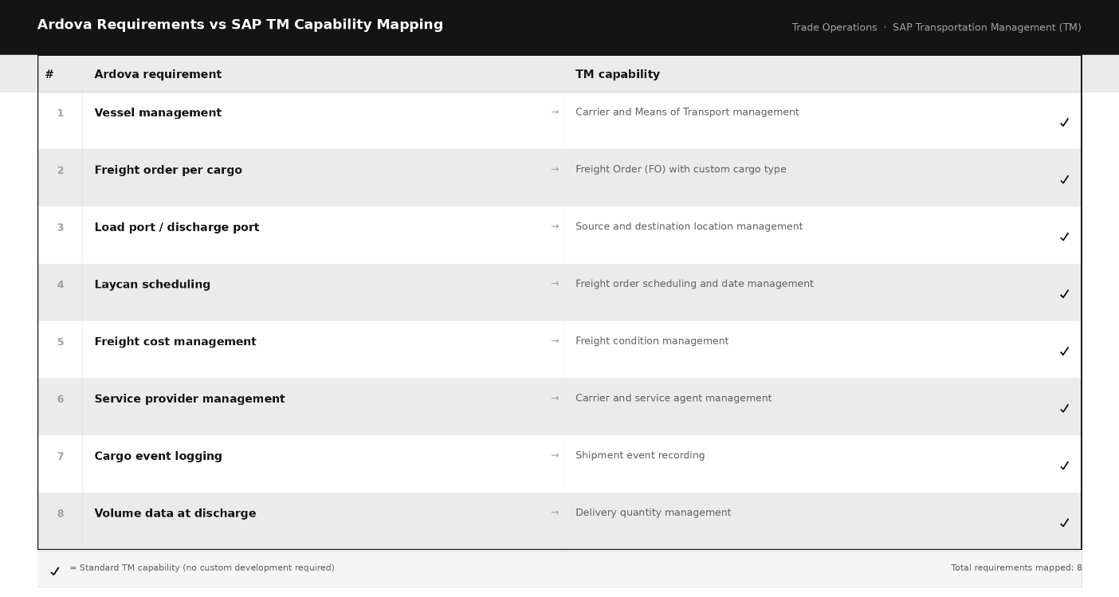
7.2 Configuration Approach
Like Treasury Management, Transportation Management configuration in S/4HANA Public Cloud is performed through the Configure Your Solution application and the relevant module setup Fiori applications. Key configuration areas include:
FREIGHT ORDER TYPE
A custom freight order type ARDCARGO is created to represent an Ardova petroleum cargo movement. This type is configured with:
- Transport mode: Sea (maritime)
- Dangerous goods relevant: Yes (petroleum products classification)
- Date profile: Requires Laycan Start, Laycan End, Loading Dates,
Sailing Date, Arrival Date, Discharge Dates
- Completion profile: All mandatory date and volume fields must be
populated before the freight order can be set to Completed status
MEANS OF TRANSPORT — VESSEL MASTER
Vessels are maintained in Transportation Management as Means of Transport. A specific means of transport category ARDVSL (Ardova Vessel) is configured to represent the vessel fleet. Each vessel in the fleet is set up as an individual means of transport record under this category, with its own
identifier, name, and capacity parameters.
SERVICE TYPES FOR PETROLEUM CARGO OPERATIONS
Each category of third-party service provider engaged during cargo operations is defined as a distinct service type in TM:
ARDFEND — Fendering Services ARDSTOR — Interim Storage Services
ARDSTS — Ship-to-Ship Transfer Operations ARDLAGNT — Load Port Agent
ARDPSRV — Port Surveyor Services ARDDAGNT — Discharge Port Agent
Freight conditions for each service type allow the system to capture budgeted service costs at the time the freight order is created, with actual invoiced costs updated when service provider invoices are received and processed.
7.3 Key User Field Extensions on Transportation Management
Custom fields added via the Custom Fields and Logic application extend the standard Freight Order to capture petroleum-specific operational data:
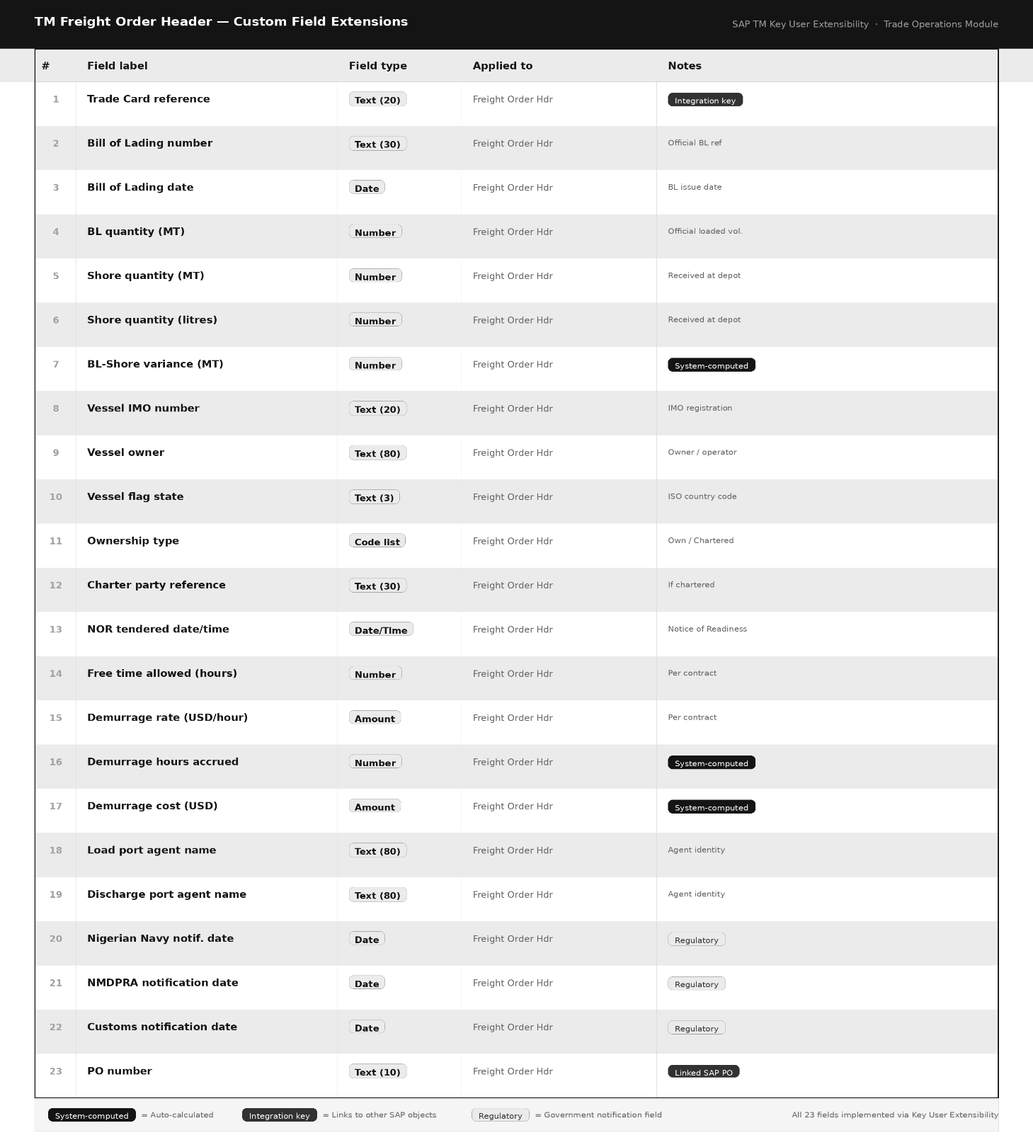
As with Trade Finance, the Trade Card Reference field drives automatic population of contract data from the Trade Card CBO when entered by the Trade Operations officer.
The BL-Shore Variance and Demurrage Cost fields are system-computed through custom logic defined in the Custom Fields and Logic application:
BL-Shore Variance (MT) = BL Quantity (MT) — Shore Quantity (MT)
Demurrage Hours = MAX( 0, Loading Commencement — (NOR Tendered + Free Time) )
Demurrage Cost = Demurrage Hours × Demurrage Rate (USD/Hour)
These computations execute automatically when the relevant input fields are saved, removing the need for manual calculation and eliminating the risk of arithmetic errors on high-value items.
7.4 Multi-Point Volume Capture
Given the financial significance of volume measurements in petroleum cargo operations — where a single metric tonne of AGO may represent USD 700 to 800 of value — the system maintains a structured volume capture framework as a sub-node of the Trade Card CBO. Five measurement points are defined, each with its own date/time, volume in MT, volume in litres, and recording user:
Capture Point | When Recorded
Before Loading | Prior to loading operations at load port terminal
Bill of Lading | At conclusion of loading (Port Surveyor certified)
Vessel Departure | As vessel sails from load port
Vessel Arrival | As vessel arrives at discharge port
Shore Tank Receipt | At conclusion of discharge into depot tanks
When the Shore Tank Receipt measurement is saved, custom logic automatically computes the variance against the Bill of Lading quantity and expresses it as both an absolute figure (MT) and a percentage. If the variance exceeds 0.5%, the system raises a notification to the Trade Operations Approver and blocks
the cargo closure action until the variance is formally acknowledged.
7.5 Operational Event Log
A chronological event log sub-node on the Trade Card CBO records all significant
operational milestones with their date, time, and the identity of the recording
officer:
Laycan Confirmed / NOR Tendered / Free Time Commenced / Loading Commenced /
Loading Completed / Vessel Sailed / Vessel Arrived at Discharge / Regulatory
Clearance Obtained / Discharge Commenced / Discharge Completed / Shore Tank
Receipt Confirmed / Cargo Closure Initiated
This log forms the basis for performance analysis across voyages and provides the date and time records that service provider invoices are validated against.
7.6 Regulatory Notification Tracking
A dedicated notification tracking sub-node records the dispatch and acknowledgement of mandatory regulatory notifications:
Regulatory body | Notification type | Submission mode
Nigerian Navy | Vessel movement | Electronic / Physical
NMDPRA | Import notification | Electronic / Physical
Nigeria Customs | Import clearance | Electronic
Each notification record captures the date sent, the submission mode (the regulatory environment in Nigeria means some authorities continue to require physical document submission in addition to or in place of electronic notification), the acknowledgement date, and the reference number issued by
the receiving authority.
7.7 Real-Time Trading Position View
The real-time trading position is a dynamic view of the net balance between volumes purchased and volumes sold or committed at any given moment. This view is a critical operational tool for the Trading Desk — it informs trigger execution decisions, additional procurement needs, and sales commitment capacity. The position view is implemented as an embedded SAP Analytics Cloud story within
the custom Trade Operations Fiori application deployed on BTP. The story reads from the Trade Card CBO data in real time, computing:
Net Position = Total Volume Purchased — Total Volume Sold / Committed
Positive result → Long position (purchased exceeds sold; price risk if market falls)
Negative result → Short position (sold exceeds purchased; supply risk)
The dashboard displays:
- Current net position by product type (AGO, PMS, DPK, HFO)
- Breakdown between triggered volume (priced) and unpriced open quantity
- Intra-day position movement chart showing position at each event
- Active cargo table: one row per live Trade Card with triggered,
untriggered, and sold volumes per transaction
- Automated threshold alerts when the position crosses into short territory or when an unpriced volume is approaching its pricing period end date.
The data underlying this view is refreshed on every trigger execution, every sale entry recorded by the Sales team, and every volume capture event. There is no end-of-day batch process — position data reflects the current state of the system at the moment it is viewed.
8.0 DATA FLOW AND CROSS-COMPONENT INTEGRATION
8.1 The Trade Card as the Integration Hub
The Trade Card CBO is the integration hub of this solution. It does not replicate data from Treasury Management or Transportation Management — it holds a summary reference to each, and each module reads from it when a Trade Card ID is entered. This is a pull-based integration design: the downstream module requests the contract data it needs from the Trade Card at the moment it is
needed, rather than data being pushed out proactively.
In S/4HANA Public Cloud, the integration between the CBO and the standard modules is achieved through the OData services that both the CBO and the standard modules expose. When a user enters a Trade Card ID in either Treasury Management or Transportation Management, a Custom Logic rule (defined in the Custom Fields and Logic application for each respective object) makes an OData
call to the Trade Card service, retrieves the relevant contract record, and populates the dependent fields on the screen. This is an in-system API call that does not require an external integration platform.
8.2 Cross-System Integration via SAP Integration Suite
For integration events that cross the boundary between S/4HANA and BTP — such as publishing a Trade Card creation event so that the BTP-hosted Fiori apps can respond, or sending workflow notifications, or updating the SAC analytics data model — SAP Integration Suite on BTP is the platform. Integration flows (iFlows) are designed for each integration event:
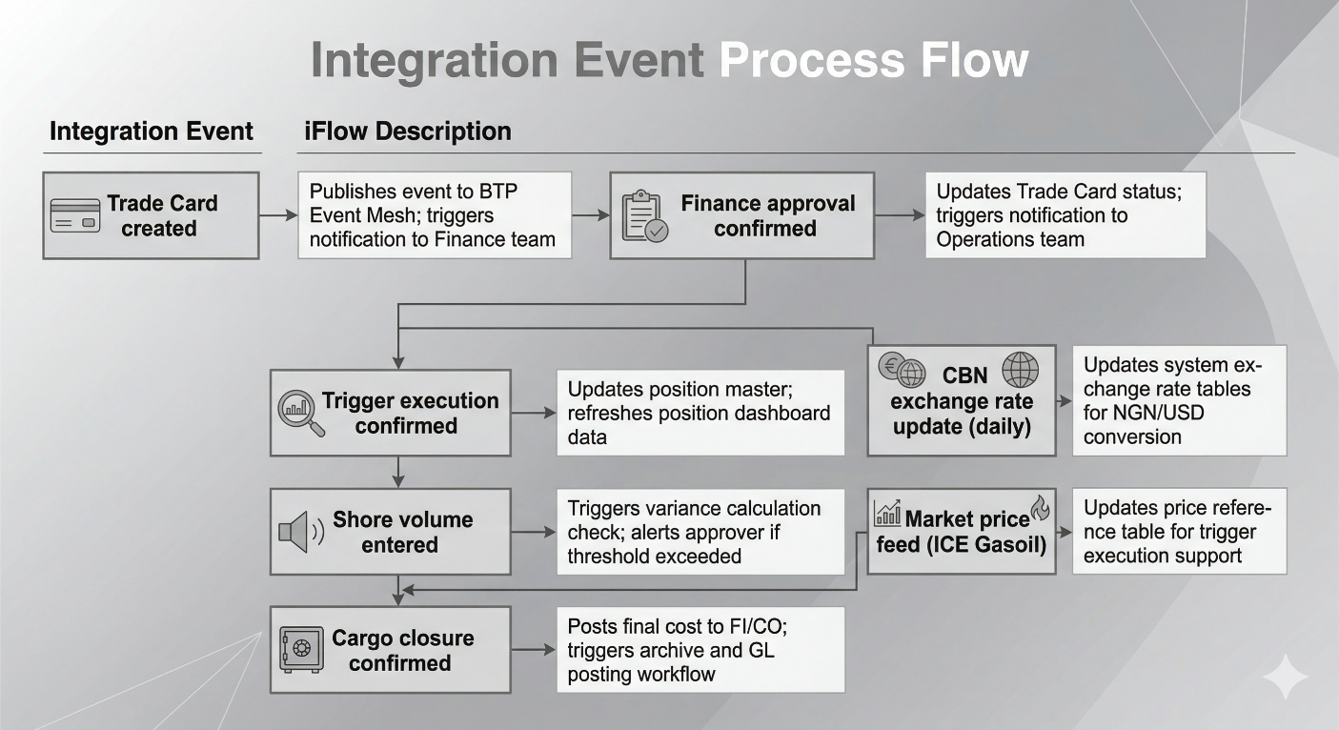8.3 Event-Driven Architecture
Events are published to SAP BTP Event Mesh using the CloudEvents specification. This decouples the producing system (S/4HANA) from the consuming applications (BTP Fiori apps, SAC, notification services). Each event carries the Trade Card ID as its primary payload key, allowing consuming services to retrieve the full record via OData if additional data is needed.
Event Topic Pattern: ardova/trade/{component}/{event}
Examples:
ardova/trade/card/created ardova/trade/trigger/executed
ardova/trade/finance/approved ardova/trade/volume/recorded
ardova/trade/cargo/closed
9.0 SAP BTP — SIDE-BY-SIDE EXTENSIONS AND ANALYTICS
9.1 What Lives on BTP
SAP BTP hosts the components of this solution that extend beyond the boundary of what S/4HANA Public Cloud natively provides — primarily the custom Fiori user interfaces, the workflow automation, the analytics layer, and the integration middleware.
BTP component | Role & description
SAP Build Work Zone | The central Fiori Launchpad where all three app tiles are presented to users with single sign-on.
SAP BTP Cloud Foundry | Hosting environment for custom SAPUI5 apps and the SAP Approuter.
SAP Integration Suite | All iFlow-based integration between S/4HANA, BTP services, and external data providers.
SAP Event Mesh | Asynchronous event publishing and consumption across trade lifecycle events.
SAP Analytics Cloud | Embedded analytics stories covering the position dashboard, P&L evolution chart, and cargo performance reports.
SAP Build Process Automation | Approval workflows for Trade Finance and cargo closure events.
SAP Document Management | Storage and retrieval of regulatory documents, LC drafts, insurance certificates, and BL copies.
9.2 Custom Fiori Applications
Three custom SAPUI5 Fiori applications are developed and deployed on BTP Cloud Foundry. Each application is built with the SAPUI5 framework (version 1.120+, Horizon theme) and follows SAP Fiori design guidelines.
Application 1 — Trade Card Application
The primary application for the Trading Desk. Provides a list view of all Trade Cards with filtering by status, product type, and date range. The detail view displays all Trade Card fields, the operational event log, volume capture summary, trigger history (for floating-price cargoes), and
navigation tiles to launch the Trade Finance and Trade Operations applications in the context of the current Trade Card. All approval actions available
to the current user based on their business role are surfaced in the page header action bar.
Application 2 — Trade Finance Application
Accessed from the Trade Card navigation tile or directly from the Work Zone. When launched from the Trade Card context, the PM/YYYY/NNN identifier is passed as a URL parameter and the corresponding TRM transaction is loaded automatically. Displays all Trade Finance-specific data with tabs for: Regulatory Prerequisites, Payment Instrument Details, Document Management,
Trigger History (for floating-price), Provisional P&L View, and Approval.
Application 3 — Trade Operations Application
Accessed from the Trade Card navigation tile or directly from the Work Zone. When launched from the Trade Card context, the identifier is passed and the corresponding Freight Order data is loaded. Displays all operational data with tabs for: Vessel and Service Provider Information, Regulatory
Notifications, Operational Event Log, Multi-Point Volume Capture, Position Dashboard (embedded SAC story), and Cargo Costing and Closure.
9.3 Connectivity from BTP to S/4HANA
All OData calls from the BTP-hosted Fiori applications to S/4HANA pass through:
- SAP Cloud Connector: Installed in the Ardova network, establishing a secure encrypted tunnel between the BTP subaccount and the S/4HANA system
- BTP Destination Service: Configured with the S/4HANA system details and Principal Propagation authentication, ensuring that the user's identity is passed through from the BTP app to S/4HANA seamlessly (no separate login)
- SAP Approuter: Handles authentication at the BTP entry point, manages CSRF tokens, and routes API calls to the appropriate backend destination
This is precisely the connectivity architecture demonstrated and validated in the Product Catalog Manager project that preceded this engagement.
10.0 AUTHORIZATION AND ACCESS CONTROL
10.1 Business Roles
Business role name | Description | Primary applications
BR_ARDOVA_TRADING_DESK | Trading Desk Officer | Trade Card App (edit)
BR_ARDOVA_TRADING_APPR | Trading Desk Approver | Trade Card App (approve)
BR_ARDOVA_TRADE_FINANCE | Trade Finance Officer | Finance App (edit)
BR_ARDOVA_FINANCE_APPR | Trade Finance Approver | Finance App (approve)
BR_ARDOVA_TRADE_OPS | Trade Operations Officer | Ops App (edit)
BR_ARDOVA_OPS_APPR | Operations Approver | Ops App (approve / close)
BR_ARDOVA_SALES | Sales Team | Position entry only
BR_ARDOVA_MANAGEMENT | Management (Read-Only) | All apps, view only
10.2 Segregation of Duties
A fundamental control principle enforced throughout the system is that no single user can both create a record and approve it. This is implemented through the separation of the Officer and Approver roles, and enforced in the Custom Logic of the Trade Card CBO and in the SAP Build Process Automation
workflows. The system will reject an approval action submitted by the same
user who created or last modified the record being approved.
10.3 Identity Management
All user identities are managed centrally through SAP Cloud Identity Services. This provides a single identity store for both the S/4HANA system and all BTP-hosted applications. Users authenticate once at the Work Zone entry point and are recognised across all applications without re-authentication. Business roles assigned in S/4HANA are reflected in the BTP applications through Principal Propagation.
11.0 WORKFLOW AND APPROVAL DESIGN
All approval workflows in this solution are implemented using SAP Build Process Automation on BTP. This is the correct workflow mechanism for S/4HANA Public Cloud, where the classical SAP workflow engine is not the appropriate tool.
Three workflows are defined:
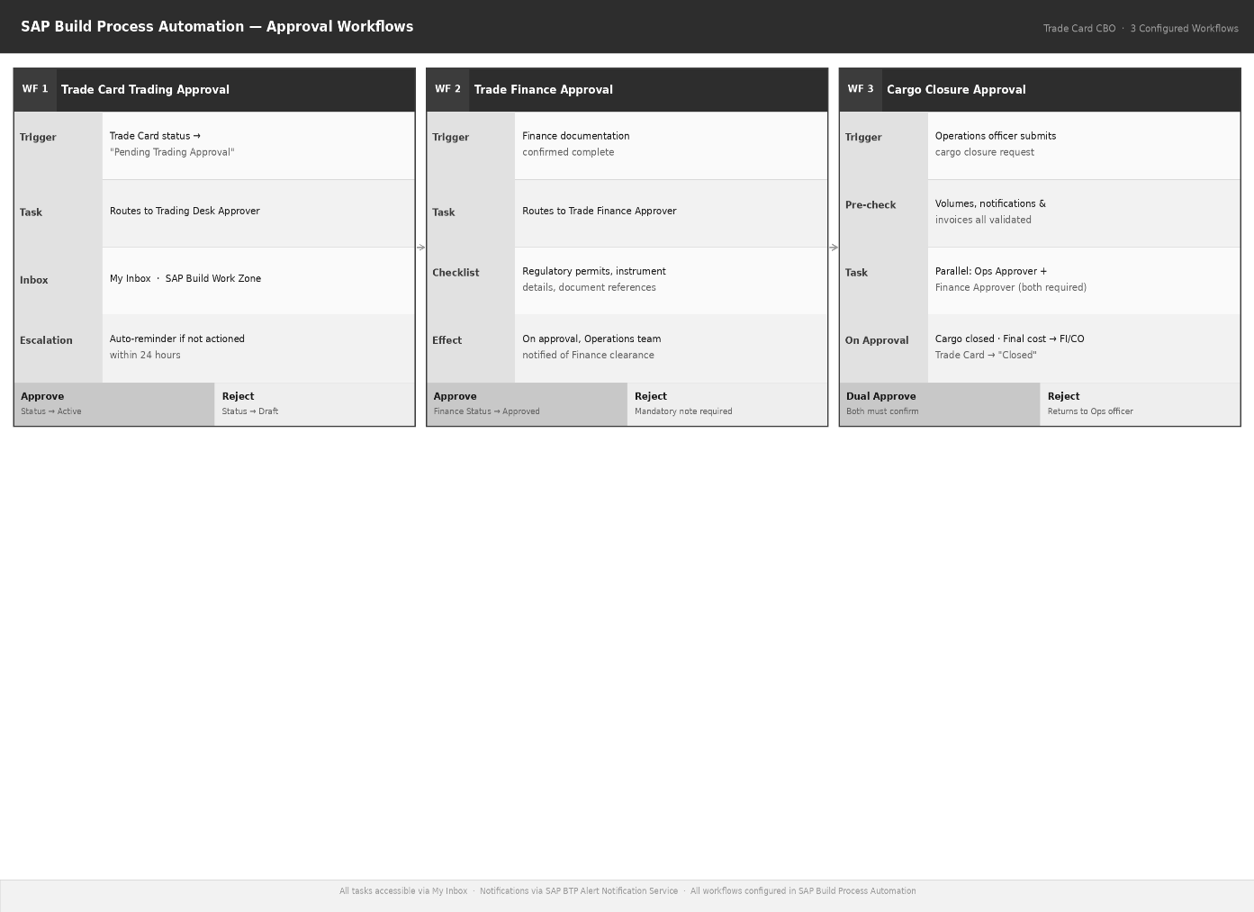
12.0 Exception Handling Scenarios
The following scenarios define system behaviour and required user actions when operational exceptions occur during the trade lifecycle.
BL-Shore Volume Variance Threshold Exceeded
Scenario
When the shore tank receipt quantity is entered, the system computes the variance against the Bill of Lading quantity. If the variance exceeds the configured tolerance threshold, the cargo closure action is blocked pending review.
Variances between 0.2% and 0.5% generate a warning notification but do not block closure.

Vessel Arrival Outside Laycan
Scenario
If the NOR Tendered date falls outside the configured Laycan window, the system flags the event in the operational log with an “Outside Laycan” indicator.
The demurrage calculation is adjusted in accordance with the relevant contract clause. An alert is sent to the Trading Desk for supplier negotiation.
The operational officer is required to enter an explanation note before the outside-laycan NOR record can be saved.

LC Amendment After Issuance
Scenario
If contract terms change after an LC has been issued, the Trade Finance officer creates a new TRM transaction of type LC110 (LC Amendment) linked to the original LC transaction.
The amendment is documented and subject to the same Finance Approval workflow as the original issuance.

Short Trading Position During an Active Trading Day
Scenario
When the Sales team records sale volumes that push the net position into negative territory (short), the position dashboard immediately reflects the short condition and triggers an alert notification to the Trading Desk.
The system does not prevent the sale from being recorded — the decision to allow a short position is a commercial judgement — but it ensures the Trading Desk is aware of the exposure without delay.

Cargo Quality Rejection at Discharge
Scenario
If the Trade Operations officer records a quality failure at the discharge port, the cargo closure action is blocked and the Trade Card is placed in a “Quality Dispute” status.
An escalation notification is sent to the Trading Desk and Trade Finance teams for supplier claim management.
The system preserves all volume and documentation records in their current state pending resolution.

13.0 Non-Functional Requirements

Requirement category | Specification
Performance | Trade Card list page load: under 2 seconds (95th percentile). Trigger execution and position refresh: under 3 seconds. Position dashboard refresh: under 5 seconds on SAC embedded view.
Availability | S/4HANA Public Cloud: governed by SAP’s standard cloud SLA (99.9% monthly uptime). BTP-hosted apps: 99.5% monthly availability target.
Scalability | The Trade Card CBO must support a minimum of 500 concurrent active records without performance degradation. The position engine must accommodate at least 300 trigger events per trading day.
Security | All communication between BTP and S/4HANA is encrypted in transit (TLS 1.3). No credentials are stored in application code or configuration files. All authentication uses SAP Cloud Identity Services.
Audit Completeness | One hundred percent of status changes on the Trade Card CBO are recorded in the audit log with timestamp and user identity. Audit records are immutable after creation. Confirmed trigger records cannot be modified.
Data Retention | Trade Card records and all associated sub-node data are retained for a minimum of seven years in accordance with Nigerian financial regulatory requirements. Archive strategy to be defined in the operational runbook.
Mobile Responsiveness | All three custom Fiori applications must be fully functional on tablet devices. Critical data entry actions must work on a mobile browser.
This document is the property of WYZE Solutions and is prepared exclusively for the use of Ardova Energy Plc in connection with the Trade and Supply Management System implementation project. It may not be reproduced, distributed, or disclosed to any third party without the prior written consent of WYZE Solutions.
WYZE Consulting Services Limited | (c) 2026 | All Rights Reserved

