README Last Updated March 14, 2014

**Purpose**

The purpose of this code is to provide an advanced chat bot engine, and an example BatterBot.

**Using the code**  
The current version of this code is only designed to be used through the eclipse console. The code can then be used by creating a project in eclipse, bringing in the relevant files, and running the BatterBotDriver class, which contains a main method which will initiate the conversation cycle. You can create your own chatter bot by creating a method that will create new Response Templates, and calling the cycle() method.

**Simple System Overview:**

We begin by examining the flow of data by defining five main components in our system. We have the Language Processor, the Response Selector, the Response builder, and the IO controller. Another critical component of the system is the Response Template class, which we discuss more in the next section. Using these components, we can construct the basic cycle observed when the user enters an input string.

The program starts with the IO console reading the user input. This input String is the given to the Language Processor, which extracts from the input all of the recognized keywords. These matched keywords are then passed to the Response Selector. The Response Selector ranks all of the relevant response templates, selecting the one with the most matched keywords. This Response Template is then passed to the Response Builder. Each Response Template contains a String with some blanks and possible variable substitutions. The Response Builder then fills in these blanks with the variable substitutions, and hands the complete string to the IO console to be printed. The cycle then repeats.

IO console

Language Processor

Response Selector

Response Builder

User Input

Matched keywords

Chatter Bot Response

Selected Response Template

**BatterBotDriver**  
  
We use a driver class BatterBotDriver which contains all of the components needed for the Chatter Bot. This class also stores the main function cycle() which iterates through the user input and chatter bot response cycle. Additionally, there is a method setup(), which can be used to load our sample Batter Bot Response Template files.

**IO Console**

The current IO class is very simple, and is simply used to read user input from the eclipse console, and then print the chatter bot responses.

**IO Socket**

This IO class establishes a client socket connection to YashaBot, given the host IP address and port number. It then reads the user input from the eclipse console and sends it to the server, and then prints the reply to the eclipse console.

**Language Processor**

Our implementation of the Language Processor is relatively simple. The Language Processor takes in the user input as a String. The Language Processor then loops through a list of all of the known keywords, and searches through the user input looking for each one. Every keyword that is found is then stored in a list, which is passed to the Response Selector.

**Response Selector**

The Response Selector contains a reference to a Hash Table storing pointers to all of the Response Templates. The keys for the hash table are the keywords, and the values are then the pointers to the Response Templates. This allows for quickly finding all of the relevant Response Tables based on a set of found keywords. The response selector now also uses the Java API for WordNet Synonyms (JAWS), which allows it to select responses based on synonyms of keywords.

**Response Builder**

Given a Response Template as input, the Response Builder fills in the canned sentence with its variable substitutions and returns the response as a string. A variable substitution may optionally come from the memTable, which contains previous user input.   
  
**MemTable**

This is a dictionary data structure used to store previous user input. For example, the key may be “Name” and the value “John Doe”. When the question “What is your name?” Is asked, the response would then be parsed and stored in the memTable.

**Response Template**

The Response Template is a class used to store the ‘canned’ sentences and their variable substitutions. Each Response Template will contain:

* An output sentence with possible blanks to be filled in
* The Array of buckets, which contain the variable substitutions
* A list of key words that will trigger that response to be selected

Additionally, a Response Template may contain a scaleRules function definition, which allows for more complicated selection rules to be defined. This function should return a value that will multiply the normal ranking determined by the number of relevant keywords. For example, supposing that the given response should only be said once, the function scaleRules could return 1 if the response has not yet been used and a value of 0 if the response already has been used. Alternatively, this function could be used to increase the weight of the responses ranking by using a number larger than 1. This should be used with caution.

If a Response Template is asking a question of the user, for example, “What is your phone number?” then the response Template must also define and additional step for interpreting the following user input. In our example, this would mean extracting the phone number from the response. The Response Template then also needs to have a memTable key, called memEntry, which is the key that will be used to store that user response in the memTable.

**KeyWordList**  
We have created our own class, the KeyWordList, which is used to store a list of keywords. This class is very simple, and was designed to facilitate the integration of new features in the future. Currently it simply wraps an array of Strings.

**Detailed System Diagram**

A more complete diagram of the relationship between the different parts of the system can be made using the more detailed information about each class.

Canned sentence and substitutions

Response Templates

Matched keywords

Relevant Response Templates

Response Template Hash Table

Old user input required to build response.

Interpreted User Input

Memory Table

Selected Response Template

Chatter Bot Response

Matched keywords

User Input

Response Builder

Response Selector

Language Processor

IO console

We note that this diagram is incomplete in that it does not show the flow of data from the IO console to the Response Template class. The previously used Response Template is also responsible for parsing the user input in the event that the user’s response needs to be stored in the Memory Table.

**Assignment 3 Updates**

The README file has been updated to reflect changes implemented since Assignment 2.

New features implemented are:

* An extra topic of 30 job interview questions has been added for use in the conversation with YashaBot via sockets. This conversation simulates a job interview, with this chat bot being the interviewer, and YashaBot being the interviewee. This feature expanded the conversation capabilities of the chat bot.

<Interviewer>What do you find are the most difficult decisions to make?

Well, to give an example, I once had an employeer who demanded that I complete a project in a given manner. The problem was, she herself had no qualifications in the area, and didn't have an understanding of how the problem could be solved. After a couple hoursof trying to explain to her that it simply couldn't be done thatway, I ended up just doing it my way, but sort of made it look likeI was doing as she asked. It worked out fine, with no problems.**Note: this is not something Yasha would actually say in an interview. ;)

<Interviewer>Tell me why you want to work here.home

I like the company's values and policies. I believe in what you do, and I want to be a part of it.

<Interviewer>How would you handle it if your boss was wrong?

That really depends on the situation and the personality of the manager.

* A feature which enables the chat bot to give 5 variable responses to user entered input outside the scope of the agent's conversational span. This allows the chat bot to respond with a more natural reply to conversations it does not know about. Some of these responses were implemented such as to extract key words from the input and incorporate them into a response.

Tell me about the universe

<Batterbot>What about the universe?

Who is Rob Ford?

<Batterbot>Who is Rob Ford? Is that the kind of question to ask Batman?

* Synonym recognition was implemented using the Java API for WorNet Synonyms (JAWS). This allows synonyms of keywords to be checked against the available replies to give proper replies to input which may not have the exact input BatterBot has in its key word lists.

How tall are you?

<Batterbot>I'm 6'2 and 210 lbs...let's stick to crime fighting questions! I don't like being objectified.

What is your height?

<Batterbot>I'm 6'2 and 210 lbs...let's stick to crime fighting questions! I don't like being objectified.

* The chat bot also has the implemented feature of being able to carry a conversation with another agent. This was done via sockets, and this client agent can connect to the YashaBot (by Yasha Pushak) server and have a 30 turn conversation.

Connect to a server? (y/n):y

How do you measure success?

<YashaBot>To me, success is when I am performing well and satisfied with my position, knowing that my work is adding value to my company but also to my overall life and the lives of other people.

What are your goals for the future?

<YashaBot>Well, I've just graduated, so right now I'm looking to find a stable career that utilizes my education. I've heard a lot of stories about graduates who can't find work, or who endup with something that doesn't match their field at all.

**Level 0 DFD:**

**Level 1 DFD:**

**GitHub Repository:**

The link to my own version of BatterBot for Assignment 3 is located here: <https://github.com/en-avtech/Assignment3>

The graph below displays how different features were developed on separate branches and then merged into the master branch.

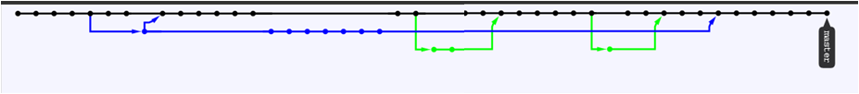

The graph below shows the commit activity for the features implemented.

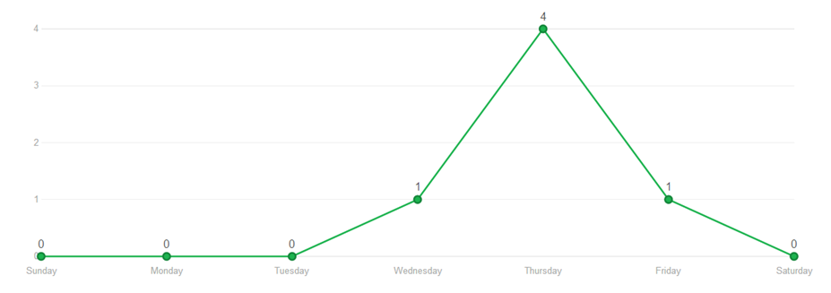

**Sample Output:**

**Features for API:**