This is the project report for Assignment 3 for Ephraim Nowak. It is a continuation of the BatterBot project, with the addition of a socketed conversation which resembles a job interview.

**Level 0 DFD:**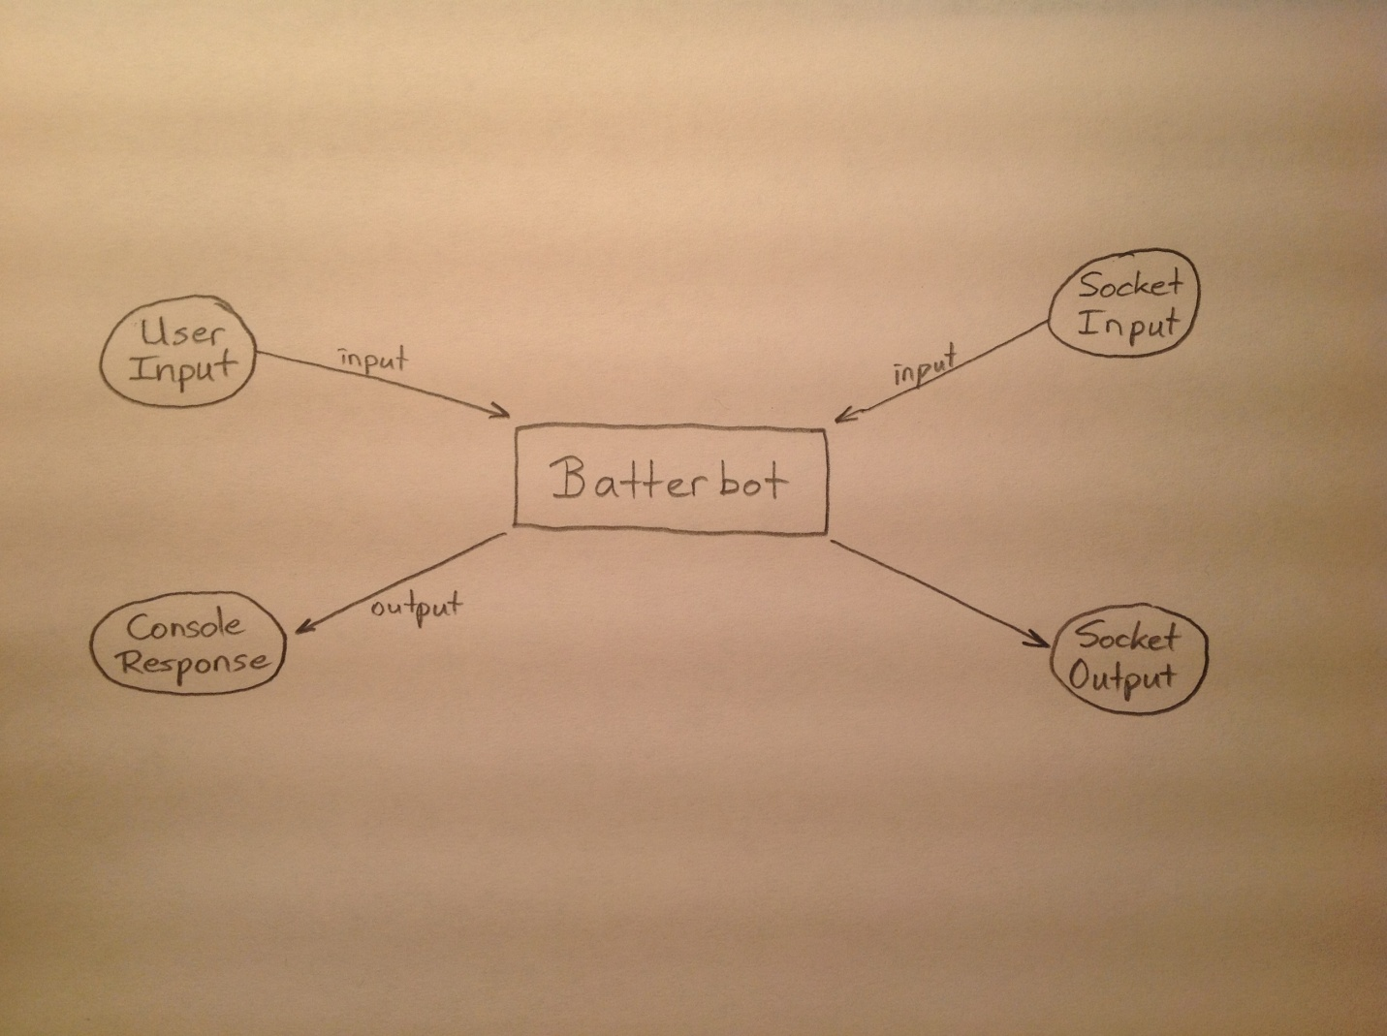

**Level 1 DFD:** 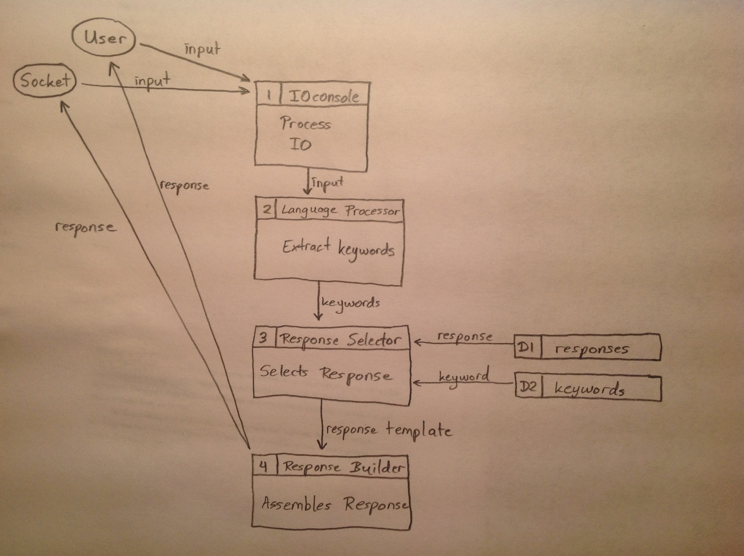

**GitHub Repository:**

The link to my own version of BatterBot for Assignment 3 is located here: <https://github.com/en-avtech/Assignment3>

The graph below displays how different features were developed on separate branches and then merged into the master branch.

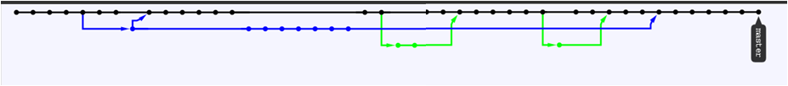

The graph below shows the commit activity for the features implemented.

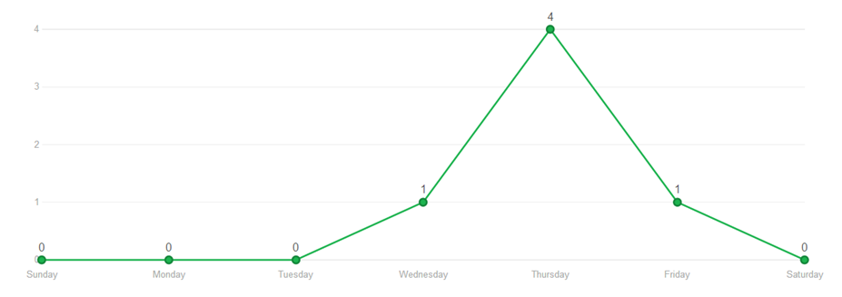

**Sample Output:**

Connect to a server? (y/n):y

What do you expect from a supervisor?

I'd like to know more about the responsibilities and the challenges of the job prior to discussing salary.

What do you find are the most difficult decisions to make?

Well, to give an example, I once had an employer who demanded that I complete a project in a given manner. The problem was, she herself had no qualifications in the area, and didn't have an understanding of how the problem could be solved. After a couple hours of trying to explain to her that it simply couldn't be done that way, I ended up just doing it my way, but sort of made it look like I was doing as she asked. It worked out fine, with no problems.**Note: this is not something Yasha would actually say in an interview. ;)

What did you like or dislike about your previous job?

I love to read books.

What can you contribute to this company?

I am absolutely the best person for this job. I'm sure this will come as a shock, but to demonstrate my work, I've made a chatterbot to simulate me during a job interview. In fact, you're actually talking to that chatterbot right now.

What challenges are you looking for in your next job?

When I need to, no problem. I realize the importance of meeting deadlines and getting work done on time.

What can you do for this company?

I have to be honest, I don't know much about company?, but that doesn't mean I'm not a fast learner.

What are you passionate about?

When I need to, no problem. I realize the importance of meeting deadlines and getting work done on time.

What are you looking for in you next position?

I have to be honest, I don't know much about position?, but that doesn't mean I'm not a fast learner.

What are your salary requirements?

I'd like to know more about the responsibilities and the challenges of the job prior to discussing salary.

Tell me why you want to work here.

I like the company's values and policies. I believe in what you do, and I want to be a part of it.

What are your goals for the future?

Well, I've just graduated, so right now I'm looking to find a stable career that utilizes my education. I've heard a lot of stories about graduates who can't find work, or who endup with something that doesn't match their field at all.

If people who know you were asked why you should be hired, what would they say?

I am absolutely the best person for this job. I'm sure this will come as a shock, but to demonstrate my work, I've made a chatterbot to simulate me during a job interview. In fact, you're actually talking to that chatterbot right now.

Is there anything else I can tell you about the job and the company?

When I need to, no problem. I realize the importance of meeting deadlines and getting work done on time.

Is there a type of work environment which you prefer?

I love to read books.

How would you describe the place at which you work?

I work at a steady pace, but usually complete my work ahead of schedule.

How would you describe yourself?

When I need to, no problem. I realize the importance of meeting deadlines and getting work done on time.

How much do you expect to get paid?

When I need to, no problem. I realize the importance of meeting deadlines and getting work done on time.

How would you handle it if your boss was wrong?

That really depends on the situation and the personality of the manager.

How do you measure success?

To me, success is when I am performing well and satisfied with my position, knowing that my work is adding value to my company but also to my overall life and the lives of other people.

How do you handle pressure?

I'm not a person who has a difficult time with stress. When I'm under pressure, I focus, and get the job done.

Have you gotten angry at work? What happened?

I like the company's values and policies. I believe in what you do, and I want to be a part of it.

How long do you expect to work for this company?

When I need to, no problem. I realize the importance of meeting deadlines and getting work done on time.

Have you ever had difficulty working with a manager?

I would say that I have never really had a problem working with anyone. I try to find our common ground, and get along with everyone's different personality.

Do you take work home with you?

When I need to, no problem. I realize the importance of meeting deadlines and getting work done on time.

Describe your work style.

I am very focused on my work, and consequently, am able to work quickly.

This conversation was a sample of the conversation which was done via sockets.

The program is still limited in a few areas. One area is the extraction if keywords, in which the bot sometimes mistakes substring of a keyword as a keyword. For example, the word houseboat may be recognized as 'house' and 'boat', and thereby trigger an incorrect, or 'I don't understand' response.

What is a houseboat?

<Batterbot>My house is located in Gotham City.

The program also has difficulties with combining questions into the catch-all responses.

Tell me about the planet mars.

<Batterbot>Tell me about the planet mars.? Is that the kind of question to ask Batman?

okay

<Batterbot>What about okay?

More example conversation snippets are found in the README file.

**Features for API:**

* The language processor could be made available. It is used to extract key words from user input.
* The response builder is used to construct logical responses based on user input, and could be made into an API.
* In conjunction with the response builder, the response selector is used to determine which response to display, and more importantly when to display it. It includes features for tracking how often a response has been used, and when in a conversation to use the response to guide natural conversational flow.
* Response templates can also be made available as API's as they are used to create variable responses with substitutions available for words or phrases.
* Similarly, the scale rules used by the program can be made available as an API. They encapsulate the weighting of various keywords to ensure the most relevant response is selected.