PESTLAND
APP MANUAL
Plant health surveillance for any plant, in any region
Version 1.0 · September 2026
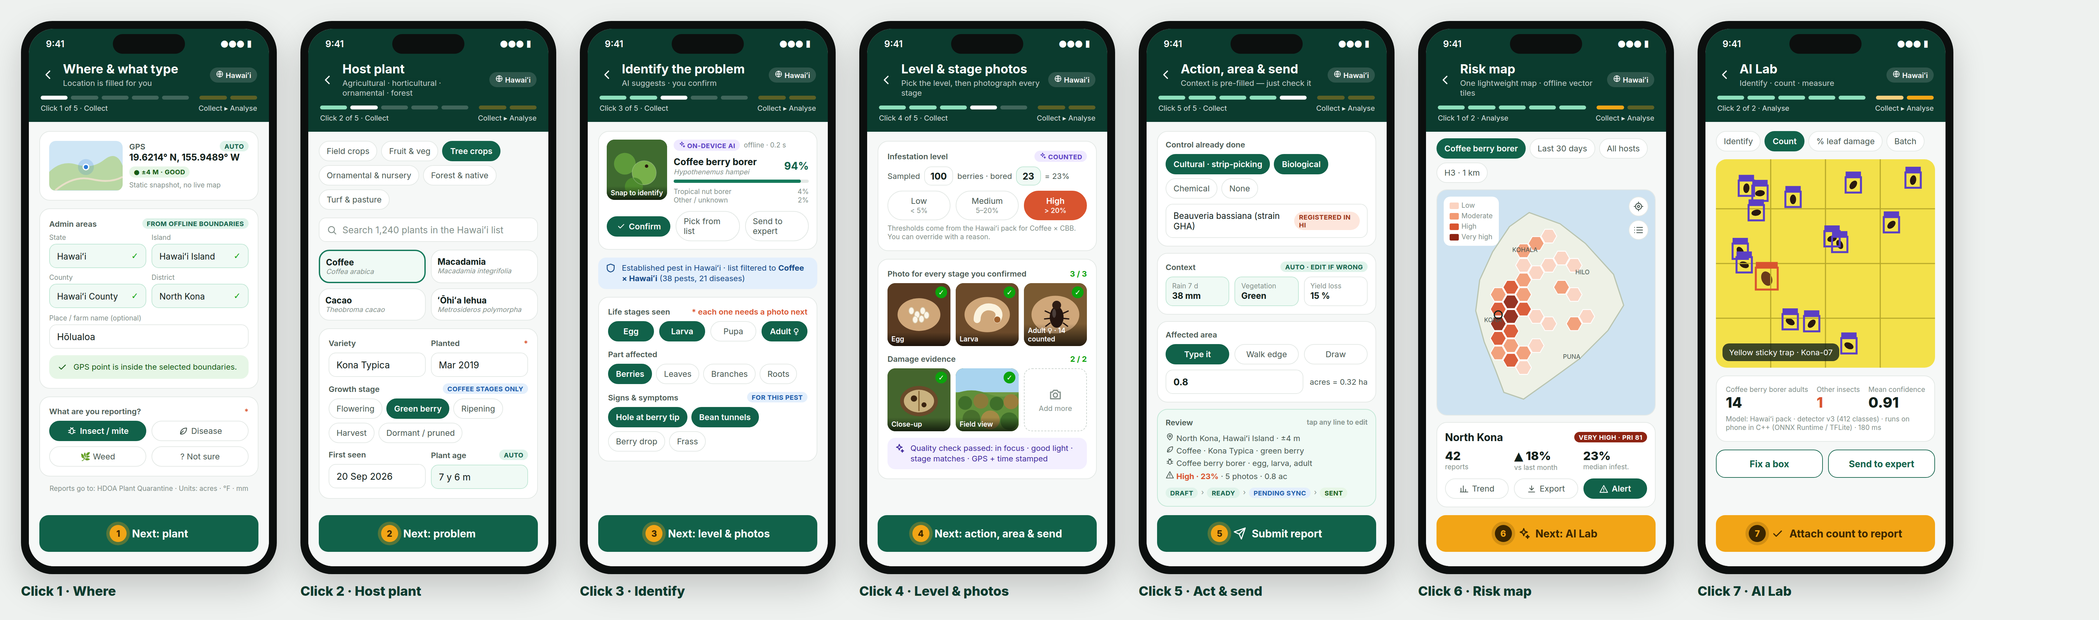
5 clicks to collect a report, 2 clicks to see the results

Contents

Right-click the table and choose Update Field if page numbers are missing.

1. About PestLand
PestLand is a mobile app for reporting and mapping insect pests, plant diseases and weeds on any plant: field crops, fruit and vegetables, tree crops, ornamentals and nursery stock, forest and native plants, turf and pasture.
It keeps the backbone of CropProtect (where → plant → problem → evidence → context → area → submit) and adds the features CropProtect was missing from ODK Collect, Plantix and FAO FAMEWS.
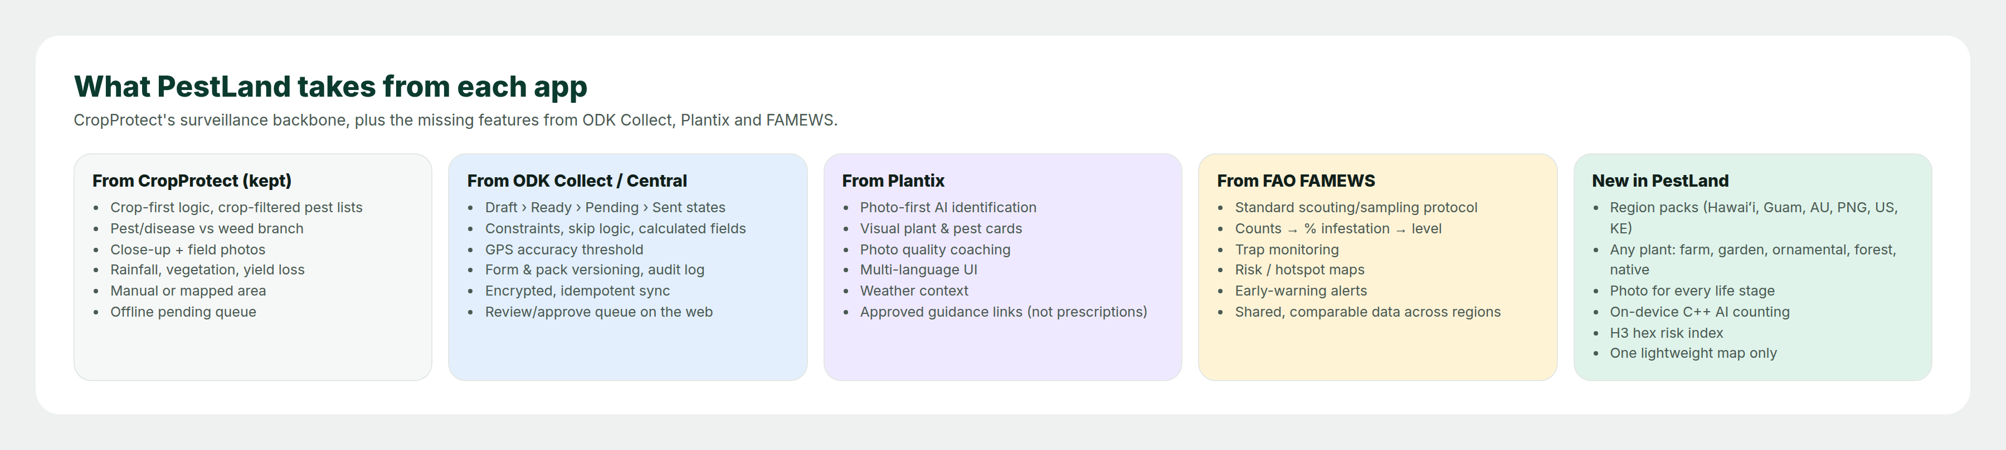
What PestLand takes from each app

Two design rules
- Simple. 5 screens to collect a report and 2 screens to see results. Anything the phone can work out (place names, plant age, weather, level from a count) is filled in for you.
- Light. CropProtect loaded a Google/Leaflet map on several pages. PestLand opens a map only when you draw an area or look at the risk map, and that map uses small offline vector tiles.

2. Getting started

2.1 Permissions
When PestLand first opens, tap Allow while using the app for each request. These are part of the app's settings and are needed for the fields that fill themselves in.
Permission | Why PestLand needs it
Location | Fills in GPS and every admin area in Click 1
Camera | Stage photos, damage photos and AI identification
Storage / photos | Keeps reports and photos on the phone until they are sent
Notifications (optional) | Regional alerts and reports that need your attention

2.2 Sign in
Sign in with your email, or the phone number your region uses. Your role (collector, expert, reviewer or region admin) decides what you see.

2.3 Choose your region pack
On first launch PestLand reads your GPS and suggests a region pack, for example Hawaiʻi. Tap Download & use.  The region pack decides everything that follows:  - admin areas and their names  - plant, pest, disease and weed lists  - the legal status of each pest in that region  - severity rules and registered control products  - the AI model and the offline map  - language and units (acres or hectares, °F or °C)  Choose Hawaiʻi and every list and map stays inside Hawaiʻi. You can hold several packs and switch any time from Profile › Region. | 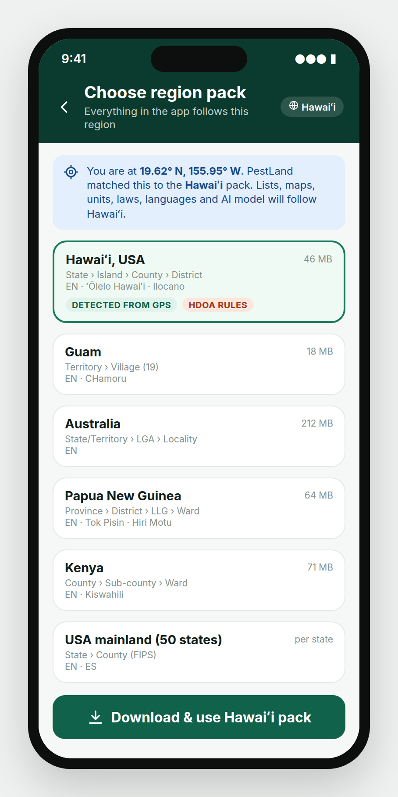  Choose region pack

3. Home screen and sync
Report new incident Required  Brief description: Starts the 5-click report.  How to fill it: Tap the large green button.  Risk map / AI Lab Optional  Brief description: Shortcuts to Click 6 and Click 7.  How to fill it: Tap either button.  Status cards Optional  Brief description: Drafts, Ready to send, Pending sync and Sent today.  How to fill it: Tap a card to open that list.  Regional alert Optional  Brief description: Messages from the region's plant-protection agency.  How to fill it: Read it; tap to see details.  Recent reports Optional  Brief description: Your latest reports with tags: Sent, Pending, Needs ID.  How to fill it: Tap a report to open or finish it. | 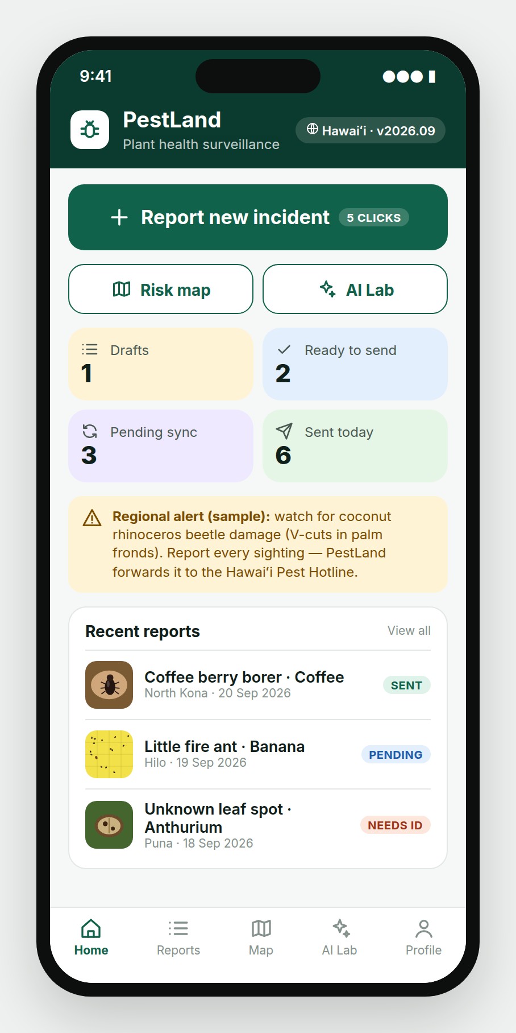  Home

Working offline
Every report moves through clear states:  Draft → Ready → Pending sync → Sent → Approved / Rejected / Needs ID  - Everything works offline: lists, boundaries, AI, map tiles and photo checks are all in the region pack on your phone.  - Each report gets a unique ID on the phone, so a retry never creates a duplicate.  - Photos upload in pieces and resume after a dropped connection.  - In low-connectivity packs such as PNG, a short text summary can go by SMS and the photos follow later.  As in the CropProtect manual: send the day's reports right after fieldwork. PestLand reminds you if anything is still Pending at the end of the day. | 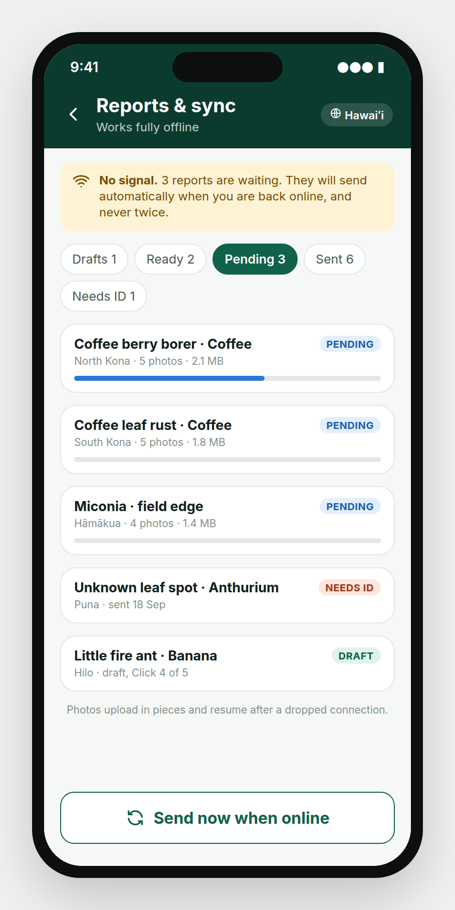  Reports & sync

4. The 5 + 2 clicks
A click means one screen, finished with one Next tap. The yellow numbered dot on each Next button shows which click you are on. The bar at the top shows 5 green segments for collecting and 2 amber ones for analysing.
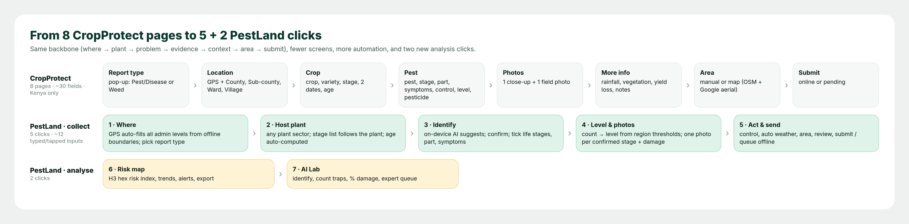
From 8 CropProtect pages to 5 + 2 PestLand clicks
Click | Screen | You do | PestLand does for you
1 | Where & what type | Check location; pick Insect, Disease, Weed or Not sure | GPS, accuracy, every admin level, boundary check
2 | Host plant | Pick sector, plant, stage, planting date | Stage list for that plant, plant age
3 | Identify | Snap a photo, confirm the AI answer, tick stages, parts, symptoms | AI suggestion, lists filtered to this plant in this region, legal status
4 | Level & stage photos | Enter your count, then one photo per stage | % → level from the region rule, photo quality check, AI count
5 | Action, area & send | Control used, yield loss, area, Submit | Weather, vegetation, unit conversion, review, offline queue
6 | Risk map | Filter and read | Hexagon risk index, trend, alerts, export
7 | AI Lab | Photograph a trap or leaf | Identification, counting, % damage, expert queue

5. Click 1 — Where & what type
GPS Required  Brief description: Latitude and longitude of where you are standing, with an accuracy badge.  How to fill it: Filled in automatically. Good = 10 m or better, Fair = 10–30 m, Poor = over 30 m. If Poor, step into the open and wait a few seconds.  Admin areas Required  Brief description: The administrative areas for the report. The levels follow the region: Hawaiʻi uses State › Island › County › District; Kenya uses County › Sub-county › Ward, as in CropProtect.  How to fill it: Filled in automatically from the offline boundaries in your region pack. Tap a level to change it.  Boundary check Required  Brief description: Confirms that the GPS point is inside the areas selected.  How to fill it: If a yellow warning appears, check the areas or your GPS. About 1 in 100 CropProtect reports from the three main counties were more than 80 km from their county's centre; this check stops that error.  Place / farm name Optional  Brief description: A local name, e.g. a village, ahupuaʻa or farm.  How to fill it: Type the name.  What are you reporting? Required  Brief description: Chooses the branch of the form, like CropProtect's Report Type pop-up.  How to fill it: Tap Insect / mite, Disease, Weed or Not sure. Not sure makes photos compulsory and sends the report to an expert. | 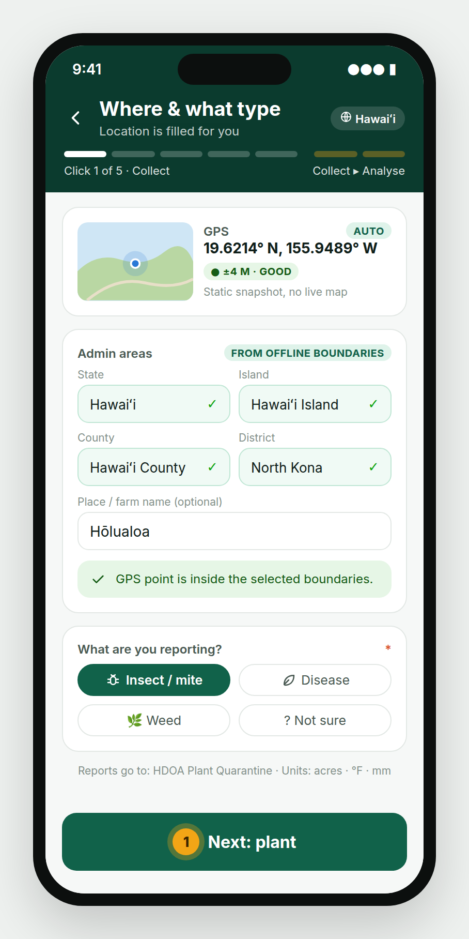  Click 1
Tap Next: plant — this is click 1.

6. Click 2 — Host plant
Sector Required  Brief description: The kind of plant: Field crops, Fruit & veg, Tree crops, Ornamental & nursery, Forest & native, Turf & pasture.  How to fill it: Tap one chip.  Plant Required  Brief description: The plant with the problem. Only plants in the region pack are listed.  How to fill it: Tap a card or search. If a plant is missing, type it under Other and the region admin is told.  Variety Optional  Brief description: The variety or cultivar, e.g. Kona Typica.  How to fill it: Type it.  Growth stage Required  Brief description: The plant's stage when the problem was seen. Only stages of the chosen plant are shown.  How to fill it: Tap one stage.  Planted / First seen Required  Brief description: When the plant was planted and when the problem was first seen.  How to fill it: Pick both dates. PestLand blocks a planting date after the first-seen date. Choose Unknown if the grower doesn't know.  Plant age Required  Brief description: Age of the plant at the time of the report.  How to fill it: Worked out automatically from the planting date. | 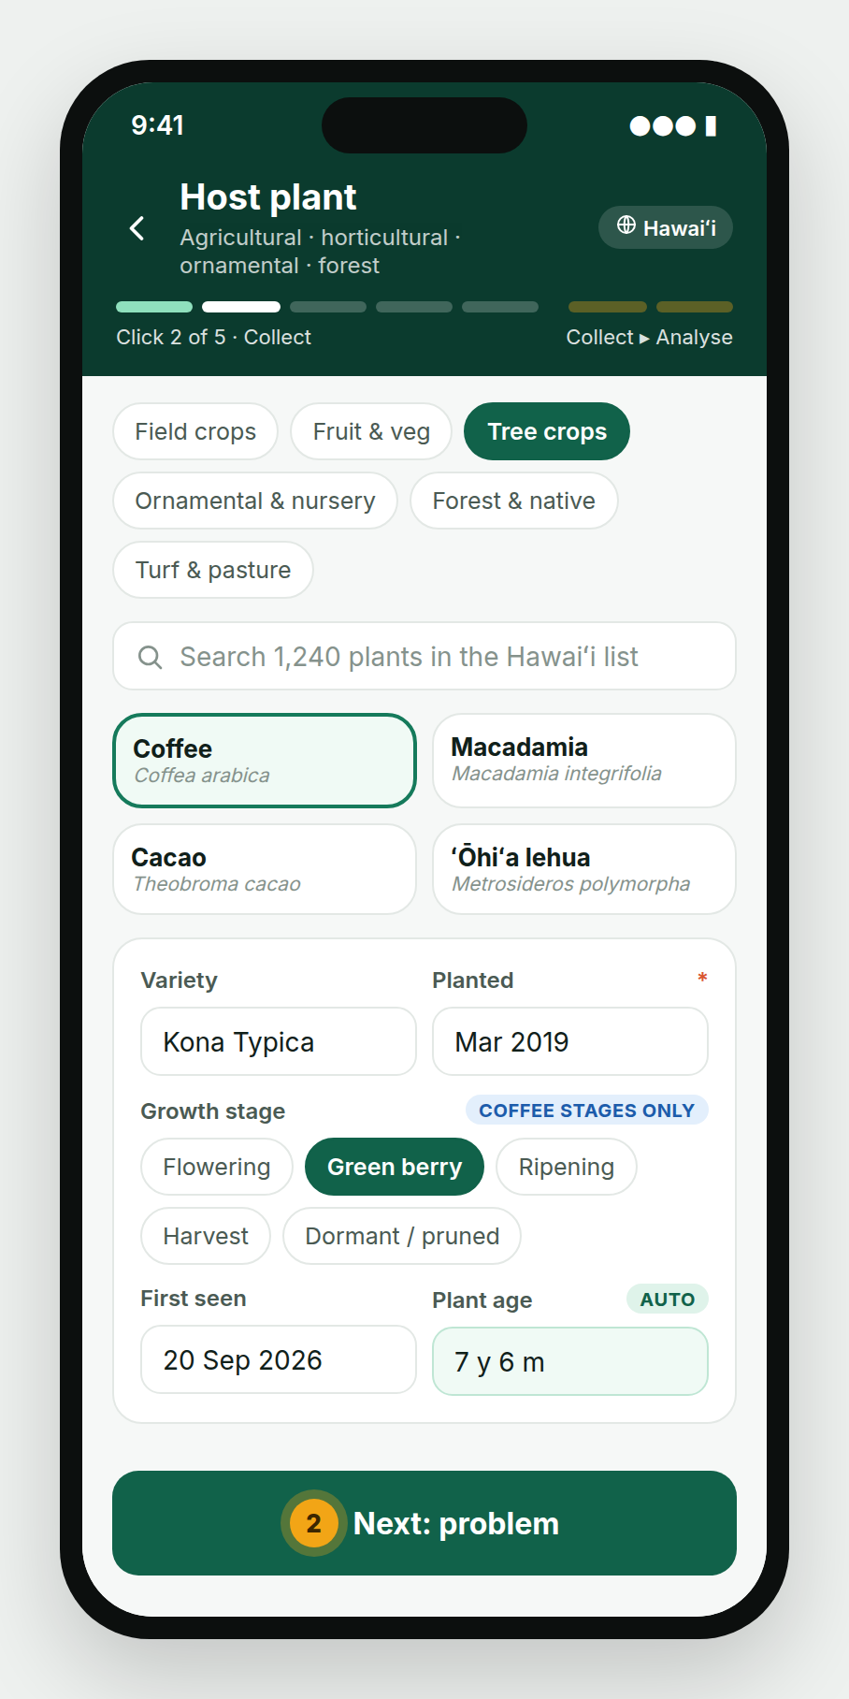  Click 2
Tap Next: problem — this is click 2.

7. Click 3 — Identify the problem
Snap to identify Optional  Brief description: The on-device AI names the problem from a photo, offline, in about 0.2 seconds.  How to fill it: Take one clear photo. The top three answers appear with confidence.  Problem Required  Brief description: The pest or disease. The AI only suggests; your choice is what is recorded.  How to fill it: Tap Confirm, Pick from list (filtered to this plant in this region) or Send to expert (saved as Needs ID).  Status badge Required  Brief description: The problem's legal status in your region: Established, Regulated, Quarantine, Exotic or New to region.  How to fill it: Shown automatically. Regulated, quarantine and exotic reports are forwarded to the agency named in the region pack.  Life stages seen Required  Brief description: The stages you actually saw: Egg, Larva/Nymph, Pupa, Adult. For diseases: Early, Advancing, Late.  How to fill it: Tick every stage seen. Each ticked stage needs its own photo in Click 4.  Part affected / Signs & symptoms Required  Brief description: Where the damage is and what it looks like. Lists are filtered to the chosen problem.  How to fill it: Tick all that apply. | 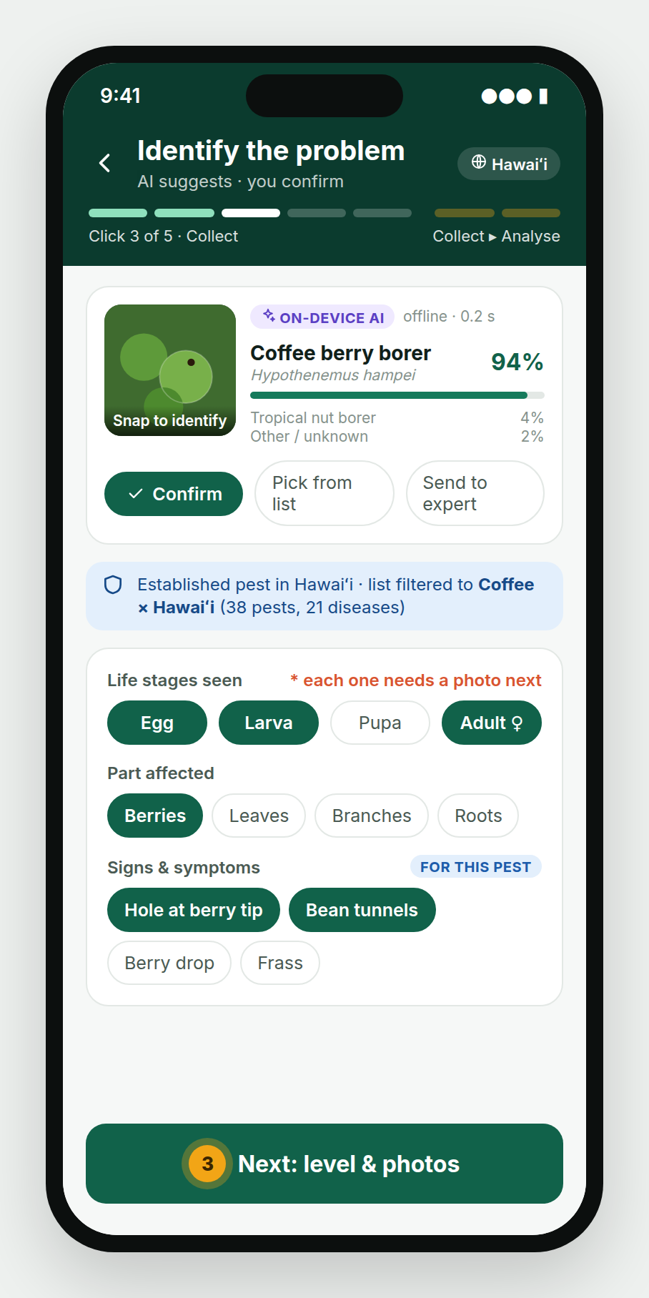  Click 3 — insect

Weed branch
If you picked Weed in Click 1, Click 3 shows weed lists instead. CropProtect had a separate weed form; PestLand uses the same screens.  Weed Required  Brief description: The weed or invasive plant, e.g. Miconia in Hawaiʻi.  How to fill it: Confirm the AI answer, pick from the list or send to an expert.  Growth stages seen Required  Brief description: Seedling, Vegetative, Flowering, Seeding.  How to fill it: Tick every stage seen; each needs a photo in Click 4.  Where is it growing? Required  Brief description: In the crop, field edge, pasture, forest/native, waterway.  How to fill it: Tap one.  Cover Required  Brief description: Share of the area covered by the weed. This sets the weed's level.  How to fill it: Tap a range. | 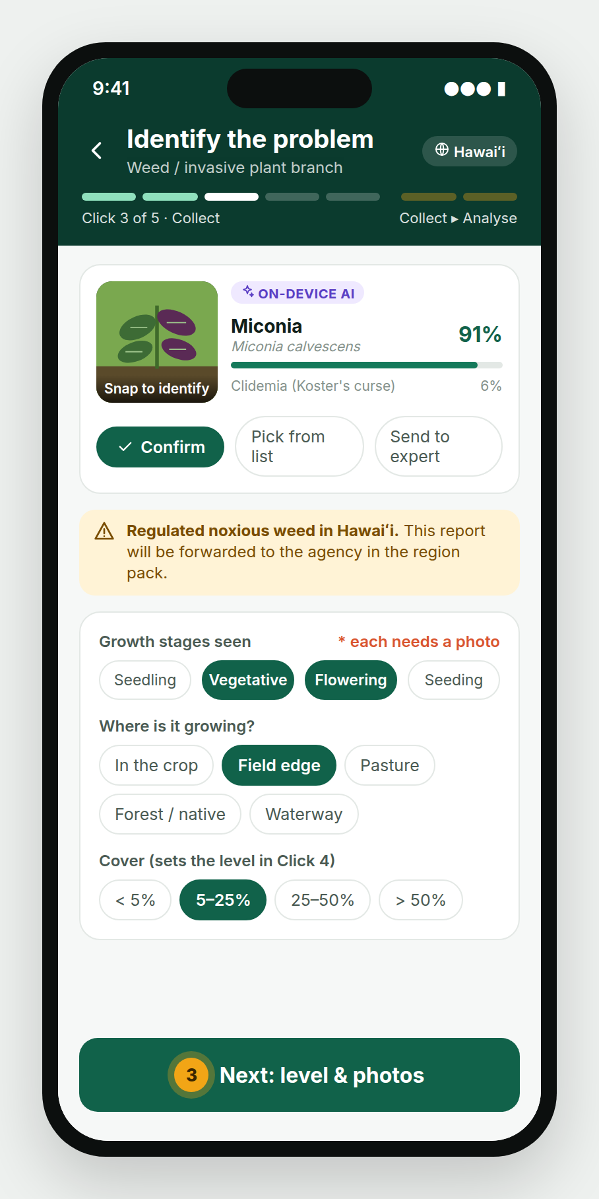  Click 3 — weed
Tap Next: level & photos — this is click 3.

8. Click 4 — Level & stage photos
Select the level first. Then take a photo of every stage you confirmed in Click 3.
Infestation level Required  Brief description: How bad the problem is. PestLand replaces CropProtect's bare Low/Medium/High with a count, as in FAMEWS.  How to fill it: Enter the number sampled and the number affected (e.g. 100 berries, 23 bored). PestLand works out the % and picks the level from the region's rule. To disagree, tap another level and give a reason.  Stage photos Required  Brief description: One photo for every stage ticked in Click 3.  How to fill it: Tap each slot and take the photo. Next stays locked until every stage has a photo that passes the quality check (focus, light, stage visible).  Damage close-up / Field view Required  Brief description: Close-up of the affected part, and a wide shot of the patch.  How to fill it: Take both. Add more if useful. | 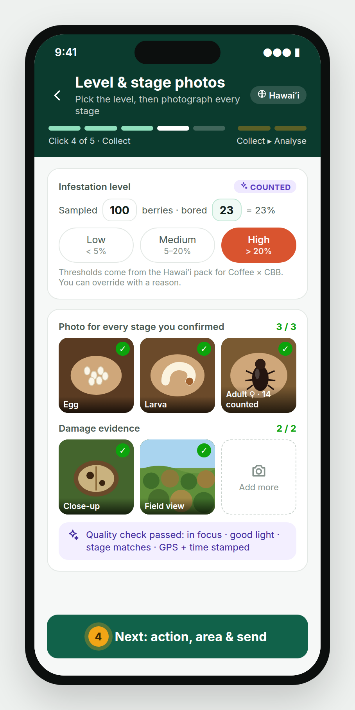  Click 4 — insect
  Coffee × coffee berry borer (Hawaiʻi example) | Low | Medium | High
  Bored berries per 100 | < 5 % | 5–20 % | > 20 %

Disease example
For a disease the stages are symptom stages. In this coffee leaf rust example the collector ticked Early, Advancing and Late in Click 3, so Click 4 opens three stage slots.  The level comes from leaves checked and leaves with rust (60 checked, 14 with rust = 23 % = Medium under this example rule). The AI also estimates the % of leaf area infected from the photos. | 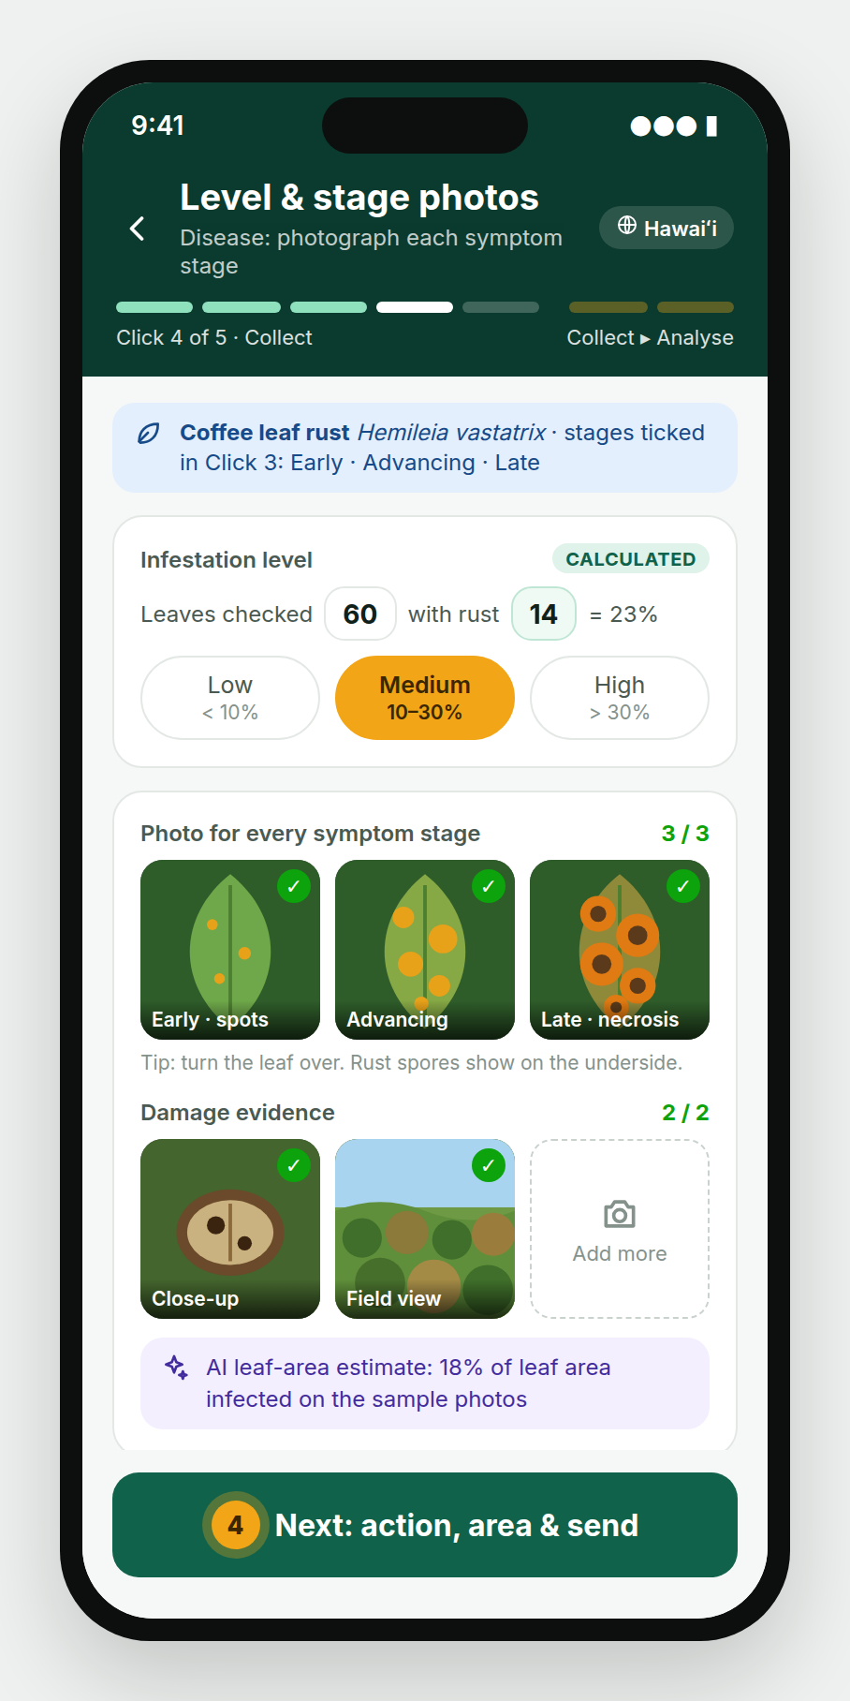  Click 4 — disease

Photo guide
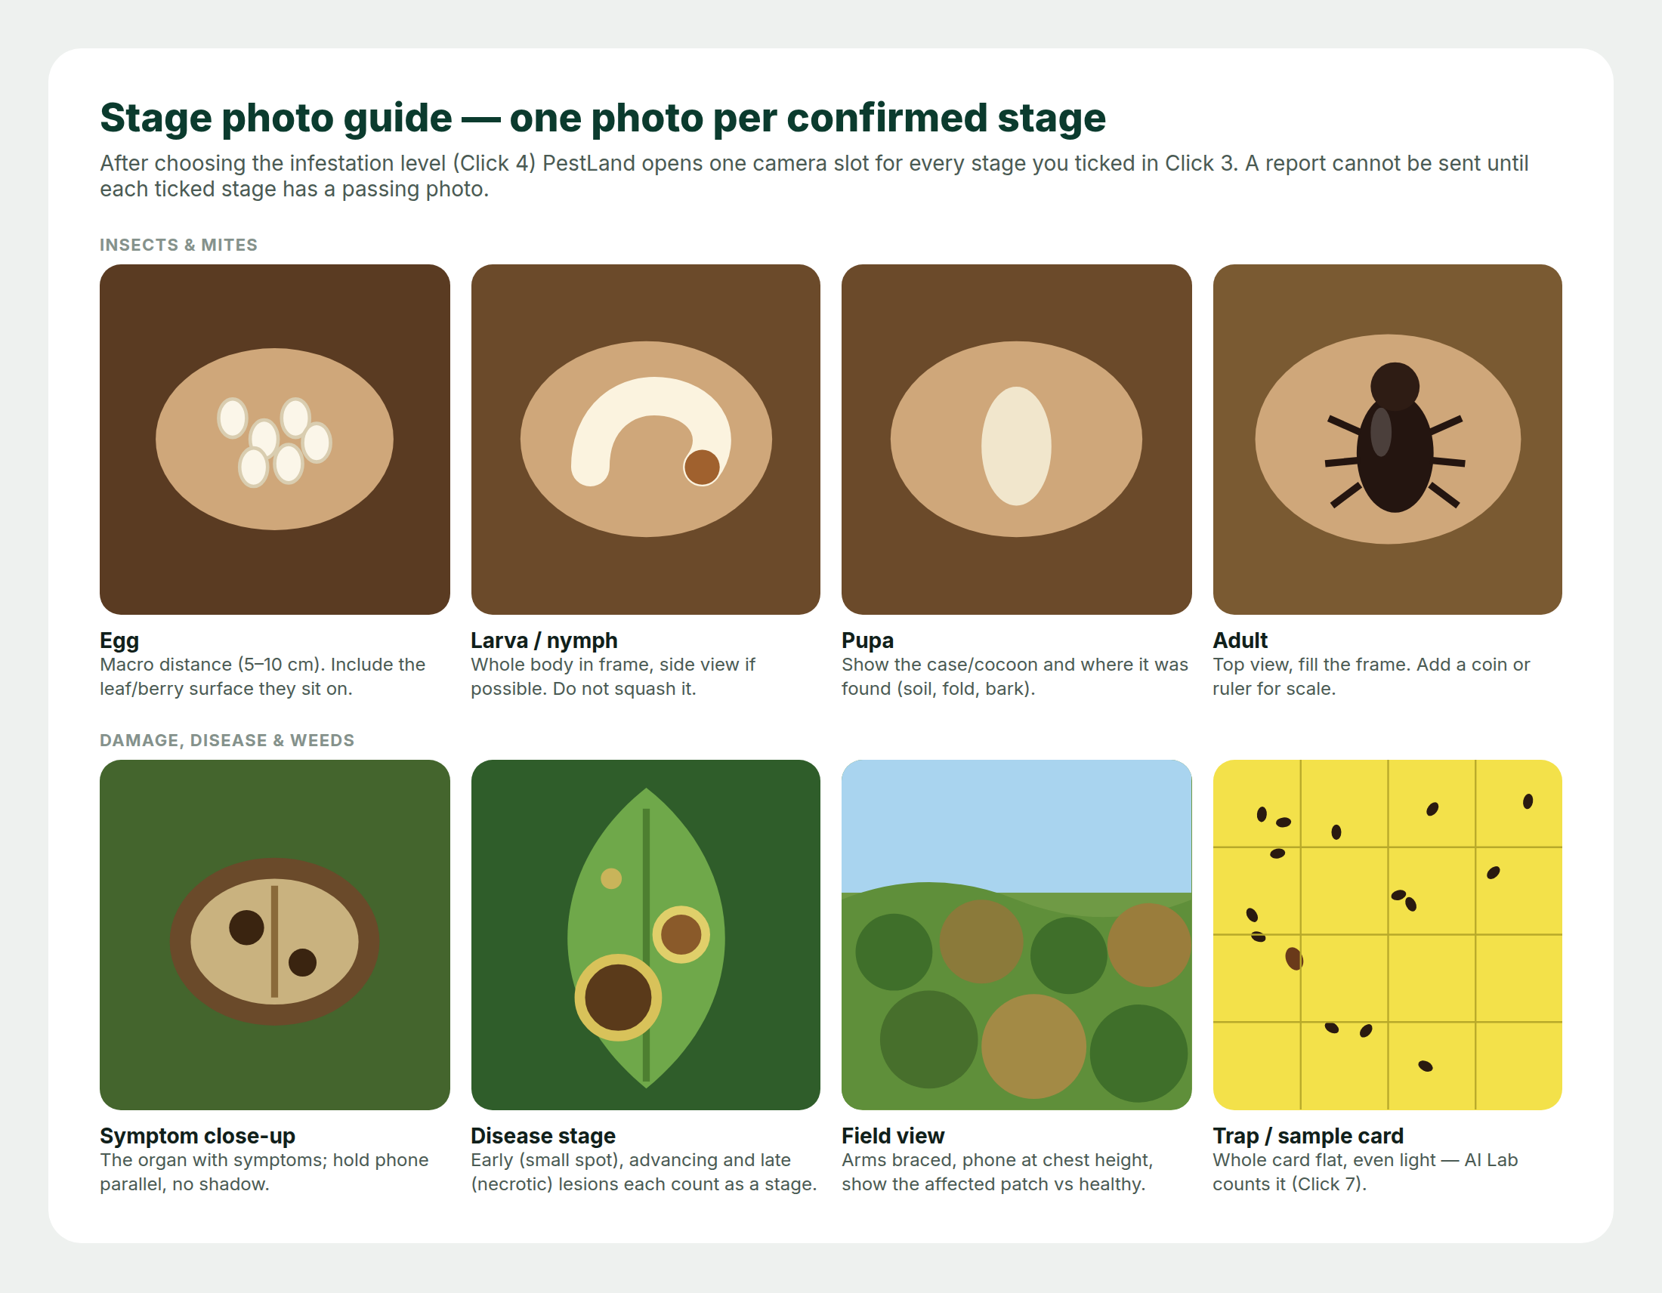
One photo per confirmed stage
Photo tips from the CropProtect manual still apply:
- Hold the phone parallel to the pest or leaf and don't cast a shadow.
- Get close enough that the pest fills the frame, without disturbing it.
- For the field view, hold the phone at chest height with both hands and brace your elbows against your body.
- Use Retry freely. Only accepted photos are kept.
Tap Next: action, area & send — this is click 4.

9. Click 5 — Action, area & send
Control already done Optional  Brief description: Actions taken against the problem: Cultural, Physical/mechanical, Biological, Chemical, None.  How to fill it: Tick all that apply. For Chemical or Biological, pick the product from the region's registered list or type it under Other. PestLand records what was done; it does not prescribe.  Rain, last 7 days Required  Brief description: Recent rainfall. In CropProtect this was blank in 88 % of reports.  How to fill it: Pre-filled from a weather service when online. Edit it if the grower says otherwise; the source is saved.  Vegetation Required  Brief description: State of plants around the field: Green, Greening, Drying, Dry.  How to fill it: Pre-suggested from the field photo; change if wrong.  Yield loss Required  Brief description: Estimated loss, 0–100 %.  How to fill it: Type the grower's estimate.  Affected area Required  Brief description: The size of the affected patch.  How to fill it: Type it (acres or hectares, per region), Walk edge (GPS track) or Draw on the map. Draw is the only data-collection step that opens a map.  Review Required  Brief description: A one-card summary of the report.  How to fill it: Tap any line to go back and edit. | 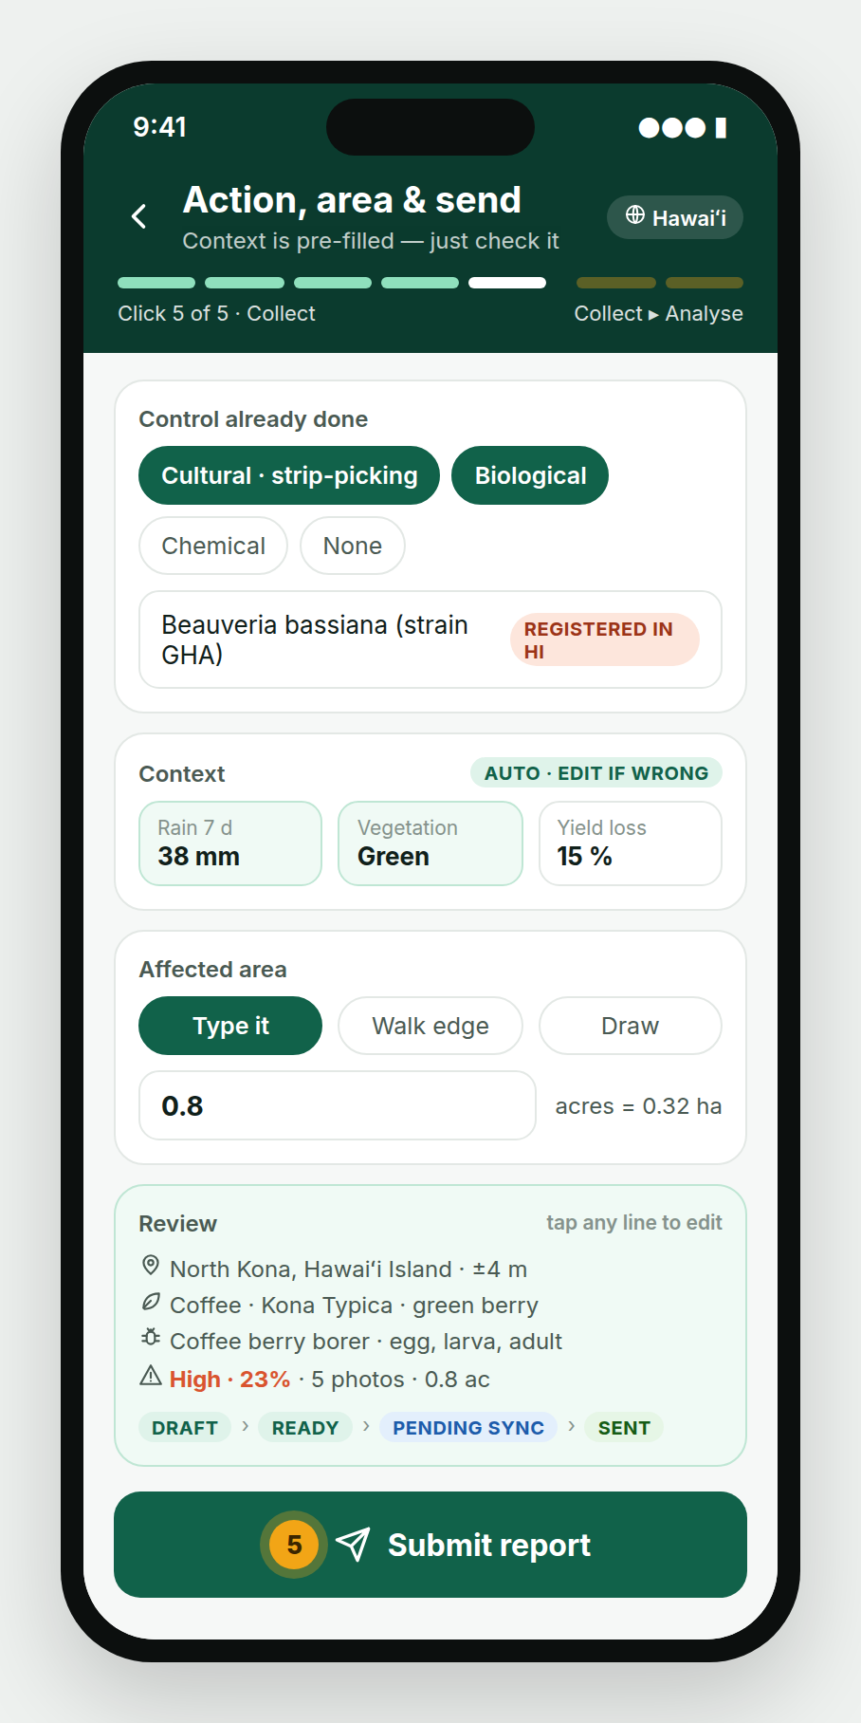  Click 5
Tap Submit report — this is click 5.
With a signal the report is sent. Without one it moves to Pending sync and goes automatically later.

10. Click 6 — Risk map
The risk map is the only analysis map in PestLand. It shows hexagon cells (about 1 km across) coloured by the PestLand Risk Index (PRI).  - Filters: problem, period, host plant, cell size.  - Tap a cell or area: number of reports, trend against last month, median infestation.  - Trend, Export (CSV, GeoJSON, Shapefile) and Alert (notify the agency). | 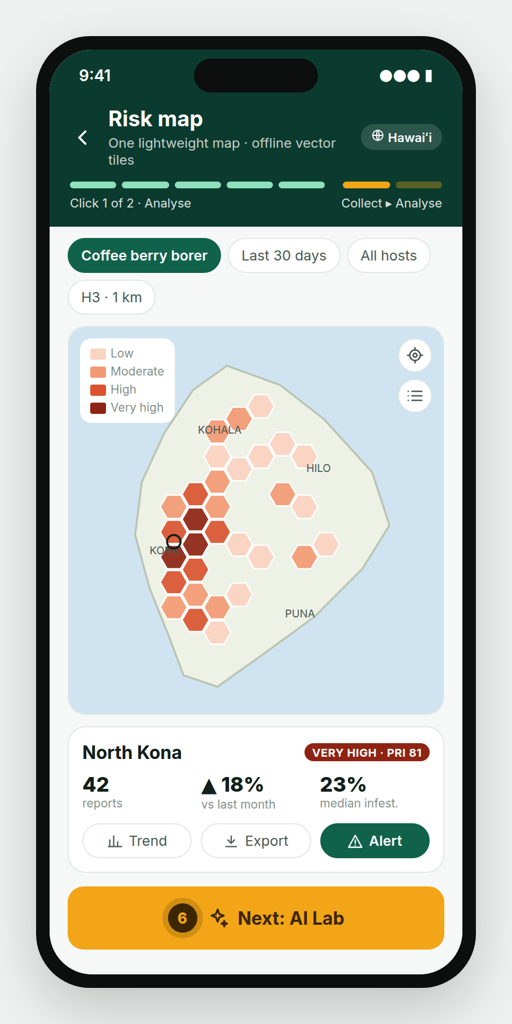  Click 6
  PRI = 100 × (average severity − 1) ÷ 2 × confidence. Severity: Low = 1, Medium = 2, High = 3. Confidence = reports in the cell ÷ 5, up to 1.
  PRI | Class
  < 25 | Low
  25–50 | Moderate
  50–75 | High
  75 and over | Very high

Example from real CropProtect data
These charts come from the 38,762 anonymized CropProtect records (March 2024 – February 2026). PestLand produces the same views automatically.
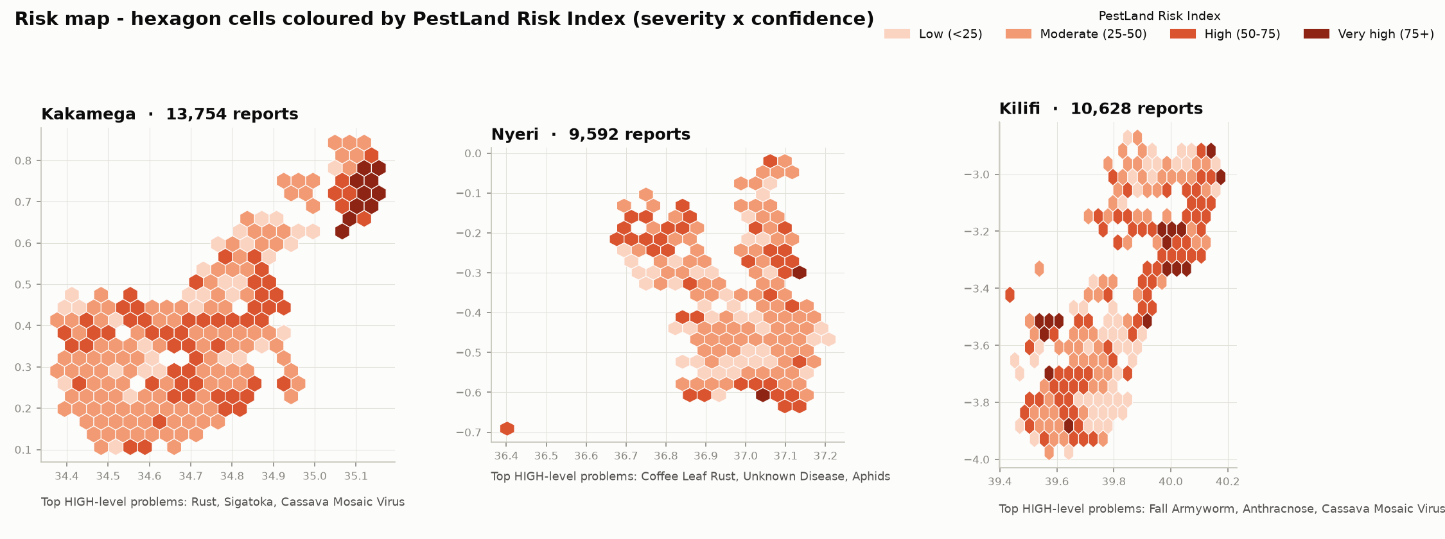
Risk map by hexagon cell, three most-surveyed counties
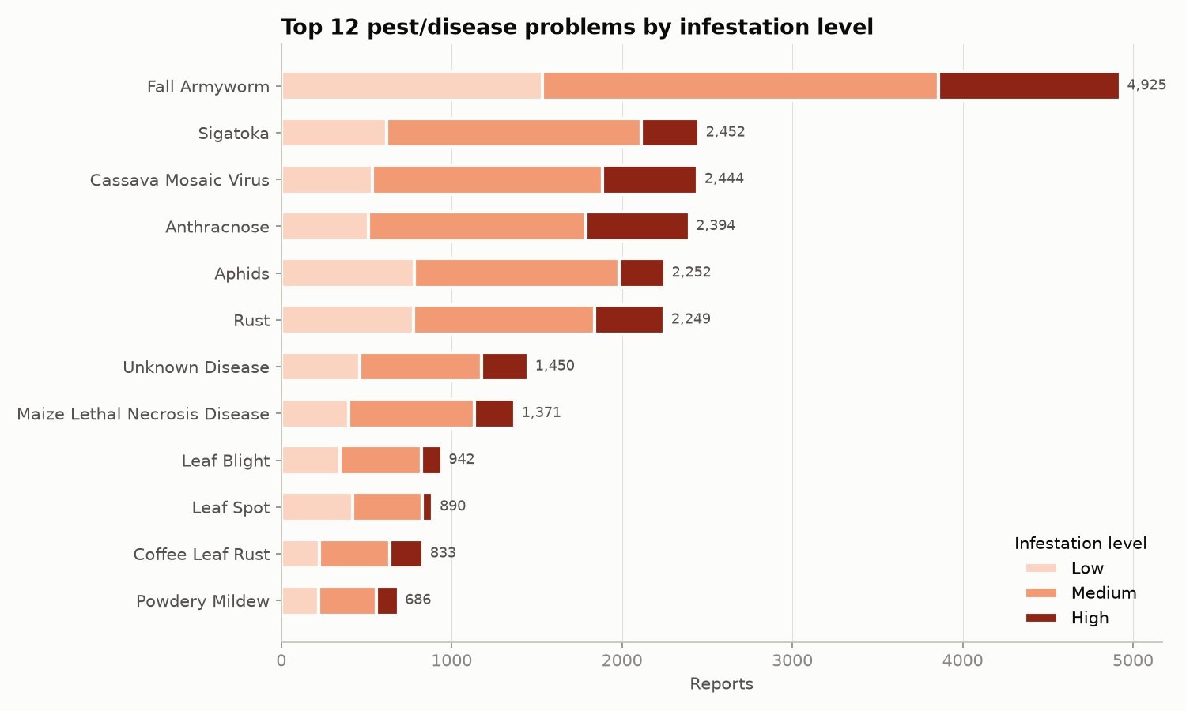
Top 12 pest/disease problems by infestation level
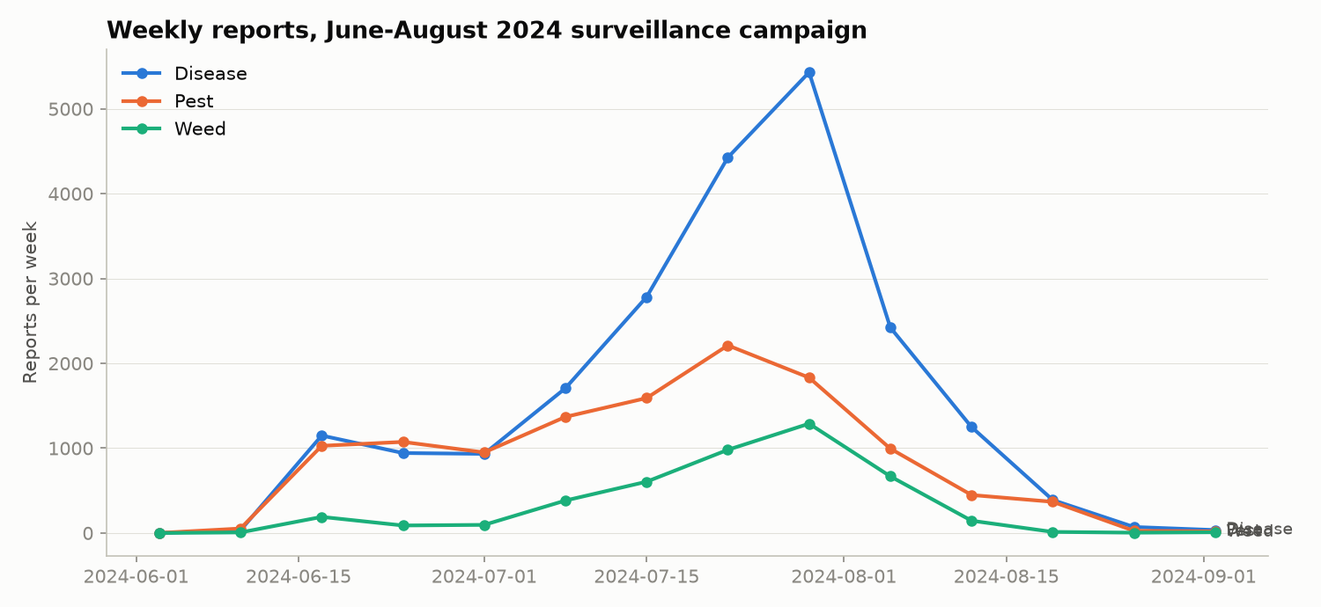
Weekly reports during the June–August 2024 campaign
- Fall armyworm was the most reported problem (4,925 reports, over 1,000 of them High).
- 1,458 Unknown disease reports had no route to an expert. In PestLand they become Needs ID.
- Most reports came from one June–August 2024 campaign; the trend view makes gaps in surveillance visible.

11. Click 7 — AI Lab
- The AI runs on the phone (native C++), so it works offline. The model comes with the region pack.  - Fix a box: drag, delete or relabel. Corrections train the next model.  - Send to expert puts the photo in the expert queue.  - Attach count to report adds the count to the current or a new report. | 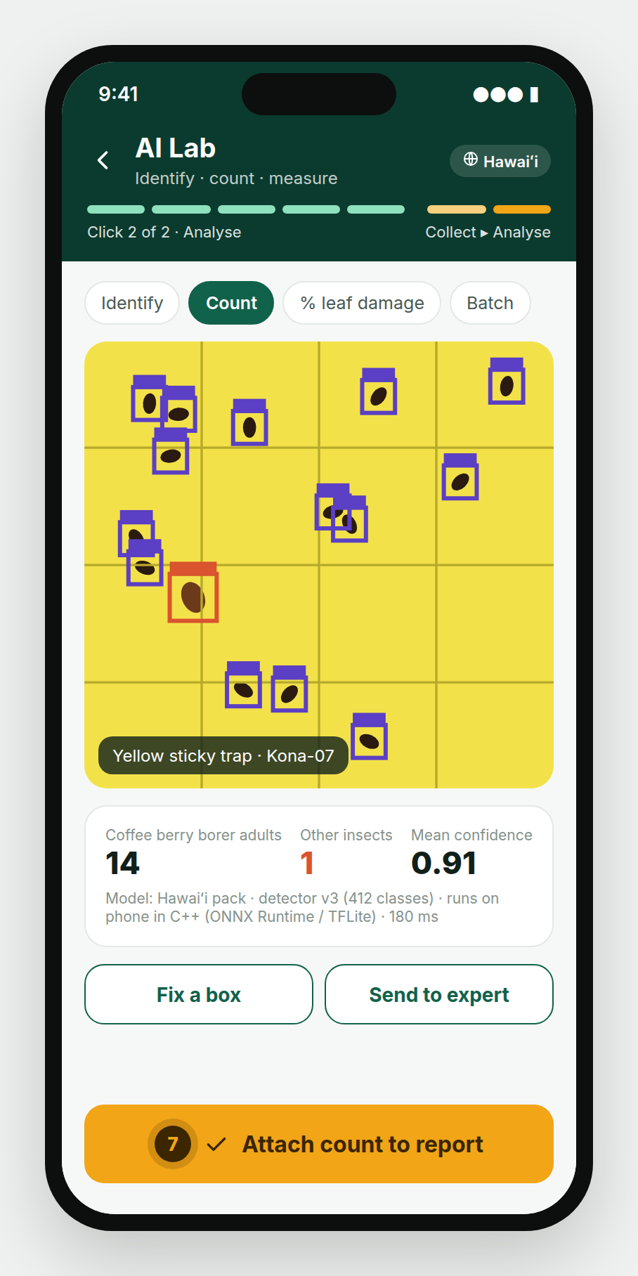  Click 7
  Mode | Use it for | Output
  Identify | Any pest, symptom or weed photo | Top-3 names with confidence
  Count | Sticky traps, pheromone traps, berries, leaves | A box around each object, totals per species
  % leaf damage | Leaf or canopy photos | % area damaged → suggested level
  Batch | A set of trap photos from a route | Counts per trap
Tap Attach count to report — this is click 7.

12. Taking PestLand to another region
What if I take it to Australia, Guam or PNG? Only the region pack changes. Pick the new region, or let GPS pick it, and every list, rule, map and language switches with it.
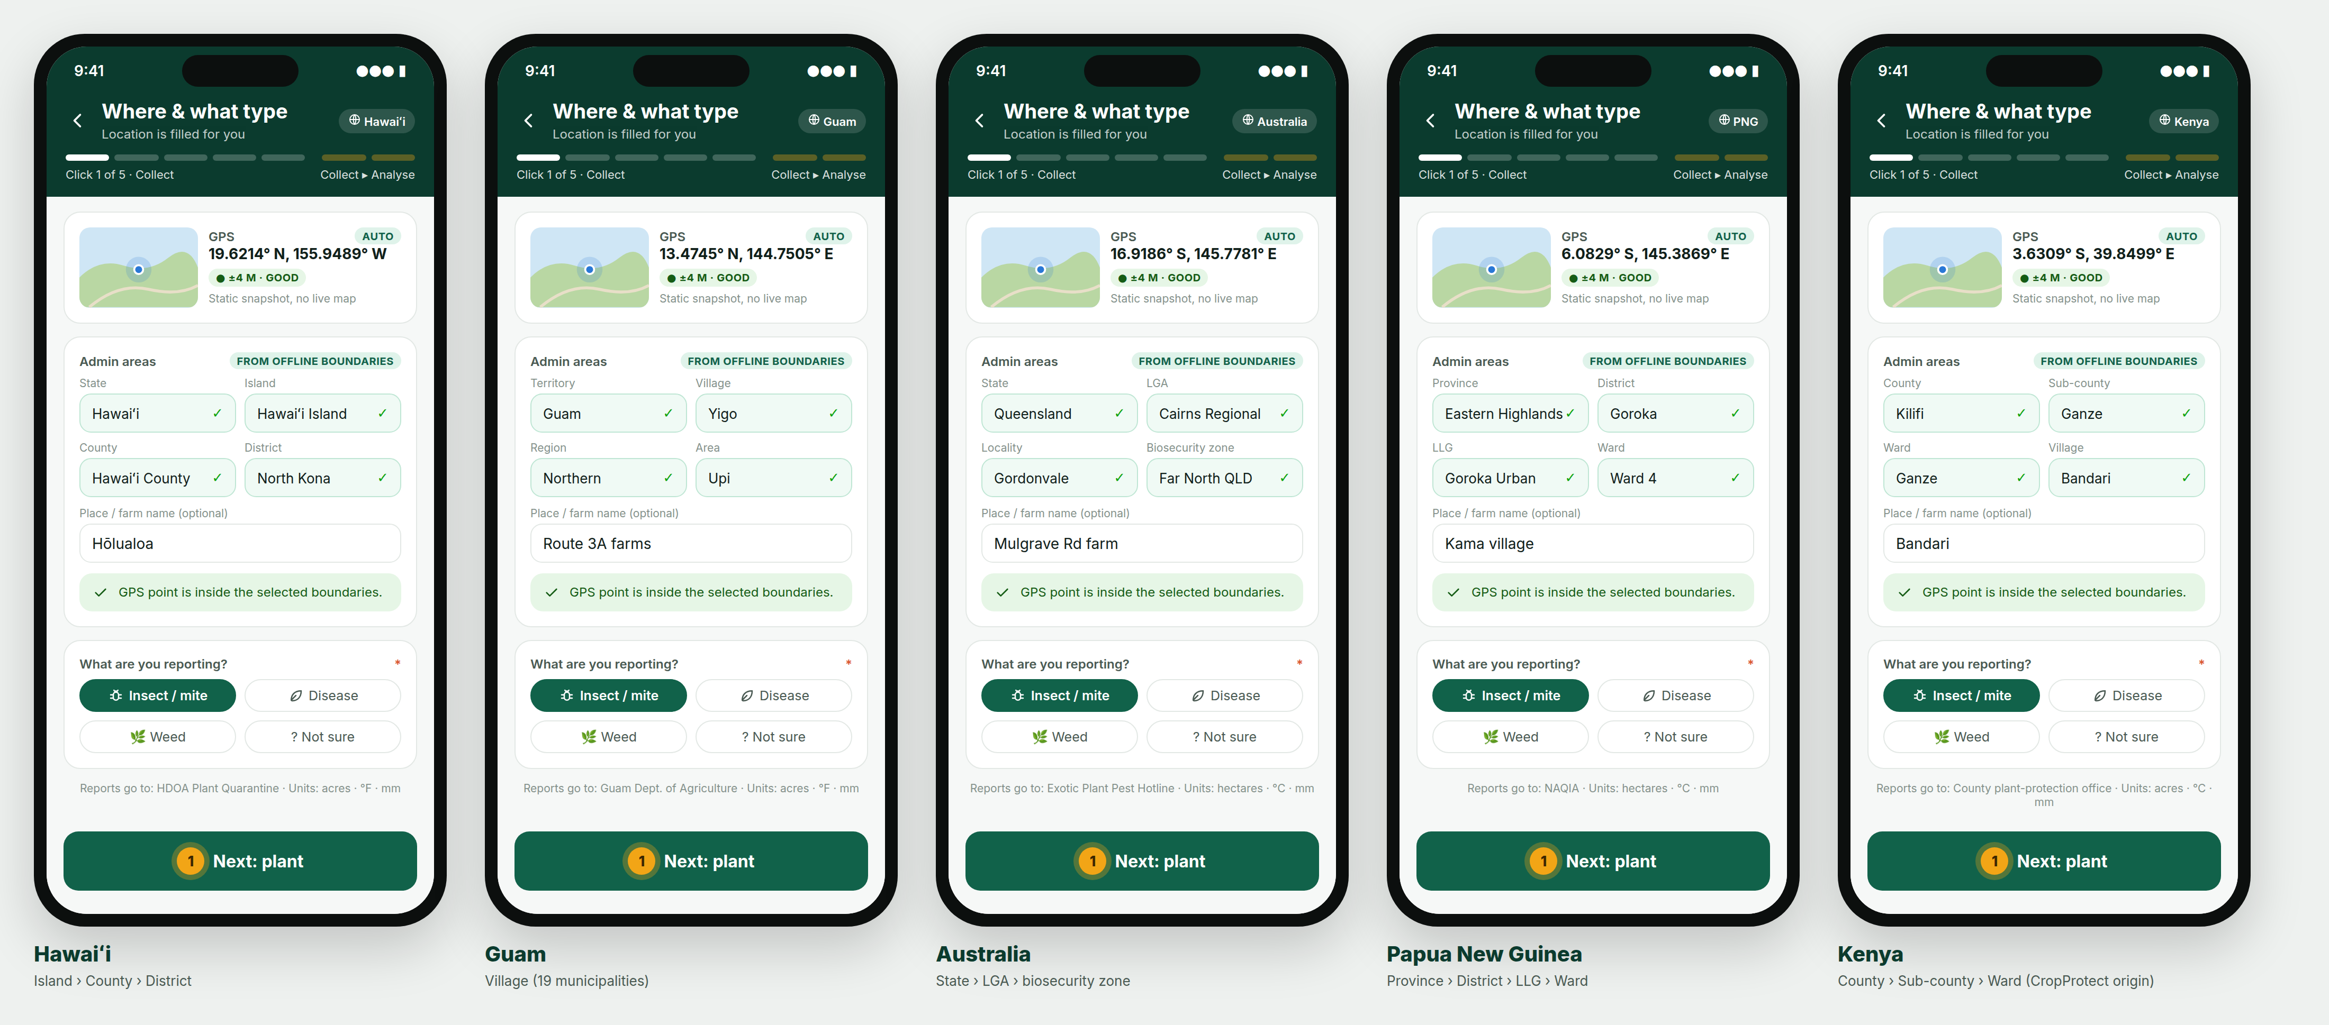
The same Click 1 screen under five region packs
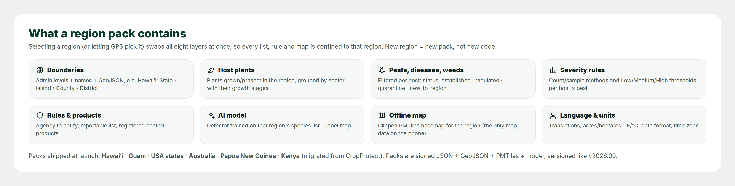
What a region pack contains
Region pack | Admin levels | Units | Languages | Example problems | Report channel
Hawaiʻi | State › Island › County › District | acre, °F | English, ʻŌlelo Hawaiʻi, Ilocano | Coffee berry borer, coffee leaf rust, coconut rhinoceros beetle, little fire ant, Rapid ʻŌhiʻa Death, miconia | HDOA Plant Quarantine · 643-PEST
Guam | Territory › Village (19) | acre, °F | English, CHamoru | Coconut rhinoceros beetle, cycad aulacaspis scale, little fire ant | Guam Dept. of Agriculture (set by admin)
USA mainland | State › County (FIPS) | acre, °F | English, Spanish | Spotted lanternfly, emerald ash borer | State Dept. of Agriculture + USDA APHIS
Australia | State/Territory › LGA › Locality | hectare, °C | English | Fall armyworm, Queensland fruit fly, Panama TR4; Xylella (exotic watch) | Exotic Plant Pest Hotline 1800 084 881
Papua New Guinea | Province › District › LLG › Ward | hectare, °C | English, Tok Pisin, Hiri Motu | Cocoa pod borer, coffee berry borer, coconut rhinoceros beetle, fall armyworm | NAQIA (set by admin)
Kenya | County › Sub-county › Ward | acre, °C | English, Kiswahili | Fall armyworm, Sigatoka, cassava mosaic, MLN | County plant-protection office

- The same pest can have a different status in different regions. Coffee berry borer is Established in Hawaiʻi but Regulated in the PNG example pack, so a PNG report triggers an agency notification.
- A region without a pack: a region admin builds one in the web console from boundaries, plant and pest lists, severity rules, contacts and translations. A shared global AI model is used until a regional one is trained.
- Packs can nest (USA › Hawaiʻi; Australia › Queensland). The app uses the most specific pack that contains your GPS point.

13. CropProtect → PestLand field map
For teams moving from CropProtect. Every CropProtect field is kept or improved.
CropProtect page · field | PestLand click · field | Change
Report type pop-up | 1 · What are you reporting? | Adds Not sure; splits Insect and Disease
Location · Lat/Long | 1 · GPS | Accuracy badge
Location · County, Sub-county, Ward | 1 · Admin areas | Automatic; levels follow the region
Location · Village | 1 · Place / farm name | Same
Crop · Crop affected | 2 · Sector + Plant | Any plant type, picture cards
Crop · Variety | 2 · Variety | Same
Crop · Crop stage | 2 · Growth stage | Filtered per plant
Crop · Planting / Initial detection date | 2 · Planted / First seen | Date logic enforced
Crop · Crop age | 2 · Plant age | Automatic
Pest · Pest/Disease | 3 · AI suggestion + confirm | AI, Needs ID, legal status
Pest · Pest stage | 3 · Life stages seen | Multi-select; each needs a photo
Pest · Part affected, Symptoms | 3 · Part affected, Signs & symptoms | Filtered
Pest · Level of infestation | 4 · Count → level | Count-based, per region rule
Photos · Pest/Disease photo | 4 · One photo per stage | 1 photo → one per stage
Photos · Damage severity photo | 4 · Close-up + Field view | Split in two
Pest · Control measures, Pesticide | 5 · Control done + product | Registered product list
Weed · Weed, Control, Chemical | 3 + 5 (weed lists) | One flow instead of two
More info · Rainfall, Vegetation | 5 · Context | Pre-filled, source recorded
More info · Yield loss, Additional info | 5 · Yield loss, Notes | 0–100 % enforced
Area · Manual / Mapping / Aerial | 5 · Type / Walk / Draw | One offline map
Submit / Pending submissions | 5 · Submit + sync states | Draft › Ready › Pending › Sent
— | 6 · Risk map | New
— | 7 · AI Lab | New

14. Data, privacy & support
- Reports belong to the programme that runs your region pack. Reviewers in your region see them. Public maps show only hexagon summaries, never individual farms.  - Collector names are never published. Exports use pseudonymous IDs such as COL-042.  - The CropProtect sample data used in this manual had collector names replaced this way and GPS rounded to about 100 m. It contained no email or phone columns.  - Photos keep their GPS and time for audit and are shared only through signed links.  Support: open Profile › Help. The support email, phone or hotline and reporting agency shown there are set by your region admin in the region pack. | 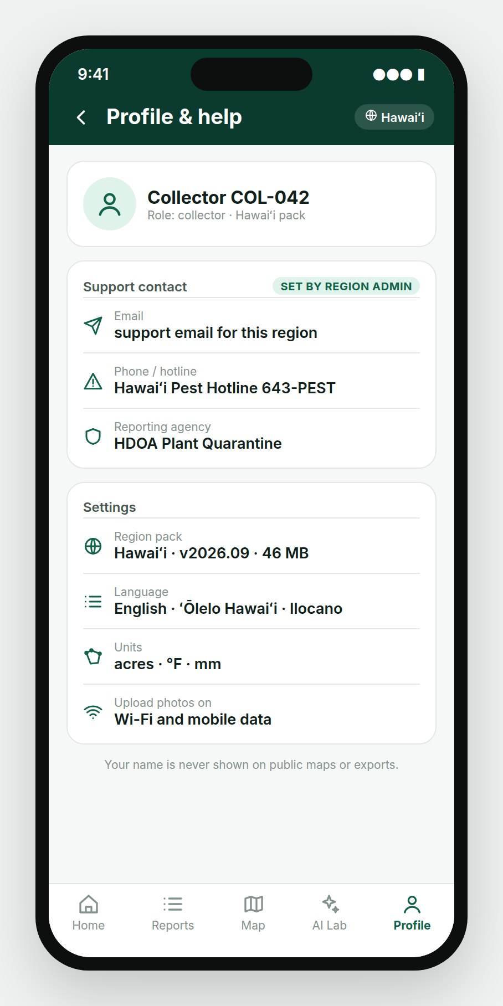  Profile & help

Great job in mapping!

Appendix — How PestLand is built
PERN stack with native C++ modules. Full details are in docs/TECHNICAL_SPEC.md.
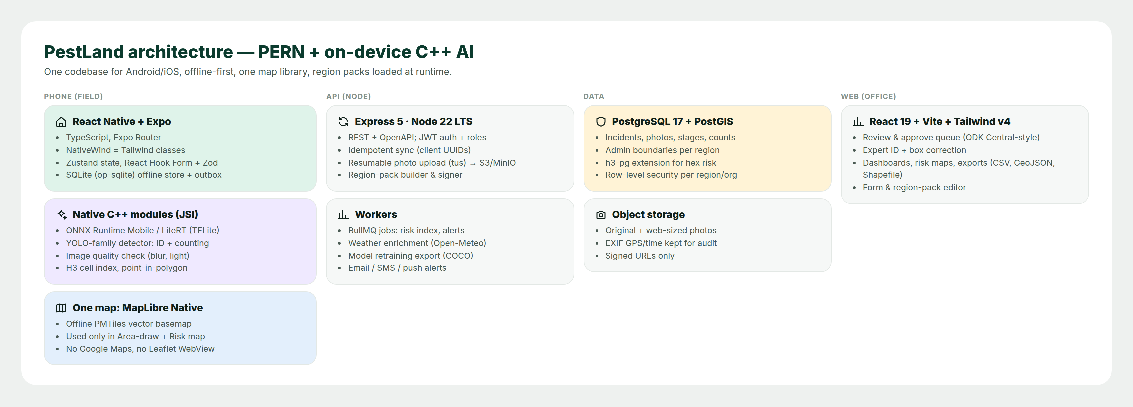
PestLand architecture

