Teorie
Chapter 6
- The final modifier prevents a class from being extended any further.
- Use public getters and setters to access private fields instead of exposing them directly.
- Keep one public class per file, named after the file. Use package-private helper classes only when they’re tightly related and don’t need external visibility.
- The compiler only inserts the default constructor when no constructors are defined.
- Despite using the same keyword, this and this() are very different. The first, this, refers to an instance of the class, while the second, this(), refers to a constructor call within the class.
- If you don’t define a constructor, Java provides a default one that calls super().
- If the superclass has no no-arg constructor, you must call one of its existing constructors explicitly using super(args). Java inserts super() by default, which will fail if it doesn’t exist.
- Each final field must be assigned exactly once. Initialize them in one consistent place — either in all constructors or in an initializer block, but never both.
Chapter 7
- @Deprecated — marks code as outdated; it still works, but you should avoid using it and prefer the newer alternative.
@SafeVarargs — tells the compiler that your generic varargs usage is safe, preventing unnecessary warnings.
Both annotations affect compiler behavior, not runtime execution.
- In interfaces, a private method works like an instance method — it can be called only from default (non-static) methods.
- A private static method works like a static method — it can be called only from other static methods.
- Accessing a Java enum for the first time triggers class initialization: all constants are instantiated in declaration order, running their constructors once. Subsequent accesses reuse the same singleton instances—no constructors, no extra prints.
- Even when a variable is declared as an interface or superclass type, Java executes the method of the actual object (runtime type).
- This is called dynamic method dispatch — a core feature of polymorphism in Java.
- Always program to an interface, not to an implementation.
It’s like using a universal plug — as long as the object fits the interface, it works perfectly.

Chapter 8
-A functional interface has exactly one abstract method.
default, static, or private methods don’t affect this rule.
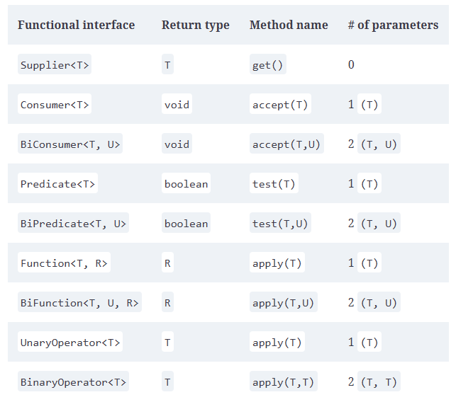
Upper bound (? extends T) → safe to read, not to write.
Lower bound (? super T) → safe to write, not to read.
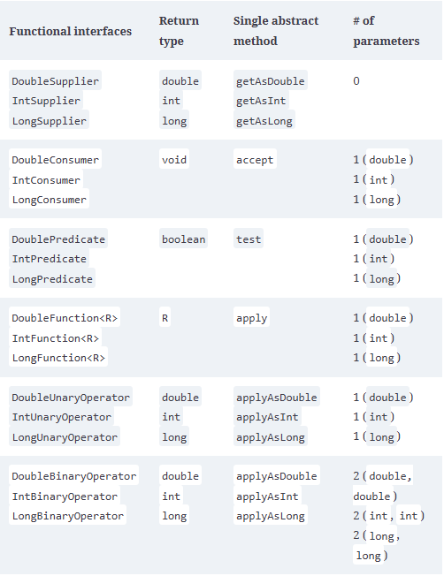
Remember PECS: Producer Extends, Consumer Super.

Chapter 11

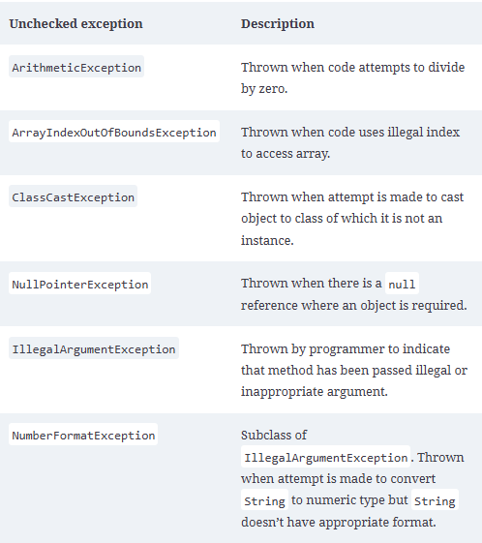
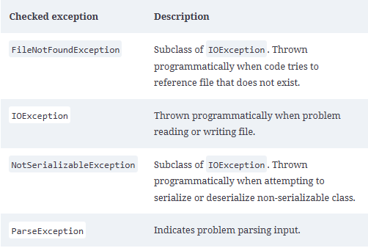
Checked = compile-time safety.
Unchecked = runtime danger.
If you can predict and recover from it → checked.
If it’s a programming bug or logic error → unchecked.

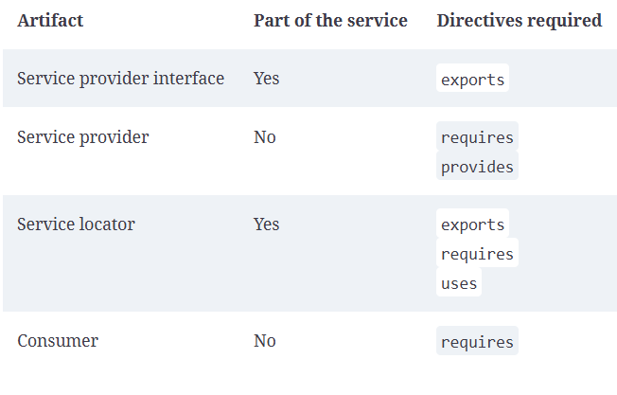
If more than two resources throw an exception, the first one to be thrown becomes the primary exception, and the rest are grouped as suppressed exceptions. And since resources are closed in the reverse of the order in which they are declared, the primary exception will be on the last declared resource that throws an exception
Chapter 12
✅ The service provider interface defines the contract.
✅ The provider implements it.
✅ The service locator uses ServiceLoader to discover implementations.
✅ The consumer calls the locator to use the service.

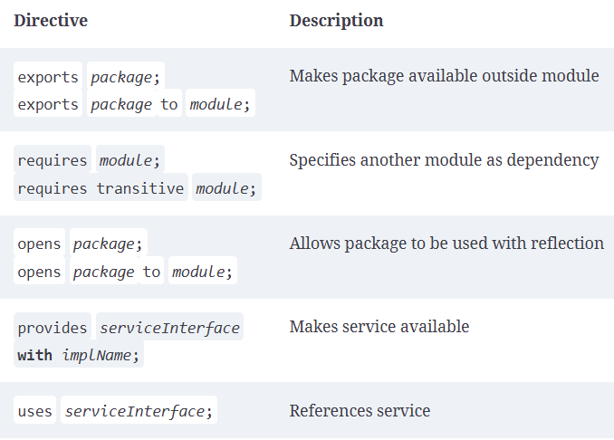
jlink --module-path mods --add-modules zoo.animal.talks --output zooApp
https://learning.oreilly.com/library/view/ocp-oracle-certified/9781394286614/c12.xhtml#R_c12-tbl-0010

