Full Stack Development with MERN
Project Documentation format
1. Introduction
• Project Title: HotelPro - Complete hotel booking and management
2. OverviewProject
• Purpose: Briefly describe the purpose and goals of the project. • Features: Highlight key features and functionalities.
3. Architecture
• Frontend: Describe the frontend architecture using React.
• Backend: Outline the backend architecture using Node.js and Express.js. • Database: Detail the database schema and interactions with MongoDB.
4. Setup Instructions
• Prerequisites: List software dependencies (e.g., Node.js, MongoDB). • Installation: Step-by-step guide to clone, install dependencies, and set up the environment variables.
5. Folder Structure
• Client: Describe the structure of the React frontend.
• Server: Explain the organization of the Node.js backend.
6. Running the Application
• Provide commands to start the frontend and backend servers locally. o Frontend: npm start in the client directory.
o Backend: npm start in the server directory.
7. API Documentation
• Document all endpoints exposed by the backend.
• Include request methods, parameters, and example responses. 8. Authentication
• Explain how authentication and authorization are handled in the project. • Include details about tokens, sessions, or any other methods used.
9. User Interface
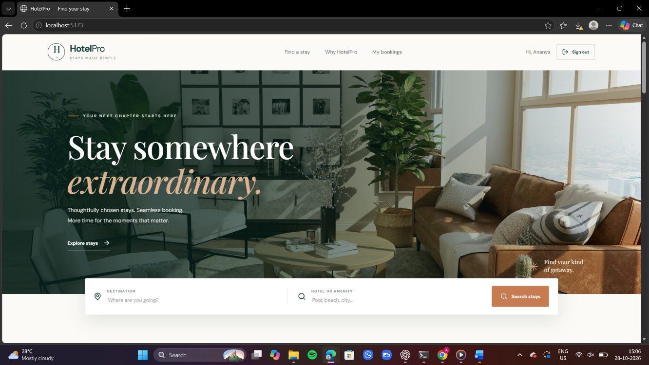
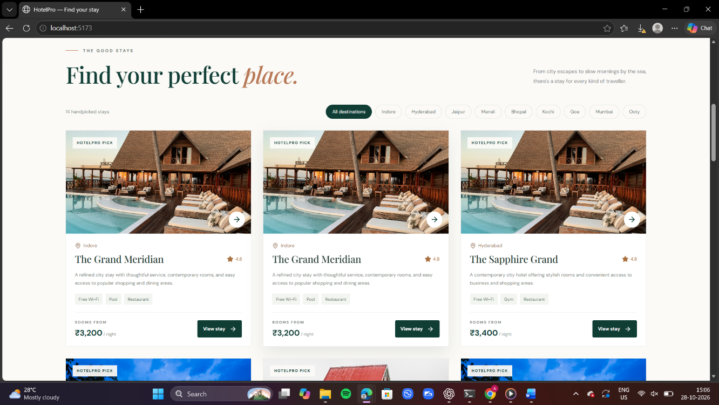
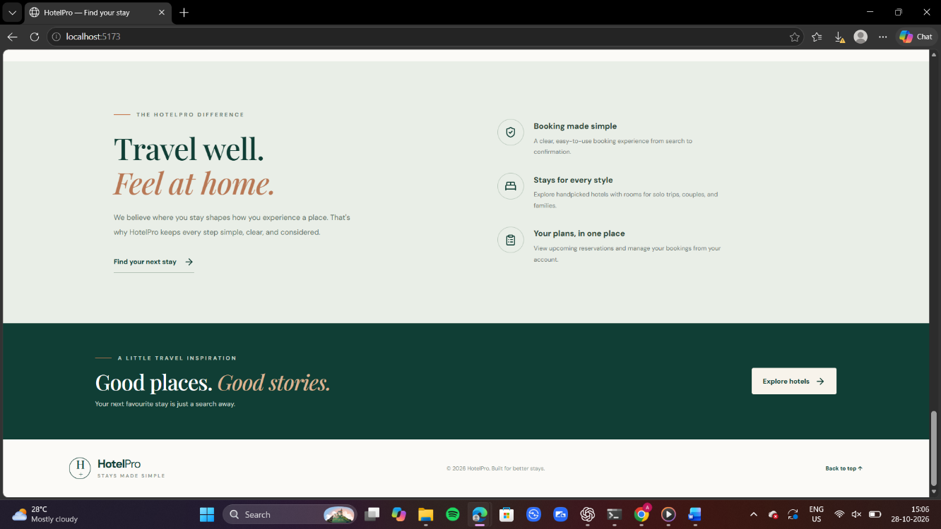
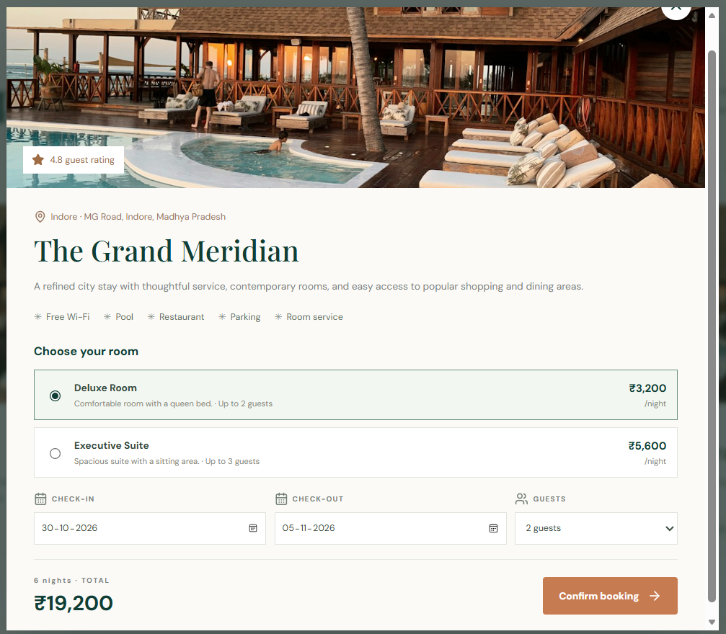
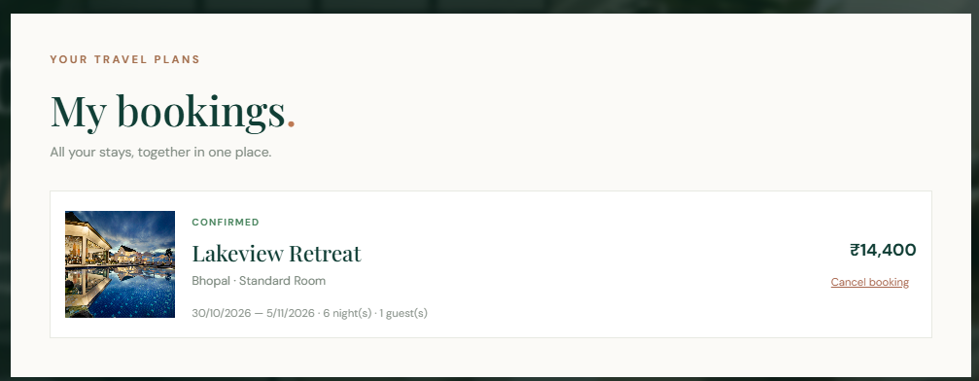

10. Testing
• Describe the testing strategy and tools used.
11. Screenshots or Demo
Project Demonstration Video:
Watch the HotelPro project demo here:
https://drive.google.com/file/d/1P0W9-u_KypcppCBIHwpd1WX9Pn1W8qIc/view?usp=sharing

12. Known Issues
• Document any known bugs or issues that users or developers should be aware of. 13. Future Enhancements
• Outline potential future features or improvements that could be made to the project.

