Ideation Phase
Date | 12 October 2026
Team ID | SWUID2026402437
Project Name | StaffSync – Human Resource Management System
Maximum Marks | 4 Marks

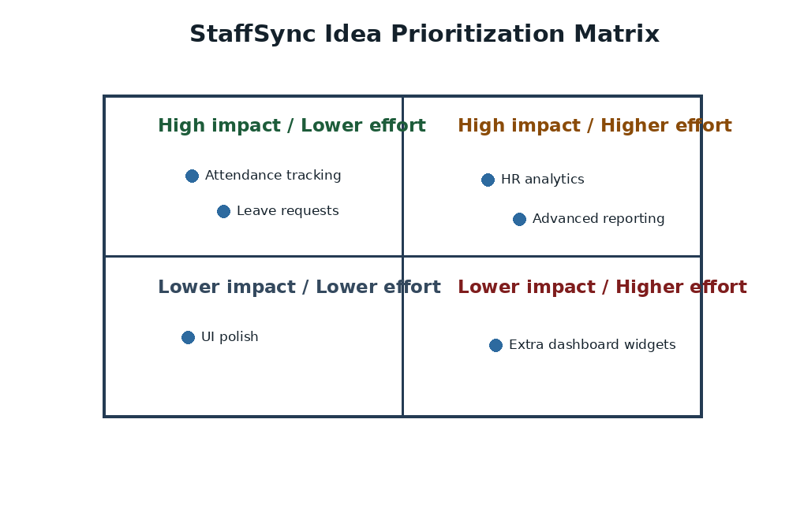
Figure 1. Impact-versus-effort prioritization matrix
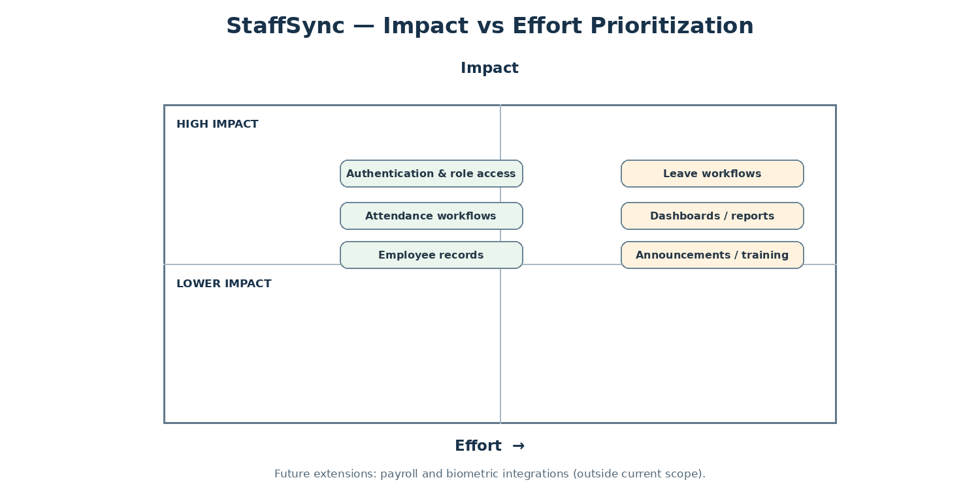

Brainstorm & Idea Prioritization

Brainstorm & Idea Prioritization
Brainstorming helped identify practical ways to improve everyday HR work. For StaffSync, the team considered centralized staff information, authentication, attendance workflows, role-specific views and possible future HR modules.

Step-1: Team Gathering, Collaboration and Select the Problem Statement
- Defer judgment while ideas are collected.
- Generate multiple ideas before prioritizing them.
- Build on suggestions and keep discussion tied to employee, manager and HR needs.
- Prefer features feasible within the MERN stack and the academic project scope.
Selected problem statement (How might we…): How might we provide HR personnel, managers and employees with one reliable web application to manage employee information, attendance, leave requests, announcements and training without scattered manual records?
Input | Source
Problems to solve | Scattered employee records, slow leave approvals, hard-to-track attendance, missed announcements and repetitive reports.
Users involved | HR personnel, managers and employees.
Project constraints | MERN stack, role-based access, academic schedule and deployable web application.

Step-2: Brainstorm, Idea Listing and Grouping
Idea group | Ideas generated
Employee records | Central employee directory, profile updates, HR employee and manager management, search and filters.
Attendance | Employee check-in/check-out, attendance history, late/half-day status, HR tracking and correction.
Leave management | Leave application, balance, overlap checks, manager/HR review, cancellation and status tracking.
Communication | Announcements by category, searchable updates and in-app notifications.
Training | Programme creation, employee enrolment, capacity handling and team assignment.
Reporting | Role-specific dashboards, HR analytics, attendance/leave summaries and CSV export.
Security | JWT authentication, role-based permissions, protected routes, validation and rate limiting.

Step-3: Idea Prioritization
Priority | Selected feature | Reason
High | Authentication and role access | Protects workforce data and restricts permissions.
High | Employee and manager records | Creates a centralized staff directory.
High | Attendance and leave workflows | Supports core daily HR operations.
High | Dashboards and notifications | Improves visibility of status and important events.
Medium | Announcements and training | Supports internal communication and development.
Medium | Reports and CSV export | Helps HR review workforce activity.
Future | Payroll and biometric integrations | Possible extensions beyond current scope.

Outcome
The selected solution is a MERN web application with authentication, role-oriented screens and HR/attendance functionality in the current project. Leave, announcements, training, notifications and advanced reporting should be treated as proposed extensions unless confirmed in the deployed build.

