Project Design Phase-II
Team ID: SWUID2026402437
Data Flow Diagram & User Stories
Date | 12 October 2026
Team ID | SWUID2026402437
Project Name | StaffSync – Human Resource Management System
Maximum Marks | 4 Marks

Data Flow Diagrams
A DFD explains how StaffSync users exchange information with the application and how data is read or updated. HR personnel, managers and employees use the React frontend, which sends requests to the Express API. The API validates requests and permissions before interacting with MongoDB.

Legend
Element | Meaning
External entity | HR personnel, manager or employee.
Process | Login, leave review, attendance check-in, training enrolment or report generation.
Data store | MongoDB records for users, employees, attendance, leaves, announcements, trainings and notifications.
Data flow | Requests, responses and record updates.
Figure 1. StaffSync Context Diagram (DFD Level 0)
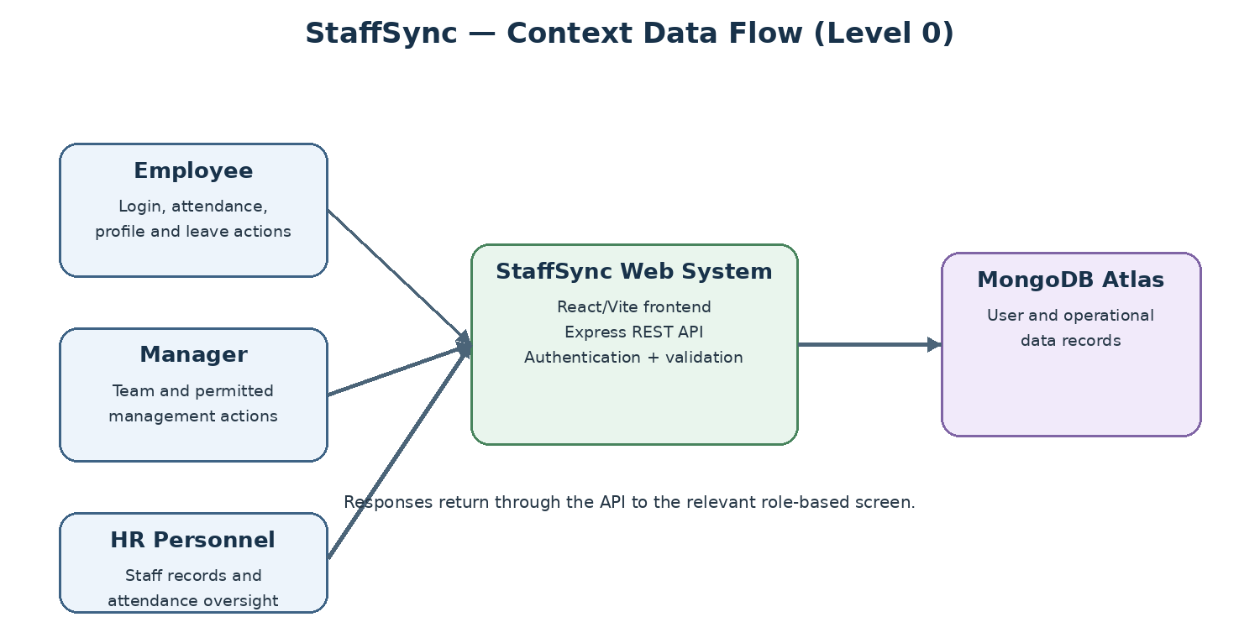
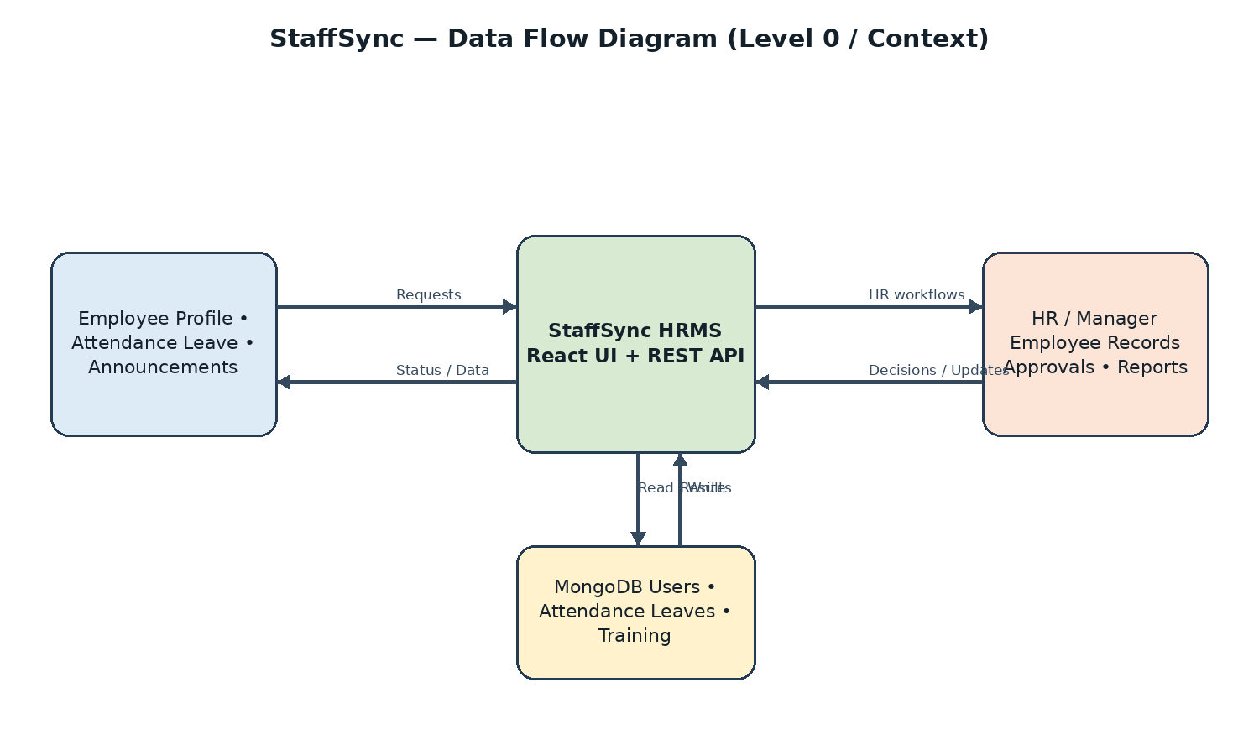

DFD Level 0 – Context Diagram
External Entity | Data sent to StaffSync | Data received
Employee | Login/profile updates, attendance actions, leave requests, training enrolment | Dashboard, attendance history, leave balance/status, announcements, trainings, notifications
Manager | Login, leave decisions, team/training actions and performance review details | Team list, team attendance, leave queue, training and dashboard data
HR Personnel | Employee/manager maintenance, attendance corrections, announcements, training and report requests | Employee directory, attendance overview, leave queue, analytics and reports
Figure 2. StaffSync Process Diagram (DFD Level 1)
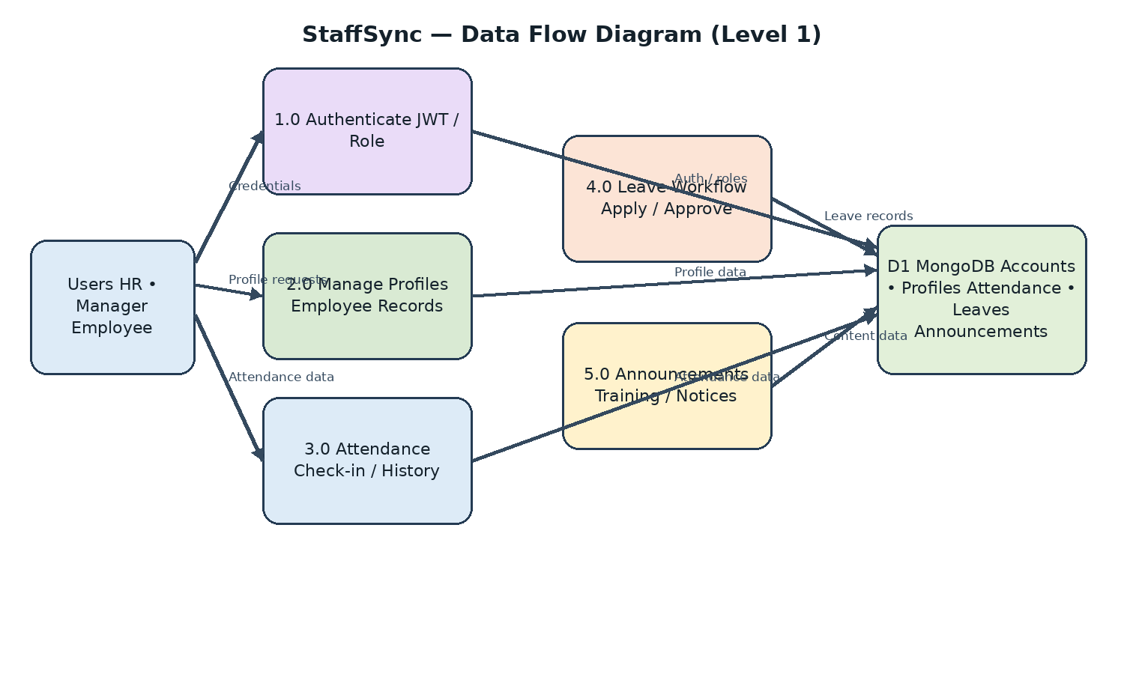

DFD Level 1 – Major Processes
Process | Input / processing | Data store
1.0 Authentication & Profile | Register/login/logout, validate JWT, view/update profile. | Users, employees, managers
2.0 Employee & Team Management | HR maintains staff; manager views team and manages permitted membership. | Users, employee/manager records
3.0 Attendance Management | Check-in/out, attendance history, team attendance and HR correction. | Attendance records
4.0 Leave Management | Apply, check balance/overlap, review, approve/reject and cancel eligible requests. | Leave requests and balances
5.0 Announcements | HR creates/manages announcements; users search and view. | Announcements
6.0 Training Management | Create programmes, enrol/unenrol employees and assign team members. | Training programmes and enrolments
7.0 Notifications | Create alerts for leave, announcements, training and reviews. | Notifications
8.0 Dashboards & Reports | Role-specific summaries, analytics and CSV export. | Attendance, leaves, users, training and notifications

User Story Table – StaffSync
Story ID | User Story | Priority
US-01 | As a user, I want to register/login securely and access only permitted features. | High
US-02 | As an employee, I want to view and update my profile. | Medium
US-03 | As an employee, I want to check in/out and view attendance history. | High
US-04 | As an employee, I want to apply for leave and view balance/status. | High
US-05 | As a manager, I want to approve/reject my team's leave requests. | High
US-06 | As HR, I want to manage employee and manager records. | High
US-07 | As HR, I want to track and correct attendance records. | High
US-08 | As a manager, I want to view my team and team attendance. | Medium
US-09 | As HR, I want to publish announcements for staff. | Medium
US-10 | As an employee, I want to browse and enrol in training. | Medium
US-11 | As a manager/HR user, I want to create and manage training programmes. | Medium
US-12 | As a user, I want to receive and manage relevant notifications. | Medium
US-13 | As HR, I want workforce analytics and CSV report export. | Medium
US-14 | As a manager, I want to manage team membership and review performance where supported. | Medium
US-15 | As an employee, I want to cancel an eligible pending leave request. | Medium
US-16 | As HR, I want to search/filter employee and attendance records. | Medium
US-17 | As a user, I want clear success and validation messages. | Medium
US-18 | As a user, I want role-specific dashboard information. | High
US-19 | As a developer, I want validation, error handling and deployment configuration. | High

