Project Design Phase
Date | 12 October 2026
Team ID | SWUID2026402437
Project Name | StaffSync – Human Resource Management System
Maximum Marks | 4 Marks

Figure 1. StaffSync Layered System Architecture
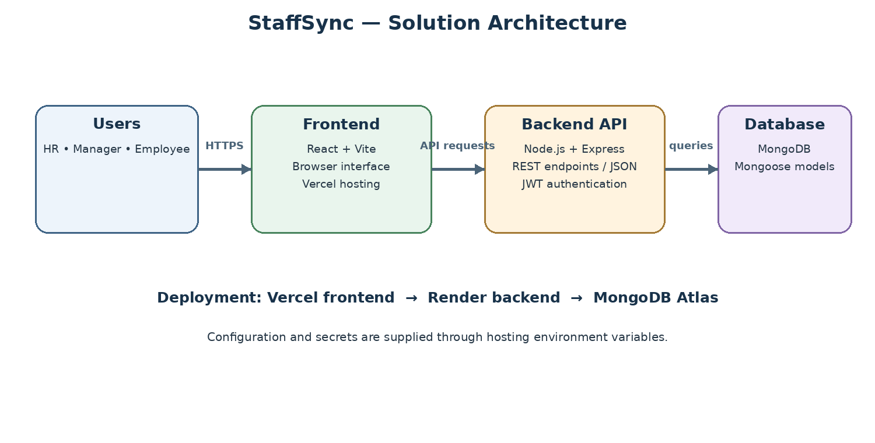
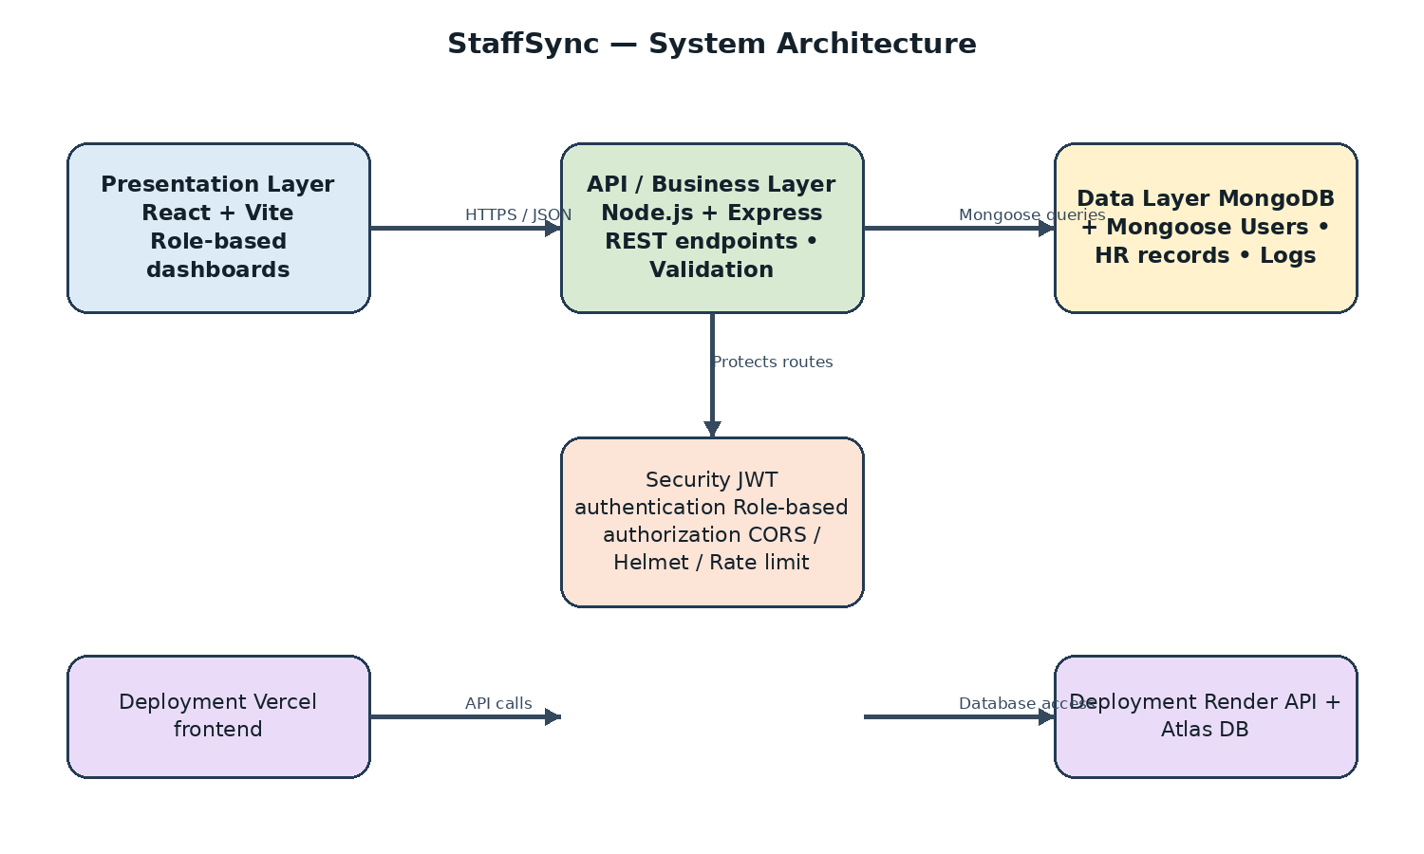
Solution Architecture

Solution Architecture
StaffSync is a layered MERN web application. Users access the React/Vite interface in a browser. The frontend sends JSON requests to the Node.js/Express API, which handles authentication and application requests and uses Mongoose to read or update MongoDB. The deployed frontend is hosted on Vercel, the API on Render and the database on MongoDB Atlas.
- Presentation: React pages for HR, managers and employees.
- API/business logic: Express routes for authentication, HR-related operations and attendance; the frontend provides login and role-oriented workspace/dashboard screens.
- Security: JWT-based authentication and request authorization where implemented, plus CORS configuration and environment-based secrets. Do not claim additional security middleware unless it is present in the deployed code.
- Data layer: MongoDB accessed through Mongoose models, including user and attendance-related records and other models included in the repository.
- User experience: login, dashboard/workspace screens and HR/attendance workflows represented by the current application. Describe advanced reporting or CSV export as implemented only if verified in the running version.

Example – Solution Architecture Diagram
Layer | Components | Flow
Presentation | Browser, React + Vite, forms, dashboards | User actions and displayed results
API / Business logic | Node.js + Express, REST routes/controllers, validation, JWT/role middleware | HTTPS/JSON requests and responses
Data access | Mongoose models and query logic | Validated reads and writes
Database | MongoDB Atlas / MongoDB | Users, employee/manager records, attendance, leaves, announcements, trainings and notifications
Deployment | Vercel frontend → Render API → MongoDB Atlas | Environment-configured URLs and secrets
Request flow: User → React frontend → Express REST API → authentication/authorization and controllers → MongoDB → API response → React UI.

