Project Design Phase-II
Technology Stack (Architecture & Stack)
Date | 12 October 2026
Team ID | SWUID2026402437
Project Name | StaffSync – Human Resource Management System
Maximum Marks | 4 Marks

Figure 1. StaffSync Technology Architecture
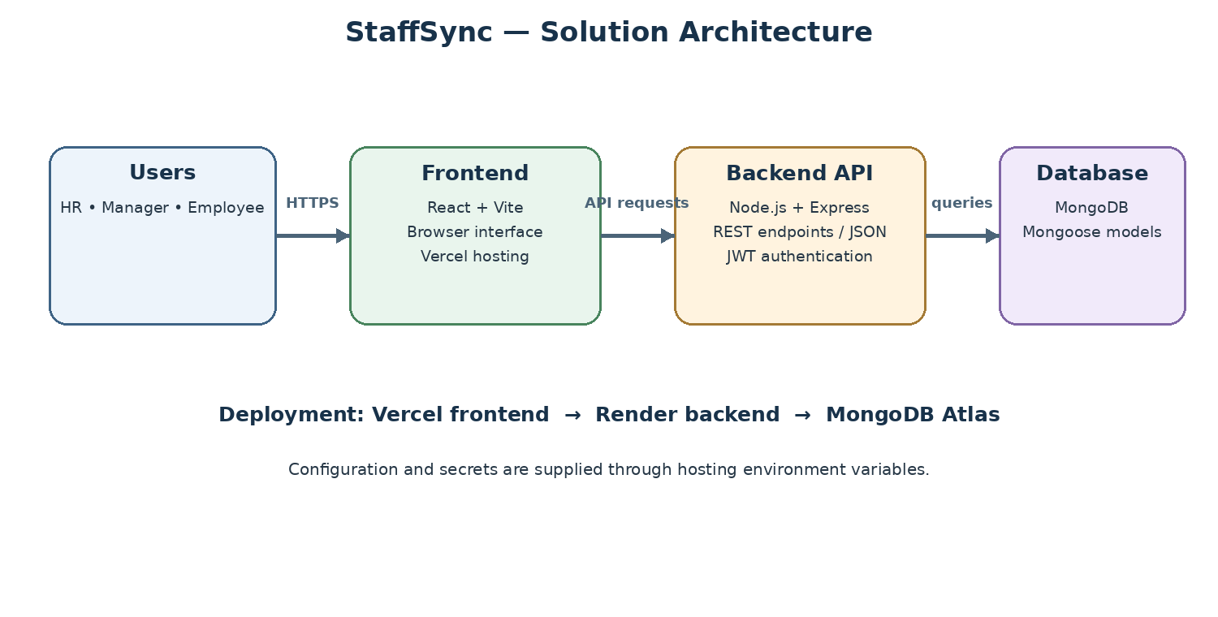
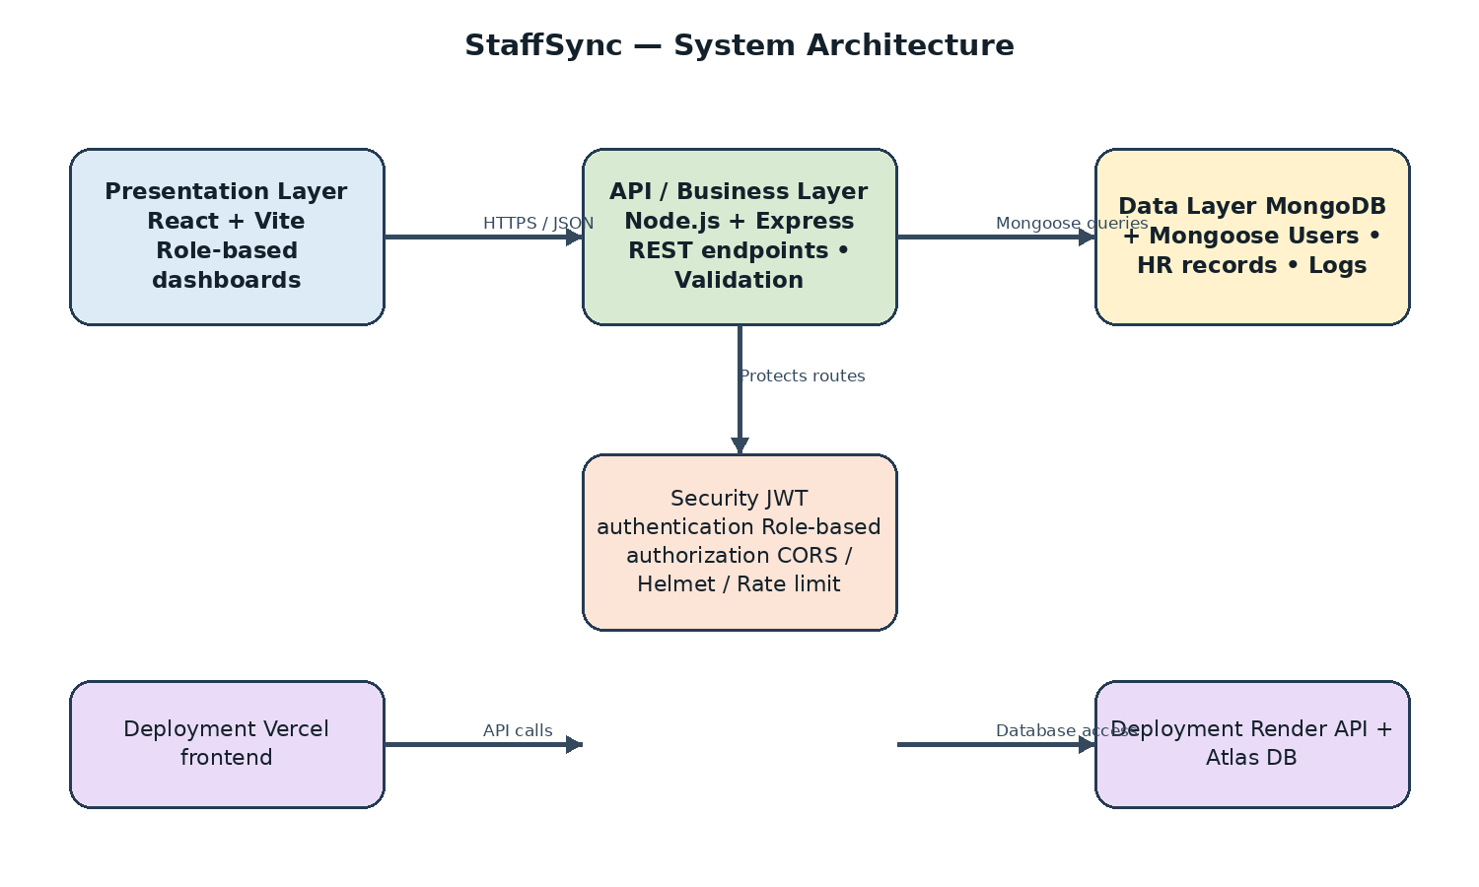

Technical Architecture
StaffSync uses the MERN stack: React with Vite for the frontend, Node.js and Express for the REST API, and MongoDB accessed through Mongoose. The frontend and backend communicate using JSON. JWT authentication supports signed-in access. The live demo is deployed with Vercel (frontend), Render (API) and MongoDB Atlas (database).

Table-1: Components & Technologies
S.No. | Component | Description | Technology
1 | User Interface | Single-page interface with forms, dashboards, attendance, leave and training pages. | HTML5, CSS3, JavaScript, React.js, Vite
2 | Client State & API | Shared auth state, protected pages and API requests. | React hooks/components, Redux Toolkit where used, Axios
3 | Application Logic | REST endpoints for authentication, profiles, employees, managers, team, attendance, leaves and related modules. | Node.js, Express.js
4 | Authentication & Security | JWT, role authorization, secure cookies, validation and security middleware. | JWT, bcrypt, Helmet, CORS, express-rate-limit
5 | Database | User, employee, manager, attendance, leave, announcement, training and notification records. | MongoDB, Mongoose
6 | Reporting | Role-specific dashboards, HR analytics and CSV export. | Express controllers, MongoDB queries
7 | Frontend Build | Development server and optimized production assets. | Vite
8 | Backend Development | Local development and production start scripts. | Node.js, npm, nodemon
9 | Version Control | Source code history and repository hosting. | Git, GitHub
10 | Deployment | Frontend, backend service and managed database hosting. | Vercel, Render, MongoDB Atlas

Table-2: Application Characteristics
S.No. | Characteristic | Description | Technology / Approach
11 | Open-source frameworks | JavaScript full-stack web development. | React, Node.js, Express, MongoDB
12 | Security implementation | JWT authentication, role access, protected routes, Helmet, CORS and rate limiting. | JWT, Express middleware, bcrypt
13 | Layered architecture | Frontend, REST API, controllers, models and database are separated. | React, Express, Mongoose
14 | Data integrity | Schema validation, ObjectId validation and query filtering; indexes for frequent queries. | Mongoose schemas and MongoDB indexes
15 | API testing | REST endpoints can be checked with browser tools or API clients. | HTTP/JSON, Postman or equivalent
16 | Testing | Manual role, workflow, validation and responsive checks; health endpoint. | Browser DevTools, /api/health
17 | Version control & tools | Source management and development. | Git/GitHub, VS Code, npm

References
- React documentation: https://react.dev/
- Node.js documentation: https://nodejs.org/docs/
- Express documentation: https://expressjs.com/
- MongoDB documentation: https://www.mongodb.com/docs/
- Vite documentation: https://vite.dev/

