Ideation Phase
Date | 12 October 2026
Team ID | SWUID2026402449
Project Name | StaffSync – Human Resource Management System
Maximum Marks | 4 Marks

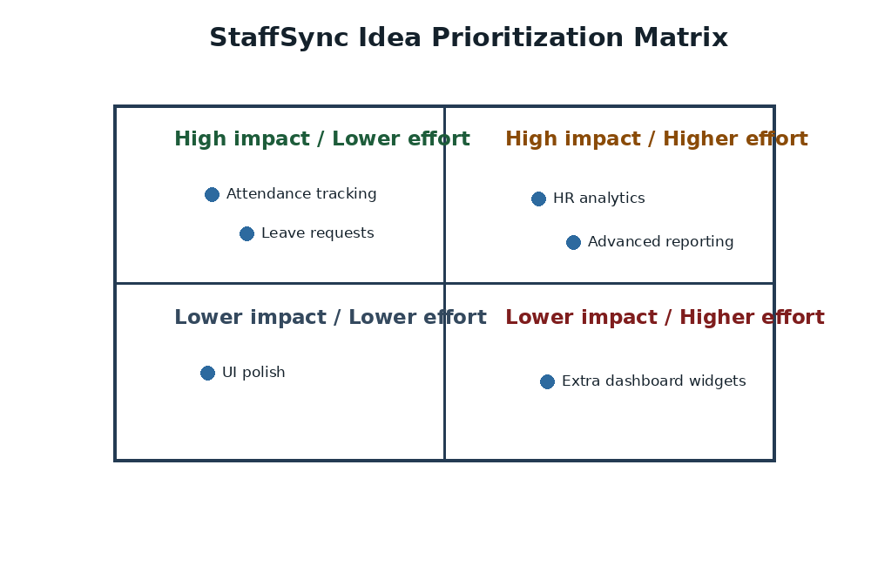
Figure 1. Impact-versus-effort prioritization matrix

Brainstorm & Idea Prioritization

Brainstorm & Idea Prioritization
Brainstorming helps the team identify practical improvements to everyday HR operations. For StaffSync, ideas were generated around employee records, attendance, leave processing, internal communication, training coordination and reporting.

Step-1: Team Gathering, Collaboration and Select the Problem Statement
- Defer judgment while ideas are collected.
- Generate multiple ideas before prioritizing them.
- Build on suggestions and keep discussion tied to employee, manager and HR needs.
- Prefer features feasible within the MERN stack and the academic project scope.
Selected problem statement (How might we…): How might we provide HR personnel, managers and employees with one reliable web application to manage employee information, attendance, leave requests, announcements and training without scattered manual records?
Input | Source
Problems to solve | Scattered employee records, slow leave approvals, hard-to-track attendance, missed announcements and repetitive reports.
Users involved | HR personnel, managers and employees.
Project constraints | MERN stack, role-based access, academic schedule and deployable web application.

Step-2: Brainstorm, Idea Listing and Grouping
Idea group | Ideas generated
Employee records | Central employee directory, profile updates, HR employee and manager management, search and filters.
Attendance | Employee check-in/check-out, attendance history, late/half-day status, HR tracking and correction.
Leave management | Leave application, balance, overlap checks, manager/HR review, cancellation and status tracking.
Communication | Announcements by category, searchable updates and in-app notifications.
Training | Programme creation, employee enrolment, capacity handling and team assignment.
Reporting | Role-specific dashboards, HR analytics, attendance/leave summaries and CSV export.
Security | JWT authentication, role-based permissions, protected routes, validation and rate limiting.

Step-3: Idea Prioritization
Priority | Selected feature | Reason
High | Authentication and role access | Protects workforce data and restricts permissions.
High | Employee and manager records | Creates a centralized staff directory.
High | Attendance and leave workflows | Supports core daily HR operations.
High | Dashboards and notifications | Improves visibility of status and important events.
Medium | Announcements and training | Supports internal communication and development.
Medium | Reports and CSV export | Helps HR review workforce activity.
Future | Payroll and biometric integrations | Possible extensions beyond current scope.

Outcome
The selected solution is a role-based MERN web application covering authentication, employee management, attendance, leave, announcements, training, notifications, dashboards and HR reporting.

