Project Design Phase-II
Technology Stack (Architecture & Stack)
Date | 12 October 2026
Team ID | SWUID2026402449
Project Name | StaffSync – Human Resource Management System
Maximum Marks | 4 Marks

Figure 1. StaffSync Technology Architecture
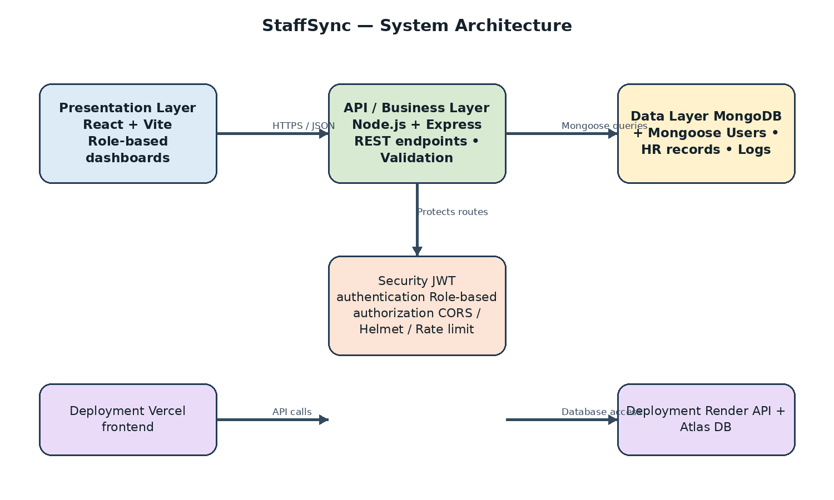

Technical Architecture
StaffSync is a MERN-stack web application. The React frontend communicates with a Node.js/Express REST API using JSON. The API uses Mongoose to access MongoDB. Authentication and role checks protect HR, manager and employee functions. The live demo uses Vercel, Render and MongoDB Atlas.

Table-1: Components & Technologies
S.No. | Component | Description | Technology
1 | User Interface | Single-page interface with forms, dashboards, attendance, leave and training pages. | HTML5, CSS3, JavaScript, React.js, Vite
2 | Client State & API | Shared auth state, protected pages and API requests. | React hooks/components, Redux Toolkit where used, Axios
3 | Application Logic | REST endpoints for authentication, profiles, employees, managers, team, attendance, leaves and related modules. | Node.js, Express.js
4 | Authentication & Security | JWT, role authorization, secure cookies, validation and security middleware. | JWT, bcrypt, Helmet, CORS, express-rate-limit
5 | Database | User, employee, manager, attendance, leave, announcement, training and notification records. | MongoDB, Mongoose
6 | Reporting | Role-specific dashboards, HR analytics and CSV export. | Express controllers, MongoDB queries
7 | Frontend Build | Development server and optimized production assets. | Vite
8 | Backend Development | Local development and production start scripts. | Node.js, npm, nodemon
9 | Version Control | Source code history and repository hosting. | Git, GitHub
10 | Deployment | Frontend, backend service and managed database hosting. | Vercel, Render, MongoDB Atlas

Table-2: Application Characteristics
S.No. | Characteristic | Description | Technology / Approach
11 | Open-source frameworks | JavaScript full-stack web development. | React, Node.js, Express, MongoDB
12 | Security implementation | JWT authentication, role access, protected routes, Helmet, CORS and rate limiting. | JWT, Express middleware, bcrypt
13 | Layered architecture | Frontend, REST API, controllers, models and database are separated. | React, Express, Mongoose
14 | Data integrity | Schema validation, ObjectId validation and query filtering; indexes for frequent queries. | Mongoose schemas and MongoDB indexes
15 | API testing | REST endpoints can be checked with browser tools or API clients. | HTTP/JSON, Postman or equivalent
16 | Testing | Manual role, workflow, validation and responsive checks; health endpoint. | Browser DevTools, /api/health
17 | Version control & tools | Source management and development. | Git/GitHub, VS Code, npm

References
- React documentation: https://react.dev/
- Node.js documentation: https://nodejs.org/docs/
- Express documentation: https://expressjs.com/
- MongoDB documentation: https://www.mongodb.com/docs/
- Vite documentation: https://vite.dev/

