Project Design Phase-II
Data Flow Diagram & User Stories

Date | 28/10/2026
Team ID | Akshara Jain
Project Name | Electric Vehicle Market Performance & Insights
Maximum Marks | 4 Marks

Data Flow Diagrams:
A Data Flow Diagram (DFD) is a traditional visual representation of the information flows within a system. A neat and clear DFD can depict the right amount of the system requirement graphically. It shows how data enters and leaves the system, what changes the information, and where data is stored.
DFD Symbol Legend
Symbol | Name | Description
Oval / Rounded  shape | External Entity | A person, organization, or system outside the project that sends or receives data (e.g., Customer, Payment Gateway).
Rectangle with  numbered header | Process | An activity that transforms incoming data into outgoing data (e.g., Validate Request, Process Order).
Rectangle (solid fill, no number) | Data Store | A place where data is held for later use (e.g., Customer Database, Inventory).
Labeled arrow | Data Flow | The movement of data between entities, processes, and data stores, labeled with what data is being passed.

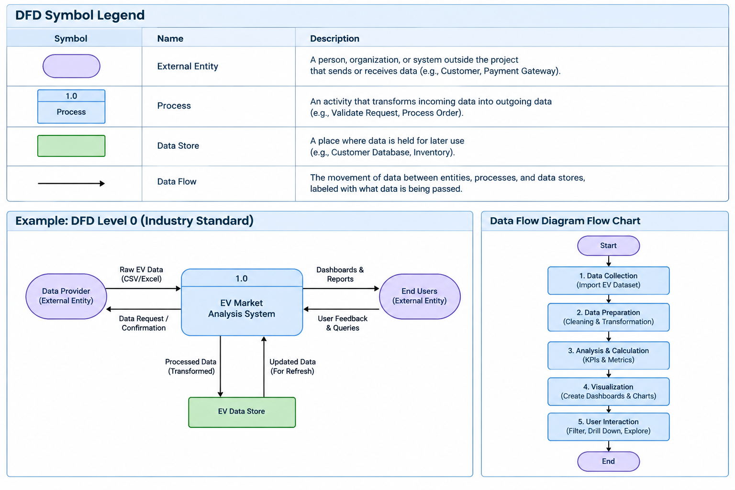

User Stories
Use the below template to list all the user stories for the product.
User Type | Functional Requirement (Epic) | User Story Number | User Story / Task | Acceptance criteria | Priority | Release
Market Strategy Director | Data Access & Integration | USN-1 | As a Market Strategy Director, I want to access the EV market dataset containing vehicle, sales, manufacturer, battery, range, country, and customer rating information so that I can evaluate overall market performance. | EV market data is successfully connected to Tableau and the required fields are available for analysis. | High | Release-1
Market Strategy Director | Business Analysis | USN-2 | As a Market Strategy Director, I want to compare annual sales across different vehicle categories so that I can identify the categories contributing the most to the EV market. | Dashboard displays annual sales by vehicle category and allows categories to be compared. | High | Release-1
Market Strategy Director | Business Analysis | USN-3 | As a Market Strategy Director, I want to compare manufacturers based on annual sales so that I can identify leading manufacturers in the EV market. | Dashboard ranks or compares manufacturers according to their annual sales. | High | Release-1
Market Strategy Director | Business Insights & Analytical Outputs | USN-4 | As a Market Strategy Director, I want to analyze customer ratings across vehicle categories so that I can understand customer satisfaction and identify better-performing segments. | Customer ratings are visualized by vehicle category and can be compared across segments. | High | Release-1
Market Strategy Director | User Interaction & Analysis | USN-5 | As a Market Strategy Director, I want to filter the dashboard by manufacturer, vehicle category, and battery technology so that I can focus on specific market segments. | Selecting a filter updates the relevant dashboard visualizations and KPIs. | High | Release-1
Automotive BI Manager | Business Analysis | USN-6 | As an Automotive BI Manager, I want to analyze manufacturer performance and market share so that I can identify competitive positions within the EV market. | Manufacturer sales and market-share information are calculated and presented clearly. | High | Release-1
Automotive BI Manager | Business Insights & Analytical Outputs | USN-7 | As an Automotive BI Manager, I want to analyze the distribution of battery technologies so that I can identify which technologies are most widely adopted. | Dashboard displays the distribution of LFP, NMC, NCA, Sodium-Ion, Solid-State, and other available battery technologies. | High | Release-1
Automotive BI Manager | Business Analysis | USN-8 | As an Automotive BI Manager, I want to compare driving range across vehicle categories and manufacturers so that I can identify vehicles with better range performance. | Average or relevant driving-range values are displayed and can be compared by category and manufacturer. | High | Release-1
Automotive BI Manager | Business Insights & Analytical Outputs | USN-9 | As an Automotive BI Manager, I want to analyze manufacturing countries so that I can understand geographical production trends in the EV industry. | Manufacturing countries are visualized with relevant vehicle or sales information for geographical comparison. | Medium | Release-1
Sustainable Mobility Research Analyst | Business Analysis | USN-10 | As a Sustainable Mobility Research Analyst, I want to compare battery technologies based on vehicle performance so that I can understand their relationship with driving range and market adoption. | Battery technologies can be compared using available performance and adoption measures. | High | Release-1
Sustainable Mobility Research Analyst | User Interaction & Analysis | USN-11 | As a Sustainable Mobility Research Analyst, I want to analyze customer ratings across different EV categories so that I can identify segments with stronger customer acceptance. | Customer ratings are presented by vehicle category and can be compared using dashboard visualizations. | Medium | Release-1
Sustainable Mobility Research Analyst | Business Insights & Analytical Outputs | USN-12 | As a Sustainable Mobility Research Analyst, I want to filter and compare EV data by battery technology, vehicle category, manufacturer, and country so that I can investigate specific technological and market trends. | Dashboard filters allow the analyst to select relevant dimensions and the visualizations update accordingly. | High | Release-1

