
Story

Date | 28/10/2026
Team ID | Akshara Jain
Project Name | Electric Vehicle Market Performance & Insights
Maximum Marks | 5 Marks

A data story presents complex information in a clear, engaging sequence that helps viewers understand important patterns and make informed decisions. For the Electric Vehicle Market Performance & Insights project, the story brings key EV market indicators together to explain sales performance, battery adoption, and customer satisfaction.
The dashboard can be explored using filters such as year, manufacturer, vehicle category, country, and battery technology. Charts help compare which vehicle categories contribute most to sales, which battery technologies are most common, and how customer ratings vary across segments. These views can support market strategy, competitive analysis, and research into sustainable mobility.

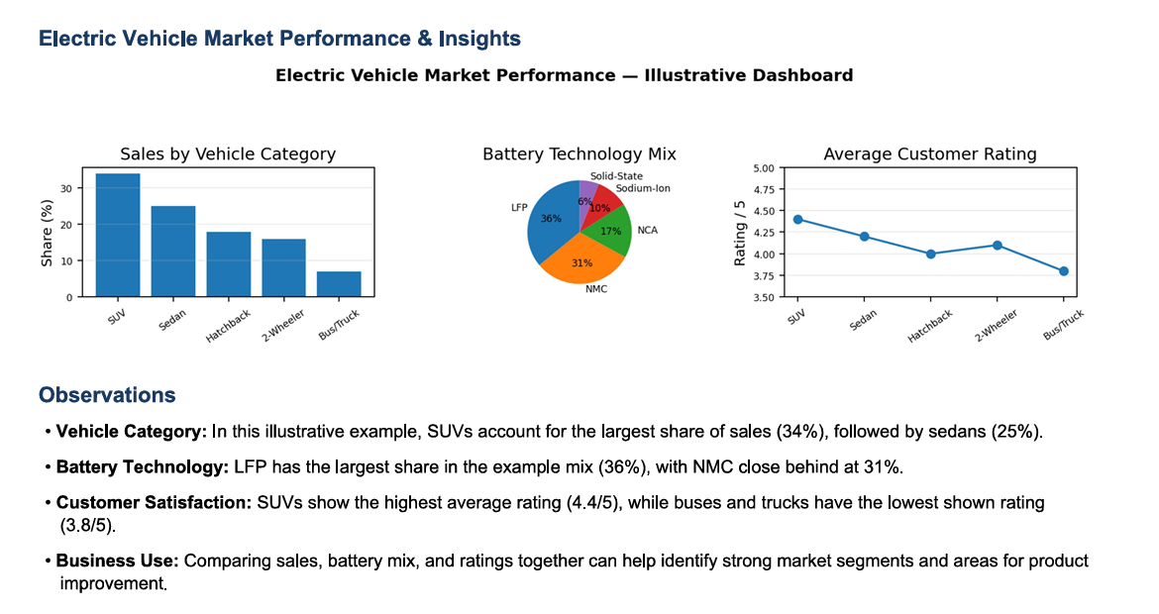

Activity 2:
Publish Story on Tableau Public and Paste Public link below
https://public.tableau.com/views/EVCountbyManufacture/Story1?:language=en-US&publish=yes&:sid=&:redirect=auth&:display_count=n&:origin=viz_share_link

