Project Design Phase-II
Data Flow Diagram & User Stories

Date | 26 October 2026
Team ID | Individual
Project Name | EV Industry Market Analysis Dashboard (Tableau)
Maximum Marks | 4 Marks

Data Flow Diagrams:
A Data Flow Diagram (DFD) is a traditional visual representation of the information flows within a system. A neat and clear DFD can depict the right amount of the system requirement graphically. It shows how data enters and leaves the system, what changes the information, and where data is stored.
DFD Symbol Legend
Symbol | Name | Description
Oval / Rounded  shape | External Entity | A person, organization, or system outside the project that sends or receives data (e.g., Customer, Payment Gateway).
Rectangle with  numbered header | Process | An activity that transforms incoming data into outgoing data (e.g., Validate Request, Process Order).
Rectangle (solid fill, no number) | Data Store | A place where data is held for later use (e.g., Customer Database, Inventory).
Labeled arrow | Data Flow | The movement of data between entities, processes, and data stores, labeled with what data is being passed.

DFD Level 0: EV Market Analysis Dashboard
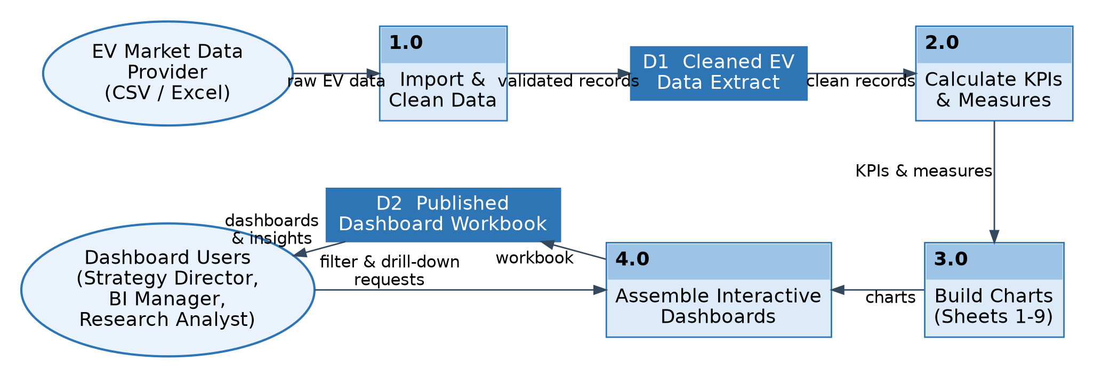

User Stories
Use the below template to list all the user stories for the product.
User Type | Functional Requirement (Epic) | User Story Number | User Story / Task | Acceptance criteria | Priority | Release
Market Strategy Director | Sales Analysis | USN-1 | As a strategy director, I can view annual sales units and average price by vehicle category so that I know which categories contribute most to sales. | A bar-line chart shows sales units and price for every category | High | Sprint-1
 |  | USN-2 | As a strategy director, I can see the top 15 manufacturers by annual sales so that I can identify the market leaders. | Top-15 bar chart is shown, coloured by average customer rating | High | Sprint-1
 | Battery Technology | USN-3 | As a strategy director, I can view battery type adoption (LFP, NMC, NCA, Sodium-Ion, Solid-State) across vehicle categories. | Stacked bar shows sales units by battery type and category | High | Sprint-1
 | Customer Satisfaction | USN-4 | As a strategy director, I can compare average customer ratings across manufacturers to judge customer preferences. | Rating colour legend is visible and updates with filters | Medium | Sprint-2
Business Intelligence Manager | Manufacturer Benchmarking | USN-5 | As a BI manager, I can filter the dashboard by manufacturer so that I can benchmark competitors. | Charts update when manufacturers are selected or deselected | High | Sprint-1
 |  | USN-6 | As a BI manager, I can compare average 0-100 acceleration across manufacturers. | Manufacturer vs acceleration view is displayed | Medium | Sprint-2
 | Market Positioning | USN-7 | As a BI manager, I can compare average price against average range by category to position products. | Scatter plot of price vs range is displayed by category | High | Sprint-1
Sustainability Research Analyst | Charging & Battery Performance | USN-8 | As a research analyst, I can compare DC fast-charging and AC charging time by battery type. | Chart shows both charging times for each battery type | High | Sprint-2
 |  | USN-9 | As a research analyst, I can view battery degradation against maximum DC charging power. | Degradation vs DC kW chart is displayed with CO2 saved | Medium | Sprint-2
 | Range & Efficiency Trends | USN-10 | As a research analyst, I can view average driving range by model year (2018-2026) to track technology improvements. | Line chart shows range trend per category | Medium | Sprint-2
 |  | USN-11 | As a research analyst, I can compare efficiency (Wh/km) by recommended use case. | Efficiency by use case chart is displayed | Low | Sprint-3
Dashboard Administrator | Data Update & Publishing | USN-12 | As an administrator, I can refresh the EV dataset and republish the dashboards so that users see current data. | Dashboards show the updated data after refresh | Medium | Sprint-3

