Project Planning Phase
Project Planning Template (Product Backlog, Sprint Planning, Stories, Story points)

Date | 28 October 2026
Team ID | PNT2022TMIDxxxxxx
Project Name | Project - EV Market Analysis Dashboard using Tableau
Maximum Marks | 8 Marks

Product Backlog, Sprint Schedule, and Estimation (4 Marks)
Use the below template to create product backlog and sprint schedule
Sprint | Functional Requirement (Epic) | User Story Number | User Story / Task | Story Points | Priority | Team Members
Sprint-1 | Data Collection | USN-1 | As an analyst, I can collect the EV market dataset (CSV/Excel) containing sales, price, battery, range, charging, manufacturer and rating fields. | 3 | High | Team Member 1
Sprint-1 |  | USN-2 | As an analyst, I can understand the dataset fields and define the KPIs (annual sales, range, price, charging time, customer rating). | 2 | High | Team Member 2
Sprint-1 | Data Preparation | USN-3 | As an analyst, I can clean the data (remove nulls and duplicates, fix data types) so that the analysis is accurate. | 5 | High | Team Member 3
Sprint-1 | Data Connection | USN-4 | As an analyst, I can connect the cleaned dataset to Tableau and create an extract for fast performance. | 3 | High | Team Member 4
Sprint-1 | Data Preparation | USN-5 | As an analyst, I can create calculated fields (e.g., average price, average range, average customer rating). | 3 | Medium | Team Member 1
Sprint-1 |  | USN-6 | As an analyst, I can validate the loaded data against the source to confirm totals and categories match. | 4 | Medium | Team Member 2
Sprint-2 | Worksheets (Market Overview) | USN-7 | As a strategy director, I can see annual sales units and price by vehicle category (bar + line dual-axis chart). | 3 | High | Team Member 3
Sprint-2 |  | USN-8 | As a strategy director, I can see battery type vs annual sales split by category (stacked bar chart). | 3 | High | Team Member 4
Sprint-2 |  | USN-9 | As a researcher, I can compare average price vs average range by category (scatter plot). | 3 | High | Team Member 1
Sprint-2 |  | USN-10 | As a BI manager, I can view the top 15 manufacturers by annual sales with average customer rating (bar chart). | 4 | High | Team Member 2
Sprint-2 | Worksheets (Battery & Performance) | USN-11 | As a researcher, I can compare average DC fast-charging and AC charging time by battery type. | 3 | High | Team Member 3
Sprint-2 |  | USN-12 | As a BI manager, I can see recommended use case vs average efficiency (Wh per km). | 2 | Medium | Team Member 4
Sprint-2 |  | USN-13 | As a researcher, I can see average range by model year for each category (line chart). | 2 | Medium | Team Member 1
Sprint-3 | Worksheets (Battery & Performance) | USN-14 | As a BI manager, I can compare manufacturers by average acceleration 0-100 (heat map). | 3 | Medium | Team Member 2
Sprint-3 |  | USN-15 | As a researcher, I can see battery degradation vs max DC charging power by battery type (area chart). | 3 | Medium | Team Member 3
Sprint-3 | Dashboard Design | USN-16 | As a strategy director, I can view Dashboard 1 (Market Overview) combining sales, battery, price-range and manufacturer sheets. | 5 | High | Team Member 4
Sprint-3 |  | USN-17 | As a researcher, I can view Dashboard 2 (Battery & Performance) combining charging, efficiency, range, acceleration and degradation sheets. | 5 | High | Team Member 1
Sprint-3 | Interactivity | USN-18 | As a user, I can filter by manufacturer, category and battery type, and highlight related data across charts. | 4 | High | Team Member 2
Sprint-4 | Dashboard Design | USN-19 | As a user, I can read clear titles, colour legends and tooltips on every chart. | 4 | Medium | Team Member 3
Sprint-4 |  | USN-20 | As a user, I can open the dashboards in Default and Phone layouts (device preview). | 3 | Medium | Team Member 4
Sprint-4 | Testing & Publishing | USN-21 | As a tester, I can verify the accuracy of charts, filters and actions and fix any issues found. | 5 | High | Team Member 1
Sprint-4 |  | USN-22 | As a stakeholder, I can access the final dashboards through a published Tableau Public / Server link. | 3 | High | Team Member 2
Sprint-4 | Insights & Reporting | USN-23 | As a stakeholder, I can read the key insights on top categories, manufacturers, battery trends and customer satisfaction. | 3 | Medium | Team Member 3
Sprint-4 |  | USN-24 | As a team, we can complete the final project documentation and report. | 2 | Low | Team Member 4

Project Tracker, Velocity & Burndown Chart: (4 Marks)
Sprint | Total Story Points | Duration | Sprint Start Date | Sprint End Date (Planned) | Story Points Completed (as on Planned End Date) | Sprint Release Date (Actual)
Sprint-1 | 20 | 6 Days | 26 Oct 2026 | 31 Oct 2026
Sprint-2 | 20 | 6 Days | 02 Nov 2026 | 07 Nov 2026
Sprint-3 | 20 | 6 Days | 09 Nov 2026 | 14 Nov 2026
Sprint-4 | 20 | 6 Days | 16 Nov 2026 | 21 Nov 2026

Velocity:
Imagine we have a 10-day sprint duration, and the velocity of the team is 20 (points per sprint). Let’s calculate the team’s average velocity (AV) per iteration unit (story points per day)

For this project: sprint duration = 6 days and team velocity = 20 story points per sprint, so the average velocity (AV) = 20 / 6 = 3.33 story points per day. Total planned work = 4 sprints x 20 = 80 story points.

Burndown Chart:
Planned (ideal) burndown for the 4 sprints; the actual line is updated as story points are completed.
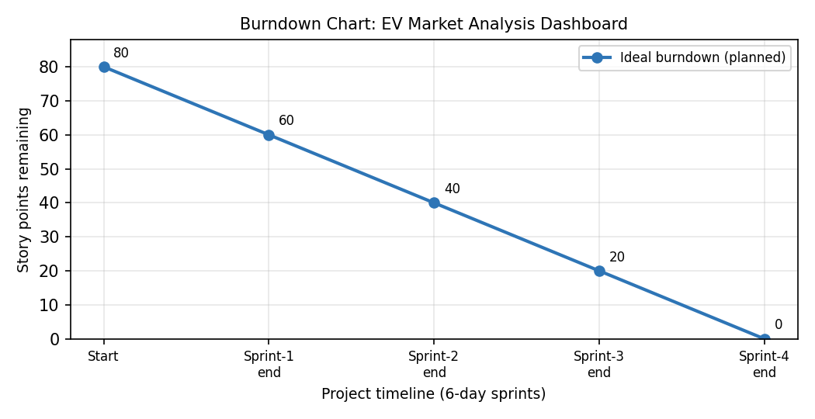
A burn down chart is a graphical representation of work left to do versus time. It is often used in agile software development methodologies such as Scrum. However, burn down charts can be applied to any project containing measurable progress over time.

https://www.visual-paradigm.com/scrum/scrum-burndown-chart/
https://www.atlassian.com/agile/tutorials/burndown-charts

Reference:
https://www.atlassian.com/agile/project-management
https://www.atlassian.com/agile/tutorials/how-to-do-scrum-with-jira-software
https://www.atlassian.com/agile/tutorials/epics
https://www.atlassian.com/agile/tutorials/sprints
https://www.atlassian.com/agile/project-management/estimation
https://www.atlassian.com/agile/tutorials/burndown-charts

